**专题五 参考答案20161008周六**

|  |  |  |  |  |  |  |  |  |  |  |
| --- | --- | --- | --- | --- | --- | --- | --- | --- | --- | --- |
| **1** | **2** | **3** | **4** | **5** | **6** | **7** | **8** | **9** | **10** | **11** |
| **B** | **D** | **A** | **C** | **A** | **B** | **D** | **A** | **D** | **B** | **B** |

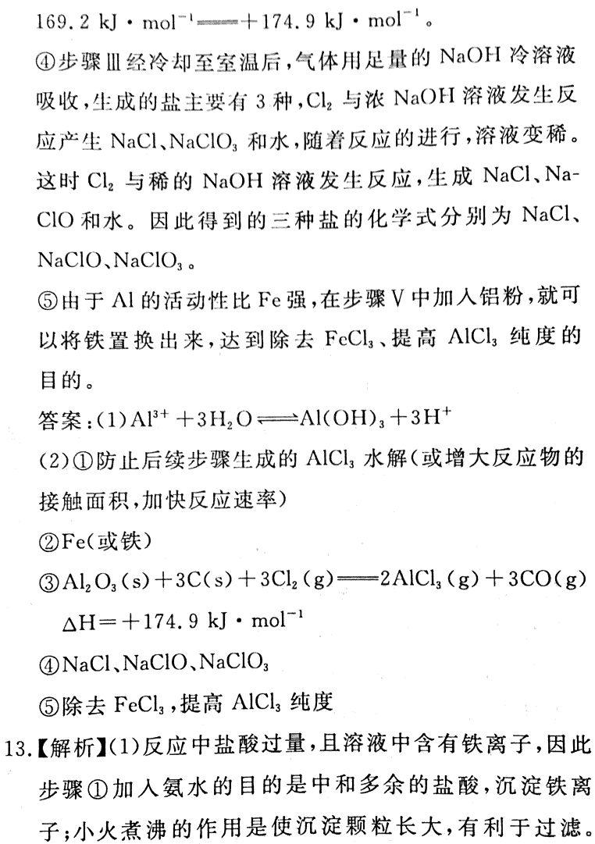12.

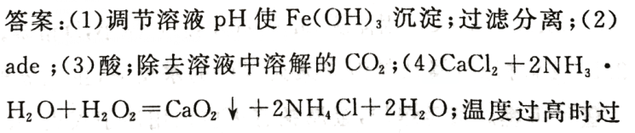

13.

氧化氢分解（5）去除结晶表面水分；（6）工艺简单、

操作简单；纯度较低

|  |  |  |  |  |  |  |
| --- | --- | --- | --- | --- | --- | --- |
| **1** | **2** | **3** | **4** | **5** | **6** | **7** |
| **B** | **B或C** | **B** | **A** | **A** | **D** | **B** |

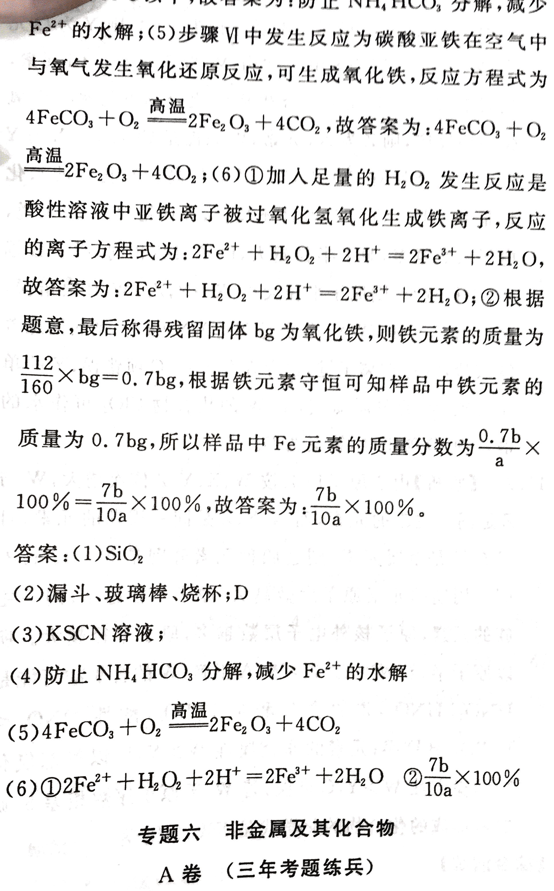8.