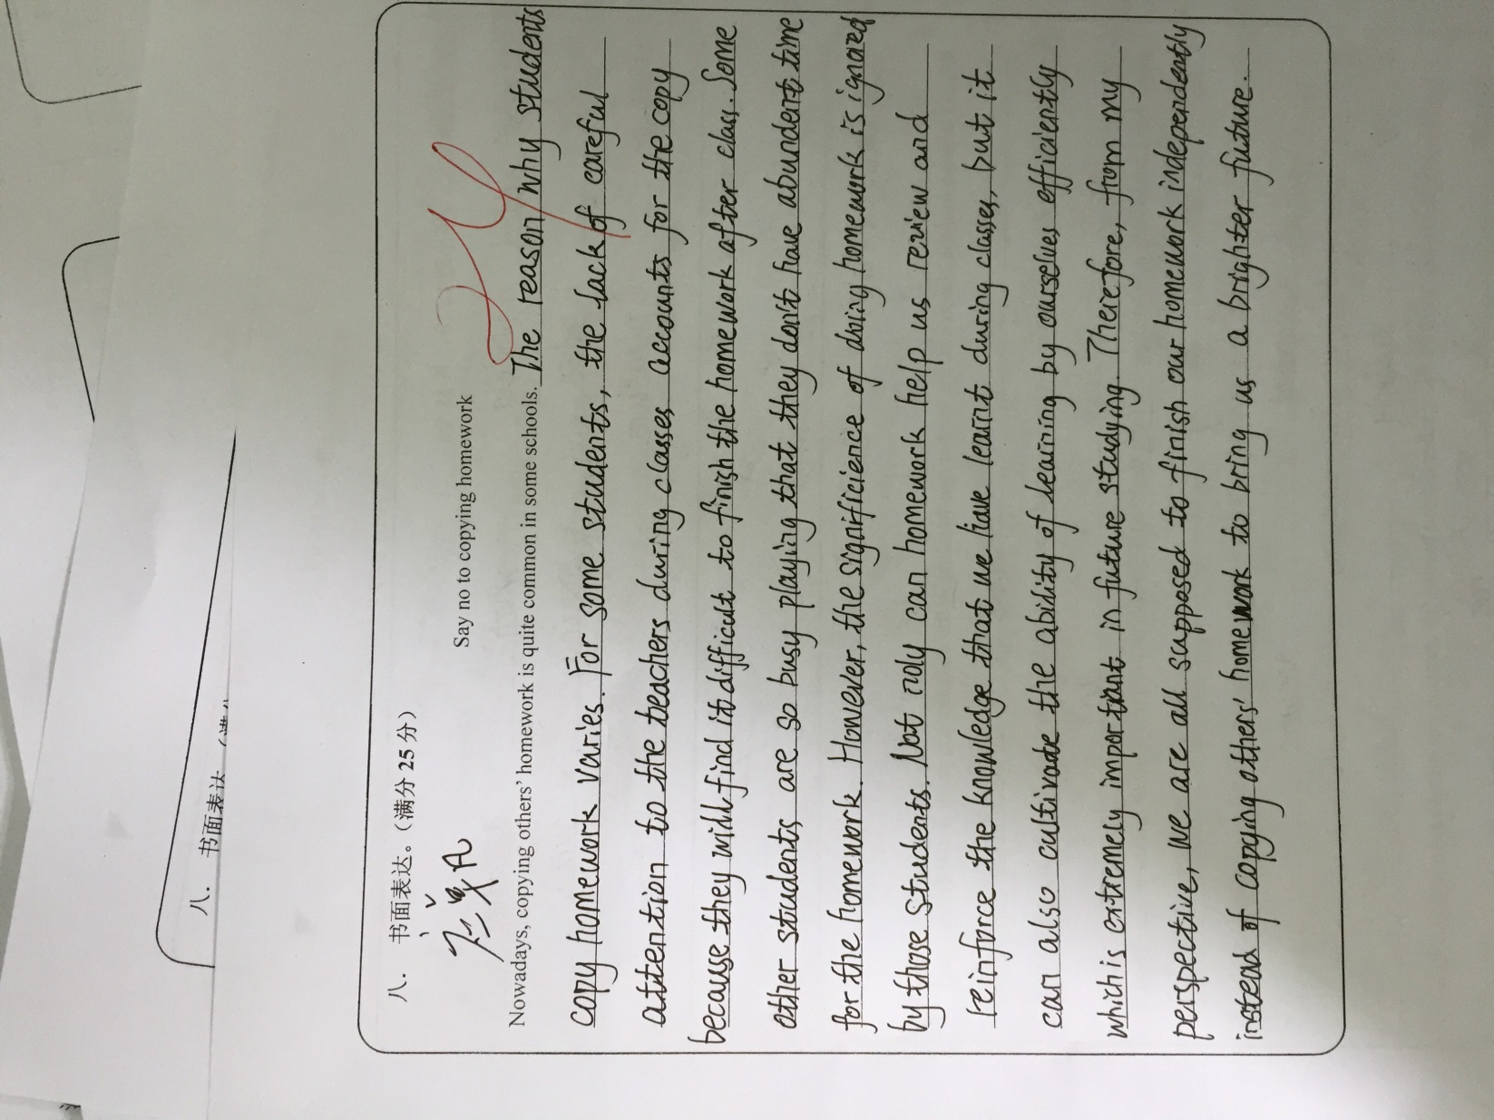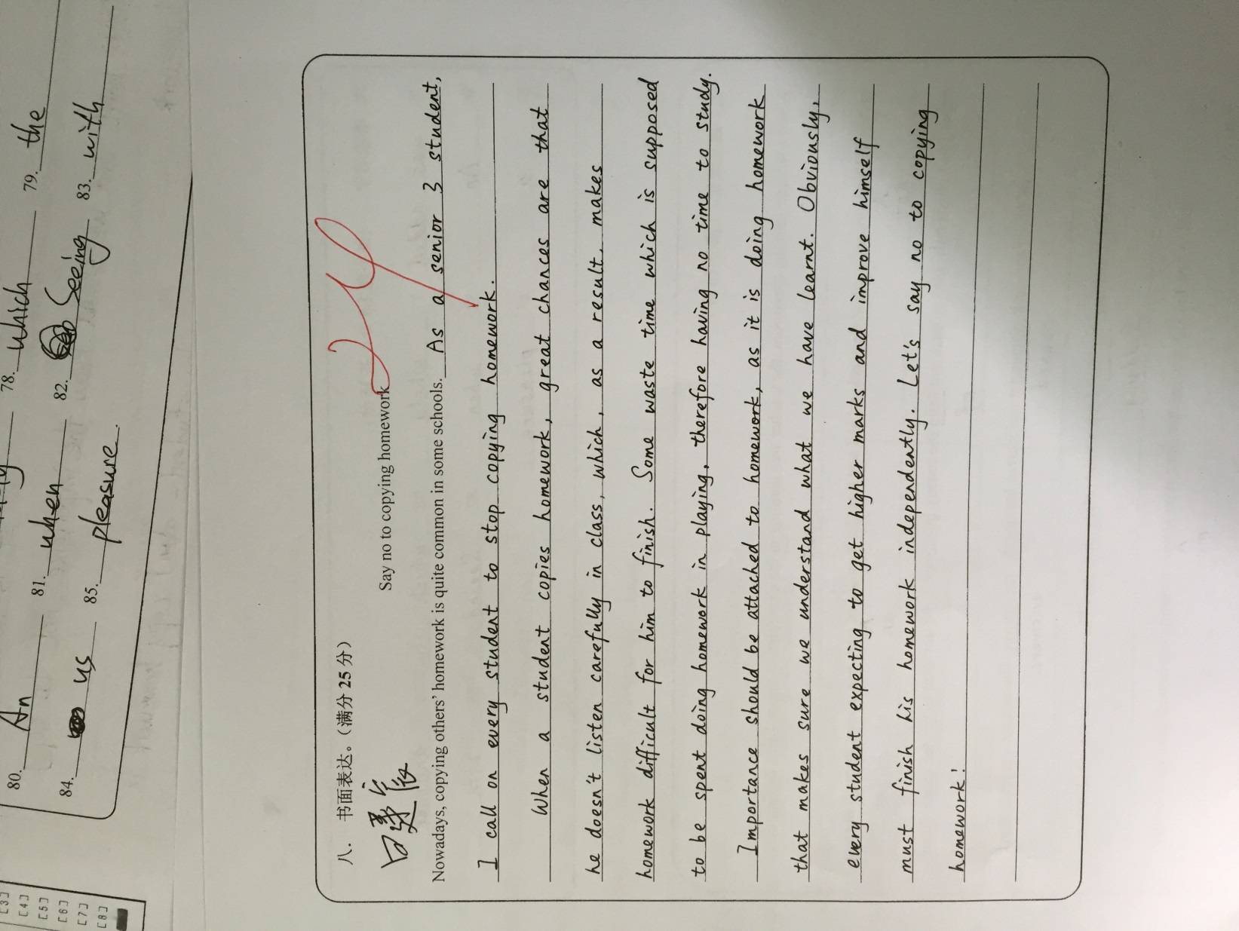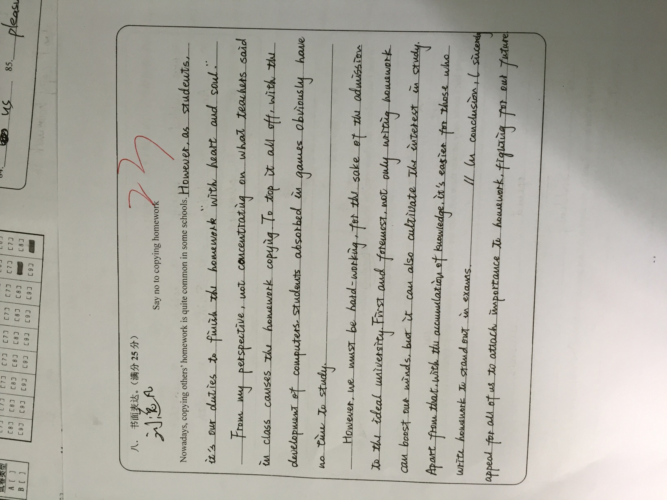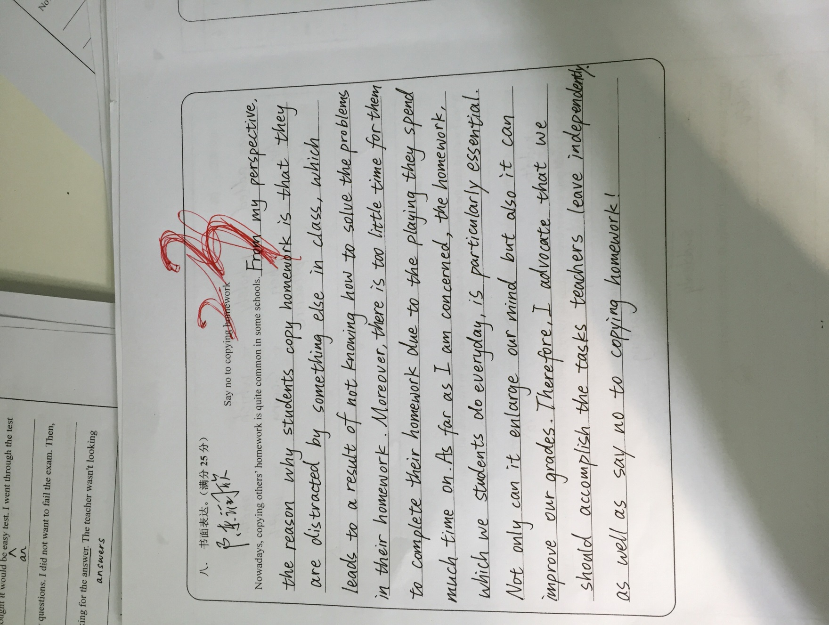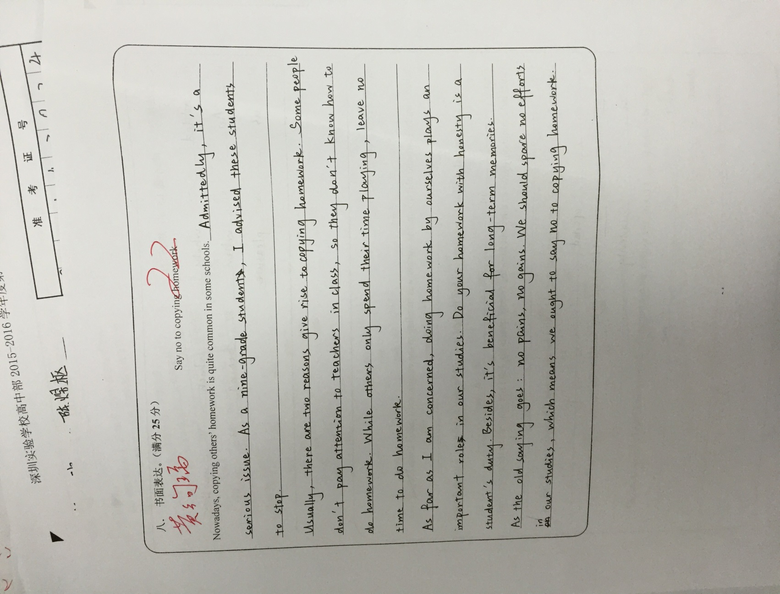

1. 电视不仅吸引阅读的人，而且也吸引了不会阅读的人。

Not only does television appeal to those who can read but to those who can't.

1. 这个可怜的人不仅被罚款，而且还被送进了监狱

Not only had the poor man been fined, but also he had been sent to prison.