听力

1-5 ACCAB 6-10 CBAAB 11-15 CBACA 16-20 CBBCA

单选

BDACA ADCCB

阅读理解

31-33 BCD 34- 37 CDDA 38 -41 BDCA 42- 45 CDAC 46- 50 DEFAG

完形填空

51- 55. BADCD 56- 60 BACDA 61-65 BCDBC 66- 70 ADBCA

短语填空

1. has dried up 72. day in and day out 73. fitted /fit in 74. in need 75. picking out

76. dried out 77.settle in / have settled in 78. is out of the question 79.. occupied with 80. Keep it up

语法填空

81. touching 82. stricken 83. to 84. accessible 85. while

86.is /has been estimated 87. annually 88. graduates 89. to improve 90. who/that

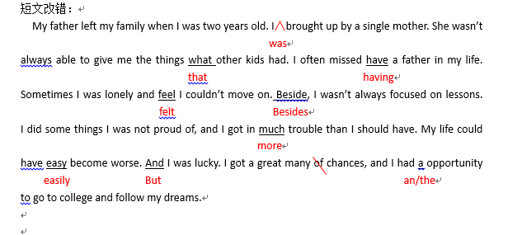参考范文：

Dear Peter,

I’m a student from Shenzhen Experimental High School. I’m wondering whether you can do us a favor. My classmates and I are preparing for the rugby match that is to take place next month. As we are not only organizers but also players, these days we are practising very hard. Since the rugby game is still new to us, we badly need professional directions from you.

We sincerely hope that you can spare some time to see us training and give us some instructions. We’re on the school soccer field every afternoon after 4:30. Please let me know which day is good for you, and your arrival will be warmly welcomed. Besides, please give us some advice on how to organize the match well enough.

Yours,

Li Hua