2016年英语听说考试E套题

Ever since I was a child, food is meant the world to me. I opened my first restaurant at the age of twenty. Now I’m better known for writing cook books. For me, nothing beats cooking at home. It’s my real inspiration, and I want to share my love of it with you. I’m going to show you five recipes a good cook would be proud of. Meals you could make in your own kitchen. Lovely home-made dishes that would impress your family and friends. Follow my lead and you’ll be able to cook some exceptionally good food.

**情绪不饱满（低沉、懒洋洋）**

**语音语调**

**发音错误（完全没读对）**

**录音质量**

**Part A 模仿朗读**

**His father(s) is a worker(s).**

**----加音导致准确度失分。**

**I don’t thin(k) I can do i(t) at the momen(t) .**

**----吞音导致准确度扣分严重，导致准确度失分。**

**Body language is often used in our daily communication.**

**----未正确连读和停顿，导致流畅度失分。**

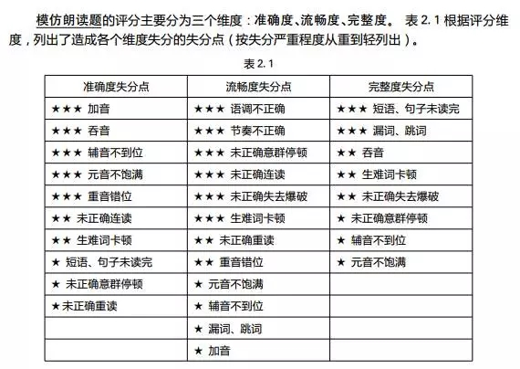

Q1:你从课程中学到了什么？

What do you learn from the course?

What have you learned from the course?

Q2:你怎么知道女性在学习语言方面做得更好？

How do you know that women can do better in learning languages?

Q3:他们在行为上有什么差异？

What are the differences in their behaviors?

What is the difference about their behaviors?

What are the differences between men and women in behavior?

What does the course cover?

**A1: The differences between men and women in behavior, psychology and so on.**

How long is one class?

**A2: {45}<forty five> minutes.**

In what aspect are men stronger than women?

**A3:** In the physical aspect.

Men are physically stronger than women.

How many boys are there in the English department?

**A4:** {28}<twenty eight>.

There are {28}<twenty eight> boys.

There are {28}<twenty eight> boys in the English department.

Why do businesswomen use manly body language?

**A5:** Because it shows power and certainty.

**Mary kept a dog and she thought of the dog as her companion. She took the dog everywhere. She liked doing adventurous sports. One day, Mary and her dog went to a big mountain for camping. When Mary took pictures, she fell down from a rock and broke her leg. She yelled for help, but nobody was there. Her dog ran to the main road, trying to stop cars but he failed. He went back to see how Mary was, only to find that Mary was in great pain. Again, the dog went to the road and stopped a car successfully. The driver followed the dog to where Mary was. He sent Mary to a hospital. Three months later, Mary recovered and she knew she owed much to the dog.**

**Part C 故事复述**

**对于故事复述这一部分，最重要的就是采集信息要点，其他的例如发音和语法，虽然也是采分点，但相对来说，权重不如信息要点那么高。**

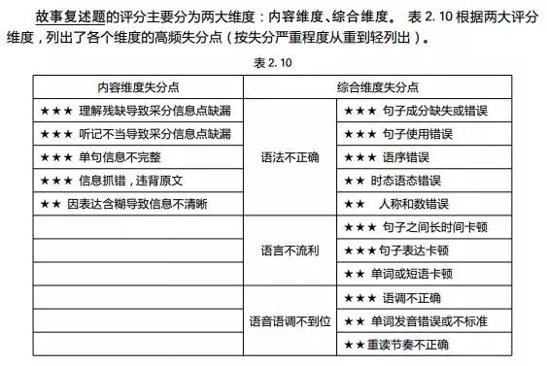

**极速冲刺2**

If the current trend continues, the Arctic ocean could be free of sea ice each summer by the year {2050}. Even if we can’t stop this loss, we can slow it down. Just as we release the green-house gases that are warming the region, we can help reduce them. Ocean currents flow from the Arctic and cool the entire planet. So we are all closely connected to the top of the world. Most Arctic glaciers are melting faster than ever before. Ironically, the faster these glaciers melt, the more majestic their waterfalls. The distance between ice packs is growing.

发音不清晰

精神不集中，读错、漏读信息

过于小心翼翼，犹豫过多，不够自信

停顿有误

不可在下一句话的停顿说更改读错的单词

Q1:你给你奶奶准备了什么礼物？

What present have you prepared for your grandma?

What gift have you prepared for your grandma?

Q2:你们打算周六回去吗？

Are you going to go back on Saturday?

Are you going back on Saturday?

Do you plan to go back on Saturday?

Q3:你家乡离市中心有多远？

How far is your hometown from the city center?

What’s the distance between your hometown and the city center?

A1:How old is Susan’s grandma?

Eighty.

Eighty years old.

A2:When did Susan’s grandpa pass away?

Two years ago.

A3:What did Susan buy for her grandma last year?

A camera.

A4:Where do Susan’s parents intend to take her grandma?

A newly-built art museum in the town.

A5:What’s Susan’s hometown famous for?

Its natural scenic spots and seafood.

Tom had a bad temper and got angry easily. One day, his father told him to hammer a nail in the fence every time he lost his temper. On the first day, he hammered nearly 30 nails into the fence. Then the number of nails decreased day by day. Because he discovered it was easier to hold his temper than to hammer those nails. Finally, the day came when he didn’t lose his temper at all. His father suggested he pull out one nail for each day that he could hold his temper. He finally pulled out all the nails in the fence as the days passed. His father led him to the fence and told him the fence would never be the same as before. He seemed to understand what his father meant.