**2016年高考听说考试B卷**

**模仿朗读**

**平均分：16.3／20**

Almost eleven kilometers deep, the Pacific is the deepest body of water on the planet. But sometimes, the seabed shoots to the surface. The creation of a new island. This is Kavachi, one of the most active undersea volcanoes in the world. Powerful waves keep sweeping its efforts away. Today, only 1% of this vast ocean is land, and much of it owes its existence to the powers of volcanoes like Kavachi. The never-ending rise and fall of land in the Pacific will continue to produce strange and wonderful worlds. The natural force that created land here in the first place, the ocean volcano.

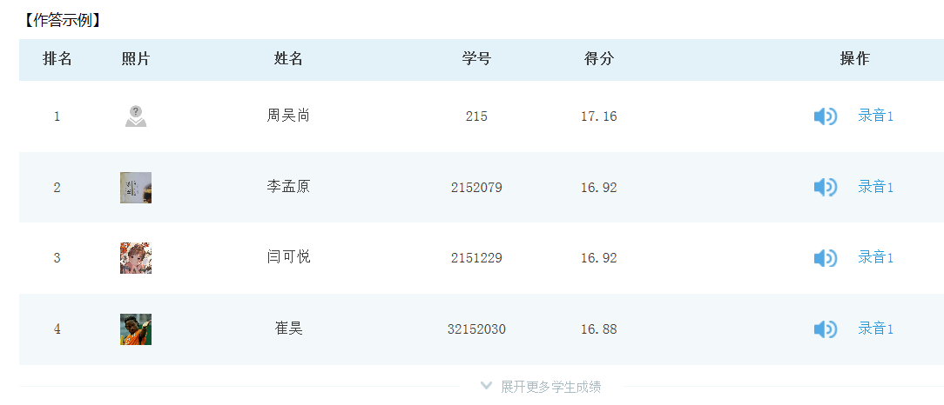

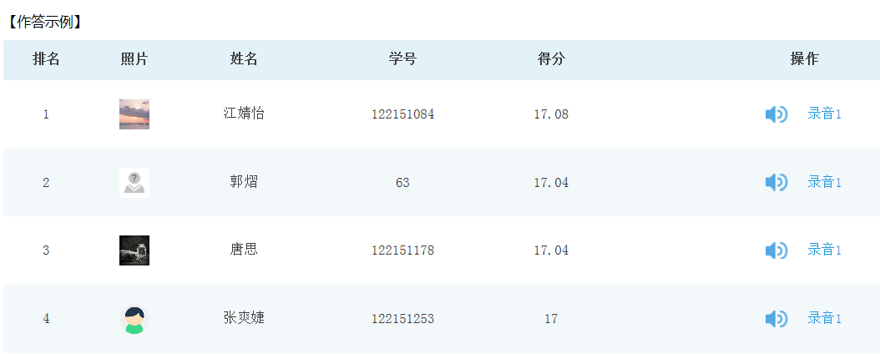

角色扮演

平均分：13.38／16

三问

**1.你12岁时，学校是怎样的？**

* How was the school when you were twelve?
* What was the school like when you were twelve?
* How was your school when you were twelve years old?
* What was the school like when you were twelve years old?
* How was the school at your age of twelve?
* What was the school like at your age of twelve?

**2. 你认为体育活动将是一样的吗？**

* Do you think that sports will be the same?
* Will sports be the same in your opinion?

**3. 最大的变化会是什么？**

* What will the greatest change be?
* What is the greatest change going to be?
* What can the greatest change be?
* What might the greatest change be?
* What will the biggest change be?
* What is the biggest change going to be?
* What can the biggest change be?
* What might the biggest change be?

五答：

**1.Why was Tom so excited?**

* Because he has just had a new-born son.
* Because he has just had a new-born baby.
* Because he has just become the father of a new-born baby.
* Because Tom has just had a new-born son.
* Because Tom has just had a new-born baby.
* Because Tom has just become the father of a new-born baby.

**2.What does Tom do for a living?**

* A teacher.
* He is a teacher.
* Tom is a teacher.
* He works as a teacher.
* Tom works as a teacher.

**3. What did Tom’s teacher use in the classroom?**

* The white board.
* His teacher used the white board in the classroom.
* Tom’s teacher used the white board in the classroom.

**4. What games did Tom play when he was twelve?**

* Basketball games or baseball games.
* He played basketball games or baseball games when he was twelve.
* Tom played basketball games or baseball games when he was twelve.
* He played basketball games or baseball games when he was twelve years old.
* Tom played basketball games or baseball games when he was twelve years old.
* When he was twelve, he played basketball games or baseball games.
* At the age of twelve, he played basketball games or baseball games.

**5. Why could the future learning be more interesting and easier?**

* Because each student may have a robot to help with reading and writing.
* Because every student may have a robot to help with reading and writing.

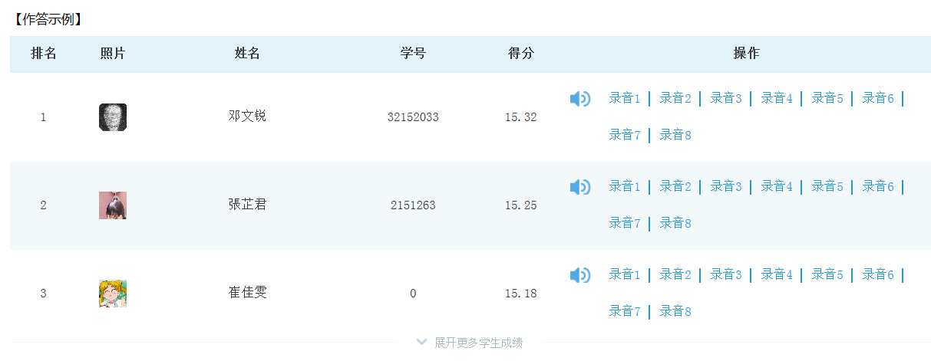

### 

### 故事复述

**平均分：22.44／24**

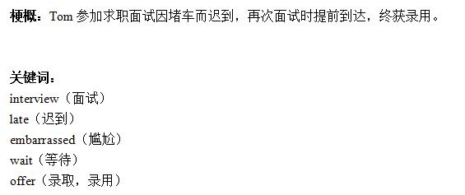

【参考答案】

**①Tom was invited to a job interview in a university in New York City. The interview started at ten o’clock a.m. ②Tom didn’t know much about the morning traffic there. When he was near the downtown, the bus was moving very slowly.③When he got to the university, the interview had finished.④Luckily, he got another interview which was again at ten o’clock a.m.⑤This time, Tom decided he would never be late again. ⑥He started out very early that day. It was very cold and Tom made his way in the falling snow. ⑦He got to the university two hours earlier and waited at the gate of the building.⑧When the director came, he was very surprised to see Tom so early. ⑨Tom explained that he didn’t want to be late again. ⑩And the director gave Tom an offer right away. He said a man who cared much about time should be trusted.**

