2017-02-09

河北省“五个一联盟·质量检测

假定你是李华，你校即将举行一年一度的“校园书市“(a campus book fair)”活动，其目的是给同学们提高一个交换、利用图书的机会。请你用英语写信给你的加拿大笔友Mike，介绍此次活动的有关情况。内容应包括：

1 活动目的；

2 活动内容：买书、卖书，交换图书；

3 活动意义。

Held annually by our school, the activity provide students precious chances to exchange and take full advantages of their books.

Initially, the activity was established mainly to offer a platform where students can exchange their books. Not only can we purchase our beloved books at a cheaper price, but also we can sell the books that are no longer needed. Ultimately, I think it’s the activity that make the various books accessible to us and build a love-reading atmosphere in our school.

Reading makes a full man.

enrich one’s mind

broaden one’s scope

sharpen one’s insight

develop one’s sense of beauty

derive/obtain pleasure, enjoyment, inspiration and encourage

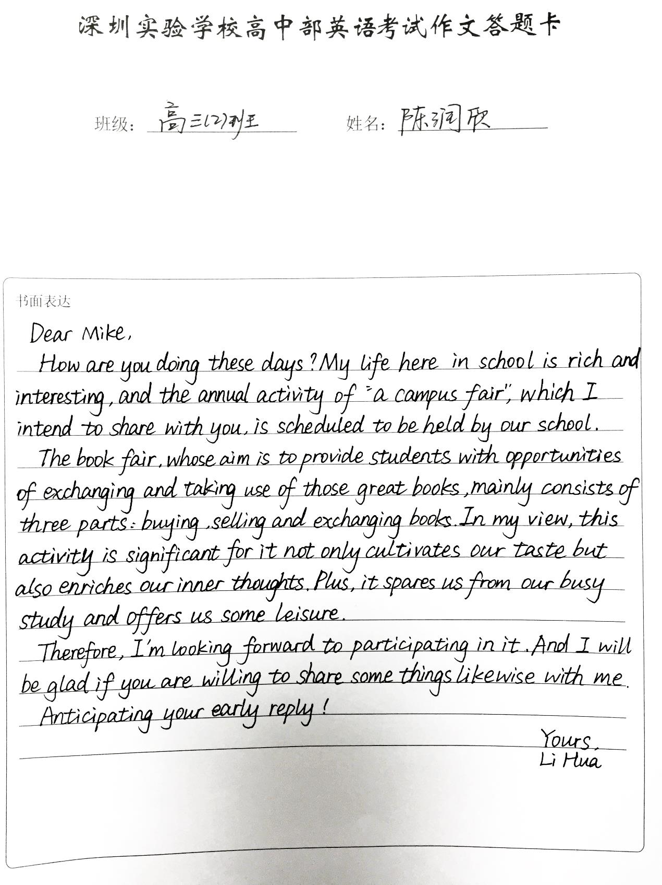

From my perspective, by reading the books from others, not only can we greatly enrich our book lists but also refresh our ways of thinking and cultivate our life-long enthusiasm for books. 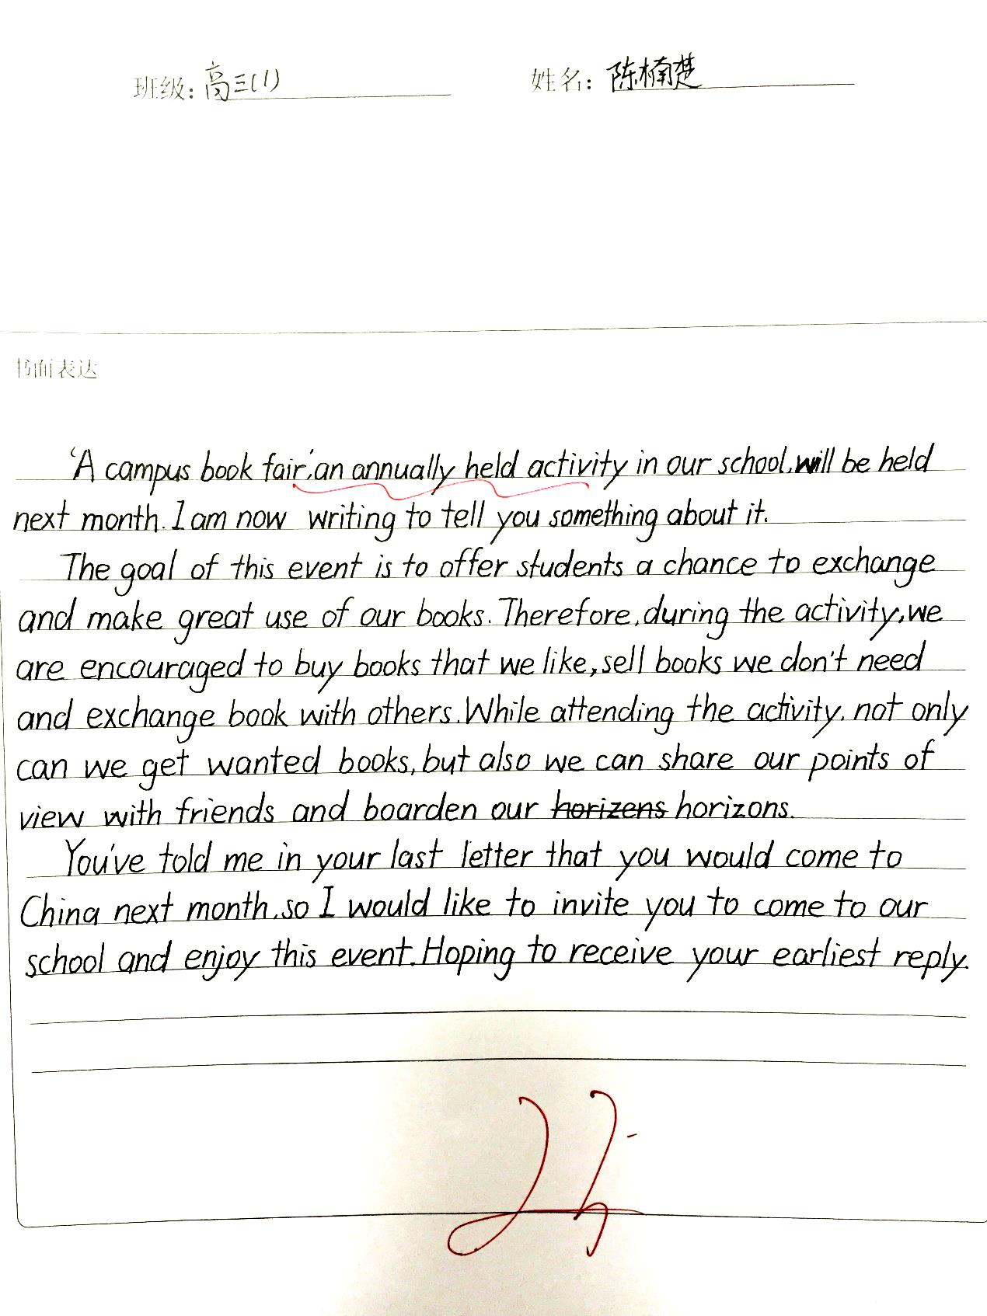

参考范文

Dear Mike,

How are you doing these days?

Aimed at providing a platform where students can have a chance to exchange and make use of their books, the annual campus book fair will soon be held in our school. The fair will attract a huge crowd from the entire school, who are to sell, purchase and exchange their second-hand books with their peers.

As a regular visitor, I’ve found myself increasingly drawn by the fair. For one thing, the fair exhibits books of hundreds of types on diverse topics, motivating us to further develop our reading habits and help to broaden our horizons. For another, most books are sold at a lower price than what the bookstores offer.

Please let me know if you have any suggestions on how to host such a book fair better.

Yours,

Li Hua