2016年·全国卷（三）

假定你是李华，与留学生朋友Bob约好一起去书店，因故不能赴约。请给他写封邮件，内容包括：

1．表示歉意； 2．说明原因； 3．另约时间。

*Dear Bob,*

**I’m sorry to say that I cannot go to the bookstore with you on Friday afternoon**. I have just found that I have to attend an important class meeting that afternoon. I hope the change will not cause you too much trouble.

Shall we go on Saturday morning? We can set out early so that we’ll have more time to read and select books. If it’s convenient for you, let’s meet at 8:30 outside the school gate. If not, let me know what time suits you best. I should be available any time after school next week.

*Yours,*

*Li Hua*

2017最新密破考情卷（二）

假定你是李华，上周日是你的外国朋友Anne的生日。你本来答应参加她的生日聚会，但是你当时正忙于准备月考，不小心忘了赴约。请写信向Anne表达你的歉意。说明原因，并提出补救方法。

Dear Anne,

I am very sorry that I didn’t attend your birthday party last Sunday. I feel awful about it and want to apologize to you.

It was nice of you to invite me to your party. I should have come and celebrated the precious moment with you, but the monthly test is around the corner, so I was so busy preparing for the test that I forgot the appointment. I hope you understand my situation and forgive me. Is it possible for you and me to have a private meeting after the test? I do long for a pleasant chat with you.

It is much great that I missed the chance of a happy get-together. Once again, please accept my sincere apology.

Yours,

Li Hua

Students’ Samples

**补救： make up for / compensate for/ remedy**

Class 10

Can you give me chance to make up for it? I want to invite you to have dinner with me this Sunday. Are you free at that time? If not, when will you be free then?

Class 1

Now I’m thinking about how to compensate for my mistake. As I’m skilled at baking, I made you a hand-made chocolate cake, which stands for my love and our friendship. Could we meet at the central park, so I could hand it to you with my sincere apology?

你的评分：？？？

Class 11

Dear Anne,

I’m so sorry for my absence from your birthday party last Sunday. I’m writing to explain my mistake and make up for it.

Last Sunday morning, I was occupied in preparing y monthly exam. I planned to go to your house as soon as I finished reviewing. However, I was so tired that I fell asleep. And it was at midnight that I woke up. I knew my mistake and careless must have broken your heart. I truly want to compensate for my absence. So I’d like to ask if I can make an appointment with you this Sunday to celebrate your birthday again. I promise I’ll meet with you on time and give you a surprising gift.

I do hope you can accept my apology and the appointment. Looking forward to your reply.

Yours,

Li Hua

作文如下看原作文

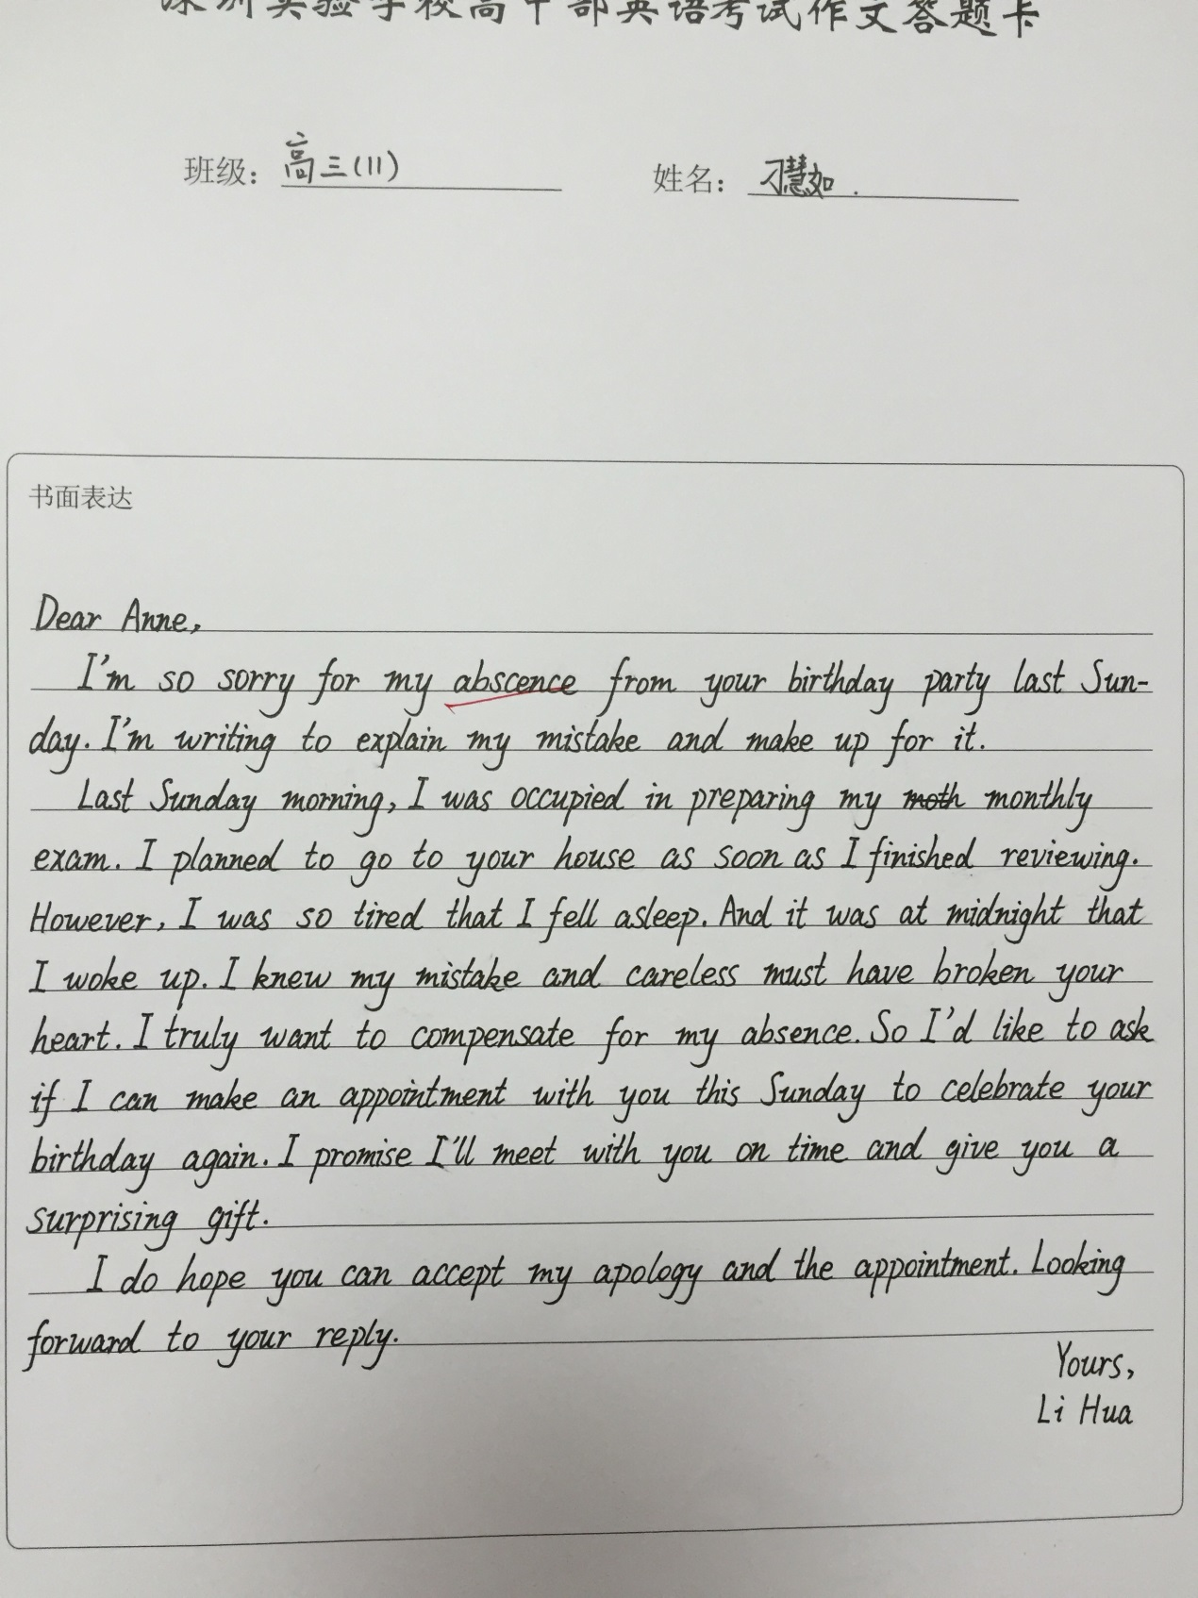

Class 11·洪晶晶·24

Dear Anne,

I’m Li Hua. I feel awfully sorry for missing your birthday party last Sunday, which I have promised to participate in, so I’m writing to make an apology to you.

I really cherish this precious opportunity to foster our friendship. However, it is because of my being occupied with preparing for the coming monthly test that I failed to join in your party. We could have had an enjoyable time together. What a pity!

Therefore, in order to remedy this matter, I mean to set another time for you to celebrate your birthday in a special way. And I have some hand-made presents for you which convey my heartfelt wishes. Please tell me what time suit you best so that I can make appropriate arrangement.

I hope that you can kindly understand my situation and accept my apology. Looking forward to your reply.

Yours

Li Hua

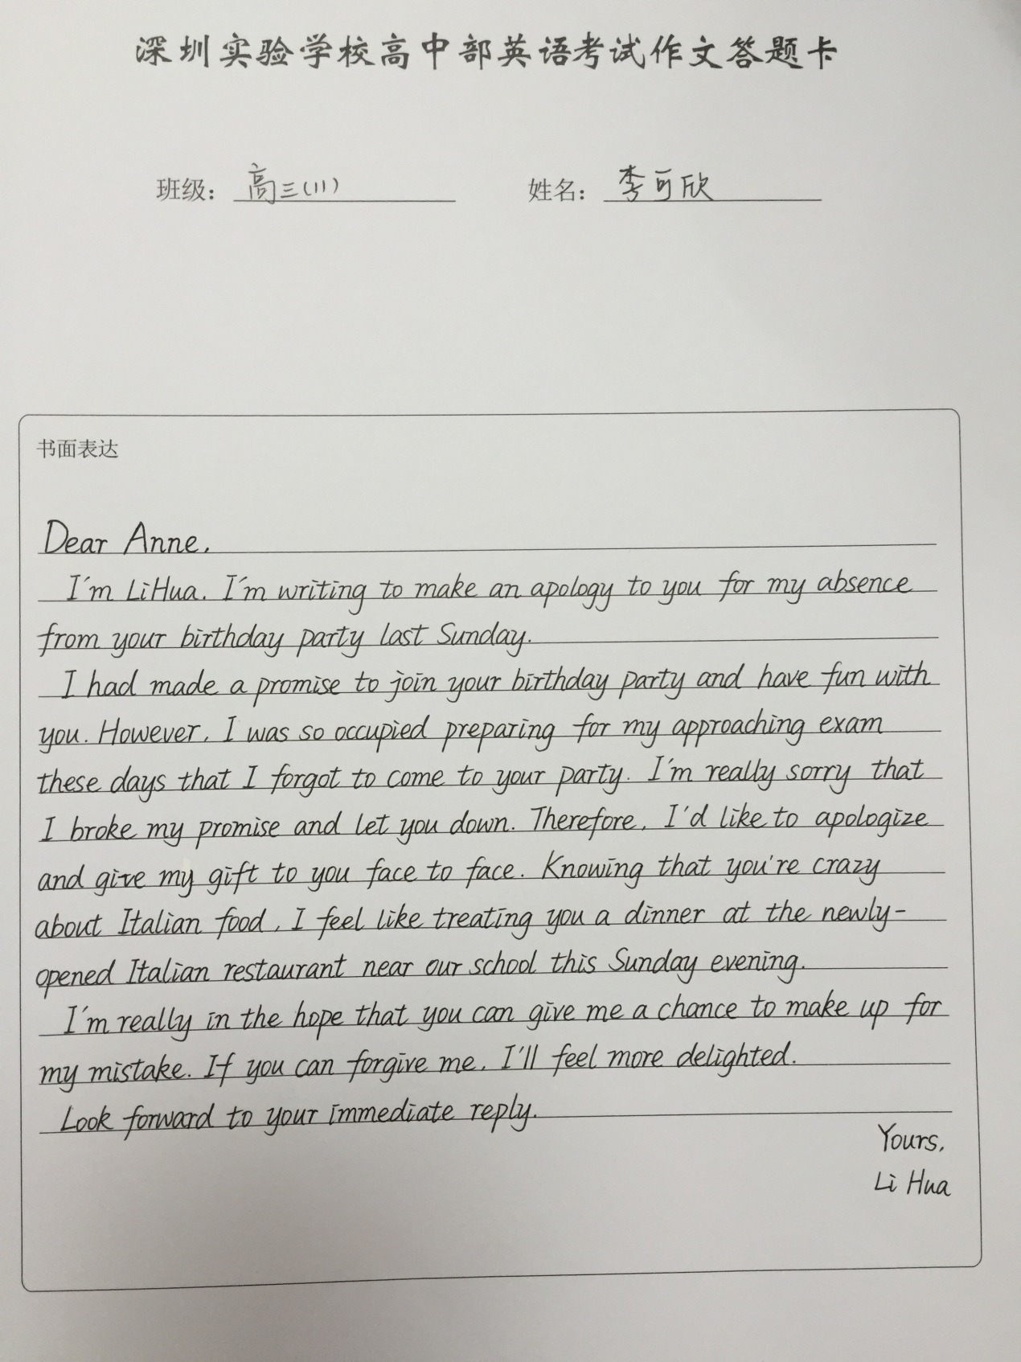Class 11·李同学· ？评分？