2016-10-6

咨询信 双语报（12）

假定你是李华，正在加拿大学习英语。下面的这则广告引起了你的注意，请根据下列要点给该组织写封信，询问有关情况。

1 如何得知该消息；

2 为何对它感兴趣；

3 询问相关事宜（时间、地点、费用等）。

**professional. affordable. fun.**

**Stay Active All Summer and Lose Weight!**

注意：1 词数100左右；

2 可以适当增加细节，以使行文连贯。

2016年深圳一模

假定你是李华，你计划去英国兰卡斯特大学参加为期六个月的语言培训。你想寄宿在学校附近的英国人家里。该大学网站上的一则广告引起了你的注意，但一些具体信息不明确（箭头所指内容）。请你给校发一封电子邮件，询问有关情况。

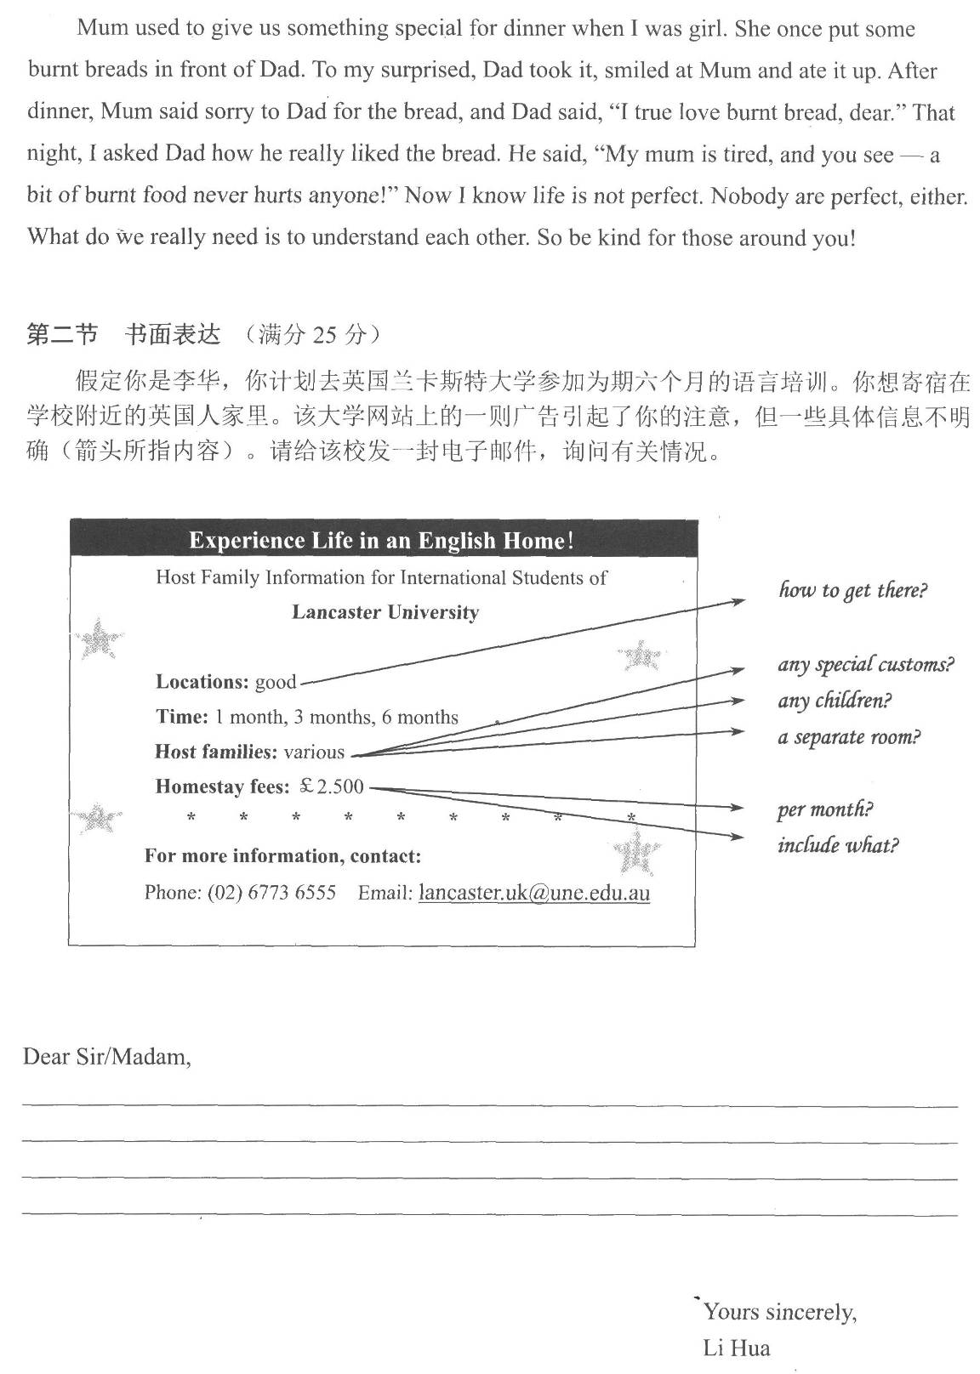

Dear Sir/Madam,

I am a student from China and plan to learn English in Lancaster University for 6 months. I am writing **in response to** your advertisement. Here are a few things I’d like to clarify.

**Firstly**, how can I get to the University from my host home? **Secondly**, would I have a separate room of my own? And are there any children in the family? It would be beneficial to have someone of a similar age living with me. **Also** I’d like to know if they have any special customs. **Lastly**, I wonder what is included within the fees in the ad, and whether it should be paid monthly or weekly.

I look forward to hearing from you.

Yours sincerely,

Li Hua

2014年全国卷（一）

假定你是李华，计划暑假间去英国学习英语，为期6周。下面的广告引起了你的注意，请给该校长写封信，询问有关情况（箭头所指内容。）

ENJOY A RELAXING STUDY BREAK IN BEAUTIFUL LANCASTER

**LANGUAGE CENTRE AND COLLEGE OF ARTS**

UNIVERSITY OF LANCASTER

***Languages*** · English · French · Spanish

***Arts***·Politics·Sociology·History

* * *

**3 wk, 6wk and 12 wk course**

* * *

**Reasonable fees**

* * *

**Accommodation service**

***start dates?***

***class size?***

***hours per week?***

***how much?***

***type of accommodation***

注意：1. 词数100左右； 2. 可以适当增加细节，以使行文连贯。

3. 参考词汇：住宿 accommodation

Dear Sir/Madam,

___________________________________________________________

Yours faithfully

Li Hua

***Possible Version***

*Dear Sir/Madam,*

I am a student in China and I plan to go to Britain to attend a summer school during the vacation. I’ve seen your ad, and I’d like to know more about your six-week English course.

**First** when will the course start and how many class hours are there per week? **Besides**, I wish there would not be too many students in a class. I**’d also like** to know how much I have to pay for the course and whether accommodation service is included. Would there be host family or university dormitory?

I am looking forward to your early reply.

*Yours faithfully*

*Li Hua*

Students’ Paper · Class 2

To whom it may concern,

I’m a Chinese student learning English in Canada. Recently, I saw your “Learn Teen Program” when surfing the Internet.

Due to the fact that your program is professional, affordable and fun, which is exactly what I’m looking for. I’m willing to spend my holiday participating in your program. What’s more, looking at my increasing weight, I long to find an activity to lose my weight, and luckily, your words perfectly suits my thought!

Since I don’t know the details of your program, could you please send me some information such as schedule, place and price. I would appreciate it if you reply to my letter soon.

Yours

Li Hua

Dear Sir or Madam,

I am Li Hua, an exchange student who is studying English in Canada. I saw your advertisement from a newspaper yesterday. It was the introduction of losing weight that really caught my attention. In the hope of know more details, I am writing to you eagerly so as to get further information.

First, when and where will this program be held? Secondly, how much will I spent if I go in for the program? Hoping to lose weight during the program, not only do I wonder what activities will be held but also I would like to know how many kilograms I can lose. I will appreciate it if you can offer me a schedule of this program.

Looking forward to your reply.

Yours,

Li Hua

Students’ Paper · Class 1

Dear Sir,

Noticing it on a poster, I would appreciate it very much if you can provide me with more details about this ad.

Not only its affordable price but also its attractive plan has a deep impression on me. Aiming to lose 5 kilograms during this summer, I am eager to get some professional trainings. In addition, participating in this program won’t cost much so it will not improve the economic burden of my family. Last but not least, could you send me the relevant information, including time schedule, place, and fee immediately? I have to make final decision in two days.

I am expecting your early reply.

Yours

Li Hua

Dear Sir or Madam,

As a Chinese student in Canada for further study, I am in favor of taking every opportunity to improve myself. Hardly had I been extremely interested in this program when I you’re your advertisement in the newspaper. In order to keep healthier and more active, it must be a good choice.

So I am asking for some necessary details about the program. Not only do I wonder the time when the program is scheduled to start, but also I am confused where the program is held. Having little financial support, I wonder whether the cost is as affordable as what you advertise or not.

I would sincerely appreciate it if you could offer more important details to me. I’m looking forward to your reply.

Sincerely,

Li Hua

书面表达 (One possible version)

Dear Sir / Madam,

I am a Chinese student studying English in Canada. Quite upset about my heavy body, I am planning to attend a training program that can help me effectively lose weight. I’ve seen your ad online, and I’d like to know something more about your program.

First, where and when is your program held? How could I sign up for it? Second, how many class hours are there in the daytime per week? Third, I am very concerned about the expense of the program as I am still a student supported by my parents.

I am looking forward to your reply.

Yours,

Li Hua