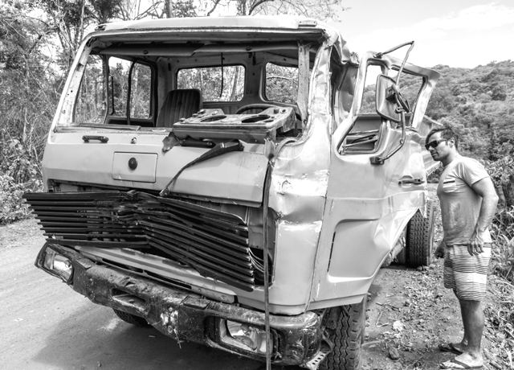

We lived in a very quiet neighborhood. One evening, I heard a loud crash in the street. Earlier, my wife had asked me to go to the store to get some soft drinks. It seemed like this would be a good time to let my teenage daughter Holly practice her driving, so I sent her to the store in my truck.  
  
At dinner my son talked about how much he liked my truck. I enjoyed having it, but I said: “Guy, my heart is not set on that truck. I like it, but it is just metal and won’t last forever. Never set your heart on anything that won’t last.”  
  
After hearing the loud noise, the whole family ran outside. My son shouted: “Dad! Dad, Holly crashed your truck.”  
  
My heart sank and my mind was flooded with conflicting thoughts. Was anyone hurt? Who else was involved? As I ran to the door, I heard a voice in my heart say: “Here is a chance to show Holly what you really love. She’ll never forget it.”  
  
The accident had occurred in my own driveway. Holly had crashed my truck into our other vehicle, the family van (搬运车). In her inexperience, she had confused the brakes (刹车) and the gas pedal. Holly was unhurt physically, but when I reached her, she was crying and saying: “Oh, Dad, I’m sorry. I know how much you love this truck.” I held her in my arms as she cried.  
  
Later that week a friend stopped by and asked what had happened to my truck. I told her the whole story. Her eyes moistened (湿润) and she said: “That happened to me when I was a girl. I borrowed my dad’s car and ran into a log (木头) that had fallen across the road. I ruined the car. When I got home, my dad knocked me to the ground and began to kick me.”  
  
Over 40 years later, she still felt the pain of that night. It was a deep wound on her soul.  
  
I remember how sad Holly was the night she crashed our truck, and how I comforted her. One day, when Holly thinks back on her life, I want her to know that I love her a thousand times more than any piece of property (财产).  
  
I repaired the van, but the dent (凹痕) in my truck is still there today. It reminds me every day of what really matters in my life.