**Possible version:**

*Dear Jack,*

*It’s been some weeks since I last wrote you. How have you been?*

Recently I have read **a collection of poems**, **arousing my great interest in** poetry. Now I’m **more willing to** share my feelings with you in this letter.

As far as I’m concered, there are a few **unique characteristics** making poetry **fascinating**. First, **featuring strong rhythms and harmonious rhymes**, poems usually sound beautiful. Furthermore, the language of poetry, **brief but provoking imagination**, can not only **portray** some fair things, like splendid natural scenery, but also **keep an account of** historical events. Last but not least, usually used as an ideal way to **convey** a poet’s feelings, poetry is a best form of literature to express one’s emotions.

Being so keen on poetry, I have written a short poem and **attach it to this letter**. Please take some time to read it and tell me what you think of it.

*Looking forward to your next letter.*

*Yours sincerely,*

*Li Hua*

**Let’s appreciate some beautifully-written sentences!**

1. Besides, it’s the poems in brief that **arouse our imagination** to **have a close description of** something nice, as well as setting down historical events.
2. **There’s no denying the fact that** poems play a significant role in our daily life, **satisfying our spiritual need and refreshing ourselves**. They serve as an excellent language style to convey our feelings. **Exposed to** the atmosphere of varieties of poems, we’ll find it easy to have a good mood and broaden our horizons.
3. First and foremost, **blessed with a strong sense of rhythm and rhyme**, poetry sounds gorgeous and wonderful, which make people relaxed when facing troubles or getting exhausted.
4. In addition to all these advantages, **what set the poem apart is** that it’s also a good form to convey feelings, no matter how complicated the feelings are.
5. **So strongly rhythmic are the poems** and **so many rhymes do the poems have** that they sound pretty elegant and gentle, which exert an influence on releasing my pressure.
6. **Simultaneously**, historical events can **be documented** in poems, which is of great help to discover the covered history and study the development of the country.
7. In other words, not only can it **inspire my imagination** and present an all-rounded description of the ever-present positive things such as sunshine in life, but **it also serves as a box that stores events happening in the history**.
8. **Finally but most strikingly**, every single word in the poems **is laden with** the poets’ emotions, which turns out to have a far-reaching impact on readers’ hearts.
9. Having a brief statement, poems let us **fly over the rainbow of the imagination**. Like a magic pen, it can make those memories come to life. Like an old photo, it **overwhelm**s us by the memories of historical things.
10. Besides, with brief sentences, not only does it **spark my imagination** to picture wonderful things, but also it can work as a carrier recording historical incidents. Additionally, **it can never fail to be an ideal form to express our feelings**.

**Two high-graded compositions:**

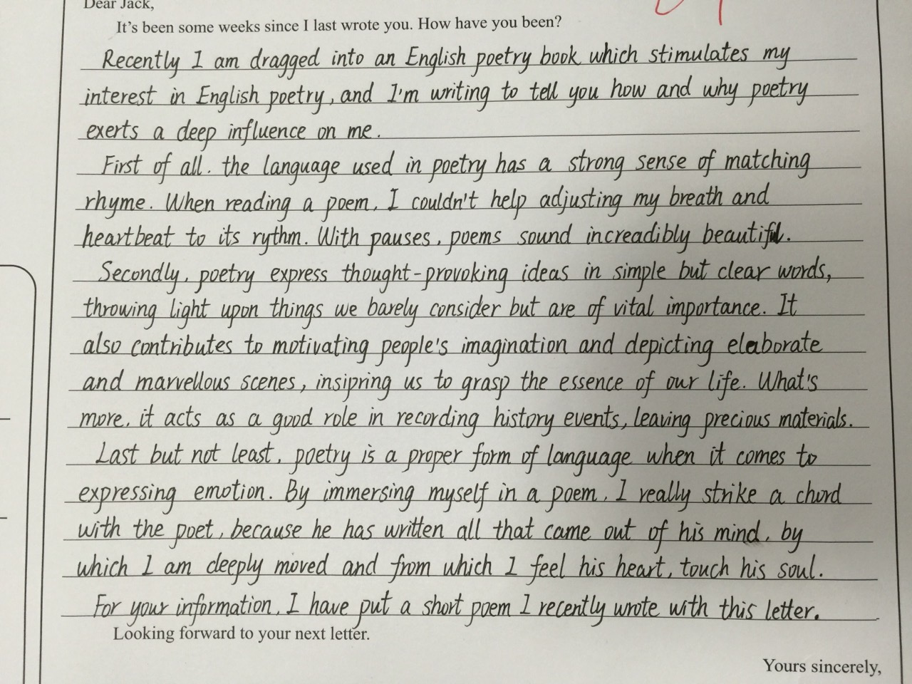

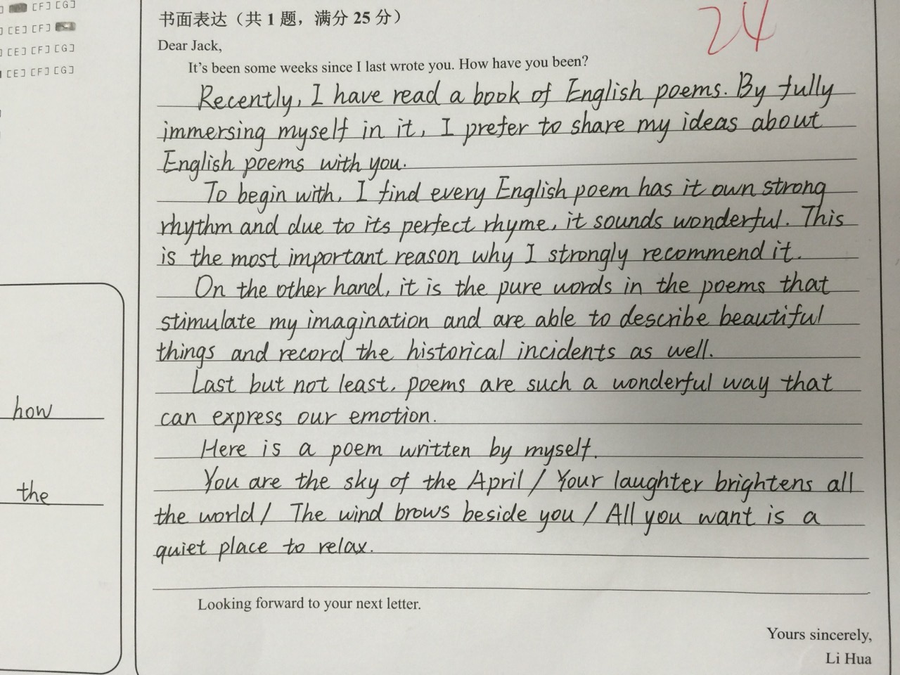

**书面表达注意事项**

1. 写给谁：定语气。
2. 主题是什么。
3. 写出所有的要点，在此基础上增加细节。
4. 怎么增加细节：谈谈个人感受；在一些关键名词前多用一些评价性形容词；根据每个要点引申相关细节说明。
5. 分几个段落：一般三段式，详略要得当。
6. 详写段落结构：主题句 + 支撑句。
7. 用什么句型：长短句相结合。
8. 准确表达，语言地道：重视平时的积累！
9. 书写：整洁，整齐，大小一致，字母间与单词间距离匀称，每个字母整齐地落在横线上，每个字母要清晰，避免毛刺。