Unit 2 The United Kingdom
Part 1 Teaching Design
第一部分 教学设计

Period 3 A sample lesson plan for Using Language
(SIGHTSEEING IN LONDON)

Introduction
Language is learned to be used in and for communication. So in this period we shall have the students warmed up by watching a video show, listening about London, reading a passage entitled Sightseeing in London, underlining and copying useful expressions, listening and ticking and speaking and writing.
Objectives
- To help students read the passage “Sightseeing in London on page 13
- To help students use the language by listening, speaking and writing as well
Procedures
1. Warming up by watching a video show
Hello, class! I am your travel guide today. We shall go to visit London for this weekend. Now let’s watch a video show about London attractions first. You may also read the caption in English.
 |  | 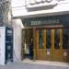  BBC  Experience |  | 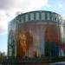  BFI London  Imax  Cinema |  | 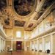  Banqueting House |  |   Battersea Park |  | 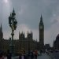  Big Ben - Houses of  Parliament |  | 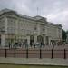  Buckingham Palace
 |  | 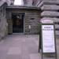  Cabinet  War  Rooms |  | 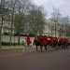  Changing  of the  Guard |  | 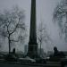  Cleopatra's  Needle |  | 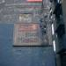  Clink  Exhibition |  | 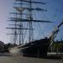  Cutty Sark |  | 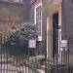  Dr Johnson's  House
 |  |   Eltham Palace |  | 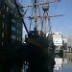  Golden Hinde |  |   HMS Belfast |  | 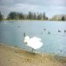  Hyde Park |  | 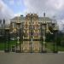  Kensington  Palace |  | Kew Gardens
 |  |   London  Aquarium |  | 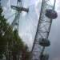  London Eye |  | 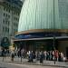  London  Planetarium |  |   London Wetland Centre |  | 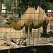  London Zoo |  | 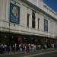  Madame  Tussaud's

2. Listening about London
To better enjoy our trip to London listen to the recording of the article SIGHTSEEING IN LONDON on page 13. Take notes of the main facts of the attractions talked about in the article.

3. Reading and completing
Skim the text for information to complete the form below.

Facts of Sites in London
The Tower | Built by…, Queen’s jewels…
St Paul’s Cathedral | Built after…, looking…, contains…
Greenwich | Old ships, famous clock, the longitude line…
Karl Marx’s statue | …
Windsor Castle | …
4. Underlining and copying
To learn more from this article, you are next to go over it to underline all the useful collocations. After class write a short passage, making use of them.

Expressions from Sightseeing in London
make a list of…, remain standing for…, expand around…, remain part of…, find…guarded by…, on special occasions, wear the uniform, there follows…, look splendid, in memory of…, ring out…, finish the day by…, divide the eastern and western halves of the worlds, pass through…, have a photo taken, develop communism, be thrilled by…, be displayed in…, feel proud of…, fall asleep
5. Listening and ticking
You did a nice job just now. Next let’s go to page 15. Listen to the tape and tick the English Kings or Queens you hear about.

6. Speaking and writing
In pairs choose an interesting building or attraction in your hometown. Act as a tour guide for your partner. Show him around and tell him about it. The best pairs will be invited to present their imagined tour in front of class.

7. Closing down by writing a local tour guide

To invite more classmates to visit your local sightseeing attractions you shall set about collecting information and putting it into a short local tour guide entitled WHY NOT VISIT OUR LOCAL XX?
Tomorrow you will read your tour guide to your group members. Let’s wait and see whose guide will be most convincing.

