Section 2: Background information about the text
- Related news report about the Shenzhou V
- BEIJING, Oct. 18 (Xinhua net) -- The secret "cargo" on China's first manned spacecraft was revealed at an opening ceremony of the spacecraft's re-entry vehicle Saturday in Beijing. The items aboard the Shenzhou V included China's national flag, a flag of the Beijing 2008 Olympics, the United Nations flag, a Renminbi note, memorial stamps for China's first manned spaceflight, memorial envelopes of the manned space flight project and crop seeds from China's Taiwan Island. The cargo had traveled with China's first astronaut in space, Lt. Col. Yang Liwei, for over 20 hours and were returned to their owners at Saturday's ceremony.
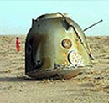
The re-entry vehicle of Shenzhou V was taken to Beijing Friday afternoon after the successful landing in central Inner Mongolia Autonomous Region, north China.
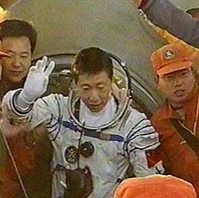
- BEIJING, Oct. 17 (Xinhua net)-- The re-entry capsule of Shenzhou-5,which carried China's first astronaut Lt. Col. Yang Liwei to and returned from the space between Oct. 15-16, was handed to the Chinese Research Institute of Space Technology here Friday. The capsule, which landed safely in north China's Inner Mongolia Autonomous Region at 6:23 a.m. Thursday, just 4.8 kilometers off the pre-set target, arrived in Beijing Friday afternoon on a special train. After a primary inspection, experts concluded that the buffer engines of the capsule operated normally before the landing and the entire capsule remained intact. Shenzhou-5, measuring 9.2 meters in length and weighing 7,790 kilograms, consists of the orbit, re-entry and propulsion modules. The capsule will soon be opened and the data collected by the scientific apparatus on board will be studied.
2. Background information about the manned space flight of China
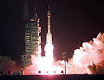
China launches manned space flight
Tuesday, October 11, 2005; Posted: 10:30 p.m. EDT (02:30 GMT)
The rocket carrying the Shenzhou 6 capsule and astronauts blasts off. YOUR E-MAIL alerts
JIUQUAN, China (AP) -- Two years after China became only the third nation to launch a human into orbit, a pair of astronauts blasted off Wednesday on a longer, riskier mission after receiving a farewell visit from Premier Wen Jiabao.
Wen said the "glorious and sacred mission" would demonstrate China's national confidence and ability.
rocket carrying the Shenzhou 6 capsule and the astronauts blasted off Wednesday from the remote base in China's northwest. In a break with the space agency's typical secrecy, the launch was shown live on Chinese state television. The mission, reportedly due to last up to five days, is a key prestige project for China's communist leaders, who have justified the expense of a manned space program by saying that it will drive economic development. It will be more complicated than the first flight in 2003, which carried one astronaut and lasted just 21 1/2 hours.
Minutes after liftoff, mission control announced that the first stage booster had successfully separated from the rocket and that the flight had entered its preset orbit. The official Xinhua News Agency said the two astronauts, or "taikonauts," will take off their 22-pound spacesuits to travel back and forth between the two halves of their vessel -- a re-entry capsule and an orbiter that will stay aloft after they land.
Earlier in the day, Xinhua announced the identities of the two taikonauts -- Fei Junlong, 40, and Nie Haishen, 41. Previous reports said 14 former fighter pilots were training for the mission. Images of Fei and Jun in their cockpit as the craft roared toward orbit were broadcast live to hundreds of millions of Chinese television viewers. None of the 2003 space flight was shown live by Chinese television. "Feeling pretty good," Fei said in the first broadcast comment from the astronauts. Xinhua said the crew was picked from a field of six finalists. Nie was one of three finalists for the 2003 mission, which made a national hero of Yang Liwei. The two taikonauts will conduct experiments in orbit, Xinhua said without elaborating.
China, the third nation to put a man into orbit, insisted ahead of the launch that its aspirations in space were strictly peaceful and that it opposes deploying weapons there. Space officials say they hope to land an unmanned probe on the moon by 2010 and launch a space station. "We do not wish to see any form of weapons in outer space, so we reaffirm that our space flight program is an important element of mankind's peaceful utilization of outer space," Foreign Ministry spokesman Kong Quan said.
International reporters were barred from the launch base. The handful of Chinese journalists allowed to attend the liftoff were warned they might be ordered to hand over any photos or video -- a possible image-control measure in case of an accident.
The Shenzhou -- or Divine Vessel -- capsule is based on Russia's three-seat Soyuz, though with extensive modifications. Spacesuits, life-support systems and other equipment are based on technology purchased from Russia. But space officials say all equipment launched into orbit is Chinese-made. China has had a rocketry program since the 1950s and fired its first satellite into orbit in 1970. It regularly launches satellites for foreign clients aboard its giant Long March boosters.
3. Introduction to People's Daily
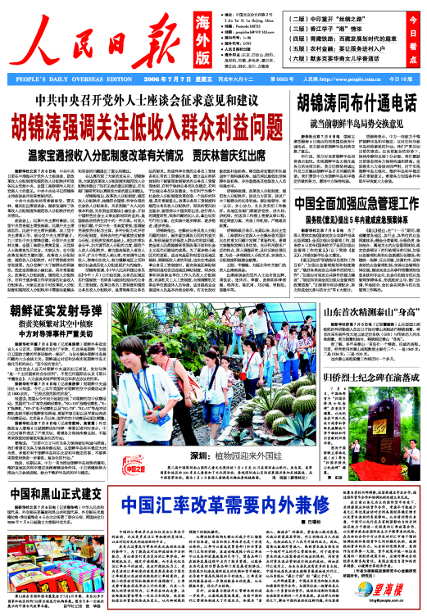
With publication started in June 1948 and a current circulation of 3 million, People's Daily is the most influential and authoritative newspaper in China. According to UNESCO, it takes its place among the world top 10.
People's Daily brings you the latest news dispatches of policy information and resolutions of the Chinese Government and major domestic news and international news releases from China. It reflects the views of the Chinese people, expounds on justice and lambastes various forms of malpractice.
Published under the People's Daily are also ten newspapers including People's Daily Overseas Edition, East China News, South China News, Market Daily, International Financial Daily, Jiangnan Times, Global Times, Securities Times, Health Times, Satire and Humor and six monthly magazines including The Earth, News Front, Listed Companies, Times Trend, People Forum.
To date, People's Daily has got the contents of its subsidiary papers and magazines onto the Internet to disseminate information throughout the world.

