Aims and requirements
●Learn to talk about the future using will and be going to and the differences between them.
●Improve the students’ reading ability
●Enable the students to understand the best way to make sure that we’ll feel and look fine is to develop healthy habits by learning the reading text.
●Let the students learn how to correctly use the Nouns used as Verbs.

Teaching procedures

Period 1: Introduction and reading

Step 1: Revision
1. Revise last book by asking them which kind of food they like best and why.
2. Revise everyday English by asking which kind of sports they like best and why with the help of everyday English.
Step2: Warming up
1. Warming up by questions:
Show the following questions to the students, and ask them to discuss for the answers.
1) Do you often get ill? And why does that often happen?
2) How do you think you should avoid getting ill?
2. Warming up by reading :

Staying Healthy
Good health is the most valuable thing a person can have, but one can’t take good health for granted. It is important to remember that the body needs proper care in order to be healthy. There are three things that a person can do to help stay in good shape: one should eat right food, get enough sleep, and exercise regularly.
Proper nutrition is important for good health. Your body can’t work well unless it receives the proper kind of “fuel”. Don’t eat too much food with lots of fat and sugar. Eat plenty of food high in protein like meat, fish, eggs and nuts. Vegetables and fruits are very important because they provide necessary vitamins and minerals. However, don’t overeat.
Getting the proper amount of sleep is also important. If you don’t get enough sleep, you feel tired and easily get angry. You have no energy. Over a long period of time a little amount of sleep may even result in a change of personality. Be sure to allow yourself from seven to nine hours each night.
Finally, get plenty of exercise. Exercise firms the body, strengthens the muscle and prevents you from gaining weight. It also improves your heart and lungs. If you follow a regular exercise program, you will probably increase your life span. Any kind of exercise is good.

Test your nutrition IQ
All of us eat every day, but most of us don’t understand nutrition. How much do you know about good nutrition? Are the following statements true or false?
1. People who don’t eat meat can stay healthy.
True. As long as people eat enough milk, eggs and meat alternatives(取舍), they can get enough protein.
2. Fresh vegetables cooked at home are always more nutritious than canned vegetables.
False. The differences depend more on how vegetables are prepared than whether they are fresh or canned. Vegetables cooked in too much water can lose a great amount of vitamins.
3. Food eaten between meals can be just as good for health as food eaten at regular meals.
True. Nutritional value depends on what types of food you eat, not when you eat them. Eating an egg or an orange between meals can contribute to a good diet.
4. Food grown in poor soil is lower in vitamins that food grown in rich soil.
False. The vitamins in our food are made by the plants themselves. They don’t come from the soil. However, the minerals in a plant depend on the minerals in the soil.
If you have answered the above questions correctly, you can say you know much about food and nutrition by today’s standards. But remember that nutrition is a growing science and that it may change as new information is obtained.
Step3: Pre-reading
1. Look at some pictures and ask the students what these sports and foods are and what their favorites are.


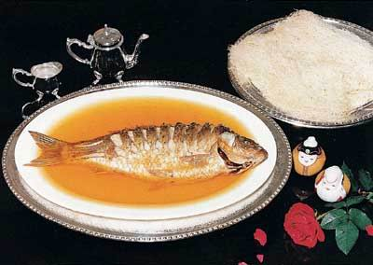

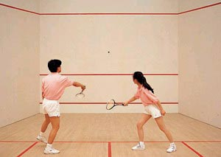

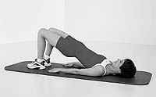
2. Make a survey of the students.
1). Do you sometimes get colds and flu?
2). Do you eat at least three portions of fruit and vegetables a day?
3). Do you eat fish once a week or more?
4). Do you take at least two hours’ exercise a week?
5). Do you eat much fat, for example, fatty meat?
6). Do you eat a lot of sweet things, for example, chocolate?
7). Do you rarely get toothache, but sometimes go to the dentist for examining?
8). Are you quite fit?
Step4: Reading
1. Leading-in
Some Chinese proverbs on health
1) 病从口入。
A close mouth catches no flies.
2) 健康胜于财富。
Health is over wealth.
3) 饭后百步走，延年又益寿。
After dinner sit a while; after supper walk a mile.
4) 冬吃萝卜夏吃姜， 不用医生开药方。
Carrots in winter and gingers in summer keep the doctor away.
5) 饮食决定人生
You are what you eat.
2. Fast reading for the next tasks
Read the text quickly and try to find the answer to these questions:
1) Why is Zhou Kai’s mother anxious?
2). What does she think will happen?
3). What does she ask him to do?
(Keys: 1.Because he is going out to play football in the rain.
2. She thinks Zhou Kai will catch a bad cold.
3. She asks him to at least wear his jacket.)
3. Detailed reading for information
Play the tape for the students and ask them to listen & read following the tape in a low voice then finish the exercises.
1). Zhou Kai's family _________.
A. avoid eating too much fat or sugar B. eat a lot of vegetables, fruit and meat
2). Zhou Kai ________________.
A. sometimes gets colds and flu B. seldom gets colds or flu
3). A week ago, Zhou Kai _________.
A. caught a cold B. injured his arm
4). Two years ago, Zhou Kai _______.
A. hurt his leg B. hurt his arm
5). Zhou Kai describes himself as ___.
A. crazy B. someone who loves football
(Keys: 1A 2B 3A 4B 5B)
Step5: Reading practice
This is the Radio Doctor with another word of advice on how to keep yourself healthy and how to keep away from doctors. As everyone knows, prevention is the best cure (治疗). If you haven’t cold, stay away from the people who have. Keep your rooms aired. Keep yourself warm. And don’t get yourself too tired or too excited by pleasure. Remember that an hour’s sleep before midnight is worth two hour’s sleep after midnight. Don’t get yourself too sad or too excited. A healthy mind is a healthy body. If you have caught a cold, go to see your doctor and don’t be afraid to take the medicine your doctor gives to you. Remember not to sneeze over anybody else. Those little viruses (病素) enjoy nothing better than taking a free ride through the air into anybody else. In this way he will get a cold.
1.The Radio Doctor’s advice today is to tell people ________.
A. how to stay away from doctors
B. what to do to keep themselves healthy
C. how to prevent themselves from catching a cold
D. how to have a nice sleep
2. In order not to catch a cold, you should ________.
A. stay away from the people who have a cold
B. keep your room aired
C. not to get too tired or too excited
D. all the above answers together
3. The Radio Doctor also advises people to ________.
A. go to bed early
B. sleep less before midnight
C. sleep less after midnight
D. get up early in the morning
4. A healthy person usually has ________.
A .a clever mind
B. quick mind
C. healthy mind
D. pleasant mind
5. _______ if you have caught a cold.
A. Don’t meet anybody
B. Don’t talk to anybody you meet
C. Stay at home alone
D. Don’t sneeze over anybody else
(Keys: 1C 2D 3C 4C 5D)

