Tornado!
Although tornadoes occur in many parts of the world, these destructive forces of nature are found most frequently in the United States east of the Rocky Mountains during the spring and summer months. In an average year, 800 tornadoes are reported nationwide, resulting in 80 deaths and over 1,500 injuries. A tornado is defined as a violently rotating column of air extending from a thunderstorm to the ground. The most violent tornadoes are capable of tremendous destruction with wind speeds of 250 mph or more. Damage paths can be in excess of one mile wide and 50 miles long. Once a tornado in Broken Bow, Oklahoma, carried a motel sign 30 miles and dropped it in Arkansas!

What causes tornadoes?
Thunderstorms develop in warm, moist air in advance of eastward-moving cold fronts. These thunderstorms often produce large hail, strong winds, and tornadoes. Tornadoes in the winter and early spring are often associated with strong, frontal systems that form in the Central States and move east. Occasionally, large outbreaks of tornadoes occur with this type of weather pattern. Several states may be affected by numerous severe thunderstorms and tornadoes.
During the spring in the Central Plains, thunderstorms frequently develop along a "dryline," which separates very warm, moist air to the east from hot, dry air to the west. Tornado-producing thunderstorms may form as the dryline moves east during the afternoon hours.
Along the front range of the Rocky Mountains, in the Texas panhandle, and in the southern High Plains, thunderstorms frequently form as air near the ground flows "upslope" toward higher terrain. If other favorable conditions exist, these thunderstorms can produce tornadoes.
Tornadoes occasionally accompany tropical storms and hurricanes that move over land. Tornadoes are most common to the right and ahead of the path of the storm center as it comes onshore.
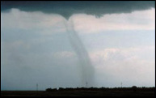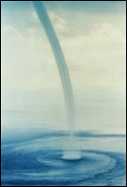
Colorado Tornado (David Blanchard) Dr. Joseph Golden (NOAA)

Tornado Variations
- Some tornadoes may form during the early stages of rapidly developing thunderstorms. This type of tornado is most common along the front range of the Rocky Mountains, the Plains, and the Western States.
- Tornadoes may appear nearly transparent until dust and debris are picked up.
- Occasionally, two or more tornadoes may occur at the same time.

Waterspout
- Waterspouts are weak tornadoes that form over warm water.
- Waterspouts are most common along the Gulf Coast and southeastern states. In the western United States, they occur with cold late fall or late winter storms, during a time when you least expect tornado development.
- Waterspouts occasionally move inland becoming tornadoes causing damage and injuries.

How Do Tornadoes Form?
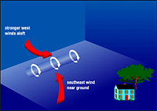  Before thunderstorms develop, a change in wind direction and an increase in wind speed with increasing height creates an invisible, horizontal spinning effect in the lower atmosphere. | 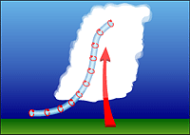  Rising air within the thunderstorm updraft tilts the rotating air from horizontal to vertical. | 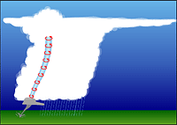  An area of rotation, 2-6 miles wide, now extends through much of the storm. Most strong and violent tornadoes form within this area of strong rotation.
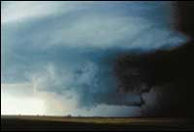  Woodward OK (Ron Przybylinski)  A lower cloud base in the center of the photograph identifies an area of rotation known as a rotating wall cloud. This area is often nearly rain-free. Note rain in the background. | 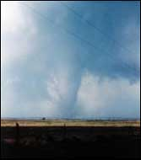  Woodward OK (Ron Przybylinski)  Moments later a strong tornado develops in this area. Softball-size hail and damaging "straight-line" winds also occurred with this storm.

Tornadoes Take Many Shapes and Sizes
Weak Tornadoes  - 69% of all tornadoes  - Less than 5% of tornado deaths  - Lifetime 1-10+ minutes  - Winds less than 110 mph  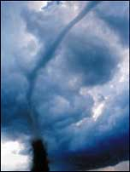 | Strong Tornadoes  - 29% of all tornadoes  - Nearly 30% of all tornado deaths  - May last 20 minutes or longer  - Winds 110-205 mph  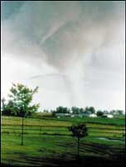 | Violent Tornadoes  - Only 2% of all tornadoes  - 70% of all tornado deaths  - Lifetime can exceed 1 hour  - Lifetime can exceed 1 hour  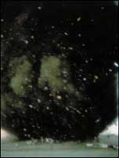

Tornado Myths:
MYTH: Areas near rivers, lakes, and mountains are safe from tornadoes.
FACT: No place is safe from tornadoes. In the late 1980's, a tornado swept through Yellowstone National Park leaving a path of destruction up and down a 10,000 ft. mountain.
MYTH: The low pressure with a tornado causes buildings to "explode" as the tornado passes overhead.
FACT: Violent winds and debris slamming into buildings cause most structural damage.
MYTH: Windows should be opened before a tornado approaches to equalize pressure and minimize damage.
FACT: Opening windows allows damaging winds to enter the structure. Leave the windows alone; instead, immediately go to a safe place.

Tornadoes Occur Anywhere
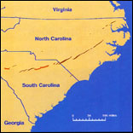  Carolinas Outbreak:  - March 28, 1984, afternoon-evening  - 22 tornadoes  - 57 deaths  - 1,248 injuries  - damage $200 million  - 37% of fatalities in mobile homes | 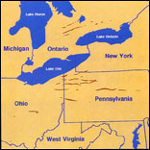  Pennsylvania-Ohio Outbreak:  - May 31, 1985, late afternoon-evening  - 41 tornadoes, including 27 in PA and OH  - 75 deaths in U.S.  - 1,025 injuries  - damage $450 million | 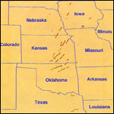  Plains Outbreak:  - April 26-27, 1991, afternoon of 26th through early morning 27th  - 54 tornadoes  - 21 deaths  - 308 injuries  - damage $277+ million  - 15 deaths in/near mobile homes, 2 deaths in vehicles

Weather Radar Watches the Sky
Meteorologists rely on weather radar to provide information on developing storms. The National Weather Service is strategically locating Doppler radars across the country which can detect air movement toward or away from the radar. Early detection of increasing rotation aloft within a thunderstorm can allow life-saving warnings to be issued before the tornado forms.
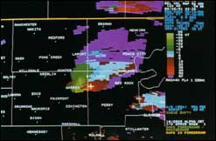
Doppler Radial Velocity
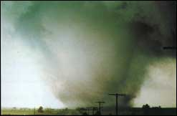
Jim Ladue

Frequency of Tornadoes

Tornadoes can occur at any time of the year.
- In the southern states, peak tornado occurrence is in March through May, while peak months in the northern states are during the summer.
- Note, in some states, a secondary tornado maximum occurs in the fall.
- Tornadoes are most likely to occur between 3 and 9 p.m. but have been known to occur at all hours of the day or night.
- The average tornado moves from southwest to northeast, but tornadoes have been known to move in any direction. The average forward speed is 30 mph but may vary from nearly stationary to 70 mph.
- The total number of tornadoes is probably higher than indicated in the western states. Sparce population reduces the number reported.
Months of Peak Tornado Occurrence  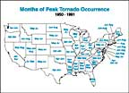  larger image | United States Totals 1961-1993  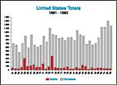  larger image | US Reported Tornadoes and Average Number of Deaths Per Year 1961-1993  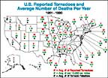  larger image

STAY INFORMED ABOUT THE STORM
by listening to NOAA Weather Radio, commercial radio, and television for the latest tornado WATCHES and WARNINGS.

When conditions are favorable for severe weather to develop, a severe thunderstorm or tornado WATCH is issued
Weather Service personnel use information from weather radar, spotters, and other sources to issue severe thunderstorm and tornado WARNINGS for areas where severe weather is imminent.
Severe thunderstorm warnings are passed to local radio and television stations and are broadcast over local NOAA Weather Radio stations serving the warned areas. These warnings are also relayed to local emergency management and public safety officials who can activate local warning systems to alert communities.
Remember, tornadoes occasionally develop in areas in which a severe thunderstorm watch or warning is in effect. Remain alert to signs of an approaching tornado and seek shelter if threatening conditions exist.

Environmental Clues

Look out for:
- Dark, often greenish sky
- Wall cloud
- Large hail
- Loud roar; similar to a freight train

Caution:
- Some tornadoes appear as a visible funnel extending only partially to the ground. Look for signs of debris below the visible funnel.  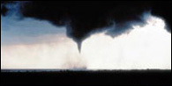  Alma, NE (Gene Rhoden) | - Some tornadoes are clearly visible while others are obscured by rain or nearby low-hanging clouds.  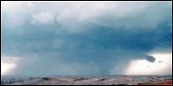  Mike Emlaw

Other Thunderstorm Hazards
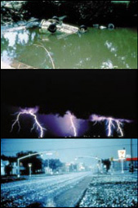
Center photo Bill Bunting

These dangers often accompany thunderstorms:
- Flash Floods: Number ONE weather killer - 146 deaths annually
- Lightning: Kills 75-100 people each year
- Damaging Straight-line Winds: Can reach 140 mph
- Large Hail: Can reach the size of a grapefruit - causes several hundred million dollars in damage annually to property and crops
Contact your local National Weather Service office, American Red Cross chapter, or Federal Emergency Management Agency office for a copy of the "Thunderstorms and Lightning...The Underrated Killers" brochure (NOAA PA 92053) and the "Flash Floods and Floods...The Awesome Power" brochure (NOAA PA 92050).

Tornado Safety

What YOU Can Do

Before the Storm:
- Develop a plan for you and your family for home, work, school and when outdoors.
- Have frequent drills.
- Know the county/parish in which you live, and keep a highway map nearby to follow storm movement from weather bulletins.
- Have a NOAA Weather Radio with a warning alarm tone and battery back-up to receive warnings.
- Listen to radio and television for information.
- If planning a trip outdoors, listen to the latest forecasts and take necessary action if threatening weather is possible.
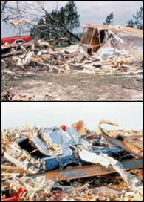
Top: James Campbell; Bottom: Gene Rhoden

If a Warning is issued or if threatening weather approaches:
- In a home or building, move to a pre-designated shelter, such as a basement.
- If an underground shelter is not available, move to an interior room or hallway on the lowest floor and get under a sturdy piece of furniture.
- Stay away from windows.
- Get out of automobiles.
- Do not try to outrun a tornado in your car; instead, leave it immediately.
- Mobile homes, even if tied down, offer little protection from tornadoes and should be abandoned.
Occasionally, tornadoes develop so rapidly that advance warning is not possible. Remain alert for signs of an approaching tornado. Flying debris from tornadoes causes most deaths and injuries.

It's Up To YOU!
Each year, many people are killed or seriously injured by tornadoes despite advance warning. Some did not hear the warning while others received the warning but did not believe a tornado would actually affect them. The preparedness information in this brochure, combined with timely severe weather watches and warnings, could save your life in the event a tornado threatens your area. After you have received the warning or observed threatening skies, YOU must make the decision to seek shelter before the storm arrives. It could be the most important decision you will ever make.

Who's Most At Risk?
- People in automobiles
- The elderly, very young, and the physically or mentally impaired
- People in mobile homes
- People who may not understand the warning due to a language barrier

Tornado Safety in Schools

EVERY School Should Have A Plan!
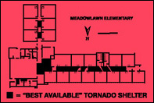

- Develop a severe weather action plan and have frequent drills,
- Each school should be inspected and tornado shelter areas designated by a registered engineer or architect. Basements offer the best protection. Schools without basements should use interior rooms and hallways on the lowest floor and away from windows.
- Those responsible for activating the plan should monitor weather information from NOAA Weather Radio and local radio/television.
- If the school's alarm system relies on electricity, have a compressed air horn or megaphone to activate the alarm in case of power failure.
- Make special provisions for disabled students and those in portable classrooms.
- Make sure someone knows how to turn off electricity and gas in the event the school is damaged.
- Keep children at school beyond regular hours if threatening weather is expected. Children are safer at school than in a bus or car. Students should not be sent home early if severe weather is approaching.
- Lunches or assemblies in large rooms should be delayed if severe weather is anticipated. Gymnasiums, cafeterias, and auditoriums offer no protection from tornado-strength winds.
- Move students quickly into interior rooms or hallways on the lowest floor. Have them assume the tornado protection position (shown at right).

Hospitals, nursing homes, and other institutions should develop a similar plan
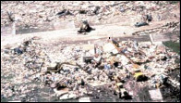
Paul Bowen
Your National Weather Service, Federal Emergency Management Agency, and American Red Cross educate community officials and the public concerning the dangers posed by tornadoes. YOU can prepare for the possibility of a tornado by learning the safest places to seek shelter when at home, work, school, or outdoors. You should also understand basic weather terms and danger signs related to tornadoes. Your chances of staying safe during a tornado are greater if you have a plan for you and your family, and practice the plan frequently.

FAMILY DISASTER PLAN
Families should be prepared for all hazards that affect their area. NOAA's National Weather Service, the Federal Emergency Management Agency, and the American Red Cross urge each family to develop a family disaster plan.
Where will your family be when disaster strikes? They could be anywhere - at work, at school, or in the car. How will you find each other? Will you know if your children are safe? Disasters may force you to evacuate your neighborhood or confine you to your home. What would you do if basic services - water, gas, electricity or telephones - were cut off?

Follow these basic steps to develop a family disaster plan...
- I.Gather information about hazards.
Contact your local National Weather Service office, emergency management or civil defense office, and American Red Cross chapter. Find out what type of disasters could occur and how you should respond. Learn your community's warning signals and evacuation plans.
- II.Meet with your family to create a plan.
Discuss the information you have gathered. Pick two places to meet: a spot outside your home for an emergency, such as fire, and a place away from your neighborhood in case you can't return home. Choose an out-of-state friend as your "family check-in contact" for everyone to call if the family gets separated. Discuss what you would do if advised to evacuate.
- III.Implement your plan
(1) Post emergency telephone numbers by phones; (2) Install safety features in your house, such as smoke detectors and fire extinguishers; (3) Inspect your home for potential hazards (such as items that can move, fall, break, or catch fire) and correct them; (4) Have your family learn basic safety measures, such as CPR and first aid; how to use a fire extinguisher; and how and when to turn off water, gas, and electricity in your home; (5) Teach children how and when to call 911 or your local Emergency Medical Services number; (6) Keep enough supplies in your home to meet your needs for at least three days. Assemble a disaster supplies kit with items you may need in case of an evacuation. Store these supplies in sturdy, easy-to-carry containers, such as backpacks or duffle bags. Keep important family documents in a waterproof container. Keep a smaller disaster supplies kit in the trunk of your car.
A DISASTER SUPPLIES KIT SHOULD INCLUDE:
A 3-day supply of water (one gallon per person per day) and food that won't spoil one change of clothing and footwear per person one blanket or sleeping bag per person a first-aid kit, including prescription medicines emergency tools, including a battery-powered NOAA Weather Radio and a portable radio, flashlight, and plenty of extra batteries an extra set of car keys and a credit card or cash special items for infant, elderly, or disabled family members.
- IV.Practice and maintain your plan.
Ask questions to make sure your family remembers meeting places, phone numbers, and safety rules. Conduct drills. Test your smoke detectors monthly and change the batteries at least once a year. Test and recharge your fire extinguisher(s) according to manufacturer's instructions. Replace stored water and food every six months.

