While reading
1. Skim the text and do the following tasks.
(1)What is the writer’s job?
(2) The writer’s attitude towards his job is ____.
A. bored B. indifferent
C. enthusiastic D. disappointing
(3)Divide the passage into three parts and get the main idea of each part.
2. Answer these questions using complete sentences.
(1)Why doesn’t the writer mind the occasional danger of his job?
(2) Where is Mount Kilauea?
(3)Why is the lava that flows on Mount Kilauea more dangerous than the actual eruption?
(4)What made the author realize that an eruption occurred?
(5)Why did the scientists have to get close to the volcano after it began erupting?
(6)What did the scientists do after the eruption?
(7)Why was it difficult for the writer to walk towards the edge of the crater?
(8)What does the writer find impressive about volcanoes even after studying them for many years?
3. Read the passage and finish the table.
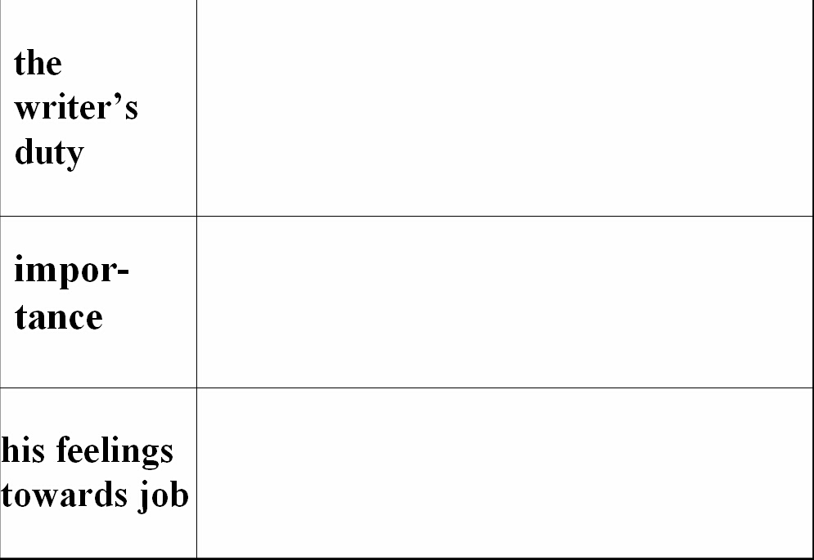
4. Put the following sentences into right order.
The writer describes his first sight of a volcanic eruption.
The writer states again his love for his work and volcanoes.
The writer expresses his love for his job and why he love it.
The writer describes his first closer look at a volcanic eruption.
The writer describes his job and its importance.
5. Choose the best answer.
(1)The writer worked as a volcanologist in Hawaii ______.
A. 5 years ago B. 10 years ago
C. 15 years ago C. 20 years ago
(2)The eruption mentioned in the passage took place _______.
A. in the morning B. in the afternoon
C. in the evening C. at noon
(3)When boiling rock erupts from a volcano, it causes less damage than you imagine because ______.
A. the temperature is not very high
C. no one lives near the top of the Mount Kilauea
C. people know how to escape the rocks
D. the buildings near the volcanoes are very firm
(4)How many scientists are driven up the mountain the next day?
A. 2 B. 3
C. 4 D. 5
(5)The passage suggests that ________.
A. the writer is worried about his job
B. the writer is anxious about his job
C. the writer is interested in his work
D. the writer is tired of his work
Post reading
1. Discussion
(1)Having learned a little more about the work of a volcanologist, do you think it is an occupation you would enjoy? Give your reasons.
(2)If you could meet the writer of the passage, what questions would you ask?
2. Complete the passage with proper words, which will help you retell the text.
The author was ____________ a volcanologist __________ the Hawaiian Volcano Observatory 20 years ago. Two weeks after he arrived in Hawaii, he saw an _______ for the first time. It was very bright ________ it was night. There had been an eruption from the side of the mountain and red hot lava was _________ hundreds of metres into the air. The day after the eruption two other scientists and he wanted to __________ the crater. They put on white protective suits, helmets, big boots and special gloves, _____ made them look like spacemen. They slowly ______________ to the edge of the carter to collect some lava for later study. _______________ volcanoes for many years, the author is still __________ their beauty as well as their _________ to cause great damage.

