John Snow and the Broad Street Cholera Outbreak of 1854
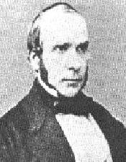
Cholera reached the British Isles in the early 1830s, and outbreaks would continue for the next fifty years. Today, it is well known that cholera is caused by the bacteria Vibria cholerae and is usually spread in poor drinking water. Early theories blamed the infection on mists and 'miasmas', which led to many of the early attempts to control cholera failing. In reality the poor sanitary conditions of a city's water supply was responsible. Early Victorian cities also included cowsheds mixed in amongst the houses. These combined with poor handling of human sewage (often merely a hole in the ground) led to a rapid contamination of the drinking water. Indeed, the famous Broad Street water pump (see below) was a shallow water pump that pumped water from the contaminated water table.
In the 1850s, John Snow performed pioneering data analysis to prove his hypothesis that cholera was spread in the drinking water. This analysis if performed today, would come under the realms of GIS (Geographic Information Systems) and Data Mining. Some have claimed his Broad Street map as being the first example of GIS, even though it was performed with a pen and paper. Although this is an exaggeration, the Broad Street map it is an excellent example of the power of maps to clearly demonstrate relationships in complex scenarios. Snow's work with the London cholera outbreaks of the 1850s, is often cited as the beginning of modern epidemiology.
Unfortunately word of this pioneering epidemiology was slow to spread, and the London cholera outbreaks would continue into the 1880s when all of the shallow water-pumps were finally decommissioned.
This page looks at Snow's two most famous analysis cases that helped to prove his hypothesis that cholera infections occurred through drinking water.

The Broad Street Outbreak, 1854
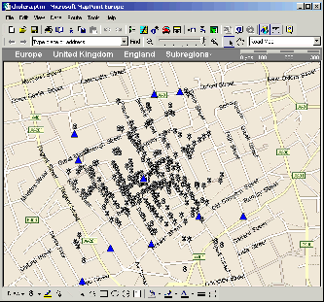
This is the most famous piece of data analysis performed by John Snow, and his prompt action undoubtedly saved many lives. The outbreak occurred in the Soho District of London, in and around Broad Street.
John Snow reasoned that if cholera was spread by a mist or miasma, as the prevailing theories suggested, then the cases should be uniformly distributed along the streets. To see if this was the case, he plotted each cholera case on a map, similar to the one on the left. He also plotted houses with multiple cases, which the modern map on the left does not show.
As can be seen, the cases are not uniformly distributed, but instead are distributed in a tight cluster around a water pump located on Broad Street (now Broadwick Street). Snow went to the pump and took a water sample. Looking in his microscope, he found the water contained a bacteria which he had not seen before. Although he guessed these were responsible, this was before the infectious microbe work of Pasteur and Koch.
He went back to the pump and removed the pump handle. The Broad Street cholera outbreak stopped almost literally overnight.
Not noted on the map was some other evidence which helped to support the water pump hypothesis. A local workhouse was almost untouched (only five cases), due to it using water from its own uncontaminated well. The map also shows some outliers. Snow's investigations showed that these were due to people who would pass the well (eg. on the way to work) and take drink.
The map above was produced with Microsoft® MapPoint®. If you are interested in using Microsoft MapPoint, see the Mapping-Tools.Com website for all of your MapPoint consultancy and programming needs.

The Grand Experiment, 1853-54
Although John Snow is most famous for his analysis of the Broad Street outbreak, this analysis merely confirmed a theory he had been developing over the preceding years. One of his biggest tests was what he called his "Grand Experiment", and was carried out throughout the outbreak of 1853-54. He carefully analysed the cholera deaths in London, correlating them with the source of drinking water.
As well as hand pumps such as at Broad Street, much of London's population received machine-pumped water similar to what we have today but without the treatment plants. Two companies supplied water like this. Due to new laws, the Lambeth Company had started to take its water from the River Thames about 20 miles up-stream of London, but the Southwark and Vauxhall Water Company was still taking its water from local wells and the Thames in Central London. This provided a perfect comparison for Snow.
Snow's final summary table:
 | No. of houses | Deaths from cholera | Deaths/10,000 houses
Southwark and Vauxhall Company | 40,046 | 1,263 | 315
Lambeth Company | 26,107 | 98 | 37
Rest of London | 256,423 | 1,422 | 59

Hence, Snow showed a strong correlation between the cholera death rate and the water source. The data also shows that a water source up-river of the London was the safest option, whilst taking water directly from the Thames in Central London was more dangerous than other local water sources combined.

