2011年普通高等学校招生全国统一考试(辽宁卷)
英 语
本试卷分第一卷(选择题)和第二卷(非选择题)两部分。考试结束后，将本试卷和答题卡一并交回。
第一卷
注意事项：
1．答第一卷前，考生务必将自己的姓名、准考证号填写在答题卡上。
2．选出每小题答案后，用铅笔把答题卡上对应题目的答案标号涂黑。如需改动，用橡皮擦干净后，再选涂其他答案标号。不能答在本试卷上，否则无效。
第一部分 听力 （略）
第二部分英语知识运用(共两节，满分45分)
第一节单项填空(共15小题；每小题1分，满分15分)
从A、B、C、D四个选项中，选出可以填入空白处的最佳选项，并在答题卡上将该项涂黑．
例: We last night, but we went to the concert instead,
A. must have studied B. might study
C. should have studied D. would study
21. If you __ go, at least wait until the storm is over.
A. can B. may C. must D. will
22. What are you doing out of bed, Tom? You're to be asleep. ,
A. supposed B. known C. thought D. considered
23. Twenty students want to attend the class that aims to teach to read first.
A. what B. who C. how D. why
24. You are old enough to your own living.
A.win B. gain  C. take D. earn
25. No matter how , it is not necessarily lifeless.
A. a desert may be dry B. dry a desert may be
C. may a desert be dry D. dry may a desert be
26. The exam results will be on Friday afternoon.
A. put down B. put off C. put up D. put away
27.- Would you like tea or coffee?
- , thank you. I've just had some water.
A. Either B. Both C. Any D. Neither
28. I'll go to the library as soon as I finish what I
A. was doing B. am doing
C. have done D. had been doing
29. He had no sooner finished his speech the students started cheering.
A. since B. as C. when D. than
30. around the fire, the tourists danced with the local people.
A. Gather B. To gather
C. Gathering D. To be gathering
31. Bring the flowers into a warm room they'll soon open.
A. or B. and C. but D. for
32. When the news came the war broke out, he decided, to serve in the army.
A. since B. which C. that D. because
33. a strange plant! I've never seen it before.
A. Which B. What C. How D. Whether
34. By the time Jack returned home from England, his son. from college.
A. graduated B. has graduated
C. had been D. had graduated
35.- I probably shouldn't have any more cake.
-Oh, . It won't kill you.
A. go ahead B. hold on, please
C. you're welcome D. that'll do
第二节完形填空(共20小题；每小题1.5分，满分30分)
阅读下面短文，从短文后各愿所给的四个选项（A、B、C、D)中，选出可以填入空白处的最佳选项，并在答题卡上将该项涂黑．
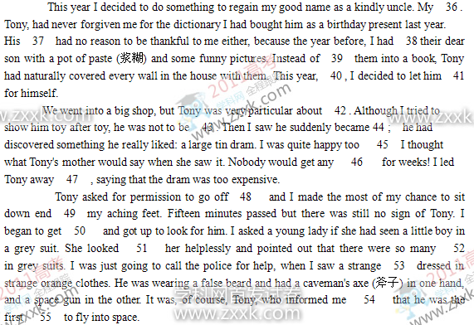 36. A. cousin B. daughter C. grandson D. nephew
37. A. friends B. parents C. classmates D. brothers
38. A. presented B. annoyed C. confused D. occupied
39. A. entering B. dividing C. sticking D. drawing
40. A. anyhow B. though C. again D. therefore
41. A. guess B. choose C. pay D. see
42. A. sweets B. toys C. clothes D. books
43. A. pleased B. disturbed C. accepted D. disappointed
44. A. surprised B. hopeful C. patient D. excited
45. A. after B. until C. unless D. since
46. A. shock B. trouble C. peace D. time
47. A. happily B. eagerly C. cautiously D. quickly
48. A. on his own B. in his way C. now and then D. more or less
49. A. drag B. rest. C. lay D. step
50. A. 8shamed B. angry C. worried D. doubtful
51.A. about B. to C. at D. across
52. A. young ladies B. new customers C. loving parents D. small boys
53. A. figure B. actor C. man D. doll
54.A. on time B. at once C. just now D. once again
55.A. policeman B. spaceman C. caveman D. postman
第三部分阅读理解(共两节，满分柏分)
第一节 (共15小题；每小题2分，满分30分)
阅读下列短文，从每题所给的四个选项(A、B、C和D)中，选出最佳选项，并在答题卡上将该项涂黑．
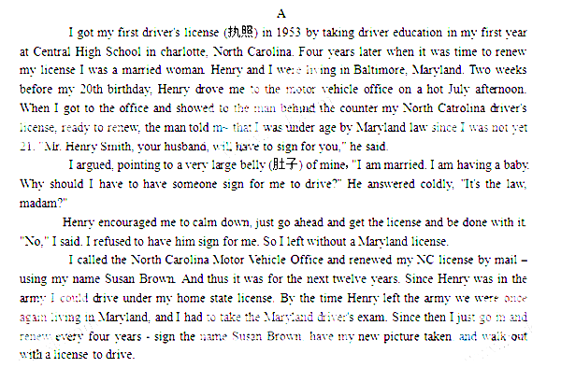56. Susan got her first driver's license
A. before she got married to Henry
B. when she was twenty years old
C. after she finished high school
D. when she just moved to Maryland
57. Susan failed to renew her license the first time in Maryland because
A. she was forbidden to drive by Maryland law
B. she lacked driving experience in Maryland
C. she was to give birth to a baby soon
D. she insisted on signing for herself
58. We can infer from the text that in the U.S.
A. American males should serve in the army
B. different states my have different laws
C. people have to renew their licenses in their home states
D. women should adopt their husbands' family names after marriage
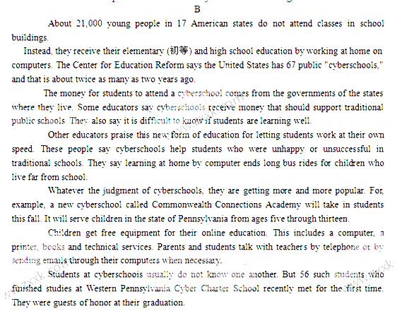59, What do we know from the text about students of a cyberschool?
A. They have to take long bus rides to school.
B. They study at home rather than in classrooms.
C. They receive money from traditional public schools.
D. They do well in traditional school programs.
60. What is a problem with cyberschoois?
A. Their equipment costs a lot of money.
B. They get little support from the state government
C. It is hard to know students' progress in learning.
D. The students find it hard to make friends.
61. Cyberschools are getting popular became
A. they are less expensive for students
B. their students can work at their own speed
C. their graduates are more successful in society
D. they serve students in a wider age range
62. We can infer that the author of the text is .
A. unprejudiced in his description of cyberschools
B. excited about the future of cyberschools
C. doubtful about the quality of cyberschoois
D. disappointed at the development of cyberschools
C
Many people believe Henry Ford invented the automobile (汽车). But Henry Ford did not start to build his first car until 1896. That was eleven years after two Germans developed the world's first automobile. Many people believe Henry Ford invented the production line that moved a car's parts to the worker, instead of making the worker move to the parts. That is not true, either. Many factory owners used methods of this kind before Ford. What Henry Ford did was to use other people's ideas and make them better. And he made the whole factory a moving production line.
In the early days of the automobile, almost every ear maker raced his cars. It was the best way of gaining public notice. Henry Ford decided to build a racing car. Ford's most famous race was his first one. It was also the last race in which he drove the car himself.
The race was in 1901, at a field near Detroit. All of the most famous cars had entered, but only two were left: the Winton and Ford's. The Winton was famous for its speed. Most people thought the race was over before it began.
The Winton took an early lead. But halfway through the race, it began to lose power. Ford started to gain. And near the end of the race, he took the lead. Ford won the race and defeated the Winton. His name appeared in newspapers and he became well-known all over the United States. Within weeks of the race, Henry Ford formed a new automobile company. In the 1903, a doctor in Detroit bought the first car from the company. That sale was the beginning of Henry Ford's dream. Ford said: "I will build a motor car for the great mass of people. It will be large enough for the family, but small enough for one person to operate and care for. It will be built of the best materials. It will be built by the best men to be employed. And it will be built with the simplest plans that modem engineering can produce. It will be so low in price that no man making good money will be unable to own one."
The Model T was a car of that kind. It only cost $850. It was a simple machine that drivers could depend on. Doctors bought the Model T. So did farmers. Even criminals，They considered it the fastest and surest form of transportation. Americans loved the Model T. They wrote stories and songs about it. Thousands of Model T's were built in the first few years.
63. What do we know about Henry Ford from Paragraph 1?
A. He made good use of ideas from others.
B. He produced the first car in the world.
C. He knew how to improve auto parts.
D. He invented the production line.
64. Why did Henry Ford take part in the 1901 car race?
A. To show off his driving skills.
B. To draw public attention.
C. To learn about new technology.
D. To raise money for his new company.
65. “That sale” in Paragraph 4 refers to .
A. the selling of Ford cars at reduced prices
B. the sale of Model T to the mass of people
C. the selling of a car to a Detroit doctor
D. the sales target for the Ford Company
66. What was Henry Ford's dream according to the text?
A. Producing cars for average customers.
B. Building racing cars of simple design.
C. Designing more car models.
D. Starting more companies.
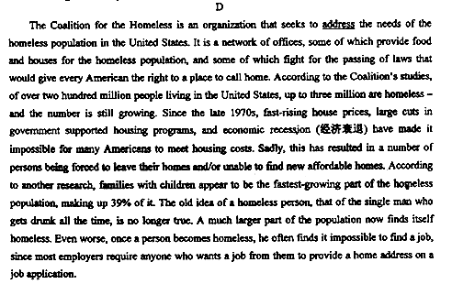
67. The word “address” in the first line probably means .
A. talk about B. deal with C. fight for D. write to
68. How many people are homeless in the U.S. according to the Coalition studies?
A. 39% of the population. B. 200 million people.
C. About 3 million people. D. About one-fifth of the population.
69. Homeless people often have difficulty f'mding a job because
A. they have no home addresses
B. they mostly have a drinking problem
C. they aren't supported by government programs
D. they often don't have enough work experience
70. What is the main cause of the rising number of the homeless in the U.S.?
A. The passing of new housing laws.
B. The fast growth of family size.
C. The slow construction of houses.
D. The ever-rising price of housing.

第二节 (共5小题；每小题2分，满分l0分)
根据短文内容，从短文后的选项中选出能填入空白处的最佳选项，选项中有两项为多余选项。
Easy Ways to Keep Your Brain Sharp
Everyone is forgetful, but as we age, we start to feel like our brains are slowing down a bit—and that can be a very annoying thing. 71 Read on for some techniques worth trying.
1. 72
People who regularly made plans and looked forward to upcoming events had a 50 percent
reduced chance of Alzheimer's disease (早老性痴呆症), according to a recent study.
73
Something as simple as setting a goal to have a weekly coffee date with a friend will do. There's evidence that people who have a purpose in life or who are working on long or short-term goals appear to do better. In other words, keep your brain looking forward.
2. Go for a walk.[
Mildly raised glucose (葡萄糖) levels can harm the area of the brain that helps you form memories and physical activity can help get blood glucose down to normal levels. In fact,exercise produces chemicals that are good for your brain. 74
3. Learn something new.
Take a Spanish class online, join a drawing club, or learn to play cards. A study found that mental stimulation (刺激) limits the weakening effects of aging on memory and the mind. But the best thing for your brain is when you learn something new and are physically active at the same time. 75 Or go dancing with your friends.
A. Focus on the future.
B. This can be espocially harmful to the aged.
C. It should be something like learning gardening.
D. So take a few minutes each day to do some reading.
E. But don't worry if your schedule isn't filled with life-changing events.
F. Luckily, research shows there is a lot you can do to avoid those moments.
G. In other words, when you take care of your body, you take care of your brain.

第二卷
注意：将答案写在答题卡上。写在本试卷上无效。
第四部分写作(共两节，满分35分)
第一节短文改错(共10小题；每小题l分，满分l0分)
假定英语课上老师要求同桌之间交换修改作文，请你修改你同桌写的以下作文,文中共有l0处语言错误，每句中最多有两处．每处错误仅涉及一个单词的增加、删除或修改。
增加：在缺词处加一个漏字符号（√)，并在其下面写出该加的词。
删除：把多余的词用斜线(／)划掉．
修改：在错的词下划一横线，并在该词下面写出修改后的词。
注意：1．每处错误及其修改均仅限一词；
2．只允许修改l0处，多者(从第11处起)不计分．
(试题内容见答题卡)
第二节：书面表达（满分25分）
假定你是李华，将于今年七月从新星外语学校毕业。你从报纸上得知B&B公司要招聘一名英文秘书，你很感兴趣。请给该公司写一封求职信，包括下列要点：
1. 年龄；
2. 学习情况及英语水平；
3. 兴趣和特长；
4. 性格特点。
注意：1. 词数100左右；
2. 可是当加入细节，以使行文连贯；
3. 开头和结尾已为你写好，不计入总次数。


