2011年普通高等学校招生全国统一考试（天津卷）
英语 笔试
本试卷分第Ⅰ卷（选择题）和第Ⅱ卷（非选择题）两部分，共130分，考试时间100分钟，第Ⅰ卷1页至10页，第Ⅱ卷11页至12页。
答卷前，考生务必将自己的姓名，准考号填写在答题卡上，并在规定位置粘贴考试用条形码，答卷时，考生务必将答案涂写在答题卡上，答在试卷上无效，考试结束后，将本是卷和答题卡一并交回。
祝各位考生考试顺利！
第Ⅰ卷
注意事项：
1.每小题选出答案后，用铅笔将答题卡上对应题目的答案标号涂黑，如需改动，用橡皮擦干净后，再选涂其他答案标号。
2.本卷共55小题，共95分
第一部分：英语知识运用（共两节，满分45分）
第一节：单项填空（共15小题，每小题1分，满分15分）
从A、B、C、D四个选项中，选出可以填入空白处的最佳选项。
例：Stand over there you will be able to see it better.
A. or B. and C. but D. while
答案是B.
1. We feel our duty to make our country a better place.
A. it B. this C. that D. one
2.----Just a moment . I haven’t finished packing my suitcase.
---- .Its high time we left for the airport.
A. Go ahead B. Take it easy C.Hurry up D. That's fine
3.In the last few years thousands of films allover the word.
A.have produced B. have been produced
C. are producing D. are being produced
4.On the next birthday.Ann married for twenty years.
A.is B.has been C.will be D.will have been
5. regular exercise is very important.It’s never a good idea to exercise too close to bedmme.
A.It B. As C.Although D.Unless
6.I a bank account after I made﹩1 000 by doing a part-time job during the summer vacation.
A.borrowed B.opened C.entered D.ordered
7.Passeagers are permitted only one piece of hand luggage onto the plane.
A.to carry B. carrying C. to be carried D. being carried
8.She an old friend of hers yesterday while she was shopping att the department store.
A.turned down B.dealt with C.took after D.came across
9. The young man couldn’t afford a new car _______, he bought a used one.
A. Besides B. Otherwise C. Instead D. Still
10. The days are gone ________ physical strength was all you needed to make a living.
A. when B. that C. where D. which
11. He was a good student and scored _________ average in most subjects.
A. below B. of C. on D. above
12.______ into English, the sentence was found to have an entirely different word order.
A. Translating B. Translated
C. To translate D. Having translated
13. Modern science has given clear evidence ______ smoking can lead to many diseases.
A. what B. which C. that D. where
14.---I need to advertise for a roommate for next term.
---________? Mary is interested.
A. Why bother B. Why not C. So what D. What for
15. I ______ sooner but I didn’t know that they were waiting for me.
A. had come B. was coming C. would come D. would have come
第二节：完形填空（共20小题：每小题1.5分，满分30分）
阅读下面短文，掌握其大意，然后次哦能够16～35各题所给出的A、B、C、D四个选项中选出最佳选项。
A Love Note To My Mom
When I was a little girl, would often accompany you as you modeled for fashion photographers. It was years later that finally understood what role modeling 16 in your life. Little did I known you were 17 every penny you earned to go to 18 school.
I cannot thank you enough for 19 you told me one autumn afternoon when I was nine. After finishing my homework. I wanted into the dining where you were buried 20 piles of law books. I was 21 .Why were you doing what I do—memorizing textbooks and studying for 22 ?When you said you were in law school, I was more puzzled. I didn’t known. Moms 23 be lawyers too. You smiled and said,“In life, you can do anything you want to do.”
As young as I was ,that statement kept 24 in my ears. I watched as you faced the 25 of completing your studies, staring companies with Dad, while still being a 26 and a Mom if five kids. I was exhausted just watching you 27 .With your words of wisdom in my 28 mind, I suddenly felt unlimited freedom to dream. My whole world 29 .I set out to live my life filled with 30 ,seeing endless possibilities for personal and professional achievements.
Your words became my motto. I 31 found myself in the unique position of being either the first (woman doctor in Maryland Rotary) 32 one of the few women (chief medical reporters) in my field. I gained strength every time I said , “Yes, I’ll try that.”
Encouraged by your 33 , I have forged ahead (毅然前行) with my life’s journey, less afraid to make mistakes, and 34 meeting each challenge. You did it, and now I’m 35 it. Sorry, got to run. So much to do, so many dreams to live.
16. A. found B. play C. kept D. provided
17. A. saving B. making C. donating D. receiving
18. A. business B. fashion C. law D. medical
19. A. what B. that C. which D. where
20. A. at B. to C. upon D. under
21. A. amused B. worried C. puzzled D. disappointed
22. A. role B. tests C. positions D. shows
23. A. must B. ought to C. need D. could
24. A. ringing B. blowing C. falling D. beating
25. A. choices B. chances C. challenges D. changes
26. A. professor B. doctor C. reporter D. model
27. A. in danger B. in action C. in trouble D. in charge
28. A. weak B. powerful C. youthful D. empty
29. A. came back B. closed down C. went by D. opened up
30. A. hope B. hardship C. harmony D. sadness
31. A. constantly B. shortly C. hardly D. nearly
32. A. and B. but C. or D. for
33. A. description B. statement C. praise D. introduction
34. A. secretly B. curiously C. carelessly D. eagerly
35. A. doing B. considering C. correcting D. reading
第二部分： 阅读理解（共20小题；每小题2.5分，满分50分）
阅读下列短文，从每题所给的A、B、C、D四个选项中，选出最佳选项。
A
Homestay provides English language students with the opportunity to speak English outside the classroom and the experience of being part of a British home.
What to Expect
The host will provide accommodation and meals. Rooms will be cleaned and bedcovers changed at least once a week. You will be given the house key and the host is there to offer help and advice as well as to take an interest in your physical and mental health.
Accommodation Zones
Homestays are located in London mainly in Zones2,3 and of the transport system. Most hosts do not live in the town centre as much of central London is commercial and not residential(居住的). Zones3 and 4often offer larger accommodation in a less crowned area. It is very convenient to travel in London by Underground.
Meal Plans Available
♢ Continental Breakfast
♢ Breakfast and Dinner
♢ Breakfast, Packed Lunch and Dinner
It’s important to note that few English families still provide a traditional cooked breakfast. Your accommodation includes Continental Breakfast which normally consists of fruit juice, cereal（谷物类食品），bread and tea or coffee. Cheese, fruit and cold meat are not normally
part of a Continental Breakfast in England. Dinners usually consist of meat or fish with vegetables followed by desert, fruit and coffee.
Friends
If you wish to invite a friend over to visit.you must first ask your host’s permission.You have no right to entertain friends in a family home as some families feel it is an invasion of their privacy.
Self-Catering Accommodation in Private Homes
Accommodation on a room-only basis includes shared kitchen and bathroom facilities and often a main living room.This kind of accommodation offers an independent lifestule and is more suitable for the long-stay student.However,it does not provide the same family atmosphere as an ordinary homestay and may not benefit those who need to practise English at home quite as much.
36.The passage is probably written for
A.host willing to receive foreign students
B.loreigners hoping to build British culture
C.travellers planning to vist famlies in London
D.English learners applying to like in English homes
37.Which of the following will the host provide?
- Room cleaning.
- Medical care.
- Free transport.
- Physical trainning.
38.What can be inferred from Paragraph3?
A.Zone 4 is more crowded than Zone 2.
B.The business centre of London is in Zone.
C.Hosts dislike travelling to the city centre.
39.According to the passage. What does continental Breakfast include?
A.Dessert and coffee
B.Fruit and vegetables.
C.bread and fruit juice
D.Centre and cold meat.
40.Why do some people choose self-catering accommodation?
A.To experience a warmer famliy atmosphere.
B.To enrich their knowledge of English\
C.To entertain friends as they like.
D.To enjoy much more freedom.
B
In the fall of 1985. I was a bright-eyed ghl heading off to Howard University, aiming at a legal career and dreaming of sitting on a Supreme Court bench somewhere. Twenty-one years later I am later I am still a bright-eyed dreamer and one with quite a different tale to tell.
My grandma, an amazing woman, graduated from college an the age of 65. She was the first in our family to reach that goal. But one year after I started college, she developed cancer. I made the choice to withdraw from college to care for her. It meant that school and my personal dream would have to wait.
Then I got married with another dream: building my family with a combination of adopt and biological children. In 1999, we adopted our first son. To lay eyes on him was fantastic---and very emotional. A year later came our second adopted boy. Then followed son No. 3. In 2003, I gave birth to another boy.
You can imagine how fully occupied I became, raising four boys under the age of 81. Our home was a complete zoo---a joyous zoo. Not surprising, I never did make it back to college full-time. But I never gave up on the dream either. I had only one choice: to find a way. That meant talking as few as one class each semester.
The hardest part was feeling guilty about the time I spent away from the boys. They often wanted me to stay home with them. There certainly were times I wanted to quit, But I knew I should set an example for them to follow through the rest of their lives.
In 2007, I graduated from the University of North Carolina. It took me over 21 years to get my college degree！
I am not special, just single-minded. It always struck me that when you’re looking at a big challenge from the outside it looks huge, but when you’re in the midst of it, it just seems normal. Everything you want won’t arrive in your life on one day. It’s a process. Remember；little steps add up to big dreams.
41. When the author went to Howard University, her dream was tobe
A. a writer
B. a teacher
C. a judge
D. a doctor
42. Why did the author quit school in her second year of college?
A. She wanted to study by herself.
B. She fell in love and got married.
C. She suffered from a serious illness.
D. She decided to look after her grandma.
- What can we learn about the author from Paragraphs 4 and 5?
- She was buy yet happy with her family life.
- She ignored her guilty feeling for her sons.
- She wanted to remain a full-time housewife.
- She was too confused to make a correct choice.
- What dose the author mostly want to tell us in the last paragraph?
- Failure is the mother of success.
- Little by little ,one goes far.
- Every coin has two sides.
- Well begun ,half done.
45.Which of the following can best describe the author ?
- Caring and determine.
- Honest and responsible.
- Ambitious and sensitive .
- Innocent and single-minded.
C
An idea that started in Seattle's public library has spread throughout America and beyond. The concept is simple: help to build a sense of community in a city by getting everyone to read the same book at the same tome.
In addition to encouraging reading as a pursuit (追求) to be enjoyed by all, the program allows strangers to communicate by discussing the book on the bus, as well as promoting reading as an experience to be shared in families and schools. The idea came from Seattle librarian Nancy Pearl who launched (发起）the "If All of Seattle Read the Same Book " project in 1998. Her original program used author visits,study guides and book discussion groups to bring people together with a book, but the idea has since expanded to many other American cities, and even to Hong kong.
In Chicago, the mayor(市长）appeared on television to announce the choice of To Kill a Mockingbird as the first book in the "One Book, One Chicago" program. As a result, reading clubs and neighbourhood groups sprang up around the city. Across the US, stories emerged of parents and children reading to each other at night and strangers chatting away on the bus about plot and character.
The only problem arose in New York ,where local readers could not decide on one book to represent the huge and diverse population. This may show that the idea works best in medium-sized cities or large towns,where a greater sense of unity(一致）can be achieved .Or it may show that New Yorkers rather missed the point ,putting all their energy
And passion into the choice of the book rather than discussion about a book itself.
Ultinatel was Nancy points out,the level of sucicess is not meastured by how many people read a book,but by how many people are enriched by the process.or have enjoyed speaking to someone with whom they would not otherwise have shared a word.
46.What is the purpose of the project launched by Nancy?
A.To invite authors to guide readers.
B.To encourage people to read and share.
C.To involve people in communnity service.
D.To promote the friendship between cities.
47.Why was it difficult for New Yorkers to carry out the projict?
A.They had little interest in reading.
B.They were too busy to read a book.
C.They came from many different backgrounds
D.They lacked support from the locat government
48.According to the passage,where would the project be more easily carried out?
A.In large communities with little sense of unity
B.In large cities where libraries are far from home
C.In medium-sized cities with a diverse population
D.In large towns where agreement can be quickly reached
49.The underlined words“shared a word”in Paragraph 5 probably mean
A.exchanged ideas with each other
B.discussed the meaning of a word
C.gamed life experience
D.used the same language
50.According to Nacy,the degree of students of the project is judged by

- the careful selection of a proper book
- the growing popularity of the writers
C.the number of people who benefit from reading.
D.the number of books that each person reads.
D
Blind imitation (模仿)is self-destruction.To those who do not recognize their unique worth. Imitation appears attractive: to those who know their strenghth. Imitation is unacceptable.
In the early stages of skill or character development, imitation is helpful. When I first learned to cook, I used recipes (菜谱) and turned out some tasty dishes. But soon I grew bored. Why follow someone else’s way of cooking when I could create my own? Imitating role models is like using training wheels on a child’s bicycle; they help you get going, but once you find your own balance, you fly faster and farther without relying on them.
In daily life, imitation can hurt us if we subconsciously (下意识地) hold poor role models. If, as a child, you observed people whose lives were bad, you may have accepted their fear and pain as normal and gone on to follow what they did. If you do not make strong choices for yourself, you will get the results of the weak choices of others.
In the field of entertainment, our culture glorifies celebrities. Those stars look great on screen. But when they step off screen, their personal lives may be disastrous. If you are going to follow someone, focus on their talent, not their bad character or unacceptable behaviors.
Blessed is the person willing to act on their sundden desire to create somrthing unique.Think of the movies,books,teachers,and friends that have affected you most deeply.They touched you because their creations were motivated by inspiration,not desperation.The world is changed not by those who do what has been done brfore them,but by those who do what has been done inside them.Creative people have an endless resource of ideas.The problem a creator faces is not running out of material;it is what to do with the material knocking at the door of imagination.
Syudy your role models,accept the gifts they have given,and leave behind what does not server.Then you can say,”I stand on the shoulders of my ancestors”tragedies and tory ,and know that they are cheering on.
51.Imitation proves useful when you .
A.know you are unique
B.lose the bslance of life
C.begin to learn something new
D.get tired of routine practice
52. To avoid the bad result of imitation, we should________.
A. forget daily fear and pain
B. choose the right example
C. ask others for decisions
D. stay away from stars
53.Acording to the author. The world moves on because of those who are .
A. desperate to intruence others with their knowledge
B. ready to turn their original ideas into reality
C. eager to discover what their ancestors did
D. willing to accept others’ideas
54.The trouble a creator faces is .
A. the lack of strong motivation
B. the absence of practical ideas
C. how to search for more materials
D. how to use imagination creatively
55. What is the author’s purpose in writing this passage?
A. To highlight the importance of creatively.
B. To criticize the characters of role models.
C. To compare imitation with creation.
D. To explain the meaning of success.
第Ⅱ卷
注意事项：
1.用黑色墨水的钢笔或签字笔将答案写在答题卡上。
2.本卷共6小题，共35分。
第三部分： 写作
第一节：阅读表达（共5小题；每小题2分，满分10分）
阅读短文，并按照题目要求用英语回答问题。
In college, Spring Break （春假）is usually associated with the beach, parties and sleepless nights, bringing about relaxation, free time and friends. Students who wish to spend their break doing something productive and rewarding, however, may choose to participate in the Alternative Break Program. It places college students in communities both at home and abroad.
The Program allows students to take part in various projects dealing with issues such as literacy （识字）, homelessness and the environment. It includes helping kids with their lessons, raising money for families in need and collecting data for environmental research.
The hope is that, by getting themselves involved in different environments, students will have the opportunity to learn about members of communities and broaden their view. In turn, they will incorporate (融合) their experiences and lessons learned into their own communities. In a word, the Program aims to encourage students to be active citizens nd engage themselves in making a difference in society.
In the spring of 2006, about 36,000 students in the USA participated in the Alternative Break Program.
Samantha Giacobozzi, now director of the Program, has been on five alternative break trips herself, including trips to New Orleans, India and Dominican Republic. “I was a student who went on alternative break trips and had my life totally transformed by that experience,” she said. “Every year, we meet many students who have attended the Program. You can see changes in their life that are connected with their alternative break experiences.”
The Program began in 1991.Today, it has become increasingly popular with college students in the United States.
56.Who mat choose to participate in the Alternative Break Program?(No mare than 10 words)
57 is the aim of the Program?(NO more than 15 words)
58.What is the meaning of the underlined word "transformed" in Paragraph 5?(1 word)
59.What is Samantha's attitude toward the Program?(No more than 10 words)
60f you take part in the Program, which project are you interested in? And why?(No more than 25 words)
- ：书面表达（满分25分）
61.
假设你是晨光中学学生会主席李华。你校将于6月26日接待来自于美国某中学的学生访问团。你受学校委托，负责安排在津的一日活动。请根据以下提示，用英语给该团的领队Smith 先生写一封电子邮件，介绍活动计划并简要说明理由，最后征求对方意见。
上午与我校学生座谈（话题如校园生活、文化差异等）；
中午与我校学生共同进餐（午餐包括饺子、面条等）；
下午与我校学生游览海河。
注意：
1. 次数不少于100；
2. 可是当加入细节，以使内容充实、行文连贯；
3. 信的开头和结尾已给出，不计入总次数。
参考词汇：
海河 the Haihe River
Dear Mr Smith
I am Li Hua, chairman of the Student Union, from Chenguang High School. __
此处不能答题 ________
Yours sincerely

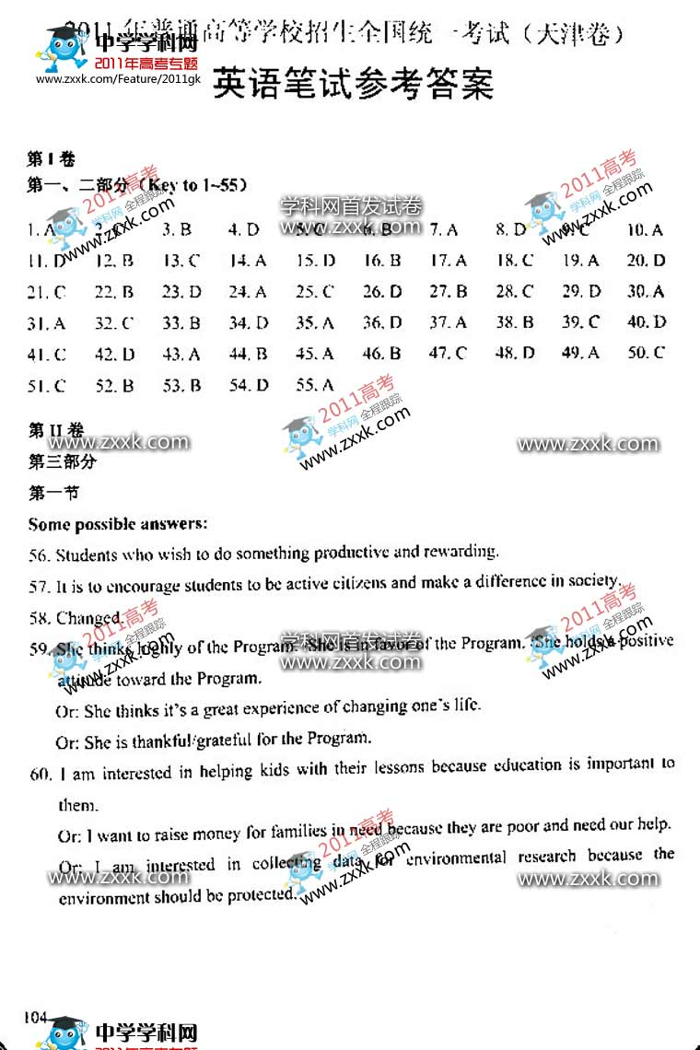 Li Hua

