Unit 2 Healthy eating
Part 1 Teaching Design
第一部分 教学设计
Period 2 A sample lesson plan for Learning about Language
(Modal verbs: ought to / ought not to / have to / don’t have to / mustn’t / needn’t)
Introduction
In this period students will be first helped by the teacher to warm up by having a dictation. Then they go on to discover useful words and expressions and learn about grammar. Some ready used materials for Modal verbs: ought to / ought not to / have to / don’t have to / mustn’t / needn’t will be offered.

Objectives
To learn about Modal verbs: ought to / ought not to / have to / don’t have to / mustn’t / needn’t
To discover and learn to use some useful words and expressions
To discover and learn to use some useful structures
Procedures
1. Warming up by reading aloud the text COME AND EAT HERE (1)
We promote reading aloud to students and by students in order to encourage a love of English books and a desire to become a fluent English speaker. So Read aloud the text before we learn about the grammar.
2. Discovering useful words and expressions
In pairs do the exercises on page 12. You must finish them in 5 minutes.
3. Reading and identifying
Read the text COME AND EAT HERE (1), discovering all the sentences which contain any of the modal verbs: ought to / ought not to / have to / don’t have to / mustn’t / needn’t.
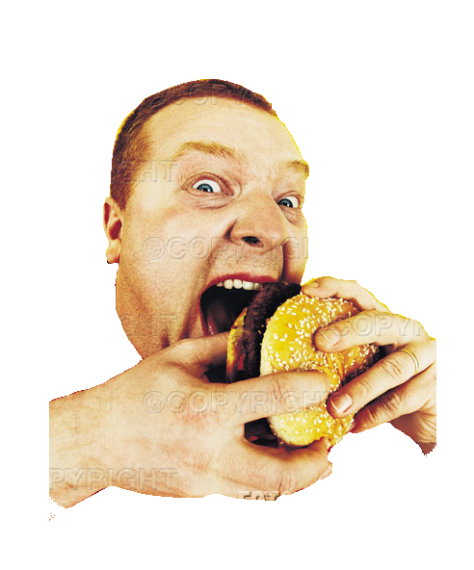
4. Consolidating by doing exercises
To consolidate your understanding you will be given 10 minutes to go over exercises on page 13. You may just write in your text book. I mean the student’s book you are working by.
5. Reading the ready used materials for Modal verbs: ought to / ought not to / have to / don’t have to / mustn’t / needn’t

1. What are Modal Verbs?
Modal auxiliary verbs help other verbs express a meaning or an idea but have no meaning by themselves. In English, modal auxiliary verbs are defective; for example, they do not have participle forms (no -ing or -ed endings).
They are used in a variety of grammatical moods such as the conditional mood, which expresses uncertainty ("I would be delighted if you came to my party").
Modal auxiliary verbs are special verbs which behave very differently from normal verbs. Next are some important differences.
2. Modal verbs do not take "-s" in the third person.
EXAMPLES:
He can speak Chinese.
She should be here by 9:00.
3. You use "not" to make modal verbs negative, even in Simple Present and Simple Past.
EXAMPLES:
He should not be late.
They might not come to the party.
4. Many modal verbs cannot be used in the past tenses or the future tenses.
EXAMPLES:
He will can go with us. NOT CORRECT
She musted study very hard. NOT CORRECT
For reference:
ought to | expectation (can use should)  e.g. If you like Picasso, you ought to enjoy the exhibition.
ought to | recommendation (can use should)  e.g. You ought to have more driving lessons before you take the test.
ought to | criticism (can use should)  e.g. You ought not to shout at your mother like that.

don’t have to | when you don’t need to do something (but you can if you want)  e.g. You don’t have to go to school if you don’t want to.

have (got) to | necessity, impersonal, not for personal feelings, but for a rule or situation. If you are unsure whether to use must or have to, it is usually safer to use have to.  e.g. I have to get up early tomorrow to catch the train to the office.

must not | prohibition (negative order)  e.g. You must not leave the table until you have finished your dinner.

need | as a normal verb  e.g. Do you need me to help you?
need | in questions (less usual)  e.g. Need you make so much mess?

needn’t | not necessary to do something (unusual)  e.g. You needn’t come to the party if you don’t want to.

don’t need to | not necessary to do something (more used than needn’t)  e.g. You don’t need to come to the party if you don’t want to.
6. Closing down by doing a quiz
Modals and Related Expressions
1. Ted's flight from Amsterdam took more than 11 hours. He_____ be exhausted after such a long flight.
A. must B. can C. had better
2. The book is optional. My professor said we could read it if we needed extra credit. But we _____ read it if we don't want to.
A. can not B. must not C. don't have to
3. Susan_____ hear the speaker because the crowd was cheering so loudly.
A. couldn't B. can't C. might not
4. The television isn't working. It ______ damaged during the move.
A. must have been B. must C. must be
5. A_____ hold your breath for more than a minute?
B: No, I can't.
A. Are you able to B. Might you C. Can you
6. You _____ be rich to be a success. Some of the most successful people I know haven't got a penny to their name.
A. can't B. don't have to C. shouldn't
7. I've redone this math problem at least twenty times, but my answer is wrong according to the answer key. The answer in the book _____ be wrong!
A. have to B. must C. should
8. You _____ do the job if you didn't speak Japanese fluently.
A. can't B. won't be able to C. couldn't
9. You _____ worry so much. It doesn't do you any good. Either you get the job, or you don't. If you don't, just apply for another one. Eventually, you will find work.
A. shouldn't B. don't have to C. can't
10. You _____ be kidding! That can't be true.
A. should B. have to C. ought to
11. You _____ leave the table once you have finished your meal and politely excused yourself.
A. would B. might C. may
12. _____ we move into the living room? It's more comfortable in there and there's a beautiful view of the lake.
A. Shall B. Must C. Will
13. If I had gone white water rafting with my friends, I _____ down the Colorado River right now.
A. would have float B. would be floating C. would float
14. At first, my boss didn't want to hire Sam. But, because I had previously worked with Sam, I told my boss that he _____ take another look at his resume and reconsider him for the position.
A. must B. ought to C. has to
15. You _____ take along some cash. The restaurant may not accept credit cards.
A. had better B. has to C. can
16. The machine _____ on by flipping this switch.
A. may turn B. could be turning C. can be turned
17. I can't stand these people - I _____ get out of here. I'm going to take off for a while you get rid of them.
A. might B. have got to C. had better
18. You _____ forget to pay the rent tomorrow. The landlord is very strict about paying on time.
A. mustn't B. don't have to C. couldn't
19. Terry and Frank said they would come over right after work, so they _____ be here by 6:00.
A. have to B. can C. should
20. The lamp _____ be broken. Maybe the light bulb just burned out.
A. might not B. must not C. could not
Keys: 1-5 BCAAC 6-10 BBCBA 11-15 CABBA 16-20 VBACA

