While reading
1. Answer the following questions.
(1)What’s the topic and how’s the information organized?
(2)How many styles of Western painting are mentioned in the text? What are they?
2. Complete the time line
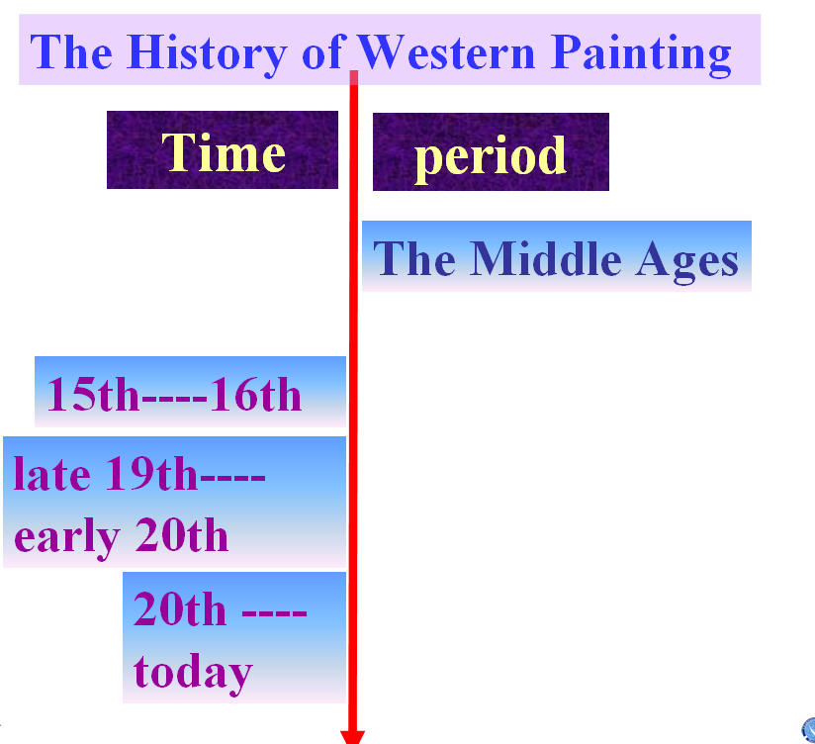
3. Read the passage and answer the questions.
(1)What influences art?
(2)Why has Chinese art changed less?
(3)What were the artists interested in from 5th to the 15th century AD?
(4)What did the artists paint in the Renaissance?
(5)How did Masaccio paint his paintings?
(6)What were the impressionists? Why did they have to paint very quickly?
(7)What is modern art?
4. Complete the chart below.（课本P3第一题）
5. Choose the best answer.
(1)The paintings with religious themes mainly appear during ______.
A. the Middle Ages B. the Renaissance
C. the late 1800s D. the early 1900s
(2)Drawing things in perspective was first used in ______ century.
A. 5th B. 15th C.16th D. 20th
(3)The beginning of “Modern Art” are the ____ paintings.
A. Religious B. perspective
C. Impressionist D. ridiculous
(4)Which of the following statements is true?
A. Paintings in Middle Ages were very realistic.
B. Western art has changed a lot since the 5th century.
C. Impressionist paintings were painted mainly indoors.
D. Modern art began in the Renaissance.
(5) In the Renaissance, painters ______.
- painted religious scenes in a more realistic style
B. focused more on religion than on humans
C. began to paint outdoors
D. returned to classical Roman and Greek ideas about art
(6)At first many people hated the impressionists’ style of painting, because _____.
A. their paintings were very abstract
B. their paintings were very realistic
C. they broke away from the traditional style of painting
D. their paintings were very ridiculous
(7)____ discovered how to make paintings look more real by using perspective.
A. Giotto di Bondone B. Masaccio
C. Claude Monet D. Pablo Picasso
6. True or False （课本P3第三题）
Post reading
1. Discussion: Which art style do you like best? Give your reasons.
2. Complete the passage with proper words, which will help you retell the text.
Art is influenced by the customs and faith of a people. Styles in Western art have changed a lot with time _________. During the Middle Ages, ____________ artists were creating pictures with a feeling of respect and love for God. In the Renaissance, people _________ a more humanistic attitude to life. Artists also began to draw things in perspective. The Impressionists between the late 19th and early 20th century were the first to paint _________. They had to paint quickly and their paintings were thought _______________ at first. However, they are _________ as the beginning of modern art today. On the one hand, some paintings of modern art are ________. _______________, some are realistic.

