Sea City - circa 1971
Information provided from the TV21 Annual 1971, published by Century 21, UK.
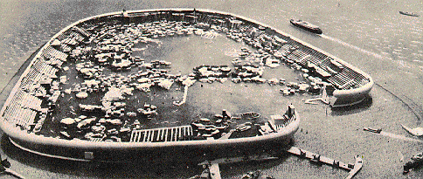
This exact model is even equipped with miniature ships and jetties.
Dogger Bank lies twenty-five miles out in the North Sea between the winkle-stalls of Great Yarmouth's seafront and the towering drilling-rigs of the Hewett offshore natural gas fields.
Man is fast running out of living space. Only a quarter of our planet is dry land; the rest is ocean. And our growing numbers are filling that quarter to bursting-point. We have to find a new place to live if we are to survive. There are three choices: on other planets, underground, and on the sea. The last of these seems the easiest choice. With this in mind, the idea of Sea City has been born - and what a fantastic idea it is! The architects who have planned this amazing place have built beautiful scale models to show what they have in mind. Looking at the models, our thoughts catapult us into the future - to the day when Sea City could be a reality ...
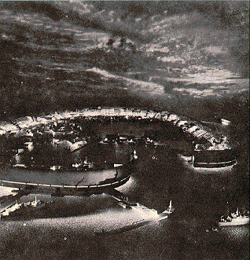
Clouds superimposed on a screen behind the illuminated model give a realistic impression of Sea City at dusk.
The hoverferry from Great Yarmouth skims across the choppy sea and within minutes of embarking the gaunt outline of Sea City appears on the horizon. Our first impression is of a great curving concrete wall, stark and white, sweeping upwards and outwards from the grey sea. How beautiful it is-but how grim and inhospitable, too! Surely, 30,000 people can't live in a fortress like this?
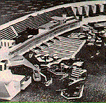
Artist's impression of an inside view of Sea City, with islands and terraces.
But then the hoverferry reaches a gap in the wall of concrete-and we see how wrong our first impression was. Inside the egg-shaped outer wall, sixteen tiers of gleaming, glass-fronted houses curve dramatically down to the smooth surface of the water. Their glittering lights reflect like a fireworks display on this sheltered lagoon. Dozens of triangular buildings float gently on the water, strung together by pedestrian walk-ways at first-floor level. All around us we see shopping centres, schools, churches and green parks. Sleek little water-buses dart about like dodgems at a fair.
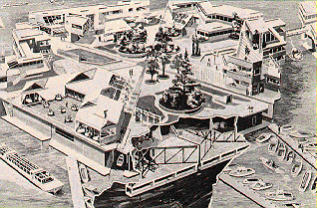
The islands inside the lagoon would comprise of six triangles, each 120 feet long with flood tanks to keep the sections level according to the building load carried.
The air is clean and fresh as we walk from the ferry to one of the fast elevators that will take us up to our new home - a seven-room flat built high into the inside of the outer concrete wall. But it is a flat with a difference - quite unlike anything that we have seen on the mainland. One wall is built entirely of reinforced glass - giving us a fantastic view of the city. There is even a garden of our own in which to relax and sunbathe in complete privacy. Automation is complete; air-conditioning, central heating, TV in every room. There's even an automatic waste-removal system to save Mum the trouble of putting out a dustbin once a week. All she has to do is pop the rubbish down a chute in the kitchen and a conveyor-belt below takes it away silently.
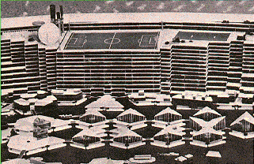
Sea City would even have its own football stadium (to background) and a Marine Zoo (floating, wedge-shaped buildings, to foreground).
It doesn't take us long to realize what a wonderful place Sea City is for young people. Take youth clubs. Instead of the dingy old hall we were used to on the mainland there are no less than eight specially designed youth centres, each one with full sport and entertainment facilities built in. There is a huge football stadium with covered-in seating for all spectators, built on top of the outer wall. (With a ground like this, Sea City United will be top of Division One in no time at all!) Then there are the water-sporting facilities. Fabulous! A huge boating-lake covers part of the inner lagoon, and there are special mooring points under the houses for our yachts and motor-boats.
On top of all this there are many public gardens, two theatres, a cinema, six churches and no less than fourteen restaurants. (There are also twenty-seven schools, but you don't want to know about those!) The biggest attraction of all is the Marine Zoo, an extra-ordinary place built half under the water, where we can watch strange creatures of the sea living in their natural conditions. Sea City is a wonderful place for Mum and Dad, too. Gleaming shopping arcades span the south side of the city, all under cover so that Mum doesn't get wet when she's staggering home with the week's provisions on a rainy day.
There's plenty of work close at hand for Dad. In the city itself are fish-farming plants, sand and ballast centres (these valuable building materials are dredged up from the ocean bed below), freshwater production plants and Marine Study Laboratories. If none of these suit him, Great Yarmouth - with its growing industry - is only a few minutes away by hoverferry.
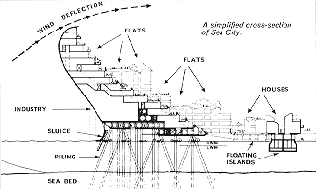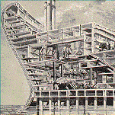
A cross-section of Sea City's wall revealing the power complex.
Life on Sea City sounds great, all right - but what about the howling gales and crashing waves that have made many a North Sea traveller never want to leave dry land again? Won't these things make life in Sea City impossible after all?
The answer is that they won't - for the architects who designed the city have learnt a lesson from the builders of medieval towns. Just as Sea City will be threatened from the outside by wind and waves, so towns in the Middle Ages were threatened by attacking armies. These armies were kept at bay by two lines of defence. The main one was a strong wall, twelve-foot thick and with firm foundations. In the same way, Sea City protects itself with that massive structure of reinforced concrete, specially curved to deflect the wind above it.
But the wall-builders of ancient times knew that one line of defence was not enough. However strong it was, attack after attack with a battering ram would eventually knock it down. So they devised a very clever way of limiting the force with which the attackers could strike their wall. They called it a moat.
In just the same way, the planners of Sea City knew that their wall of concrete would soon be brought down if the great waves were not checked before they crashed up against it. So they built a 20th-century version of the medieval moat.
All around the city, except for a gap to let ships through (just like a drawbridge), stretches a line of sausage-shaped canisters. These are positioned at some distance from the wall, and being part-filled with fresh water float low in the sea. They are enough to break the back of the giant waves coming crashing in, reducing them to harmless ripples by the time they reach the wall.
Oh, yes! Sea City is a possibility all right. It could be started tomorrow if the money were readily available.
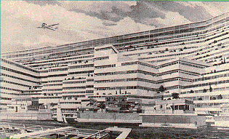
The transportation area (foreground) would link Sea City with the mainland.
Perhaps, during your lifetime, you will have the choice to live on the land-or to live on the sea. If you like fishing, sailing or swimming, then one day you might find yourself standing on the Great Yarmouth hoverferry terminal with a one-way ticket to Sea City!

