While reading
1. skim the passage quickly, and find out all the questions Zhou Yang asked. And then divide the passage into three sections.
2. Choose the best answer.
1) Zhou Yang will never forget his first assignment at the office because ______.
A. his first assignment was quite a failure
B. Hu Xin was very strict with him even though he was a journalist
C. his new boss Hu Xin asked him to go out on a story by himself
D. his discussion with his new boss, Hu Xin, was to strongly influence his life as a journalist
2) Zhou Yang can cover a story on his own only when _____.
A. he has a nose for a story
B. he listens to the answers carefully
C. he is interested in photography
D. he has seen what an experienced journalist does
3) Who will take the pictures when Zhou Yang goes out on a story for the first time?
A. Zhou Yang himself.
B. A professional photographer.
C. Hu Xin.
D. A more experienced reporter.
4) Which of the following is NOT included in Hu Xin’s list of “dos” and “don’ts”?
A. Don’t be rude.
B. Don’t laugh at the people being interviewed.
C. Don’t miss your deadline.
D. Don’t talk too much, but make sure you listen to the interviewee carefully.
3. True or False
1) Zhou can go out on a story immediately.
2) Zhou needs to take a notebook, a pen and a camera.
3) While interviewing, the journalist would just ask the questions prepared before- hand.
4) Zhou took a course of photography at middle school.
5) Zhou is very enthusiastic.
4 Read the passage and guess the meanings of these expressions.
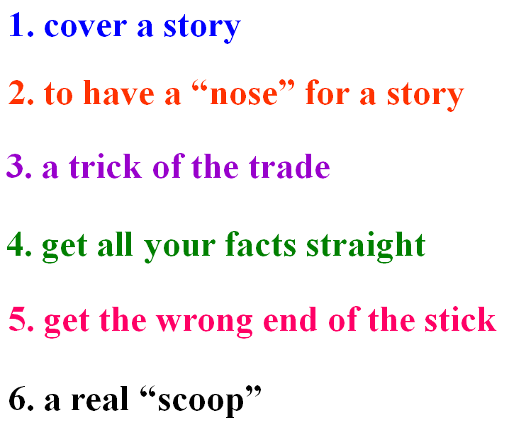
5. How to become a journalist? Use the information from the reading passage to help you. (p27-1)

After reading
1. Zhou Yang is trying to help his readers see whether they would make good journalists or good photographers. Use the reading to work out which adjectives best describe what is required for these two job. Some may be needed for both jobs. (p27-3)
2. Fill in the blanks to finish the Summary of the text and then try to retell it.
Zhou Yang will never forget his first assignment at the office of a popular English newspaper. His discussion with his new boss was to strongly influence his life ___ a journalist. The boss told him to wait ______ he was more experienced. Later he could ______ a story and ______ the article himself. Zhou Yang asked the boss _____ he needed to remember when he went out to cover a story. The boss told him that he needed to be curious. ______ he asked many different questions ______ he acquire all the information he needed to know. According to the boss, a good journalist must have a good “_____” for a story. That means that one must be able to _____ when people are not telling the whole truth and then try to ________ it. At last they discussed a case ______ someone accused the journalists of ________ the wrong end of the stick.

