第七课时 语言综合技能与评价课
一、教学内容 Listening (p. 69); Talking (p. 69); Writing task (p. 75); Summing up (p. 40); Self-test
二、教学目标
在本节课结束前，学生能够
- 自主利用中国和加拿大的地图, 分析比较中国和加拿大的相似之处和不同之处，口头做简短的报告。
- 运用本单元学过的表达方位的单词、短语和结构。
- 介绍和安排一个旅程。
- 检测本单元学习后达到的能力水平和知识的掌握程度。
三、教学步骤
步骤一 听（69页）
1. 学生听前预测和讨论。
李黛予和刘倩为加拿大朋友做了一个介绍中国的报告。与你的同伴讨论外国人最想知道什么，并且预测一下她们可能要报告哪些内容。

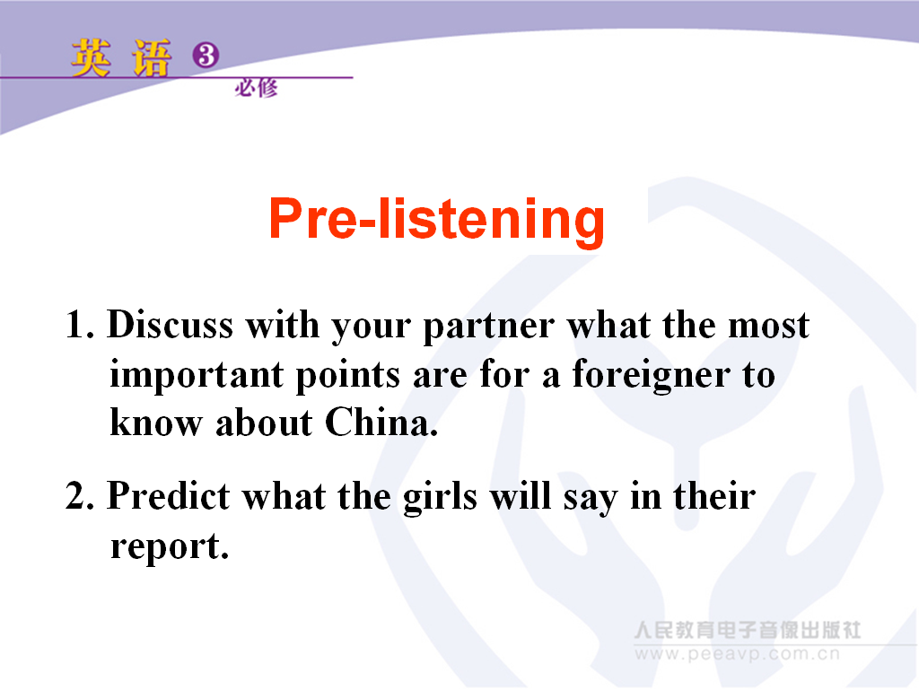

设计意图：听前预测话题，同时让学生站在听众的角度思考问题。
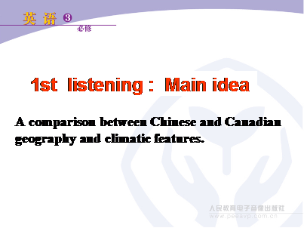
2. 学生听第一遍，听文章的大意：听力材料主要从地理和气候特色比较了中国和加拿大的相似和不同之处。
设计意图：第一遍听文章的大意，让学生整体把握全文内容，激活学生已有背景知识。
3. 学生听第二遍，判断句子正误。
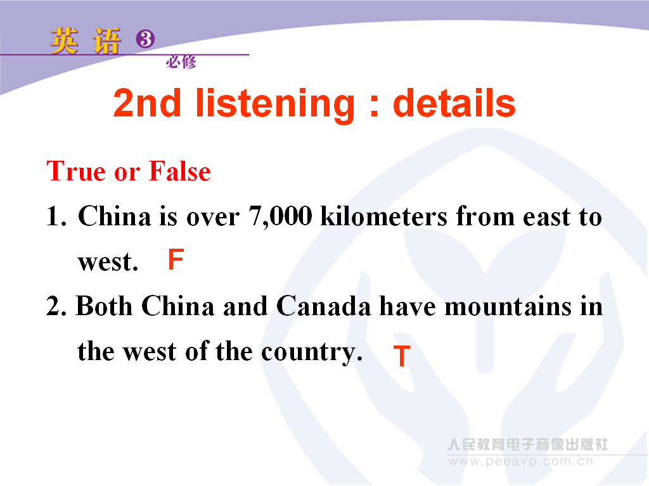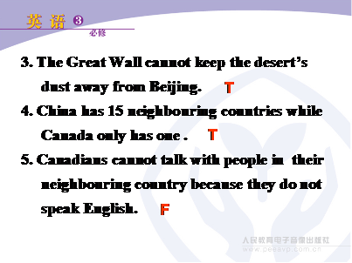

设计意图：通过判断正误，了解学生对听力内容细节的把握程度。
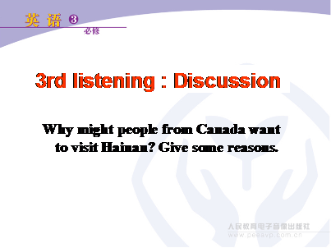
4. 学生听第三遍，讨论为什么加拿大人喜欢来中国的海南？
设计意图：让学生就听力中的一个细节讨论并且思考，发散学生的思维，促使学生使用所学语言表达自己的思想。
步骤二 说（69页）
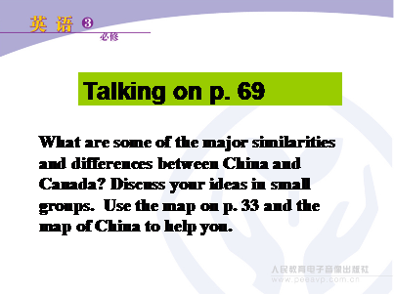
1. 教师准备两张较大的中国地图和加拿大地图，也可以让学生参考书上33页和69页的地图，以小组形式讨论中国和加拿大有哪些相似的地方和不同的地方。
2. 然后让几组同学以报告的形式展示他们的讨论结果。教师可以根据实际情况给学生提供讨论提纲。

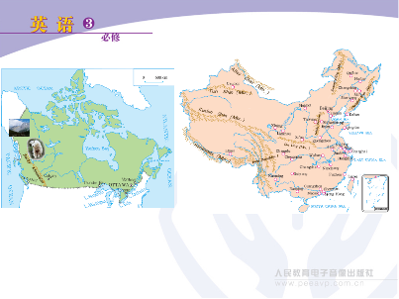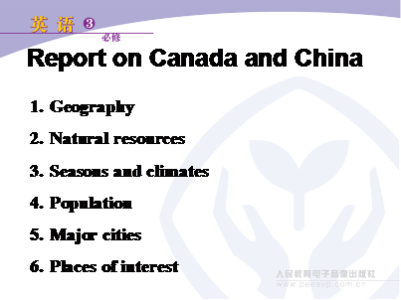
设计意图：让学生总结更多有关中国和加拿大的相似之处和不同之处，培养学生观察能力和总结归纳能力。
步骤三 写（75页）
1. 一群来访的同学到你的家乡旅游。安排一个三天到五天的行程，带他们参观你的家乡。
要求：1） 介绍每个地方的地理位置和概况。2） 尽量使用这个单元学过的单词和词组。
3） 开头已经给出。

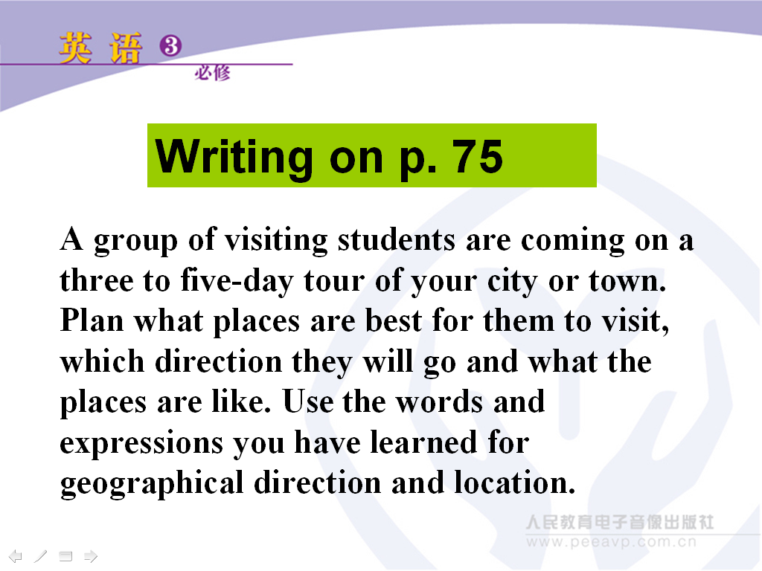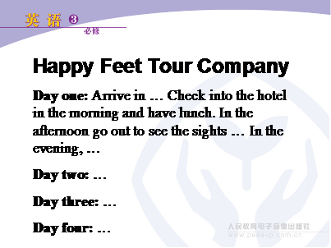
设计意图：让学生综合应用本单元学过的介绍地理位置和方向的词汇和结构，发挥学生的创造力。
2. 展示几份学生的行程安排，并且让其他同学评价，选出最佳旅游公司！
设计意图：展示学生的作品，然后让其他学生参与评判，最后选出最佳欢乐足旅游公司。
步骤四 总结与检测
学生在课堂上完成单元小结，写在笔记本上或书本40页上。单元自我检测教师以书面形式打印出来发给每个学生，可以在课下留为作业，根据每个老师的实际情况运用。
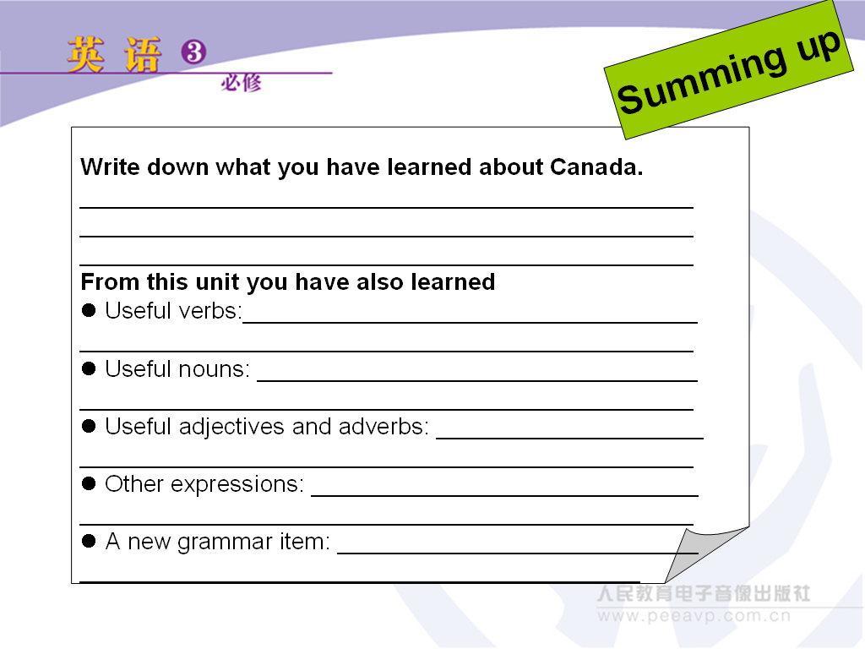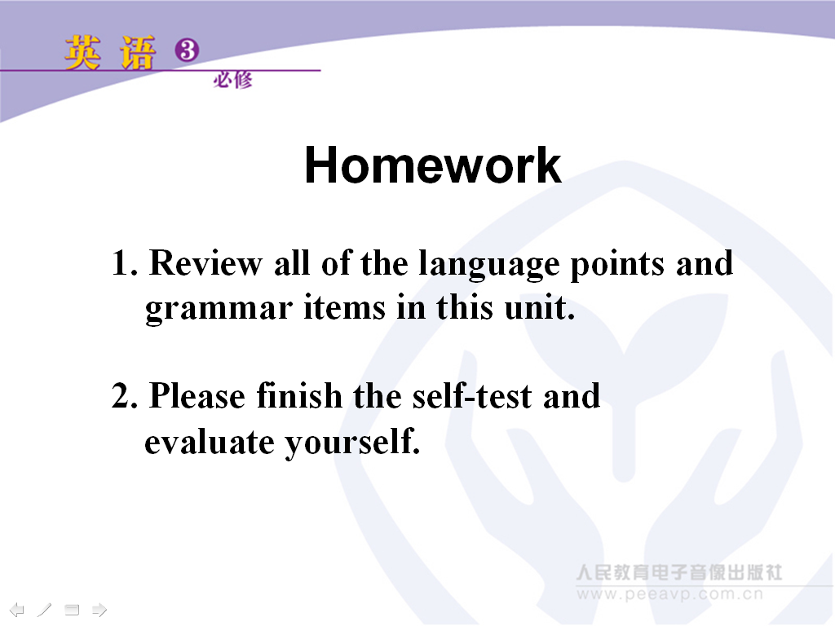

设计意图：学生自我检验，这个单元学到了什么，并且评价自己本单元学习情况如何。
附
Self-test of Unit 5
Name: ________________
一、非测试性评价
1、个体学习评价
Things I can do | Evaluation
I can read an English map. | 5 | 4 | 3 | 2 | 1
I can follow the route that the girls took during their trip to Canada. | 5 | 4 | 3 | 2 | 1
I can adjust my reading strategies, ie, first read for the general idea and then read for detailed information. | 5 | 4 | 3 | 2 | 1
I can adjust my listening strategies, ie, first listen for the general idea and then listen for detailed information. | 5 | 4 | 3 | 2 | 1
I can use the prepositions of place to describe where a place is. | 5 | 4 | 3 | 2 | 1
I know some basic information about Canada. | 5 | 4 | 3 | 2 | 1
I understand what a multicultural country really means. | 5 | 4 | 3 | 2 | 1
I can understand and use appositive clauses. | 5 | 4 | 3 | 2 | 1
I know how to write a report on a trip. | 5 | 4 | 3 | 2 | 1
I know some kills that help me to remember more words. | 5 | 4 | 3 | 2 | 1
I need more practice in _______________________________________

2、小组互评
Check to see | Assessment of yourself |  |  | Assessment of teammates
Everybody participates in group activities and makes contributions to the group. | 3 | 2 | 1 | 3 | 2 | 1
The group leader encourages each member to give his/her opinion. | 3 | 2 | 1 | 3 | 2 | 1
Everybody listens to others carefully. | 3 | 2 | 1 | 3 | 2 | 1
The task can be done successfully. | 3 | 2 | 1 | 3 | 2 | 1
Everyone is happy with the cooperation. | 3 | 2 | 1 | 3 | 2 | 1
We need to improve ___________________________________ in group work.

二、测验性评价
（一）根据首字母填写单词
1. It is said the M__________of Japan will come to visit our country next month.
2. As is known to all, there are seven c___________ in the world.
3. If you go e__________, you’ll find the sea.
4. Our school is s____________ by many trees.
5. There is a h_________ near our city, where you can find many big ships in and out.
6. After they married, they s__________ down in a small village, leading a quiet life.
7. We admire her for she has a g________ for singing and dancing.
8. An order came that we should finish the work w__________ three days.
9. There is a s___________ difference between the two words.
10. The t_________sound made me t__________.
11. I have such a good eye-sight that I can see the small things in the d___________.
12. Yesterday, it was so cold that there was some f_____________ on the ground.
13. I planned to go d____________ to watch movie this Sunday.
14. Finally, they managed to arrive at their destination (目的地) at d_________.

（二）选择题
1. — Excuse me, is the book shop far from here?
— No, it is just ______ of our college.
A. 3 kilometers long B. 3 kilometers walk
C. within 3 kilometers D. 3 kilometers far
2. — Are you worried about his safety?
— Only ______.
A. gradually B. broadly C. slightly D. extremely
3. The girl who is studying at the art college has a _______ for music and dance.
A. gift B. present C. power D. strength
4. Word came ______ our duties would be changed.
A. that B. which C. whether D. when
5. — Where is the shooting centre?
— It is about 50 kilometres ______ the city of Beijing.
A. in south of B. south of C. the south of D. southern of
6. We watched the river as it _____ on under the bridge.
A. settled B. toured C. flowed D. floated
7. It’s based on the idea ______ all people are created equal, ______ is accepted by most people.
A. that; that B. which; which C. which; when D. that; which
8. Why not get some work experience first ______ go straight on to university?
A. other than B. rather than C. more than D. less than
9. He could see the tall chimneys of the factory ______.
A. from distance B. in distance C. in the distance D. to a distance
10. The prices of the flats _______ are several times as high as in the countryside.
A. downtown B. in the downtown C. in downtown D. at downtown

（三）选择完成句子，并且标注同位语从句(appositive)或定语从句(attributive)
1. 1) Isn't it good news! The suggestions ____ have been accepted by our principal. ( )
2) The committee has accepted the suggestion ____________. ( )
A that citizens with higher income should pay higher taxes
B our students put forward
2. 1) I was very disappointed by the news ______________________. ( )
2) The news ___________________________ was not true. ( )
A that the Houston Rockets were defeated again
B that she was terrified by
3. 1) This book is full of interesting facts about the World Cup ___________. ( )
2) Mrs Rogers could not put up with the fact _______________________. ( )
A that her daughter came back late every night
B that more and more people have interest in

（四）翻译
1. 这个小村庄被青山绿水所环绕。(surround)
2. 据我所知，他有做生意的天赋。(as far as; have a gift for)
3. 随着中国经济的发展，许多外国人定居中国。(settle)
4. 位于中国东北的黑龙江省冬天非常冷。( in the northeast of; extremely)

（五）写作
根据加拿大地图以及中文提示，用英语写一段短文，简要介绍加拿大。
提示：1. 加拿大的地理位置；2. 加拿大的面积（九百九十七万多平方千米）；3. 加拿大是由十个省和两个自治区组成的联邦国家；4. 加拿大的首都所在地；5. 加拿大的人口（约3520万）；6. 要求以“目前，中加两国人民的友谊日益增强”为结尾。

参考答案：
（一）根据首字母填写单词
1. Minister 2. continents 3. eastward 4. surrounded 5. harbour 6. settled
7. gift 8. within 9. slight 10. terrifying, terrified 11. distance 12. frost
13. downtown 14. dawn
（二）选择题
1-5 CCAAB 6-10 CDBCA
（三）选择完成句子，并且标注同位语从句(appositive)或定语从句(attributive)
1. 1) B (attributive) 2) A(appositive) 2. 1) A (appositive) 2) B (attributive) 3. 1) B (attributive) 2) A (appositive)
（四）翻译
1. The village is surrounded by green hills and clear waters.
2. As far as I know, he has a gift for business.
3. With the economic development of China, many foreigners have settled down in China.
4. It is extremely cold in Heilongjiang Province which lies in the northeast of China.
（五）写作
One possible version：
Canada
Canada extends from the Atlantic Ocean in the east to the Pacific Ocean in the west and northward into the Arctic Ocean. Canada shares land borders with the United States to the south and northwest.
Canada is the second largest country in the world by total area. It has an area of over nine million nine hundred and seventy thousand square kilometers. It is made up of ten provinces and two territories each with its own capital. The capital of Canada is Ottawa. Canada has a population of about 35,200,000.
The Chinese people and the Canadian people have always been good friends. In the past few years the friendship between the two peoples has been developing with each passing day.

