Henry Clay Frick
The Frick is one of the predominant small art museums in the whole of the United States. The museum is located on Fifth Avenue and 70th street, and faces onto Central
Park. 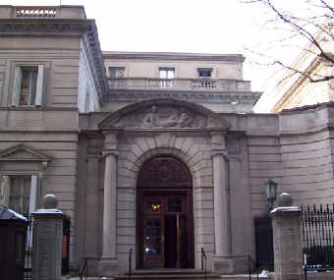The building is the former residence of steel magnate Henry Clay Frick (1849-1919). It was constructed in 1913-1914 from a design by Thomas Hastings. Frick was generally regarded as a tough entrepreneur whose only interest was in business, but within his family, he was regarded as a warm and affectionate man. He became an avid collector of art which he eventually left to the American people, plus a large endowment for its upkeep.The Frick Collection includes many very well known paintings by some of the greatest artists in Europe, plus major works of sculpture and bronzes, there is some superb eighteenth-century French furniture and porcelains, also Limoges enamels, Oriental rugs, and other works of remarkable quality.

Frick's, private art collection was made into a museum after his death. It has been designed to feel more like a private home than a public place, with the mansion itself being considered to be a work of art in its own right. The low stone building and courtyard take up almost an entire city block. Over the years the Collection has expanded, with about one third of the pictures now being exhibited having been acquired since his death. In 1935 and again in 1977, the building was enlarged to accommodate the growing collection.
The furniture that adorns all the rooms of the house is almost entirely from the sixteenth century. Many rooms have rich wood walls and floors, marble fireplaces and decorative columns, giving visitors the sense of the grandeur of a bygone age. You will see nothing more recent than 1880’s French Impressionism here; most of the work is at least a century older than that, with one piece being nearly seven hundred years old. The house has several small, rooms set off from the main ones, so take care not to miss any during your visit to the museum.

The treasures found here include major works by Bellini, El Greco, Vermeer, Velazquez, Goya, Turner, Van Dyke, Rembrandt, Renoir and Holbein, plus wall panels by Fragonard and Boucher.

The indoor courtyard with a fountain and glass ceiling is a lovely tranquil spot. Both the mansion and the works in it serve as a monument to one of America's greatest art collectors. Many of the rooms are arranged almost precisely the way Henry Clay Frick would have wanted them. Unlike many other museums, the works of art are not displayed in any particular order of date or style, which adds to the impression of intimacy. Nowhere in New York, or in the United States for that matter, will you find such an inviting, intimate museum displaying such rare works.

