While reading
1. Answer the questions.
How many forms of poems are mentioned in the text? What are they?
2. Skim the poems on pages 10 and 11 and fill in the form on page 9.（课本P9第二题）
3. Read Poems A-H, and then answer the questions.
(1) Read poem A and answer these questions.
What are the features of nursery rhymes?
(2) What are the features of list poems?
(3) What’s the main idea of poem C?
(4) Why didn’t the players in poem C win? Write down three excuses that the author gives. Does the author really believe his or her excuses? How do you know?
(5) What are poems D and E about? Do the authors like the subjects? Give your reasons.
(6) Do you know the Chinese title of this poem?
A. 蝶恋花
B. 竹枝词
C. 望夫石
D. 一剪梅
Do you know the Chinese version of poem H?
(7) What is the story that poem H tells? Tell the story in your own words.
(8) Circle the words expressing feelings. What feelings do you think the woman in poem H has? Give your reasons.
(9) Fill in the chart below according to what we’ve learned today.
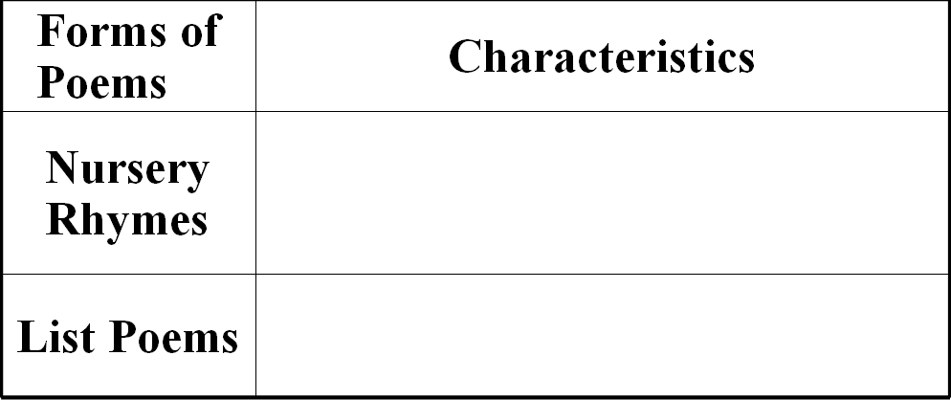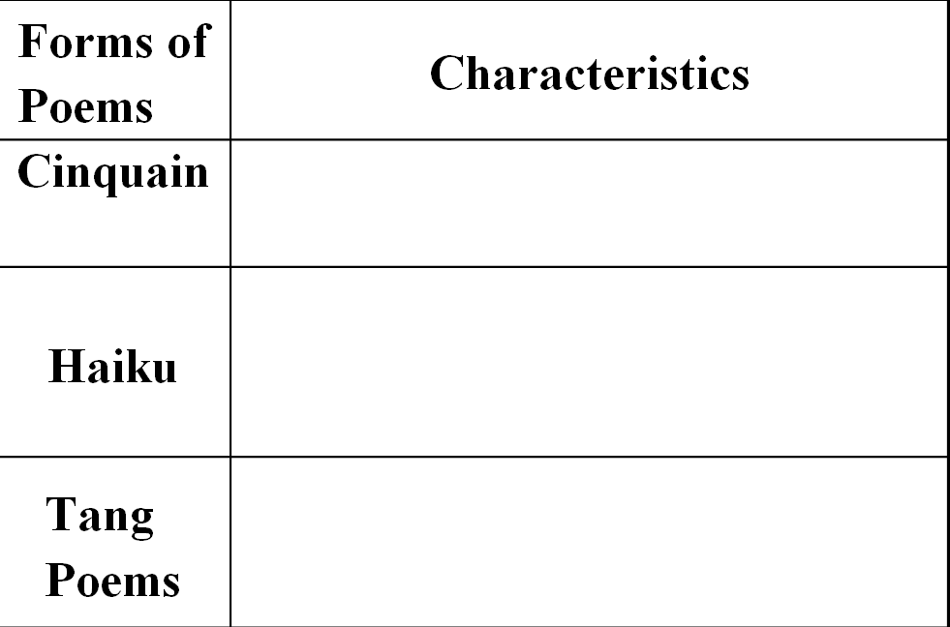
Post reading
1. Discussion: Are poems good for our life? What can we get from poems?

2. Complete the passage with proper words, which will help you retell the text.
Poets use many different forms of _________to express themselves. Here are some simpler forms. Nursery rhymes have strong ________ and a lot of repetition. The language is ________ but imaginative. They are easy to learn and recite. List poems have a ________ line length and repeated phrases. The cinquain ____________ five lines and students can ________ a strong picture in just a few words. Haiku, a Japanese form of poetry, can create a special feeling ___ using the _________ of words. A lot of Tang poetry has been translated into English.

