While reading
Skimming:
What’s the main purpose of the passage?
A. To explain the three types of burns.
B. To show the symptoms of burns.
C. To tell us the causes of burns.
D. To tell us what to do if someone gets burnt.
In which order are these topics covered in the text? Number them from 1 to 5. (见课本P35 1)
___ the three types of burns
___ what to do if someone gets burned
___ the functions of the skin
___ the symptoms of burns
___ how we get burns
Scanning:
True or False.
1. Our skin has three layers.
2. We will never get burned by the sun.
3. Burns are divided into three degrees according to the degree of pain.
4. Third degree burns are the most painful ones.
5. We need to cool burns with icy water.
6. Don’t rub the burns.
7. Under certain circumstances we can put butter oil or ointment on burns.
8. If burns are on the face, the victim should sit up.
Fill in the blanks.
◇ The skin is an essential part of your body and its ________ organ.
◇ There are ______ layers of skin.
The functions of the skin
1. Act as a ________.
2. Keep us _____________.
3. Prevent our body from ____________________.
4. Give us the ______________.
Causes of burns
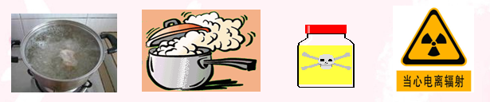
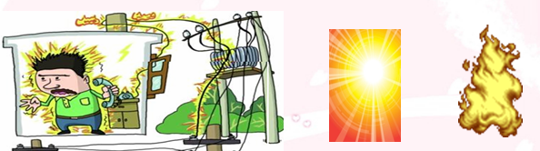

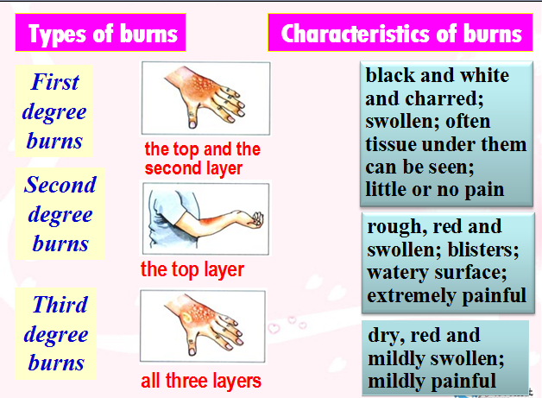
First aid treatment
Dos
1. ________ clothing and jewellery near the burn.
2. _____ burns immediately with cool but not icy water.
3. ______ cool, clean wet cloths on the burns.
4. ____ the burned area gently.
5. ______ the burned area with a dry clean bandage.
6. If burns are on arms or legs, _____ the burned area ______ than the heart, if possible. If burns are on the face, the victim should ______.
7. _____ the victim ___ the doctor or hospital at once, if the injuries are second or third degree burns.
Don'ts
1. Do not _______ the clothing that is stuck to the burns.
2. Do not cool the burns with _____ water.
3. Do not put cold water on _____ degree burns.
4. Do not ____ the burns, it may break the blisters.
5. Do not ____ butter, oil or ointment on burns.
Answer the questions. (见课本P35 3)
1. Why should you put cold water on a burn?
2. Why doesn’t a third degree burn hurt?
3. Why do you think clothes and jewellery near burns should be removed?
4. If someone has a third degree burn, why might you see tissue?
Jigsaw Retelling
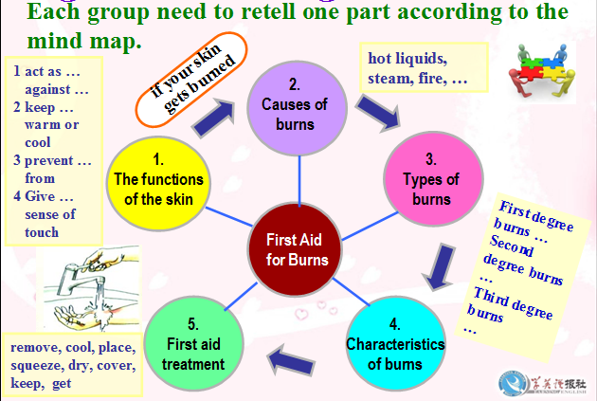
After reading
Group work: How to deal with the situations?
1. Sam knocked over a kettle full of boiling water onto his legs. His legs became red, swollen and covered with blisters.
2. While ironing clothes, Miss Good accidentally touched the iron. Her wrist blistered and became watery, It hurt a lot.
3. Mrs Casey’s sleeve caught fire while she was cooking. Her arm looked terrible but it didn’t hurt. The skin was charred.
4. After an hour in the sun, Lily noticed her arms were red and hurt a bit.
Quiz: Task-based reading.
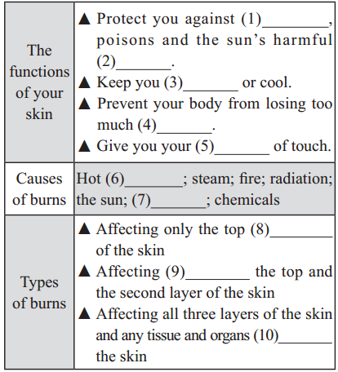
Closing words:
You can be the difference between life and death.
It is of great importance to learn about some knowledge of first aid in daily life.

