HIV/AIDS and Debt - A Deadly Combination
The United Nations agency UN AIDS estimate that by the end of 2001, a total of 40 million people across the world will be living with HIV/AIDS. The vast majority, some 28 million people, reside in sub-Saharan Africa. Although accounting for only ten per cent of the world's population sub-Saharan Africa sees 90 per cent of all new infections along with 80 per cent of AIDS related deaths. Poverty has fuelled the spread of the virus in the region. Of the 41 poorest and most heavily indebted countries in the world, 34 are in sub-Saharan Africa. Debt is a major cause of poverty and hardship in indebted countries where approximately 50 per cent of the population live on less than $1 per day and almost 50 million children are out of school.
The spread of HIV/AIDS can be controlled and its impact can be significantly reduced. The fight against HIV/AIDS depends on strong and effective campaigns in health and education. In the past year sub-Saharan Africa has paid rich creditors almost $15 billion in debt repayments. Every day vital resources are taken away from the health and education sectors in countries where the HIV/AIDS pandemic is at its worst.
Adults and children estimated to be living with HIV/AIDS
Total 40 million (UNAIDS 2001)
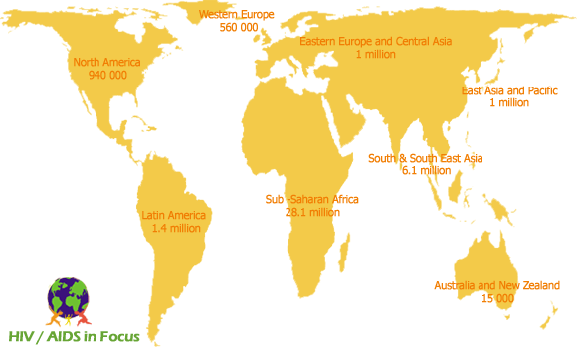

The Structural Adjustment Programmes of creditors such as the International Monetary Fund and the World Bank force indebted countries to slash government spending and introduce user fees for health and education services thereby reducing access for the poorest. Millions of people remain vulnerable to the risk of infection whilst the vast majority of the world's HIV positive population have little hope of receiving treatment or support.
High levels of illiteracy and low levels of access to mass media and information hinder AIDS education awareness campaigns. Christian Aid report that without a decent education Africa's children are more vulnerable to contracting the virus in later life; 25 per cent of 15-19 year olds in Zambia still do not know how to protect themselves from infection.
HIV/AIDS is a social and an economic catastrophe. Over 12 million children across the continent have been orphaned. The pandemic is putting enormous pressure on health care systems in countries like Zambia where approximately 50 per cent of hospital beds are occupied due to an AIDS related illness. Furthermore, experienced personnel, both semi-skilled and highly trained, are being lost in all sectors, including education, social welfare, and agriculture. For example, in Zambia the number of teachers dying of AIDS related causes in 1998, was equivalent to two thirds of all new teachers trained that year. Twenty per cent of the population of Zambia are HIV positive. The country needs to spend $25 on each person annually on healthcare; however at the moment it is spending less than $3 per person per year. Meanwhile Oxfam International report that debt servicing for 2001 in Zambia will be 6 times greater than public spending on health.

Due to the predominantly sexual transmission of HIV/AIDS in Africa, the pandemic is concentrated among the most productive members of society, those aged between 15-49. HIV/AIDS disproportionately affects sectors such as agriculture, transport and mining that are highly labour intensive or have large numbers of mobile or migratory workers. HIV/AIDS has the greatest impact on countries that rely on agricultural exports, which earn vital foreign exchange needed to pay the debt. The HIV/AIDS pandemic is reducing the labour force, productivity, outputs, overall economic growth and national food supplies. As noted by Oxfam International HIV/AIDS creates a vicious circle. The pandemic is reducing economic growth, which increases poverty and which in turn accelerates the spread of HIV/AIDS.

Response from Creditors is not good enough
Malawi is a heavily indebted poor country with nearly 16 per cent of its population testing positive for HIV. In August 2000, Malawi turned down a loan of $40 million from the World Bank. The loan was for AIDS treatment and prevention, but the deputy Prime Minister of Malawi said that it would be immoral for such a heavily indebted country to accept another loan that it really had no hope of repaying. If his country were to have a chance to fight AIDS they would need a grant and not another loan.
Debt Cancellation is urgently needed to combat the spread of HIV/AIDS
The Taoiseach Bertie Ahern recently uttered such sentiments. On June 26th 2001 Bertie Ahern addressed a special session of the General Assembly of the United Nations on HIV/AIDS. In his speech he supported the urgent need for debt cancellation for countries with a high prevalence rate of HIV/AIDS.
Debt and Development Coalition Ireland urge the Taoiseach to take action on his words by pressing the World Bank and International Monetary Fund and rich country governments to cancel the debts owed to them and allow heavily indebted countries fight the spread of HIV/AIDS.

