Substance abuse and HIV/AIDS in Africa
From the ODCCP Update, March 2002
Seventy per cent of the world's HIV/AIDS population is found in Africa. With over 25 million Africans affected, HIV/AIDS has become the number one killer on the continent.
At the same time, the abuse of illicit drugs, including cannabis, cocaine, heroin and psychotropic substances, is rising. The number of women and adolescent drug abusers is increasing and, according to studies conducted in Kenya, Nigeria and South Africa, intravenous drug use (IDU) appears to be higher than commonly believed.
The direct link between IDU and HIV/AIDS has been established elsewhere, but up until recently, the situation in Africa was not as clear. Information now being collected is painting a new picture-4 per cent of registered HIV/AIDS cases in North Africa are reportedly caused by IDU, and individual countries report even higher rates. While sexual HIV transmission is clearly predominant in Africa, transmission among IDUs also plays a role.
In Mauritius, where HIV/AIDS prevalence rates are lower than in other East and Southern African countries, IDU was found in 21 per cent of a sample group of HIV-infected people. An ongoing World Health Organization study in Nairobi City also revealed an unexpectedly high number of heroin abusers injecting the drug intravenously. In Nigeria, a study carried out in 2000 in Lagos revealed that the HIV prevalence rate among heroin and cocaine street users was almost twice as high as among non-drug users (9.8 per cent for the former versus 5.4 per cent for the latter).
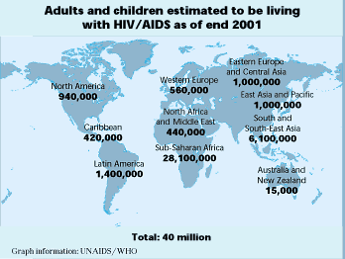
To address this situation, UNDCP and UNAIDS recently adopted a draft Action Plan against drug abuse and HIV/AIDS in Africa. The plan focuses on incorporating prevention and awareness-raising measures into existing projects. Field activities will include linking drug control master plans to national HIV/AIDS programmes, generating gender sensitive data and focusing prevention efforts on African youth. The Plan also foresees the mobilization of African governments, donors and United Nations system partners, to integrate drug abuse prevention elements into HIV/AIDS and poverty reduction programmes.

