Unit 4 Astronomy: the science of the stars
第一部分
《金色教案》教学设计说明
About the topic and the structures  单元话题和结构 | 本单元以节日为话题，介绍了世界各地的一些节日的含义、由来和民俗。通过本单元的学习，可以帮助学生更多地了解节日、体味文化；同时又可以引导学生理解、尊重不同的文化和习俗。  本单元语言功能项目是：发出指令。  本单元语言结构项目是“名词从句做主语”。  本单元还要求学生学习写作“说明文：解决问题”。  《金色教案》教学设计在单元课时划分上与课本保持一致，即“阅读课、知识课、运用课三课时/三课型划分”。但在实际教学过程中，建议教师依据学生基础、教学条件、学校安排的因素，对课本、对《金色教案》教学设计重新划分课时，裁剪、拼接使用提供的材料，以便“物尽所用”，达到最佳教学效果。教师也可以参照《金色教案》提供的“实际教学过程课时划分建议”进行教学。
Period 1  Reading  阅读课 | Warming Up 课本上的导入共有两组问题，第一组问题引导学生讨论太阳系。第二组问题探讨天文学。教师也可采用本书提供的by learning vocabulary 导入新课。  Pre-reading部分主要引导学生讨论地球上的生命起源、世界各地的宗教和文化生命起源的看法，然后观察课文标题、预测文章内容。  Reading 部分讲述了地球上生命的起源。水的形成使得地球有别与其他星球，它使得地球上生命的诞生成为可能。科学家认为，地球上的生命首先诞生于水中，上百万年后，陆地上才长出绿色植物，随后出现了陆栖动物和水陆两栖动物。最初的动物靠孵化繁衍后代，后来出现了哺乳动物，人类也随之诞生了。文章最后讲述的现象发人深省：The earth may become too hot for the lives on it.它关系到地球上生命的未来。建议采用Talking and sharing—Do you know how the universe began? Listening and reading aloud，Reading and underlining，Reading and understanding difficult sentences，Reading and transferring information，Reading and translating， Reading to decide on the type of writing and summary of the text， Reading to draw a tree diagram of the text and retell the story with the help of the diagram等步骤进行教学。而结课可以采纳Closing down by having a discussion—How Did the Universe Begin?  Comprehending部分通过篇章学习、句子顺序重组、口头讨论等六个活动检测学生对本文核心问题的理解：地球上生命的起源和延续需要哪些条件?
Period 2  Learning about language  知识课 | Learning about language课本要求首先通过英文解释帮助理解课文中的生词，然后，通过短文填空、词语分类等形式将这些词语用于一个相关的情境中。语法部分也是采用先发现后应用的学习方法。先通过到课文中找句子，让学生认识主语从句，然后，设置一个用手机发短信息的情境，让学生进行简单句与主语从句之间的转换练习。最后设置情境来复习第三单元出现的表语从句。教师也可以本书如下设计进行教学：Warming up by discovering useful words and expressions，Learning about grammar，Reading more on subject clause，  Closing down by doing exercises。
Period 3  Using language  运用课 | Using language为综合教学，训练听说读写能力。听力部分的内容介绍三位科学巨匠，不仅通过听力填表的形式训练学生捕捉细节的能力，还通过四选一的形式帮助学生找主题思想。在解释对与错的过程中，教师可以适当地介绍一下概括主题的方法。阅读部分是一个科幻小故事，通过“我”和“我的朋友”乘宇宙飞船登月球的经历，介绍了重量、失重和地球引力等科学道理。说和写部分以Visiting the moon为话题，要求学生讨论登月球需要携带的物品和在月球上可能遇到的困难，并要求学生找出克服这些困难的方法。教师可以根据课本上的提示，向学生介绍“先分述后总结”的写作方法。提出问题的解决方案时，要求学生选用适当的“指示”用语。教师可以参考使用本书提供的教学步骤：Warming up by listening and reading aloud，Understanding difficult sentences，Reading and underlining，Doing reading comprehension exercises，Discussing，Guided writing，Acting a text play 和Closing down by filling a form
实际教学过程课时划分建议
Period 1 | 将Warming Up、 Pre-reading、Reading和Comprehending整合在一起上一节“阅读课”。
Period 2 | 将Learning about language 和Workbook中的 USING WORDS AND EXPRESSIONS、USING STRUCTURES 整合在一起上一节“语言知识课”。
Period 3 | 将Using language 设计为一节包括听说读写单项技能或组合技能训练的“综合技能课（一）”。
Period 4 | 将Workbook 的READING AND LISTENING和TALKING整合在一起上一节“听说课”。
Period 5 | 将Workbook 的LISTENING TASK、READING AND WRITING TASK和 SPEAKING TASK整合为一节“综合技能课（二）”。
第二部分
教学资源说明
Section 1  Background  背景 | 围绕单元话题“Festival around the world”，《金色教案》提供了几则语言规范、短小精干的趣味性材料。这些材料既可以作为教师教学参考材料为教师所用，也可以直接或改写、重组后作为课堂内外的拓展性阅读材料呈现给学生。
Section 2  Explanation  解析 | 重点针对“阅读课型”中的课文难句，《金色教案》不仅提供了详尽的，就句论句的解析和翻译，而且还以解析的焦点话题为线索，进行了一定的归纳、辨析和总结，以帮助教师更好地实施“语言形式”的教学。
Section 3  Vocabulary  词汇 | 按照课本单元词汇表顺序，《金色教案》重点提供动词、短语搭配的讲解。所提供的例句，经典、地道、实用、易懂，完全可以直接用于教学。
第三部分
教学测评说明
围绕单元词法、句法项目，《金色教案》提供了长短不一的“单元教学测评”，并备有参考答案供教师使用。有些测评题目直接源于历年高考试卷，更具有说服力和实用性。

Part 1 Teaching Design

第一部分 教学设计

Period 1 A sample lesson plan for reading

(HOW LIFE BEGAN ON THE EARTH)
Introduction
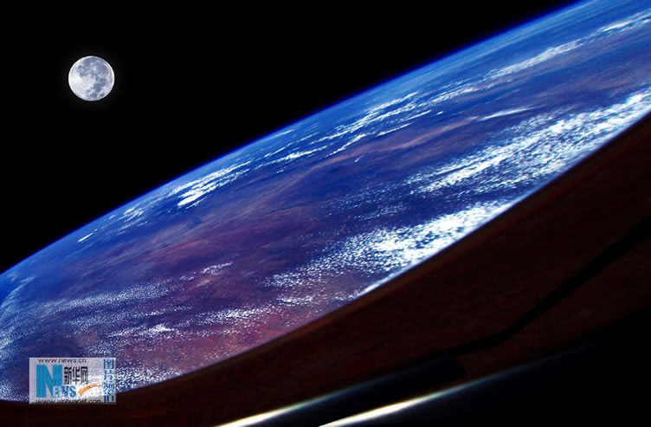
In this period, after the warming up, students will first be guided to talk and share. Then they will be helped to read an exposition（说明文）entitled HOW LIFE BEGAN ON THE EARTH. Then the students may be asked to listen and read aloud，read and underline，read and understand difficult sentences，read and transfer information，read and translate, read to decide on the type of writing and summary of the text and finally read to draw a tree diagram of the text and retell the story with the help of the diagram. The period will end in students having a discussion—How Did the Universe Begin?

Objectives

To help students understand the text’s forms and contents and learn about festival Astronomy

To help students communicate on the topic in focus with the words, expressions and structures learned in this unit
Focus
Words | dissolve， exist，puzzle，crash，pull，float，exhaust
Expressions | in time, lay eggs, give birth to, block out, cheer up, now that, break out, watch out
Patterns | 1. It exploded loudly with fire and rock, which were in time to produce the water vapor, carbon dioxide, oxygen, nitrogen and other gases, which were to make the earth’s atmosphere.  2. Nobody knew that it was going to be different from other planets going round the sun.  3. It allowed the earth to dissolve harmful gases, which had become part of the earth’s atmosphere, into the oceans and seas.  4. This encouraged the development of early shellfish and all sorts of fish.  5. They produced young generally by laying eggs.  6. They are putting too much carbon dioxide into the atmosphere, which prevents heat from escaping from the earth into space.  7. Whether life will continue on the earth for millions of years to come will depend on whether this problem can be solved.
Aids
Multimedia facilities, tape-recorder, photos, diagrams

Procedures

I. Warming up by learning vocabulary

Good morning, class! Today, we are going to take Unit 4 Astronomy: the science of the stars. Before we read the text, let’s turn to page 99 and get familiarized with the vocabulary first. Pay attention to the making of the word. Study the prefixes, roots and suffixes in the words.

II. Pre-reading
1. Looking and saying
Have you ever wondered how the universe began? Well I'm sure you may have many answers to this question, but I have one that perhaps, you may not have heard of yet. I will be giving you my theory on this subject. Now look at the screen and listen to me telling you something exciting.
科学家透露：宇宙可能有两个
我们的宇宙和一个"隐藏的"宇宙共同"镶嵌"在"五维空间"中。在我们的宇宙早期，这两个宇宙发生了一次相撞事故，相撞产生的能量生成了我们宇宙中的物质和能量。
2. Talking and sharing
Do you know how the universe began?
In the 1920s in California, astronomer Edwin Hubble observed distant galaxies using an extremely powerful telescope. He made two mind-boggling (unbelievable) discoveries.
First, Hubble figured out that the Milky Way isn’t the only galaxy. He realized that faint, cloud-like objects in the night sky are actually other galaxies far, far away. The Milky Way is just one of billions of galaxies.
Second, Hubble discovered that the galaxies are constantly moving away from each other. In other words, the universe is expanding. The biggest thing that we know about is getting bigger all the time.
A few years later, Belgian astronomer Georges Lemaître used Hubble‘s amazing discoveries to suggest an answer to a big astronomy question: “How did the universe begin?”
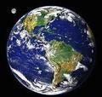
3．Listening and reading aloud
Now please listen to the recording and then read the text aloud. Pay attention to how the native speaker is reading along and where the pauses are within each sentence. I will play the tape twice and you shall read aloud twice, too.
- Reading and underlining
Next you are to read and underline all the useful expressions or collocations in the passage. Copy them into your notebook after class as homework.

Collocations from HOW LIFE BEGAN ON THE EARTH
a cloud of energetic dust（具有能量的尘埃）, combine into…（合成……）, move around the sun（环绕太阳运转）, become violent（变得激烈）, the solid surface（固体表面）, explode loudly（猛烈爆炸）, in time（及时，最终）, produce the water vapor（产生水蒸汽）, make the earth’s atmosphere（构成了地球的大气层）, cool down（冷却）, on the surface（在表面）, be different from…（与……不同）, go round the sun（环绕太阳运转）, disappear from…（从……消失）, stay on…（存留在……）, show one’s quality（显现某人的特性）, dissolve harmful gases（分解，溶解有害气体）, become part of…（变成……的一部分）, develop life（发展生命）, grow in the water（在水里生长）, fill… with…（用……来填充……，充满了……）, encourage the development of…（鼓励……的发展）, millions of years later（几万年以后）, live on land（在陆地上生活）, live in the sea（在海里生存）, grow into forests（长成森林）, produce young（生出幼仔）, lay eggs（下蛋）, animals with hands and feet（长着手脚的动物）, spread all over the earth（遍布全世界）, develop new methods（发展了新的方法）, grow food（种植）, move around（迁徙）, go by（过去，推移）, take care of…（在意……，照看好……）, put…into…（把……带入，放入……）, prevent…from…（防止……做……）, escape from… into…（从……逃离到……）, become hot（变热）, depend on….（依靠，依赖，取决与……）, solve a problem（解决一个问题）
3. Reading and understanding difficult sentences
Skim the text and identify the difficult sentences of each paragraph. You may put your hand up if you have any questions.
4. Reading and transferring information
Read the text again to complete the table below,

HOW LIFE BEGAN ON THE EARTH
What was the earth like after the “Big Bang”?
Why was the earth different?
How was life developed on earth?
What did small clever animals do?

HOW LIFE BEGAN ON THE EARTH
What was the earth like after the “Big Bang”? | A cloud of energetic dust at first and then a ball around the sun. In time as a result of its explosion, water vapor and many other gases were produced to make the earth’s atmosphere. Water then appeared when it cooled down, offering the possibility for the beginning of life.
Why was the earth different? | The arrival of small plants growing in the water filled the oceans and seas with oxygen, encouraging the development of small living things.
How was life developed on earth? | Carbon dioxide and air with oxygen helped life developed. First were insects and amphibians, and then appeared reptiles and dinosaurs, producing young by laying eggs. At first, came mammals producing young from within their bodies.
What did small clever animals do? | With hands and feet, they spread all over the earth, developing new methods of growing food, hunting and moving around, yet neglecting the environment protection, causing new problems for human being’s existence for good.
5. Reading the text once again to decide on the type of writing and summary of the text
Type of writing | This is a descriptive writing.
Main idea of the passage | The earth came into being after the “Big Bang”. Then small plants came growing in the water, followed by green plants appearing on land. In the end appeared small clever animals.
Topic sentence of 1st paragraph | After the “Big Bang”, the earth was just a cloud of energetic dust.
Topic sentence of 2nd paragraph | The earth was different because of the arrival of small plants growing in the water.
Topic sentence of 3rd paragraph | Many millions of years later the first green plants began to appear on land.
Topic sentence of 4th paragraph | Small clever animals appeared and spread all over the earth.

6. Going over the text to make a tree diagram and retell the story with its help
After the “Big Bang”, the earth being just a cloud of energetic dust.

the arrival of small plants wing in the water

green plants beginning to appear on land
Small clever animals appearing and spreading all over the earth.

- Reading and translating
As you have read the text times, you can surely put it into Chinese. Wang Hongqin, will you be the first to have a try, of putting the first paragraph into Chinese.
- Closing down by watching a movie entitled From the earth to the moon《从地球到月球》
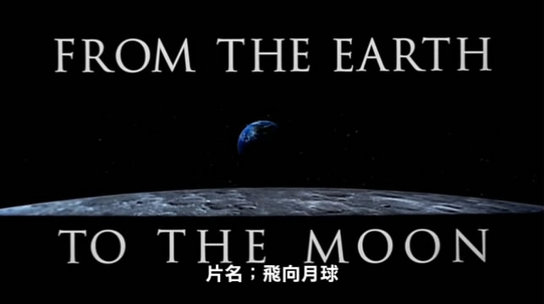
Through dramatization, this series relates the story of the conquest of the moon by the Americans, from the Mercury and Gemini projects to the legendary Apollo missions.
“这是我的一小步，却是人类的一大步。”美国太空人尼尔阿姆斯壮在1969年踏上月球的那一刻留下了这句名言。这句话代表人类文明的跃进，宣告了太空时代的到来。在阿姆斯壮登月近三十年后，好莱坞巨星汤姆汉克斯、金奖导演朗霍华与王牌製作人布莱恩葛瑟三人斥资6800万美金将美国登陆月球的太空计画拍摄成迷你影集【飞向月球】，重现当年太空人的奋斗历程，并在充满史诗的气魄中纪录了所有的艰辛、骄傲、失败与悲壮的牺牲，为人类的文明写下了精彩的一页。

