Unit 4 Astronomy: the science of the stars

Part 1 Teaching Design

第一部分 教学设计

Period 3 A sample lesson plan for Using Language
(A VISIT TO THE MOON)

Introduction
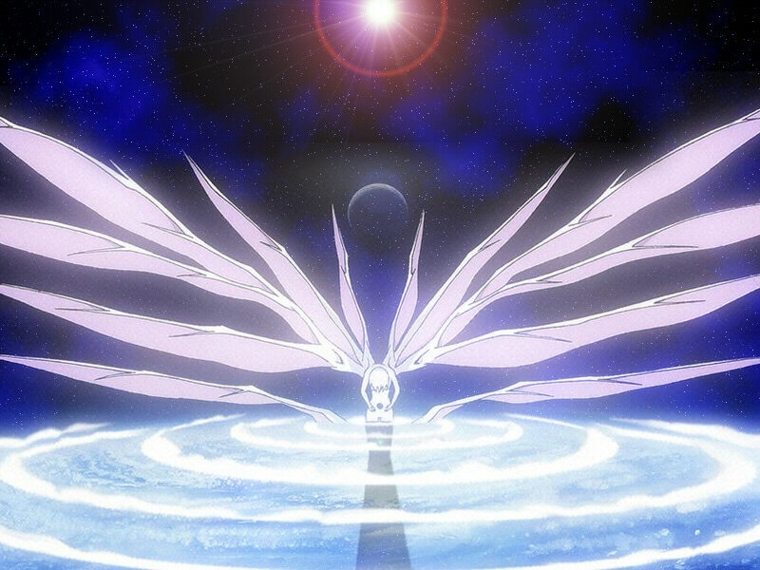
Language is learned to be used in and for communication. So in this period we shall have the students read, listen, write and speak in English, making use of the focused words, expressions, structures and topic ideas covered in this unit.
The following steps can be taken: warming up by listening and reading aloud，understanding difficult sentences，reading and underlining，doing reading comprehension exercises， discussing， guided writing，acting a text play and closing down by filling a form.

Objectives
To enjoy the passage A VISIT TO THE MOON
To learn to use the language by reading, listening, speaking and writing

Procedures

1. Warming up by listening and reading aloud
Let’s listen to the recording of the text A VISIT TO THE MOON, and then read it aloud.

2. Understanding difficult sentences
Skim the text A VISIT TO THE MOON and discuss in pairs the difficult points you find.
3. Reading and underlining
Next you are to read and underline all the useful expressions or collocations in the passage. Copy them into your notebook after class as homework.
Collocations from A VISIT TO THE MOON
be lucky enough（足够幸运）, have a chance（有个机会）, make a trip（去旅行）, visit the moon（参观月球）, in the spaceship（在太空飞船中）, explain to… that…（向……解释……）, on the journey（在旅程中）, be off（启程）, rise into the air（升人太空）, feel the pull of the earth（感觉到地球的拉力）, call…gravity（称……为地球引力）, push…into the seat（把……推向座位）, say…to each other（向彼此说……）, fall back to…（朝……落下去）,fall from a tree（从树上掉下来）, fall to the ground（朝地上落下去）, get close to…（接近……）, feel…~ing（感觉到……正在……）, cheer up（高兴起来）, float weightlessly around（失重飘来飘去）, in the spaceship cabin（太空船舱）, watch…do（看着……做）, come on（来吧）, move freely（自由的活动）, grow tall（长高）, climb down the steps（从梯级上爬下来）, step forward（向前迈步）, fall over（摔倒）, need practice（需要练习）, after a while（过了一会儿）, get the hang of…（掌握了……的诀窍）, enjoy oneself（感到自如）, leave the moon’ s gravity（摆脱月球引力）, return to…（返回到……）, break out（起火，爆发）, come back to…（回到……）
4. Doing reading comprehension exercises
Now you are going to do exercises on page 31.
5. Discussing
In pairs discuss what you need to take if you would go to the moon.

Lunar Puzzlers
If you're standing on the moon and the Earth is directly overhead, how long will it take for our planet to reach the moon's horizon? Make a shot at(guess) this and other lunar brainteasers.

Last Man on the Moon
Gene Cernan, who left man's final footprint on the moon in 1972, describes what it was like to lift off from the launchpad, walk in space, spend three days exploring the lunar surface, and reenter the Earth's atmosphere.

Hear the Space Pioneers
Buzz Aldrin on that first-ever landing. Jim Lovell on the terror of Apollo 13. Listen to the compelling stories of these and other Apollo luminaries who got us to the moon.

Origins
The moon is not made of green cheese but of bits of the Earth blasted into outer space by a Mars-sized meteor, which struck our planet four and a half billion years ago or so, says the leading theory of how the moon came to be.

6. Guided writing
Next you are going to write a short article explaining at least three problems you might meet on the moon.
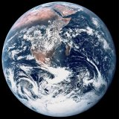
Going To The Moon
Plan your trip before you go
How will you get there?
What will you need?
Where can you buy things?
At The Moon
Find out what’s there
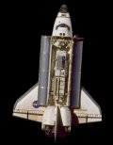
Hotels
Transport
Sport
Gone To The Moon
What happens when you come back
Pictures
Returning to gravity
Buried on the moon
7. Acting a text play
In groups of four turn the article HOW LIFE BEGAN ON THE EARTH into a text play. One of the group members is to be a space scientist, the other three the lovers of moon exploration. The winning group will be awarded.

8. Closing down by filling a form

Make use of the text A VISIT TO THE MOON to fill in the following form. Write in verb phrases to tell about the trip.

A VISIT TO THE MOON
Before the trip | be informed the three changes of the force of gravity; first change most powerful
During the trip | take off; feel the pull of the earth/or gravity; be pushed hard back to seat; talk when the weight lessen; too far to feel the pull; feel the gravity of the moon pulling; cheer up and float weightlessly around
After landing | excited when arriving; mass be less; move more freely; might grow taller to stay long enough; weigh less; be carried twice as far when step forward; fell over; get the hang of it; enjoy
Returning to the earth | leaving the moon not as painful while returning to the earth frightening; fire break out as gravity increase; be pushed hard into seats; exhausting but exciting;

