Before reading
Tangshan earthquake
The Tangshan earthquake, also known as the Great Tangshan earthquake, was a natural disaster that occurred on Wednesday, July 28, 1976. It is believed to be the largest earthquake of the 20th century by death toll(死亡率). The earthquake left 242,419 people dead, according to official figures. A further 164,581 people were recorded as being severely injured. The earthquake hit in the early morning, and lasted for around 15 seconds. Many sources list it as 8.2 on the Richter scale(里氏震级), but Chinese government’s official sources state 7.8. It was followed by a major 7.1 magnitude (量级) aftershock(余震) some 15 hour later, increasing the death toll.
While reading
1. Main idea of the passage
The passage mainly talks about_____________________________.
2. Scan the passage and find out the topic sentence of each paragraph.
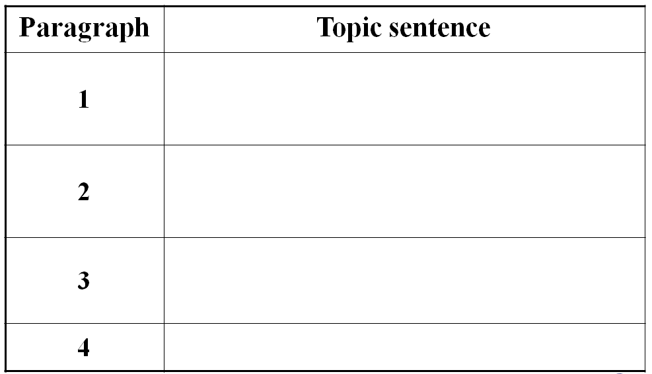
3. What do these numbers stand for?
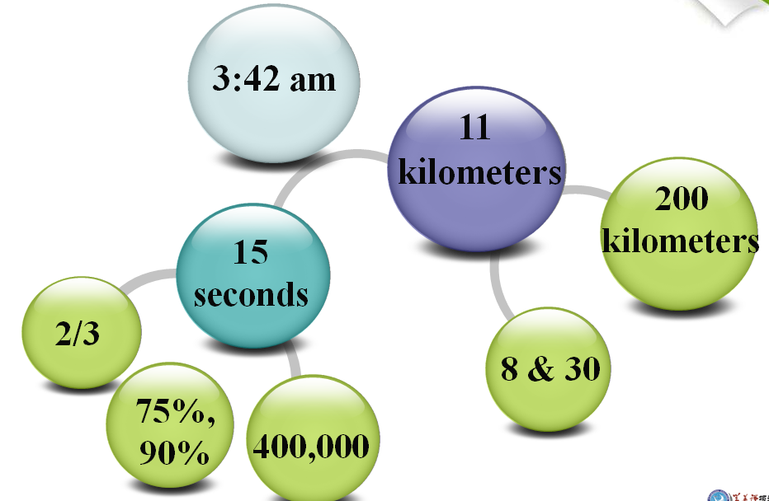
4. Choose the best answer.
1. The earthquake began at ________.
A. 3:00 am, June 28, 1976
B. 3:00 am, July 28, 1976
C. 3:42 am, July 28, 1976
2. _________ people were killed or injured in the quake.
A. Less than 400,000
B. More than 400,000
C. More than 150,000
3. Before the earthquake the following happened EXCEPT that _______.
A. the water in the well rose and fell
B. the animals were too nervous to eat
C. bright lights appeared in the sky
D. people made good preparations for the earthquake
4. How long did the earthquake last?
A. Ten seconds. B. Fifteen seconds.
C. Twenty seconds. D. Half a minute.
5. Which of the following didn’t happen during the earthquake?
A. A huge crack appeared in the roads.
B. Bricks covered the whole ground.
C. The injured were sent to hospital immediately.
D. The railway tracks became useless pieces of steel.
5. True or false
1. One-third of the people died or were injured during the earthquake.
2. Such a great number of people died because the quake happened while they were working.
3. All the hospitals had been destroyed.
4. Only supply of water and electricity was cut off.
5. Almost everything in Tangshan was destroyed.
6. Before the earthquake there wasn’t anything strange happening.
7. Workers rescued most of the 10,000 coal miners to the south of the city.
6. Join the correct parts of the sentences. (课本27页第一题)
7. Discussion
Explain in your own words what the writer means by the title “A night the earth didn’t sleep”. In pairs, suggest another title for the text.
8. Discuss with your partner and try to figure out the answers to the following questions.
1) From whose point of view are events described? How do you know?
2) What is the mood of this passage? How is this mood created?
3) What do you think the writer chose to express his feelings about the quake rather than simply report what happened?
After reading
1. Talk and Practice
Choose a paragraph and act out an interview between a reporter and a survivor from the Tangshan earthquake.
2. Summary
Fill in the blanks to finish the Summary of the text and then try to retell it.
____________ happened in Tangshan. For a few days, water in the wells _____________. From the ______ of wells __________came out. Mice, chicken, pigs and even fish became ________. At 3:00 am, everything began to ______.It seemed that the world was _________. _________ of the nation ____ it. _____________cut across the city. The city lay _______. Two-thirds of the people died or ___________. Then later that afternoon, another big quake ______ Tangshan. People began to wonder _____________________________. But all hope ____________. Soldiers came to help those ________. Slowly, the city began to _________________.

