While reading
1. Look at the title and the structure of the article.
Where does this article most probably come from?
A. a newspaper
B. a novel
C. a magazine
2. Answer the following questions. (课本P27第一题)
3. Read the passage and answer the following questions.
What has caused global warming?
What can we learn from graph 1?
How has global warming come about?
Can you explain the meaning of these two words: greenhouse gases & greenhouse effect?
4. Discussion: Is greenhouse effect good or bad?
5. Read the passage and answer the following questions.
What can we learn from graph 2?
Does every scientist accept this idea?
How high will the temperature increase go?
6. Point of view: What do Dr. Janice Foster and George Hambley think about the consequences of global warming? Do they agree with one another?
7. Fill in the blanks.
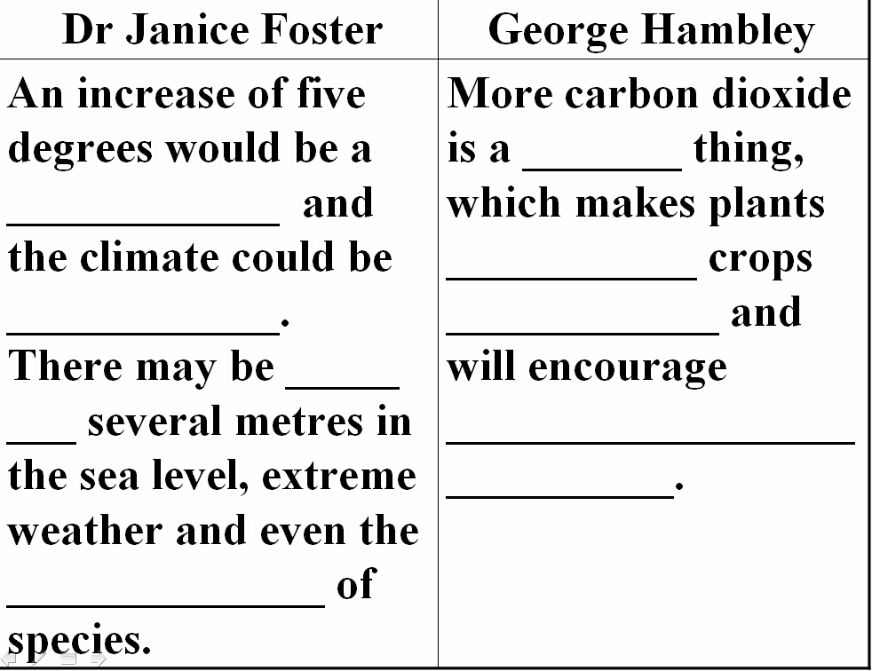
8. true or false (课本P27第2题)
9. Choose the best answer.
(1) Greenhouse gases refer to _______.
- carbon dioxide
B. the burning of fossil fuels
C. byproducts of the burning of fossil fuels
D. coal, natural gas and oil
(2) Greenhouse effect _____.
A. is a natural phenomenon
B. happens when there’s too much carbon dioxide
C. does great harm to human beings
D. makes life for human beings worse
(3)_____ found out the amount of carbon dioxide in the atmosphere from 1957 to1977.
A. Dr. Janice Foster B. Charles Keeling
C. George Hambley D. Sophie Armstrong

Post reading
1. Discussion: What should we do with global warming? No one knows the effects of global warming, does that mean we should do nothing?
2. Complete the passage with proper words, which will help you retell the text.
It is believed that the earth is __________ ________and that it is human activity ____ has caused this global warming _________ a random _____ natural phenomenon. But the attitudes of scientists ________ this warming are completely different. Dr. Janice Foster thinks the effects of global warming could be very _______. _______ George Hambley thinks global warming will ____________ few bad environmental ____________. Anyway, the climate is going to _________ warming for decades or centuries, _______ we start reducing the amount of greenhouse gases.

