Aims and requirements
● get the students to understand the texts well
● get the students to know the harms of drugs.
● help the students to improve their reading ability
Teaching procedures

Period 1: Introduction and Reading
Step 1: Revision
1. Revise last unit by asking them how to keep healthy and if drugs are harmful to our health.
2. Ask the students to give some examples of healthy habits in the form of everyday English.

Step 2: Warming up
1. Warming up by discussing
Is using drugs a healthy habit?
2. Warming up by watching and listening


Yes to life，Not to drugs！
珍爱生命，拒绝毒品！
International Day Against Drug Abuse and Illicit Trafficking
每年的6月26日是国际禁毒日
Facing Reality: Denial, Corruption and Violence
2000年国际禁毒日的主题是：

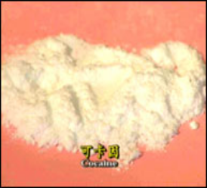General description of common drugs:
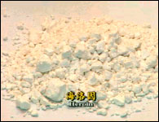
◆Cocaine [可卡因]
◇ Type of Drug: Stimulant
Fact: derived from the leaves of the coca bush that grows in the mountainous region of Bolivia and Peru. It is sold on the streets as a fine white powder .
▲ Effect: Body actually forgets to sleep at beginning, later person experiences extreme fatigue, exhaustion and depression, bacterial infections of brain and heart.
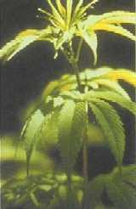
◆Heroin [海洛因]
◇ Type of Drug: Narcotic
Fact: derived from the opium poppy that is grown illegall in some areas in Southern Asia, the Middle East, Mexico, and Colombia. Today, no medical uses of Heroin at all.
▲Effect: flu-like symptoms - Nausea, vomitting, euphoria, cramps, diarrhea, runny nose, teary eyes, sweating, weekness
◆Marijuana[大麻]
◇ Type of Drug: Hallucinogen
Fact: Comes from parts of the hemp plant which contains 400 known chemical. Marijuana continues to be proven to contain higher levels of cancer-causing chemicals
than Tobacco!
▲Effect:
①white blood cells: reduction of strength of immune system.
② lungs : cause asthma, infections etc.
③brain: decrease ability to concentrate, short term memory, bad vision, irregular sleep patterns, mood swings. lack of interests in past or future.
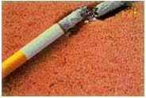
◆Tobacco (nicotine)[烟草][尼古丁]
◇ Type of Drug: Stimulant
Fact: Tobacco contains mainly of 2 substances:
①Nicotine: addictive stimulant
②Tar: yellowish brown fluid which causes cancer,
▲ Effect:
① physical: cancer, heart disease, stroke, stomach ulcer,
② psychological: anxiety, sleep disturbances, nervousness, headaches
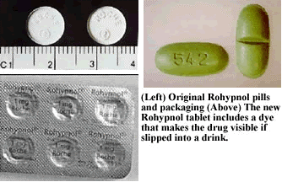
◆GHB ◆Ketamine [克他命] ◆Rohypnol 睡眠 ◆Ecstasy [入迷?]
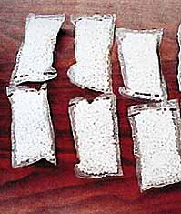
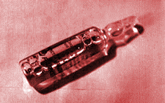
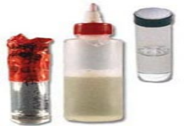
Step 3: Pre-reading
1. Ask questions:
1) Do you know anybody who uses drugs?
2) Can you describe the harm of using drugs?
2. Introduce some new words:
Show the following new words to the students and ask them to read them together twice while correcting their pronunciation.
Addictive reduce immediately break into
Danger powerful increase inject
Fill in the blanks with the proper form of the words given above
1) This drug is highly _________
2) Thieves had ________ ________ the house through an upstairs window.
3) She’s been very ill, but now she’s out of ________.
4) I went ________ after I’d eaten.
5) The population of this town has ________ greatly.
6) She ________ the rat with a new drug.
7) The minister made a ________ speech.
(Keys: addictive broken into danger immediately increased injected powerful )
3. Discussion
As we all know, drug does harm to people’s health as well as smoking. But could you list the illnesses caused by using drugs and smoking?
(Possible answers: blood pressure heart attack heart disease cancer high fever cough pneumonia)

Step 3: Reading
1.Lead-in
Smoke is the biggest killer to our life, so are drugs. Throughout the world , more and more persons are suffering from the illnesses, poverty and killings caused by using drugs. They even lose their lives for drugs. What’s a terrible phenomenon! Now, let’s learn something about Adam Rouse, ever a drug user and something about some drug called cocaine. Reading the opening paragraphs of two different articles and then you have to read parts 1—6 on page 13 and decide which article they belong to . After reading, answer the following questions:
Article1:
1)When did Adam Rouse begin to use drugs?
2)How did Adam Rouse get drugs at first?
3)What kind of drug did he use?
4)How did Adam Rouse get drugs when he was in terrible pain but he had no money?
5)Why did Adam Rouse stop taking crack cocaine?
6)What does Adam Rouse do now?
Article2:
7) What’s cocaine? And what’s crack cocaine?
8) How is cocaine used?
9) Is injecting the drug more danger than smoking it ?
10)What’s the bad effect of using cocaine?
2. Fast reading
Finishing organizing the whole passage, you have to do the following tasks:
1) Choose the right topic for each article on Workbook Page12
2) Get the general idea of each article:
Article1: Adam Rouse’s story of taking drug.
Article2: Cocaine and it’s harm.
3. Listening
Listen to the tape of the organized text, and pay more attention to the following words appearing in the story. After listening, students had better teach themselves the following words with the help of dictionaries, then finish Task3 on page 12.
Addictive powerful increase drug dealer danger addict inject
Reduce continue offer share needles
Let the students look at another picture and asked them if they knew the boy.
Zhou Kai, a middle school student, loves football very much and is very healthy.

Step4: Detailed reading for information
Read the complete articles carefully and decide whether the following sentences are true (T) or false (F) according to the text.
1) Adam Rouse is still addicted to drugs now.
2) In terrible pain, Adam Rouse broke into the drug dealer’s house and stole drugs.
3) Cocaine makes your heart go more slowly.
4) Smoking crack cocaine can change people’s behavior.
(Keys: 1F 2F 3F 4T)
Fill in the blanks in the following passage.
Adam Rouse first started ________ drugs when he was fifteen. Then,he ________ to buy cannabis from the ______ ______ ______ for about six months. Later, he was ________ some crack cocaine, which is a ________ ________ drug. ________ ________ ________ and without money, Adam Rouse had to _______ something to ________ ________ the drugs until one day he was ________ to stop ________ crack cocaine because using cocaine may ________ the user’s ________ ________ and ________ ________, and sometimes causes ________ ________, even also ________ anti-social ________.
Now Adam Rouse works in a center for drug ________, ________ others to stop ________ drugs.
(Keys: using, continued, same, drug, dealer, offered, powerfully, addictive, In, terrible, pain, steal, pay, for, advised, taking, increase, heart, rate, blood, pressure, heart, attacks, causes, behavior, addicts, helping, taking. )

Step5: Reading Practice
Read the following passage within 8 minutes and make a better choice to each problem.
Although the total percentage of daily smokers is falling in most countries, a new international study shows that six people die every minute from smoking. That equals 3 million deaths around the world every year. I f the present rate of smoking continues, the number of deaths each year from smoking could rise to 10 million by the year 2020.
The study describes smoking as the biggest cause to deadly diseases among grown-ups in industries. So far most of the smoking deaths have happened on men, especially in developing countries.
A researcher at the World Health Organization says 70% of the Chinese men smoke more than 15 cigarettes each day. In Latin America about 50% of the men are smokers. There are also a very large number of smokers in the former Soviet Union and in the east Europe. And 25% of all smoking deaths worldwide are in those areas of the world. Scientists say smoking will kill 50% of the smokers.
Smoking is known to cause lung cancer. It also can lead to cancer of the mouth and other parts of bodies. Smokers are more likely than nonsmokers to suffer from heart disease.
Experts say that people reduce their chance of dying from smoking if they stop smoking completely. They say smokers who give up smoking can improve their health.
In most Western European countries the percentage of daily smokers is falling, and far more men than women are quitting smoking. In Sweden and the Netherlands the percentage of male smokers has bee cut nearly in half in the past thirty years. In Norway about one third of the adult population smokes daily, a percentage that has fallen slightly. In 1980 this percentage was about 36, in 1990 it had fallen to 35 and in 1999 it was 32. There is no longer any difference between men’s and women’s smoking habits.
疑难词: percentage百分比 describe 描述 former 从前的 slightly 稍微地
- The best title for the passage would be ______.
A. Do give up smoking B. Smoking causes lung cancer
C. Smoking does harm to health D. Man likes smoking much more than woman
2. According to the text, if there are one hundred male Chinese smokers in the room, as a result , the number of cigarettes that they smoke a day is at least ______.
A. 1,5000 B. 5,000 C. 750 D. 1,050
3. It can be inferred from the text that if people don’t stop smoking, they will ______.
A. pollute the air B. waste a lot of money
C. become stupid D. be in poor health
4. Which of the following statements according to the text is true?______
A. Smoking is the biggest cause to deadly diseases among grown-ups.
B. Now more men than women are smokers
C. The number of smokers in east Europe is much bigger than that in Latin America
D. About one second of the Latin American men are nonsmokers.
（Keys：1C 2D 3D 4D）

Step6: Homework
1. Recite the passage before step4 .
Surf the Internet to search for information about drug users, then orally describe the condition of any drug user.

