Task: Write a film page for a magazine
Skills building 1: Discussing with group members and preparing materials
- Work in groups to discuss and prepare for the task.. You can read different magazines, try to learn what is needed in a film page, e.g.: Is there a film review? Are there any photos or pictures of film stars?
2. Prepare some materials for the film page. First, you can have a film review section with reviews of one or two films. Second, list the best films now on at the cinema and a brief description of each film, with your opinion. Third, you can add some photos of film stars or pictures of film.
Skills building 2: Writing methods
1. Words to use in the film page. You can use words which appear in the 〝Introduction〞on page 51, also you can refer to the text to find some useful words, especially the words in the box on page 51.
2. Phrases and patterns to use in the film page. You can use the following phrases as reference: come out, romantic film, martial art film ,adventure film ,belong to ,take place, as…as ,be divided into ,be popular ,make your heart leap with excitement as it’s beauty.
A possible version
The Banquet (《夜宴》)Release date: September  Directed by Feng Xiaogang,  "The Banquet" is a tale of fate (命运)  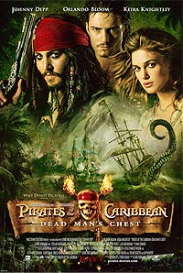      and revenge (复仇) set in 10th century China.  Pirates of the Caribbean: Dead Man's Chest  date: July 7th,2006  Directed by Gore Verbinski  Actor and actress:  Johnny Depp  Orlando Bloom  Keira Knightley  Bill Nighy  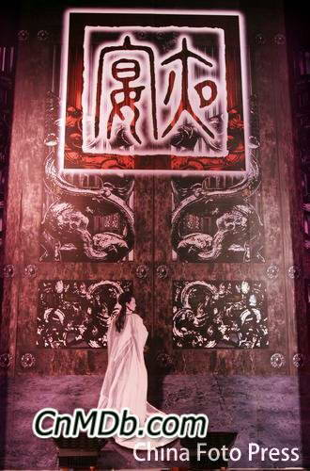  Garfield： A Tale of Two Kitties  date: July 8th,2006  Directed by Tim Hill  Actor and actress: Bill Murray  Jennifer Love Hewitt  Billy Connolly  The Devil Wears Prada  date: July 9th,2006  Directed by David Franke  Actor and actress: Anne Hathaway  Meryl Streep Emily Blunt | 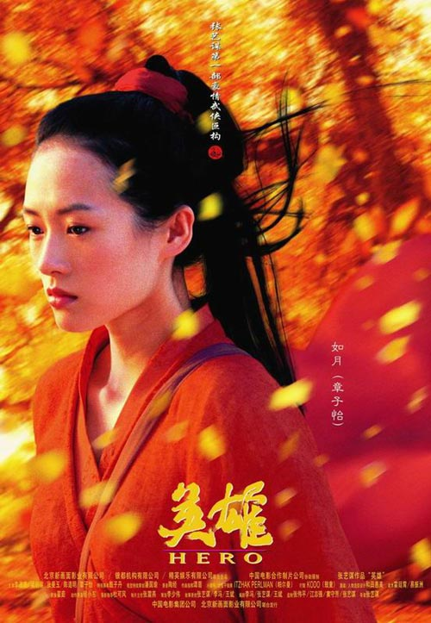  “Hero” Movie Review  Thousands of years ago, China was split up into six warring factions. The most ruthless (无情的) faction was the Kingdom (王国) of Qin, whose king (Chen Dao Ming) wanted to conquer (征服) the neighbouring kingdoms to unite (统治) the whole of China. This ideal made the king a target of numerous assassination (暗杀) attempts from neighbouring kingdoms. In particular there were three top-class assassins in pursuit of (追逐) him: Sky (Donnie Yen), Broken Sword (Tony Leung) and Flying Snow (Maggie Cheung).  The king promised anybody who could kill these assassins innumerable (无数的) wealth and an audience with the king, a high reward since nobody could come within one hundred paces of him. It was a lowly sheriff called Nameless (无名的) (Jet Li) who came with the weapons (武器) of the assassins to tell his tale of his deed to the king but as always the picture is not always what it seems.  Zhang Yimou has performed admirally to paint a colourful movie with vibrant colour and elegant (文雅的) movements.

