Section 2: Background information about Films and TV Programmes
- Information about the director Ang Lee
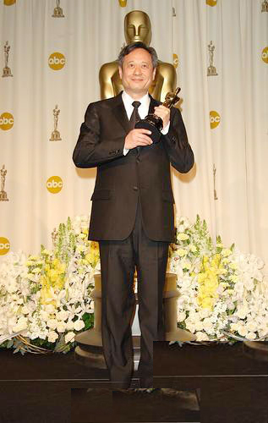
Family of Taiwan-born Ang Lee cheer in Taipei as they watch Lee at the 78th annual Academy Awards on television March6,2006. Lee won the best director Oscar for "Broke back Mountain." (Reuters)
Best director winner Ang Lee poses with his Oscar at the 78th annual Academy Awards in Hollywood, March 5, 2006. Lee won for his work on "Brokeback Mountain." (Reuters)
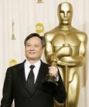
Ang Lee won the Academy Award as best director Sunday for the cowboy romance "Brokeback Mountain," becoming the first Asian to win Hollywood's top honor for filmmakers. Adept at genres from Westerns to historical romance to martial-arts pageants, Lee won his Oscar for a purely American story about two men tragically swept up in a gay romance that they conceal from their families for two decades. "Well, I wish I knew how to quit you," Lee said, smiling and clutching his Oscar. The characters "taught all of us who made `Brokeback Mountain' so much about not only gay men and women whose love is denied by society, but just as important the greatness of love itself." "Brokeback Mountain" earned Lee the best-director honor at key earlier Hollywood awards, including the Directors Guild of America ceremony and the Golden Globes. At 51, Lee scored an Oscar triumph in Hollywood unmatched even by Asia's most acclaimed filmmaker, the late Japanese master Akira Kurosawa, whose career spanned five decades. Kurosawa received an honorary Oscar in 1990, delivered a foreign- language winner with 1975's "Dersu Uzala" and was nominated for best-director for 1985's "Ran," but did not win.
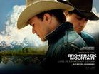
Born in Taiwan, Lee first came to Hollywood's notice with the romantic charmers "The Wedding Banquet" and "Eat Drink Man Woman," which earned back-to-back Oscar nominations for foreign-language film for 1993 and 1994. Since then, Lee has been a chameleon. He made the Jane Austen costume romance "Sense and Sensibility," a best-picture nominee; the stark American drama " The Ice Storm"; the Western "Ride With the Devil"; and the martial-arts epic "Crouching Tiger, Hidden Dragon," which won the Oscar for foreign-language film five years ago. "Crouching Tiger" also was a best-picture and best-director nominee at the Oscars. His "Crouching Tiger" follow-up was the comic-book adaptation "Hulk," an unusual commercial departure for the independent-minded director. Lee joked about his commercial foray at Saturday's Independent Spirit Awards , where "Brokeback Mountain" won best picture and director. "Crouching Tiger" took the same prizes at the Spirit Awards five years earlier. "It's been five years since the last time I stood here. Between `Crouching Tiger, Hidden Dragon' and `Brokeback Mountain,' I made `The Hulk, 'Lee said, drawing a big laugh from the Spirit Awards crowd. "But in my mind I've never left the independent spirit."
- Information about the actor Chow Yun-Fat

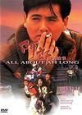
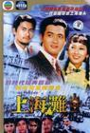
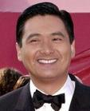

Chow Yun-Fat —— Chinese action film star
Chow Yun-Fat (Chinese: 周润发) (born May 18, 1955 on Lamma Island, Hong Kong) is among a handful of internationally recognized (认可) screen actors that Hong Kong has ever produced, along with Bruce Lee (李小龙) and Jackie Chan (成龙).
Raised on the tiny offshore island of Lamma, Chow spent his childhood (童年) in poverty.
His life started to change as his application (申请) was accepted as an actor-trainee by the local television station, TVB. It didn't take long for Chow to become a household (家喻户晓) name in Hong Kong following his role in the hit series The Bund (Chinese: 上海滩; literally: Shanghai Beach) in 1983.
Although Chow continued his TV success, his ultimate goal was to become a big screen actor. However, his occasional (偶然的) ventures onto the big screens with low-budget movies were disastrous (损失惨重的). Success finally came when he teamed up with a then relatively unknown director John Woo in the 1986 low-budget action movie A Better Tomorrow, which swept the box offices in parts of Asia and established both Chow and Woo as megastars (巨星). Taking the opportunity, Chow quit TV entirely and dedicated himself to making more 'gun fu' movies. His later films include heroic bloodshed movies The Killer (1989) and Hard Boiled (1992), and the romantic An Autumn's Tale (1987). He is, however, best known for playing honorable (可敬的) tough guys, whether cops or criminals. He starred, together with Andy Lau, in the 1989 film God of Gamblers (Du shen), directed by the prolific Wong Jing. The film surprised many and turned out immensely popular, broke Hong Kong's all-time box office record, and spawned a series of gambling (赌博) movies, as well as several more comic sequels starring Stephen Chow.
Being one of the hottest (热门的) screen commodities in Hong Kong, Chow was called upon by Hollywood (好莱坞) in an attempt to duplicate his success on an international scale. His first two films Replacement Killers (1998) and The Corruptor (1999) were box-office sleepers. His next film Anna and the King (1999) (安娜与国王) did better, but the success was mostly credited to actress Jodie Foster.
Ironically, he receded to a supporting role in the film Crouching Tiger, Hidden Dragon (2000) (卧虎藏龙), and it became a winner at both the box office and the Oscars (奥斯卡).
Chow is still waiting for the type of success he once enjoyed in Hong Kong. He once admitted to a Hong Kong reporter (记者) that his ultimate (最终) goal is to win an Oscar as an actor. When asked what if it never comes true, he replied "I would just have to laugh about it..."

