while reading
1. Skim the passage and answer the questions.
- the type of passage:
- the main idea of the passage:
2. Choose the best answer.
1) Why was Li Qiang unsettled for the first few days?
A. Because he was uncertain about what might happen during the future tour.
B. Because he became so excited whenever he thought of the future tour.
C. Because he couldn’t wait to make the future tour.
D. Because he hadn’t decided whether to take the risk of experiencing the future tour.
2) Which of the following statements is not true?
A. Li Qiang got a headache because of lack of fresh air.
B. It took Li Qiang only a short time to arrive in the future.
C. It seemed very difficult for Li Qiang to learn to drive a hovering carriage.
D. There was more oxygen inside Wang Ping’s home than outside.
3) How did Li Qiang get to the year 3008?
A. By airplane. B. By rocket.
C. In a time capsule. D. In a spaceship.
4) From the text we can see that ____.
A. there will not be enough food
B. there will be less oxygen
C. there will be traffic jams
D. living space will be too limited
5) Which is the right order of the incidents happening on Li Qiang’s travel to the year AD 3008?
a. He was transported into the future in a comfortable time capsule.
b. He tried to master a hovering carriage.
c. He won a prize to travel to the year AD 3008.
d. He arrived at Wang Ping’s house and everything in it made him surprised.
e. He put on the mask and felt better in no time.
A. a-b-c-d-e B. b-a-d-c-e
C. c-a-e-b-d D. d-e-b-c-a
3. Read the passage and answer the questions.
1) Why did Li Qiang go into the future?
2) What is a “time lag”?
3) How did he feel when he left his own time?
4) How did he get to the year 3008?
5) What did he notice first when he arrived in AD 3008?
6) What else did he find that was different?
4. The reading passage describes some changes to life in AD 3008. Discuss which changes are good or bad and give your reasons. (p19-2)
5. Read and fill in the blanks.
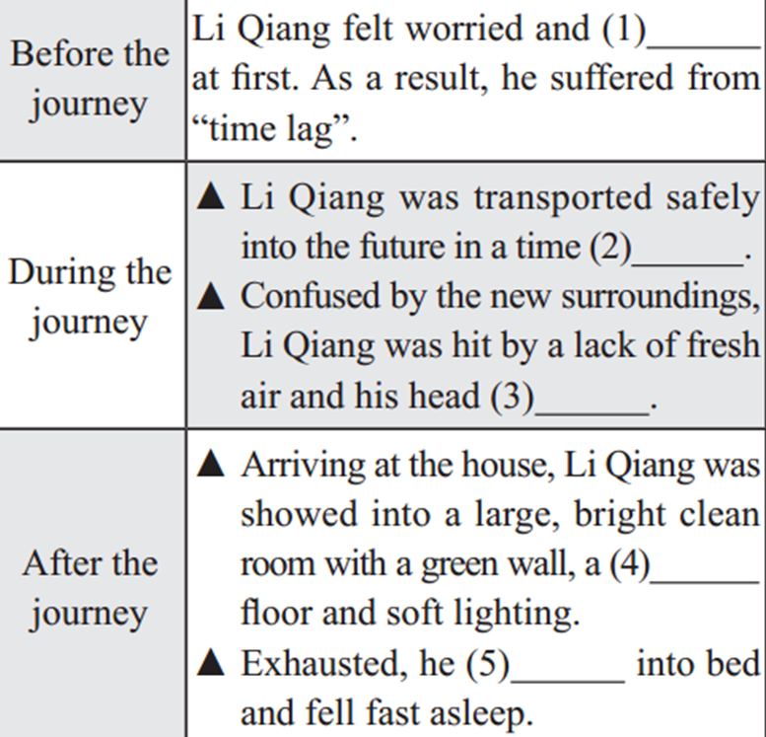
6. Write down the main idea for each paragraph in your own words.(p19-4)
7. Discussion
What’s the style of this passage? What's its feature?
After reading
1. Discussion
What’s the writer’s attitude towards the future, optimistic or pessimistic? How do you know?
2. Fill in the blanks to finish the Summary of the text and then try to retell it.
Li Qiang won a travel to the year AD 3008. He was worried and unsettled at first, so he ____________ “time lag”. To his _____, Li Qiang was transported safely into the future in a time capsule. Confused by the new surroundings, Li Qiang _______ by _________ fresh air and his head ached. Wang Ping, Li Qiang’s guide and friend, gave him a mask, which _______ him feel better. __________ his future hometown, Li Qiang was shown into a large room. Exhausted, he _________ bed and fell fast asleep.

