Before reading
John Snow, a creative London physician, achieved prominence in the mid-nineteenth century as an obstetrician who was among the first to use anesthesia. It was his work in epidemiology, however, which earned him his position as a prototype.
During the 1830s and 1840s, when severe cholera epidemics threatened London, Dr. Snow had become interested in the cause and transmission of the disease. In 1849, he published a brief pamphlet, On the Mode of Communication of Cholera, suggesting that cholera is a contagious disease caused by a poison that reproduces in the human body and is found in the vomitus and stools of cholera patients. He believed that the main, although not only, means of transmission was water contaminated with this poison. This differed from a commonly-held theory that diseases were transmitted by inhalation of vapors. The pamphlet caused no great stir, and Dr. Snow's argument was only one of many hopeful theories proposed during a time when cholera was causing great distress.
Dr. Snow was able to prove his theory in 1854, when another severe epidemic of cholera occurred in London. Through painstaking documentation of cholera cases and correlation of the comparative incidence of cholera among subscribers to the city's two water companies, he showed that cholera occurred much more frequently in customers of one water company, the Southwark and Vauxhall. This company drew its water from the lower Thames, where it had become contaminated with London sewage, whereas the other company obtained water from the upper Thames. Dr. Snow's evidence soon gained many converts.
While reading
1. Choose the best answer.
1) What made John Snow find the cause of cholera？
A. Queen Victoria’s order.
B. His wife’s death.
C. Strong determination, patience and selfishness.
D. Kindness, carefulness and good observation.
2) What’s the main idea of the passage?
A. How John Snow found the cause of cholera and defeated it.
B. The cause of cholera was polluted water.
C. The source of all drinking water should be examined.
D. John Snow was a well-known doctor in London.
2. To prove a new scientific idea, seven stages are needed. Read the text (P2-3) carefully and fill in the blanks.
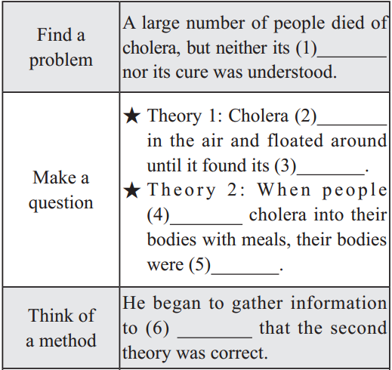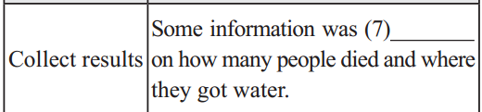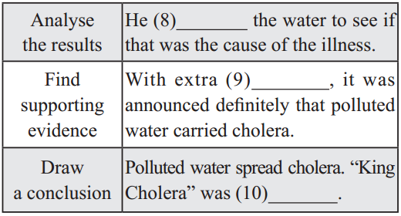
3. Read the passage and number these events in the order that they happened. (p3-1)
__ John Snow began to test two theories.
__ An outbreak of cholera hit London in 1854.
__ John Snow marked the deaths on a map.
__ He announced that the water carried the disease.
__ John Snow investigated two streets where the outbreak was very severe.
__ King Cholera was defeated.
__ He found that most of the deaths were near a water pump.
__ He had the handle removed from the water pump.
4. Answer these questions. (p3-2)
1. John Snow believed Idea 2 was right. How did he finally prove it?
2. Do you think John Snow would have solved this problem without the map? Give a reason.
3. Cholera was a 19th century disease. What disease do you think is similar to cholera today? Why?
5. Discussion
What’s the style of this passage? What’s the feature of it?
After reading
1. Discussion
How to protect yourselves from infectious diseases such as cholera and bird flu?
2. Retell the passage according to the stages for scientific research in Pre-reading.
Find a problem
John Snow wanted to _____________ of Cholera.
Make a question
He believed that people became ill after _________________.
Think of a method
He used the next __________________ to test his idea.
Collect results
He studied a small area of houses which got their water from the same _____.
Analyse the results
Many people in the area died. John Snow showed that this was because the water in the pump _____________.
Find supporting evidence
A woman and her daughter who lived in another part of London _________ cholera after __________________________________.
Draw a conclusion
He showed that cholera could be defeated if people drank clean water.
3. read, think & answer
Cholera affects an estimated 3–5 million people worldwide and causes 58,000–130,000 deaths a year as of 2010. While it is currently classified as a pandemic, it is rare in the developed world. Areas with an ongoing risk of disease include Africa and south-east Asia. While the risk of death among those affected is usually less than 5%, it may be as high as 50% among some groups who do not have access to treatment.
Why is Cholera or some other pandemics rare in the developed world?

