Section 2: Background information about Fine Arts

1. Calligraphy, the Soul of Chinese Fine Arts
Few nations in the world have calligraphy as a form of art. In China, calligraphy has a long history, is popular among its people, and has maintained a close relationship with Chinese cultural development.
Calligraphy looks simple. It seems as if anyone that can write Chinese characters on xuan paper (a high quality rice paper made for traditional Chinese painting and calligraphy) with a writing brush can become a calligrapher. But that perception is not true. Calligraphy is a form of art that involves a great deal of theory and requires many skills; so there are not many calligraphers that have reached the highest realm of calligraphy.
Calligraphy is a constructive art. The calligrapher creates his work with his handling of the ink and the writing brush. The black strokes and white space on the paper create a sense of beauty. For calligraphers, the writing brush is the extension of their fingers: the rhythm and strength of their writings are all controlled by their moods, and their calligraphy works are expressions of their sensibilities. Calligraphy is an expressive art. In a work of calligraphy, we can see the character, education level and experience of the calligrapher. Calligraphy is a practical art form. It can be used to write inscriptions on paper or inscribe wooden plaques or stone tablets. Its many attributes show us that calligraphy is a comprehensive art, expressing the subjective feeling of the writers.
Calligraphy manifests the basic characteristics of all Chinese arts. In Western fine arts, architecture and sculpture are the basis of the other formative, or visual, arts. In China, however, calligraphy and painting are leaders of the other art forms. When calligraphy and painting are mentioned together, calligraphy always comes before painting, although calligraphy is closely associated with traditional Chinese painting. The theories about handling brush and ink are similar in calligraphy writing and traditional Chinese picture drawing. Ancient Chinese sculpture was also influenced by calligraphy in that its defining characteristic lay in the composition of lines, and its decorative function is derived from the zhuan (seal characters) and li (official characters) scripts in Chinese calligraphy. Chinese architecture adheres to the calligraphic rules of symmetry and balance, and the design of Chinese gardens, pavilions and temples all reflect the structural rules and rhythms of calligraphy. The development of Chinese handicrafts and folk arts, too, has been influenced by calligraphy to some extent. Thus we can see that calligraphy is the soul of Chinese fine arts.
2. History of Chinese painting
Chinese traditional painting dates back to the Neolithic Age about 6,000 years ago. The excavated colored pottery with painted human faces, fish, deer and frogs indicates that the Chinese began painting as far back as the Neolithic Age. Over the centuries, the growth of Chinese painting inevitably reflected the change of time and social conditions.
According to Chinese tradition, painting is a delineating form of brush lines. In great paintings, the mark of the brush stroke remains invisible, while the structuring action of the strokes goes on. Chinese painting is an important part of Chinese Culture. It has a long history.
Chinese painting originated in the late Zhou Dynasty, and developed in the Han Dynasty. In Tang Dynasty (618-906), the painting has the first golden age. In Song Dynasty (960-1279), there was the first royal painting academy. Even the emperor (Huizong) is also a famous painter. The bird-and-flower painting has since been a popular theme. The Yuan (1279-1368), Ming (1368-1644), and Qing (1644-1912) Dynasties: the painting was developed with poesy and music. In the 20th Century to now, the painting developed with modernize and adopt Western styles and traditions.
An important part of the country's cultural heritage, the traditional Chinese painting is distinguished from Western pigments art in that it is executed on Xuan paper (or silk) with the Chinese brush, Chinese ink and mineral and vegetable. To attain proficiency in this branch of art calls for assiduous exercise, a good control of the brush, and a feel and knowledge of the qualities of Xuan paper and Chinese ink. Before setting a brush to paper, the painter must conceive a well-composed draft in his mind, drawing on his imagination and store of experience, Once he starts to paint, he will normally have to complete the work at one go, denied the possibility of any alteration of wrong strokes.
Philosophy and symbolism play a large part in Chinese art. Each painting has its own inner symbolic meanings and beliefs in nature. To understand the philosophy behind it, one needs to be familiar with the Chinese belief in the concept of Yin (feminine) and Yang (masculine). Chinese believe that the Yin and Yang aspects of the universe oppose each other but eventually equalize each other out; to result in balance, harmony and continuity. The artist expresses these beliefs in his painting by his choice of subject matter, the simplicity of the composition and the manner of execution. The space around the subject is as important as the brush strokes. The spaces add meaning to the painting. In landscape paintings, the spaces may be part of the image rather than merely the background.

3. The three most popular types of subject in Chinese painting
Landscape Painting
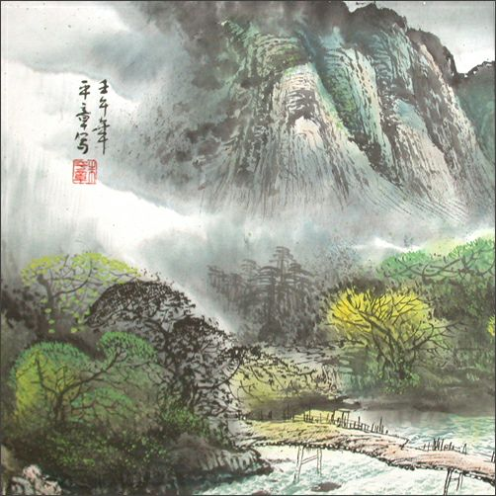
Landscape is considered the most intellectual subject in Chinese painting, on par with calligraphy. This may be due to the complex philosophy of the struggles and triumphs of mankind behind landscape painting. The earliest paintings by scholars and officials were landscapes. Prior to this, the intellectuals only did calligraphy; painting was considered a low class preoccupation.
To understand the unusual aspects of the traditional landscape, it is essential to appreciate the importance of heaven and nature compared with the relative unimportance of man. In the midst of mountain ranges and plummeting waterfalls, man's vulnerable position in nature is depicted by human figures, their homes and objects dwarfed by the towering natural elements.
Traditional landscapes consist of six elements; rocks, trees, mountains, waterfalls/ rivers, people and buildings. The Chinese word for landscape is "Shan-Shui", literally means "mountain-water".

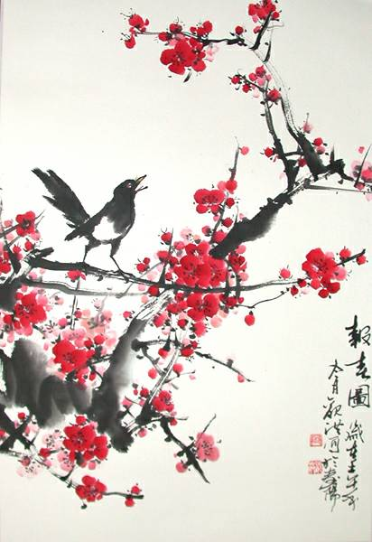
Flowers and Plants
The four popular plants/ flowers in Chinese painting are:
Chinese Orchid- Spring: The Chinese orchid grows near wet rocks, marshes or stream. It is different in appearance to the orchids as known in the West. The blossoms of Chinese orchid represent modesty and purity, characteristics admired in traditional Chinese culture. The blossoms are protected and dominated by the much larger robust leaves, yet the blossom outshines them with its quite beauty.
Bamboo – Summer: The bamboo symbolizes strength and the spirit to endure adverse circumstances. It bends with the wind and snow but it does not break, it returns to its upright position when the wind and snow ceases. The bamboo, therefore, also symbolizes flexibility but with integrity. The bamboo it's one of the most difficult subjects to paint. A painting of bamboo is essentially a painting of lines founded on calligraphy.
Chrysanthemum – Autumn: Being one of the year's last flowers and because it can survive in cold conditions that would kill most plants, it symbolizes courage and sturdiness.
Plum Blossom – Winter: The plum tree symbolizes hope and continuity of life. Plum tree is admired for its ability to reform itself to with stand adverse conditions. i.e. it manifests an appearance of hardness during winter. However, when spring comes, it nourishes itself and develops into a beautiful tree in spring. Plum Blossom is the national emblem for Chinese New Year.
These four plants symbolize the four seasons, also known as the "four Gentlemen", as each characteristic they represent were the qualities ideal gentlemen should have.
Other popular plants in traditional Chinese painting: Lotus- represents stately beauty. Peony - queen of the flowers. It signifies wealth and nobility. Camellia- symbolizes serenity.

Birds and Animals
Birds are used extensively as subjects in Chinese painting to introduce exotic interest and sometimes humor to the painting. They are usually shown with flowers, trees, fruit and other animals. To add life to the subject, painters nearly always paint the birds as though they are about
to take off or if several are painted, shown them in different altitudes. Different birds symbolize different qualities, and the way they are painted also signifies different theme.
Popular birds for painters include: Ducks- especially the Mandarin variety which is a symbol of marriage and therefore, often painted in pairs or groups. Sparrows- signifies a sense of mischief and squabbling. Cranes- signifies a promising future.
4. Forms of Mount
Unlike Western paintings, which are universally framed, there are many ways to mount and present Chinese paintings. Traditionally, Chinese painting was not meant to be permanent fixtures. They were considered to be valuable heirlooms and as such, had to be in a form that can be easily put away or transported. The three most common methods of mounting Chinese paintings were:
Vertical Hanging Scroll: This method of mounting was most probably derived from ancient Buddhist temple paintings that were long banners of silk. In vertical scroll, the painting is mounted on silk or paper malted with strips of silk brocade. The borders are specially proportioned to leave more space at the top, indicating heaven, and less space at the bottom, indicating earth. A flat piece of wood is added at the top of the scroll with a ribbon for hanging. The bottom of the scroll is weighed down by a round wooden stick, which helps the painting to hang flat on the wall.
Horizontal Scroll: Horizontal scrolls are normally no more than 19 inches in height. Usually, the painting tells a story with each section leading to the next. Each section represents a different time of the story. This technique is unique to eastern paintings. Horizontal scroll paintings are viewed from right to left. The borders are matted and the top and bottom are normally larger than the sides.
Album: Albums are usually used for mounting small paintings that have been obtained from fragments (fan shape being one of most popular shapes) of larger paintings that have been damaged. The custom of making albums from fragments of painting began much later than vertical and horizontal scrolls, in the Sung Dynasty (9th -12th century AD). The second type of album where the paintings for mounting were specifically painted for mounting in albums developed in the Yuan Dynasty (late 12th-13th century AD). These paintings were typically painted in sets of 6, 8, 10, or more.
5．Seals and Colophons (Written Dedication)
After completing a painting, the artist often writes a poem or his thoughts about the subject of his painting at a strategic place on the painting. Under this calligraphy, the artist stamps one or more of his seals identifying himself. The seal may bear his name, his family name, his artistic name or other wordings or symbols that identify him. However, a teacher often put his own seal onto student's work to indicate approval. This is why it is difficult to authenticate many of the old paintings. In ancient time, collectors of art also had their own seals. They would stamp paintings they own with their seals. The owner's seal is sometimes used to verify the artist's identity and to determine how important the artist was at that time. Therefore, an owner's seal on painting may enhance the status and value of a painting.
A colophon is a dedication by the artist's friends or owner of the painting to indicate their approval of the composition.
6．Classification of Chinese Traditional Painting
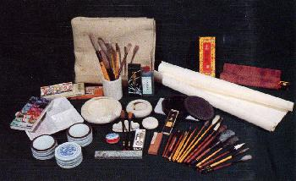
Traditional Chinese painting has its special materials and tools, consisting of brushes, ink and pigments, xuan paper, silk and various kinds of ink slabs. Based on different classification standards, Chinese traditional painting can be divided into several groups, as follows:
Techniques: According to painting techniques, Chinese painting can be divided into two styles: xieyi style and gongbi style. Xieyi, or freehand, is marked by exaggerated forms and freehand brushwork. Gongbi, or meticulous, is characterized by close attention to detail and fine brushwork. Freehand painting generalizes shapes and displays rich brushwork and ink techniques.
Forms: The principal forms of traditional Chinese painting are the hanging scroll, album of paintings, fan surface and long horizontal scroll. Hanging scrolls are both horizontal and vertical, usually mounted and hung on the wall. In an album of paintings the artist paints on a certain size of xuan paper and then binds a number of paintings into an album, which is convenient for storage. Folding fans and round fans made of bamboo strips with painted paper or silk pasted on the frame. The long, horizontal scroll is also called a hand scroll and is usually less than 50 centimeters high but maybe up to 100 meters long.
Subjects: Traditional Chinese paintings can be classified as figure paintings, landscapes and flower-and-bird paintings. Landscapes represent a major category in traditional Chinese painting, mainly depicting the natural scenery of mountains and rivers.
The range of subject matter in figure painting was extended far beyond religious themes during the Song Dynasty (960-1127). Landscape painting had already established itself as an independent form of expression by the fourth century and gradually branched out into the two separate styles: blue-and-green landscapes using bright blue, green and red pigments; and ink-and-wash landscapes relied on vivid brushwork and inks. Flower-and-bird painting deviated from decorative art to form its own independent genre around the ninth century.
Traditional Chinese painting, poetry, calligraphy, painting and seal engraving are necessary components that supplement and enrich one another. "Painting in poetry and poetry in painting" has been a criterion for excellent works. Inscriptions and seal impressions help explain the painter's ideas and sentiments and also add beauty to the painting.

