Art Attack 1
A heap of techniques to help you develop your own artistic style.
You will need:
- Paper
- Paint
- Paintbrush

 | 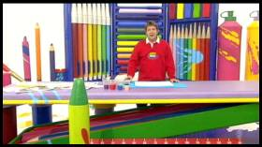 |  | If you want to be a professional artist, or study art, it's a good idea to try to develop your own style.

 | 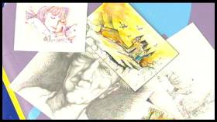 |  | All these artists each have their own style.  Because of this, it makes it easy to tell their work from everyone else's.

 | 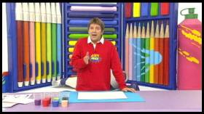 |  | So if you don't have your own style - invent one!  It's a good idea to create some style rules - little rules that make your style different. For instance, you might decide to only ever use green dots to create your pictures!

 | 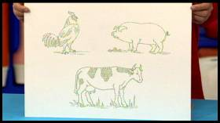 |  | It might sound silly - but it can work.  Here's a picture drawn only using green dots!

 | 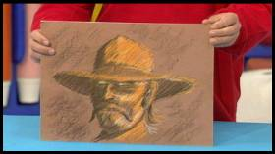 |  | Here's another distinctive style.  This picture has been created out of coloured pastel scribble.

 | 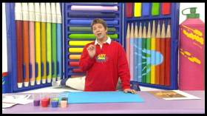 |  | If you want to develop your own style, you just need to give yourself some quick rules.  For example - "I can't draw with a pencil - I must draw with a brush and paint!"

 | 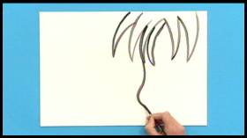 |  | Let's see what happens.  The lines come out quite thick, which means Neil has to draw big and bold.

 | 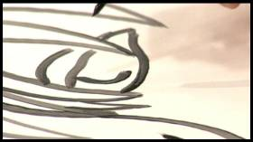 |  | Doing detail is quite difficult, so he's forced into a simple cartoon style.

 | 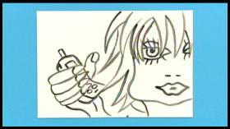 |  | The "only draw using a brush" rule makes him draw very big and close-up.

 | 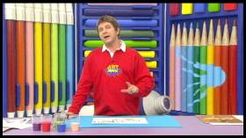 |  | It's different!

 | 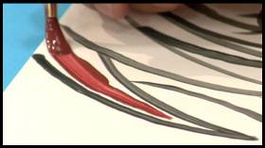 |  | For another style rule - how about "I must not touch the black lines when I'm colouring in"?

 | 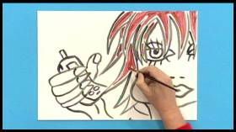 |  | Following this rule creates a white margin inside the black lines.

 | 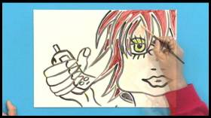 |  | This creates a certain effect.  This is the great thing about inventing a style with its own rules - you never know how it's going to come out until you've tried it.

 | 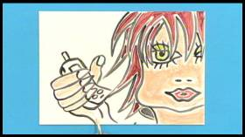 |  | This style is quite modern and graphical - good for fashion or pop stuff, like posters or magazines.

 | 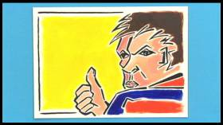 |  | It's as easy as that. Make up a few rules which force you into creating a certain effect - a style.  And when you've got a style that you're happy with, you can use it for all of your pictures.  Try it yourself!

Art Attack 2
Why not have a go at making pictures from curled up strips of paper?
You will need:
- coloured paper
- a paintbrush

 | 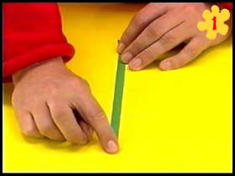 |  | Take a piece of coloured paper or thin card, and cut a thin strip that’s about 1cm wide.

 | 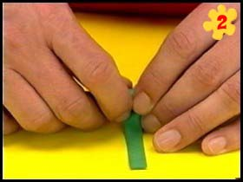 |  | Then take a paintbrush, and tightly roll the strip around the handle, from one end to the other.

 | 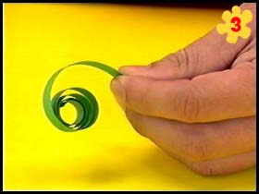 |  | Once you’ve rolled it all up, remove the paintbrush and let the curled paper spring out.  You now have a tightly curled spiral of paper.

 | 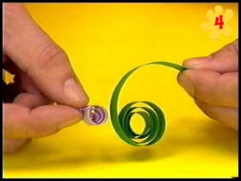 |  | You can repeat this technique with different colours of paper, and different lengths.  Here you can see a very short piece of rolled up purple paper.

 | 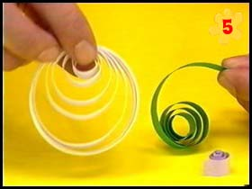 |  | Using a longer strip this time, you get a large white spiral.  This technique is called "quilling".

 | 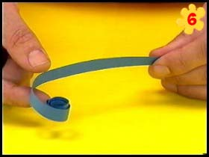 |  | Here's a blue strip of paper. Instead of being rolled all the way to the end, it's been stopped about half-way.  The result is a strip that’s straight, with a small curl at one end.

 | 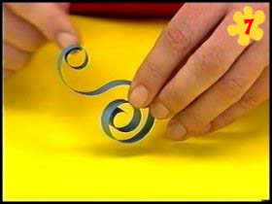 |  | Another technique is to curl both ends of the strip.  Just go to the other end, and start rolling it back on itself around a paintbrush.

 | 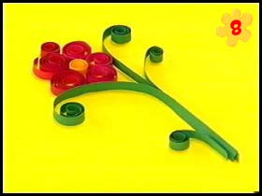 |  | So now you that you can curl the paper, it's very easy to start making pictures with it!  Here's a flower, for example.  Just put all your curls in the place you want, and then glue them to the paper.  Try it yourself!

Art Attack 3
Are you one of those people who really likes dogs, but have a bit of a problem drawing them? Well - what you need is a guide dog...
You will need:
- paper
- pencil
- paintbrush
- paint
- eraser

 | 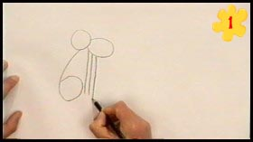 |  | The first thing that you draw is this... a round head, a pointy snout, and then the numbers 6, 1, 1, 1.  This is your "guide dog" - and this is nice and easy!

 | 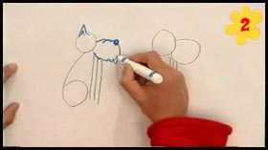 |  | Use that as a guide to drawing your dog.  Now you can put in your dog's features - eyes, snout, ears and the rest of the head.

 | 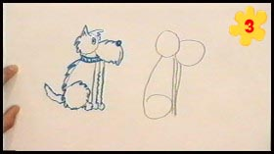 |  | Just carry on with the rest of the dog's features - collar, body shape along the 6, and then use the 1's for the guide to drawing the legs.

 | 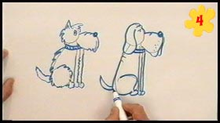 |  | You can use this guide dog to make any dog you like, depending on what size the numbers 6 and 1 are, and how close together they are.

 | 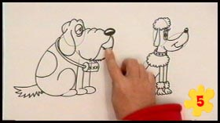 |  | Here are some more dogs based on this "6111" pattern.  And once you've done your dog, rub out the guidelines, and then you can paint them in...

 | 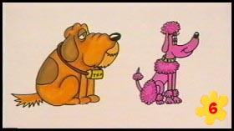 |  | ...like these ones here.  An easy but great way of drawing dogs.  Try it yourself!

