Part 1 Teaching Design
第一部分 教学设计
Period 1 A sample lesson plan for reading
(A NIGHT THE EARTH DIDN’T SLEEP)
Introduction
In this period, after the warming up, students will first be guided to share their views about earthquake. Then they will be helped to read a narration（记叙文）entitled A NIGHT THE EARTH DIDN’T SLEEP. It’s about Tangshan Earthquake which happened in 1976.
Summary of the text and analysis of the text organization is offered for teachers’ reference. Computer and overhead projector may be used to aid the teaching and learning.
Objectives

To help students learn to read about past experiences

To help students better understand “earthquake”

To help students use some important words and expressions

To help students identify examples of the attributive clause in the text
Focus
Words | burst, ruin, injure, destroy, shock, rescue, trap, burry, damage, frighten, judge, express
Expressions | right away, as if, at an end, in ruins, dig out, a number of
Patterns | But the one million people of the city, who thought little of these events, were asleep as usual that night.  It seemed as if the world was at an end! 似乎世界的末日到来了。  All hope was not lost. 并非所有的希望都失去了。  Slowly, the city began to breathe again.慢慢地，这个城市又开始呼吸了。
Aids
Multimedia facilities, tape-recorder, photos, diagrams
Procedure
1. Warming up
⑴Warming up by looking and saying
Good morning class. Have you ever experienced any natural disasters? Look at the pictures. Can you name all the disasters?
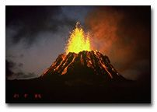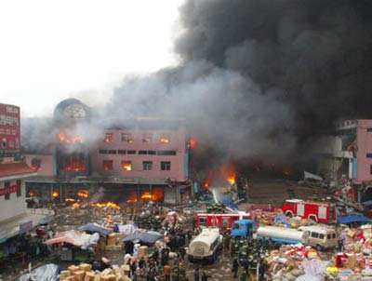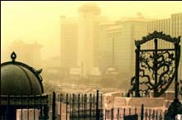
volcano fire sandstorm
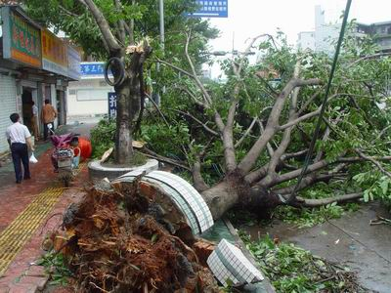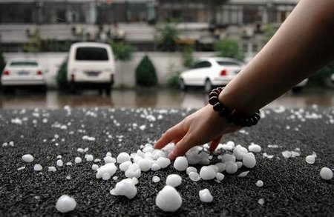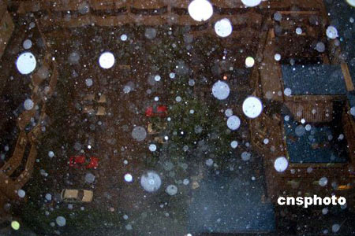
typhoon hailstone thunderstorm
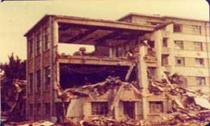
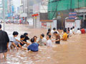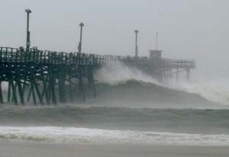
flood hurricane earthquake
Have you ever experienced an earthquake? Can you describe how terrible an earthquake is?
(The earth is shaking; all the buildings will fall down; many people will die; many children will become orphans.)
⑵Warming up by discussing
Hello, class. As we all know, earthquakes are disasters to everyone. But can we avoid or at least reduce the loss caused by earthquakes? Can we foretell earthquakes? Now let’s think and decide what may happen before a big earthquake.
WARNING SIGNS WHEN AN EARTHQUAKE IS ABOUT TO HIT
- Thermal precursor: A few months before the occurrence of an earthquake the average temperature of the area keeps increasing.
- Water precursor: There is a sudden rise or fall in water level in the wells. It could be as high as one metre.
- Seismo-electromagnetic precursor: This is a very reliable precursor. It occurs and is exhibited about 10 to 20 hours before the quake.
- Animal precursor: It is seen that 10 to 20 hours before the occurrence of an earthquake, the entire animal kingdom becomes highly disturbed and restless.
- Human precursor: Doctors and nurses observe that some sensitive patients in hospitals become highly disturbed.
- The best indicator is the number of child deliveries in any hospital.
(3) Warming up by talking about Tangshan / California Earthquake
Today we shall start Unit 4 Earthquake. But first I’d like you to learn about the two famous earthquakes: The Tangshan Earthquake and The California Earthquake.
At 3:42 a.m. on July 28, 1976, a magnitude 7.8 earthquake hit the sleeping city of Tangshan, in northeastern China. The very large earthquake, striking an area where it was totally unexpected, wiped out the city of Tangshan and killed over 240,000 people - making it the deadliest earthquake of the twentieth century.
The California earthquake of April 18, 1906 is one of the most significant earthquakes of all time.
Deaths: > 3,000
Injuries: ~225,000
Property Damage: $ 400,000,000 in 1906 $$$
2. Pre-reading by talking and sharing
Before an earthquake comes various signs could be seen. What are they?
- Cows, pigs and dogs become too nervous too eat. ]
- The mice will run out of the fields looking for places to hide.
- The water in the wells will rise and fall.
- Walls of the wells in village will have deep cracks.
- There will be bright light in the sky.
Villagers witness pre-earthquake warning signs
Villagers say they saw warning signs before the earthquake hit Chifeng city last Saturday.
Hours before the quake, villagers said they saw water flow over for over two meters from a river that had been dry for years.
About 10 hours before the quake occurred, hand phone signals were stopped for quite some time in Linxi county seat, which is 140 kilometers from the center of the earthquake. "Days before the earthquake, two pigs appeared nervous in the pen and tried to run out. " said Li Xiaohua, a villager in Gubeikou Village.
A woman village folk recalled that she happened to see crowds of sparrows
and swallows bumping into walls seemed unable to find direction during flight.
3. Listening and fast reading
Now let’s come to the text “A NIGHT THE EARTH DIDN’T SLEEP” and see what it tells us.
Please listen to the text and get the general idea of the passage. You should pay attention to the first sentences of each paragraph. In what order is the text written? (The text is written in a time order. The text tells us something that happened before the earthquake, during the earthquake and after the earthquake.)
4. Reading and underlining
Next you are to read and underline all the useful expressions or collocations in the passage. Copy them in your notebook after class as homework.
Collocations from A NIGHT THE EARTH DIDN’T SLEEP
a smelly gas, in the farmyards, think little of sth., as usual, it seemed that, at an end,
thirty meters wide, cut across, in ruins, be injury, the number of, blow away, sth. be not safe
for…, tens of thousands of, give milk, half a million, instead of, be shocked, be trapped under
the ruins, fall down, all…is/was not…, dig out, the dead, to the north of, coal mines
5. Reading for the organization of the text and retell the text
Read the text for the outline of it and retell the story in your own words with the help of the outline.
Type of writing and summary of the text
Type of writing | This is a piece of descriptive writing
Main idea of the  passage | The article describes the cause, the course and the result of Tang Shan earthquake in 1976. It shows us the terrible image of earthquake. At the same time it hits us that we must realize that we can do something to minimize the damage caused by earthquake.
Topic sentence  of 1st paragraph | Strange things were happening in the countryside in northeast  Hebei.
Topic sentence  of 2nd paragraph | Everything began to shake and it seemed that the world was at  an end.
Topic sentence  of 3rd paragraph | Everywhere they looked nearly everything was destroyed.
Topic sentence  of 4th paragraph | All hope was not lost.
A retold version of the text: See II in Part 3 Teaching Assessment
6. Making a text structure analysis
Read the text “A NIGHT THE EARTH DIDN’T SLEEP”, and then complete the following chart.
Time/ order | What happened | Result
three days before the earthquake  at about 3:00 am | saw: cracks  water in the wells—rose and fell,  animals—too nervous , hide  fish jumped out of bowls & ponds  bright light in the sky  water pipes—cracked and burst  heard: sound of planes  smelt: smelly gas in the cracks of the wells | People thought little of  the events and went to  bed as usual
at 3:42 am | felt: everything shook  one-third nation felt it  heard in Beijing 100 kilometers away  a huge crack cut across houses,  roads…  saw: steam burst from holes in the ground  hard hills of rock-rivers of dirt  city lay in ruins | 4 400,000 people  killed/injured  75% factories  90% home gone  bricks covered  dams/bridges fell  not safe railway tracks  useless  cows never milk  pigs/chickens died  wells filled with sand  rescue workers and doctors trapped under the ruins  buildings fell down  water/food/electricity  hard to get
after that | hope not lost  army sent 150,000 soldiers  workers built shelters for survivors  fresh water was taken to the city | the city began to breathe  again
7. Discussing the writing style
As you have understood the general idea of the text, I still put more questions to you.
●From whose point of view are events described? How do you know? (A writer who didn’t see the quake uses the third person “they” when he writes.)
●Why do you think the writer chose to express her feelings about the quake rather than simply report what happened? (Although the writer was not there he felt sad for the people of Tang Shan. He knows that giving some feelings will make the reading more interesting.)
●Why is the title “A NIGHT THE EARTH DIDN’T SLEEP”? (As usual, night is the time to sleep, and night should be quiet and safe. But that night everything changed. The writer used it as a title to show how terrible and how unusual that night is.)
8. Closing down by reading a prose about an earthquake
To end this period I am going to give you the following article to read.
Father and Son in An Earthquake
No matter what happens, I’ll always be there for you!——
In 1989 an 8.2 earthquake almost flattened America, killing over 30,000 people in less than four minutes. In the midst of utter devastation and chaos, a father left his wife safely at home and rushed to the school where his son was supposed to be, only to discover that the building was as flat as a pancake.
After the unforgettably initial shock, he remembered the promise he had made to his son: “No matter what, I’ll always be there for you!” And tears began to fill his eyes. As he looked at the pile of ruins that once was the school, it looked hopeless, but he kept remembering his commitment to his son.
He began to direct his attention towards where he walked his son to class at school each morning. Remembering his son s classroom would be in the back right corner of the building; he rushed there and started digging through the ruins.
As he was digging, other helpless parents arrived, clutching their hearts, saying: “My son!" "My daughter!” Other well meaning parents tried to pull him off what was left of the school, saying: “It s too late! They re all dead! You can t help! Go home! Come on, face reality, there s nothing you can do!”
To each parent he responded with one line: “Are you going to help me now?” And then he continued to dig for his son, stone by stone. The fire chief showed up and tried to pull him off the school s ruins saying, “Fires are breaking out, explosions are happening everywhere. You re in danger. We’ll take care of it. Go home.” To which this loving, caring American father asked, “Are you going to help me now?”
The police came and said, “You re angry, anxious and it s over. You re endangering others. Go home. We’ll handle it!” To which he replied, “Are you going to help me now?” No one helped.
Courageously he went on alone because he needed to know for himself: “Is my boy alive or is he dead?”He dug for eight hours...12 hours...24 hours...36 hours...then, in the 38th hour, he pulled back a large stone and heard his son s voice. He screamed his son s name, “ARMAND!” He heard back, “Dad!?! It s me, Dad! I told the other kids not to worry. I told them that if you were alive, you d save me and when you saved me, they d be saved. You promised, No matter what happens, I’ll always be there for you! You did it, Dad!” “What s going on in there? How is it?” the father asked.
“There are 14 of us left out of 33, Dad. We re scared, hungry, thirsty and thankful you re here. When the building collapsed, it made a triangle, and it saved us.”
“Come out, boy!”
“No, Dad! Let the other kids out first, because I know you’ll get me! No matter what happens, I know you’ll always be there for me!”

