正向：2V
I(mA) | 1.9999 | 1.8250 | 1.657 | 1.3720 | 0.9660 | 0.6507 | 0.4499 | 0.3265 | 0.2358
V(V) | 0.7468 | 0.7443 | 0.7417 | 0.7364 | 0.7266 | 0.7160 | 0.7051 | 0.6966 | 0.6868
I(mA) | 0.1685 | 0.1031 | 0.0840 | 0.0598 | 0.0309 | 0.0165 | 0.0138 | 0.0092 | 0.0071
V(V) | 0.6670 | 0.6627 | 0.6568 | 0.6460 | 0.6255 | 0.6076 | 0.5978 | 0.5863 | 0.5753
I(mA) | 0.0056 | 0.0038 | 0.0031 | 0.0023 | 0.0017 | 0.0008
V(V) | 0.5681 | 0.5533 | 0.5451 | 0.5350 | 0.5234 | 0.4951
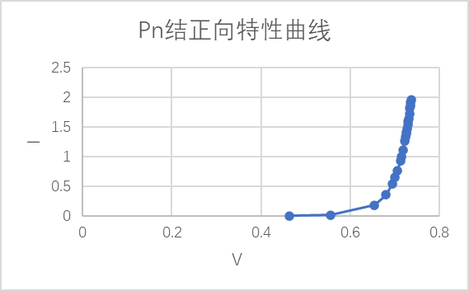
反向：20V
I(mA) | 1.9999 | 1.9871 | 1.3895 | 1.8346 | 1.6322 | 1.4299 | 1.1800 | 1.0154 | 0.8012
V(V) | 2.865 | 2.862 | 2.734 | 2.832 | 2.791 | 2.744 | 2.676 | 2.622 | 2.545
I(mA) | 0.6017 | 0.4052 | 0.2027 | 0.1059 | 0.0694 | 0.0320 | 0.0155 | 0.0113 | 0.0093
V(V) | 2.477 | 2.328 | 2.132 | 1.956 | 1.860 | 1.667 | 1.517 | 1.478 | 1.416
I(mA) | 0.0050 | 0.0040 | 0.0028 | 0.0021 | 0.0016
V(V) | 1.319 | 1.289 | 1.212 | 1.157 | 1.105
