X/格 | H(A/m) | Y/格 | B/mT
-420 | 1050000 | 4 | 46.68
-360 | -900000 | 20 | 233.4
-200 | -500000 | 38 | 443.36
-260 | -650000 | 32 | 373.33
-140 | -350000 | 44 | 513.48
-200 | -500000 | 40 | 468.8
920 | 2300000 | 74 | 863.58
-40 | -100000 | 50 | 583.5
20 | 50000 | 52 | 606.84
120 | 300000 | 56 | 653.52
180 | 450000 | 58 | 676.86
260 | 650000 | 62 | 723.54
400 | 1000000 | 64 | 746.88
500 | 1250000 | 68 | 793.56
680 | 1700000 | 70 | 816.9
800 | 2000000 | 74 | 863.58
880 | 2200000 | 74 | 863.58
-500 | -1250000 | -72 | -864.24
1000 | 2500000 | 76 | 886.92
1200 | 3000000 | 80 | 933.6
-600 | -1500000 | -76 | -886.92
-300 | -750000 | -66 | -770.22
-380 | -950000 | -68 | -793.56
-260 | -650000 | -66 | -770.22
-180 | -450000 | -62 | -723.54
-100 | -250000 | -60 | -700.2
-40 | -100000 | -56 | -653.52
0 | 0 | -56 | -653.52
100 | 250000 | -50 | -583.5
240 | 600000 | -38 | -443.46

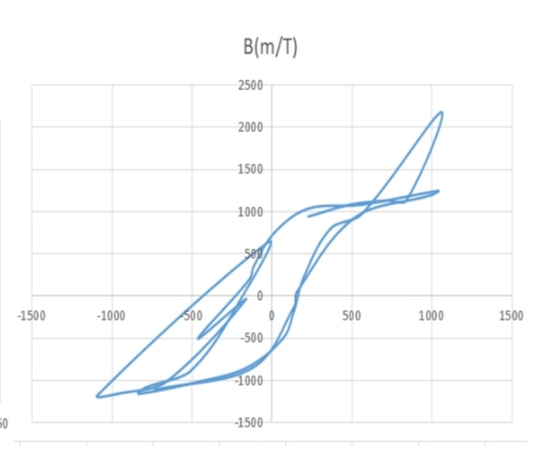

X/格 | H(A/m) | Y/格 | B/mT
2140 | 5350000 | 90 | 1050.3
2000 | 5000000 | 90 | 1050.3
1860 | 4650000 | 86 | 1003.62
1740 | 4350000 | 84 | 980.28
1640 | 4150000 | 84 | 980.28
1540 | 3850000 | 80 | 933.6
1110 | 2775000 | 72 | 840.24
820 | 2050000 | 62 | 723.54
480 | 1200000 | 42 | 480.14
360 | 900000 | 26 | 303.42
0 | 0 | 18 | 210.06
420 | 1050000 | 36 | 420.12
460 | 1150000 | 38 | 443.46
520 | 1300000 | 44 | 513.48
640 | 1600000 | 54 | 630.18
