单摆实验数据记录： 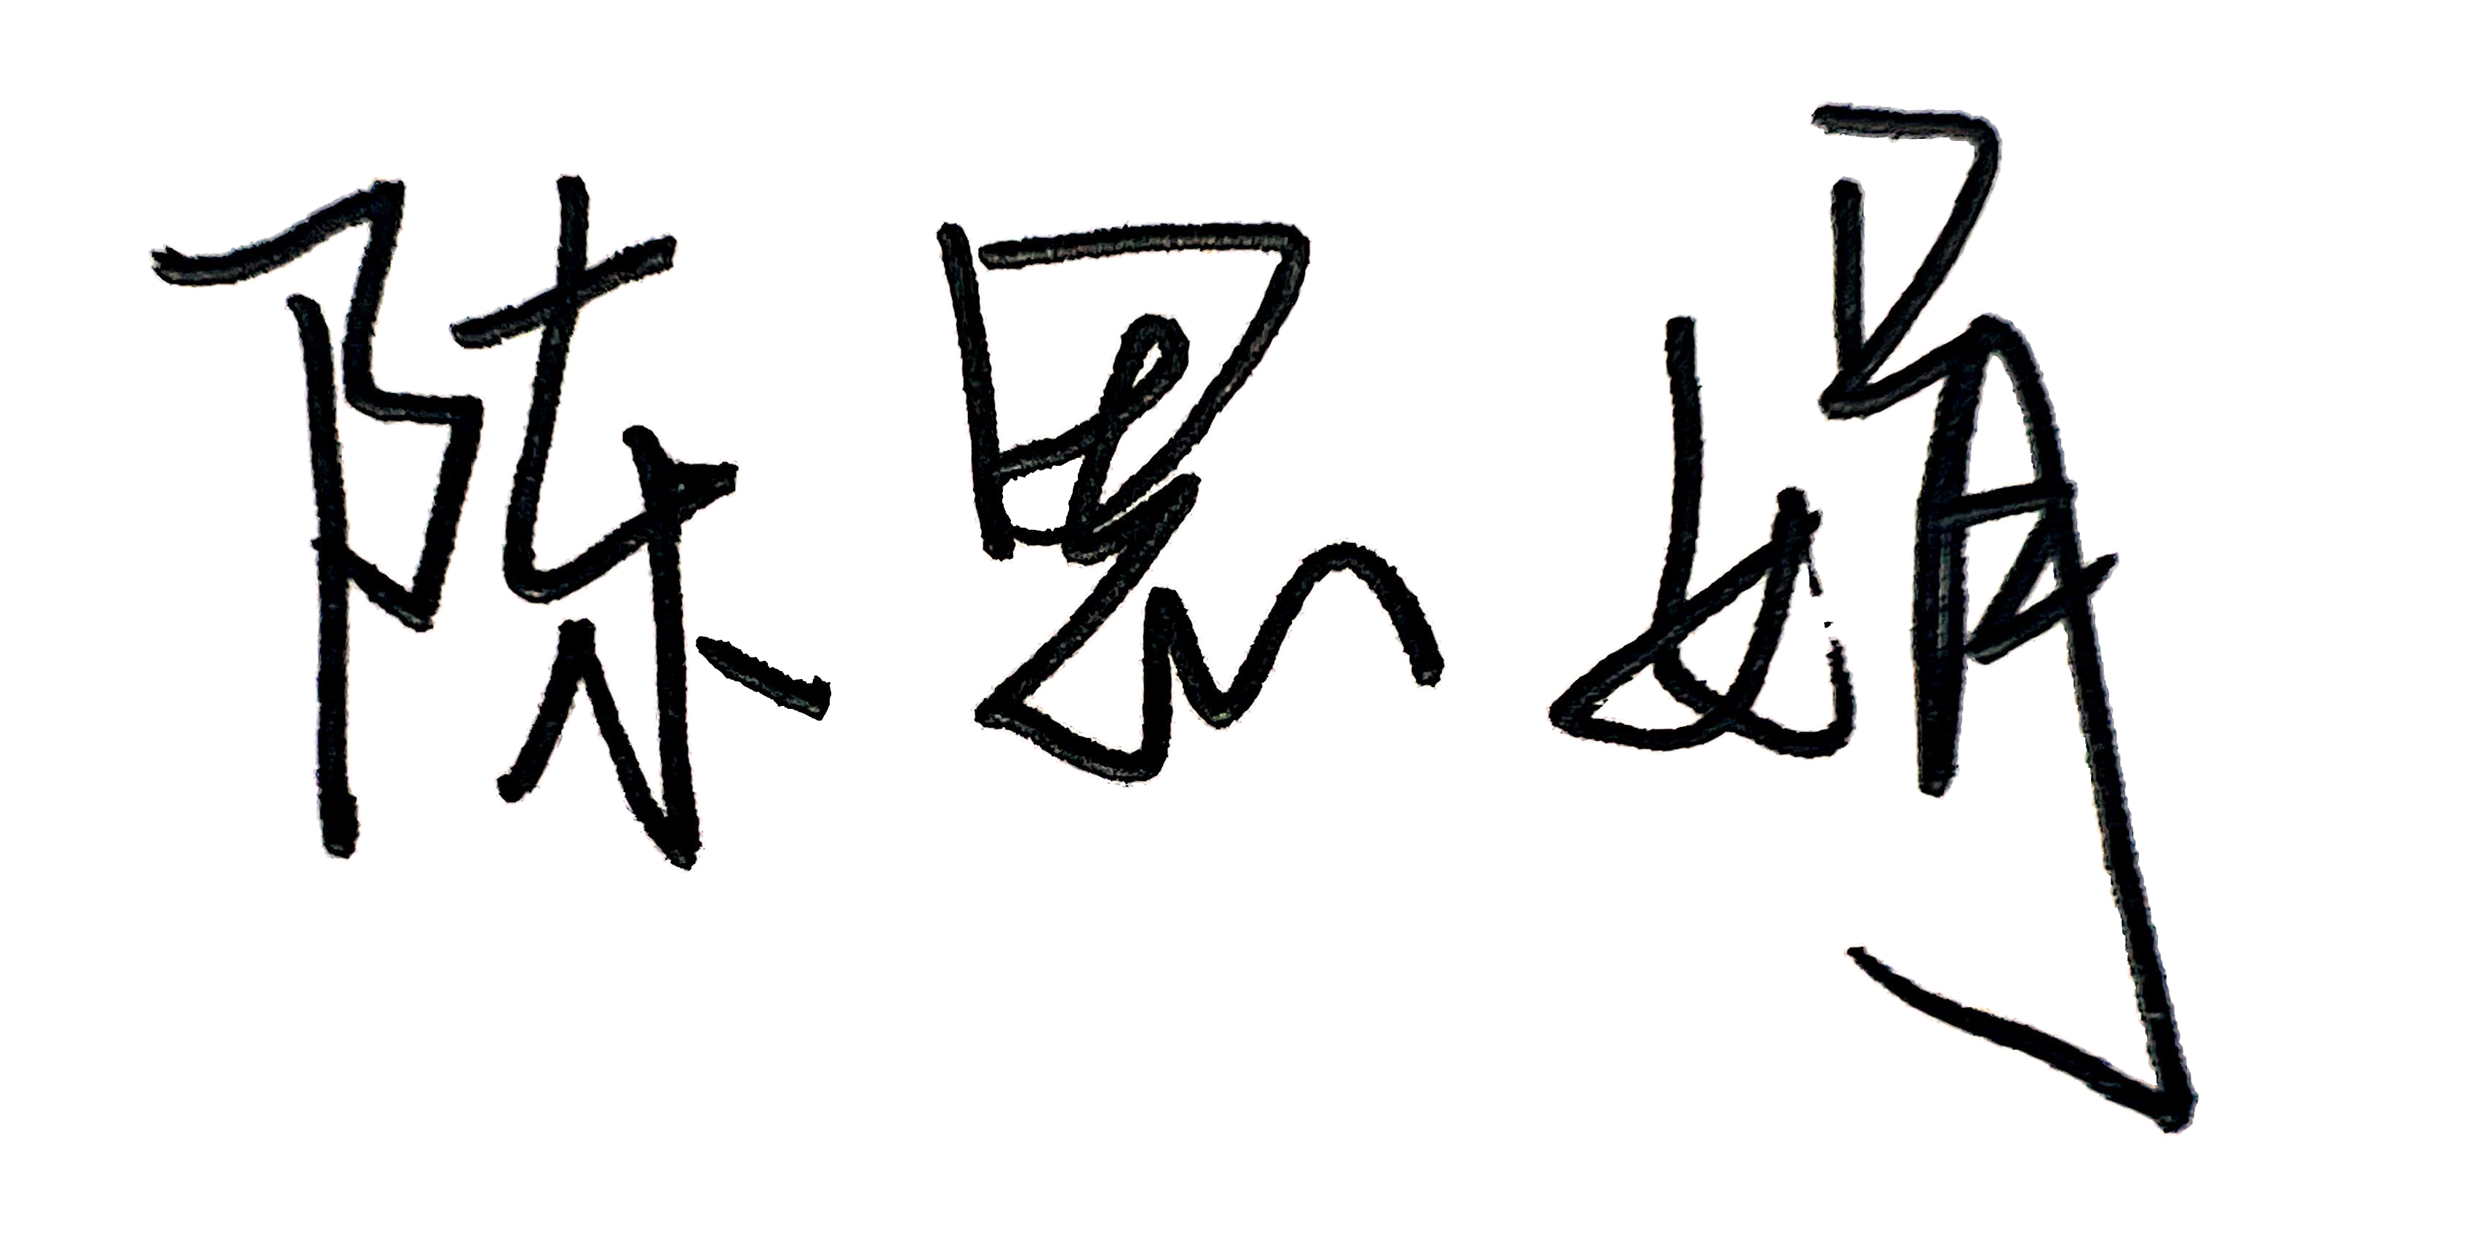37分

组号： 1 ；姓名 莫卓儒

实验 1传统单摆实验

|  |  |  |  |  |  |  |
| --- | --- | --- | --- | --- | --- | --- |
| 测量次数 | 球直径（mm） | 总长（mm） | 摆长（mm） | 25T(s) | T(s) | g(m/s²) |
| 1 | 65.0 | 850.0 | 817.5 | 45.46 |  |  |
| 2 | 65.0 | 850.0 | 817.5 | 45.41 |  |  |
| 3 | 65.0 | 850.0 | 817.5 | 45.64 |  |  |
| 4 | 65.0 | 850.0 | 817.5 | 45.55 |  |  |
| 5 | 65.0 | 850.0 | 817.5 | 45.41 |  |  |
| 6 | 65.0 | 850.0 | 817.5 | 45.32 |  |  |
| 7 | 65.0 | 850.0 | 817.5 | 45.29 |  |  |
| 8 | 65.0 | 850.0 | 817.5 | 45.43 |  |  |

实验 2 手机摆实验

|  |  |  |  |  |
| --- | --- | --- | --- | --- |
| 测量次数 | 摆长l（mm） | 周期T(s) | 频率（Hz） | g(m/s²) |
| 1 | 680 | 1.68 | 0.60 | 9.51 |
| 2 | 680 | 1.70 | 0.59 | 9.23 |
| 3 | 680 | 1.71 | 0.59 | 9.21 |
| 4 | 680 | 1.69 | 0.60 | 9.39 |
| 5 | 680 | 1.64 | 0.61 | 9.93 |

实验3 单摆周期与摆长的关系

|  |  |  |  |  |  |  |
| --- | --- | --- | --- | --- | --- | --- |
| 测量次数 | 球直径(mm) | 总长(mm) | 摆长(mm) | 20T（s） | T(s) | T²(s²) |
| 1 | 65.0 | 800 | 767.5 | 35.15 |  |  |
| 2 | 65.0 | 850 | 817.5 | 36.28 |  |  |
| 3 | 65.0 | 900 | 867.5 | 37.37 |  |  |
| 4 | 65.0 | 950 | 917.5 | 38.43 |  |  |
| 5 | 65.0 | 1000 | 967.5 | 39.46 |  |  |
| 6 | 65.0 | 1050 | 1017.5 | 40.47 |  |  |
| 7 | 65.0 | 1100 | 1117.5 | 41.45 |  |  |
| 8 | 65.0 | 1150 | 1217.5 | 42.41 |  |  |