**附页1：当堂数据记录**

组号：01 姓名：莫卓儒

**表1 线偏振光的光强随偏振片B角度的变化关系**

|  |  |  |  |  |  |  |  |  |  |  |  |  |  |
| --- | --- | --- | --- | --- | --- | --- | --- | --- | --- | --- | --- | --- | --- |
| $Φ$ (°) | 0 | 15 | 30 | 45 | 60 | 75 | 90 | 105 | 120 | 135 | 150 | 165 | 180 |
| 光强I | 50.0 | 46.6 | 37.5 | 25.0 | 12.5 | 3.4 | 0.0 | 3.4 | 12.5 | 25.0 | 37.5 | 46.6 | 50.0 |
| $Φ$ (°) | 195 | 210 | 225 | 240 | 255 | 270 | 285 | 300 | 315 | 330 | 345 | 360 |  |
| 光强I | 46.6 | 37.5 | 25.0 | 12.5 | 3.4 | 0.0 | 3.4 | 12.5 | 25.0 | 37.5 | 46.6 | 50.0 |  |

**表2 线偏振光经 $λ/4$ 波片后随偏振片B角度的变化关系**

|  |  |  |  |  |  |  |  |  |  |  |  |  |  |
| --- | --- | --- | --- | --- | --- | --- | --- | --- | --- | --- | --- | --- | --- |
| 光强I | 偏振片B的角度 $Φ$ (°) | | | | | | | | | | | | |
| $λ/4$ 波片角度 | 0 | 15 | 30 | 45 | 60 | 75 | 90 | 105 | 120 | 135 | 150 | 165 | 180 |
| $$θ_{1/4}=0°$$ | 50.0 | 46.6 | 37.5 | 25.0 | 12.5 | 3.4 | 0.0 | 3.4 | 12.5 | 25.0 | 37.5 | 46.6 | 50.0 |
| $$θ_{1/4}=15°$$ | 43.7 | 46.6 | 43.7 | 35.8 | 25.0 | 14.2 | 6.3 | 3.4 | 6.3 | 14.2 | 25.0 | 35.8 | 43.7 |
| $$θ_{1/4}=30°$$ | 31.2 | 35.8 | 37.5 | 35.8 | 31.2 | 25.0 | 18.7 | 14.2 | 12.5 | 14.2 | 18.7 | 25.0 | 31.2 |
| 光强I | 偏振片B的角度 $Φ$ (°) | | | | | | | | | | | | |
| $λ/4$ 波片角度 | 195 | 210 | 225 | 240 | 255 | 270 | 285 | 300 | 315 | 330 | 345 | 360 |  |
| $$θ_{1/4}=0°$$ | 46.6 | 37.5 | 25.0 | 12.5 | 3.4 | 0.0 | 3.4 | 12.5 | 25.0 | 37.5 | 46.6 | 50.0 |  |
| $$θ_{1/4}=15°$$ | 46.6 | 43.7 | 35.8 | 25.0 | 14.2 | 6.3 | 3.4 | 6.3 | 14.2 | 25.0 | 35.8 | 43.7 |  |
| $$θ_{1/4}=30°$$ | 35.8 | 37.5 | 35.8 | 31.2 | 25.0 | 18.7 | 14.2 | 12.5 | 14.2 | 18.7 | 25.0 | 31.2 |  |

**表3 线偏振光经 $λ/2$ 波片后随偏振片B角度的变化关系**

|  |  |  |  |  |  |  |  |  |  |  |  |  |  |
| --- | --- | --- | --- | --- | --- | --- | --- | --- | --- | --- | --- | --- | --- |
| 光强I | 偏振片B的角度 $Φ$ (°) | | | | | | | | | | | | |
| $λ/2$ 波片角度 | 0 | 15 | 30 | 45 | 60 | 75 | 90 | 105 | 120 | 135 | 150 | 165 | 180 |
| $$θ_{1/4}=0°$$ | 50.0 | 46.6 | 37.5 | 25.0 | 12.5 | 3.4 | 0.0 | 3.4 | 12.5 | 25.0 | 37.5 | 46.6 | 50.0 |
| $$θ_{1/4}=15°$$ | 37.5 | 46.6 | 50.0 | 46.6 | 37.5 | 25.0 | 12.5 | 3.4 | 0.0 | 3.4 | 12.5 | 25.0 | 37.5 |
| $$θ_{1/4}=30°$$ | 12.5 | 25.0 | 37.5 | 46.6 | 50.0 | 46.6 | 37.5 | 25.0 | 12.5 | 3.4 | 0.0 | 3.4 | 12.5 |
| 光强I | 偏振片B的角度 $Φ$ (°) | | | | | | | | | | | | |
| $λ/2$ 波片角度 | 195 | 210 | 225 | 240 | 255 | 270 | 285 | 300 | 315 | 330 | 345 | 360 |  |
| $$θ_{1/4}=0°$$ | 46.6 | 37.5 | 25.0 | 12.5 | 3.4 | 0.0 | 3.4 | 12.5 | 25.0 | 37.5 | 46.6 | 50.0 |  |
| $$θ_{1/4}=15°$$ | 46.6 | 50.0 | 46.6 | 37.5 | 25.0 | 12.5 | 3.4 | 0.0 | 3.4 | 12.5 | 25.0 | 37.5 |  |
| $$θ_{1/4}=30°$$ | 25.0 | 37.5 | 46.6 | 50.0 | 46.6 | 37.5 | 25.0 | 12.5 | 3.4 | 0.0 | 3.4 | 12.5 |  |

实验一截图

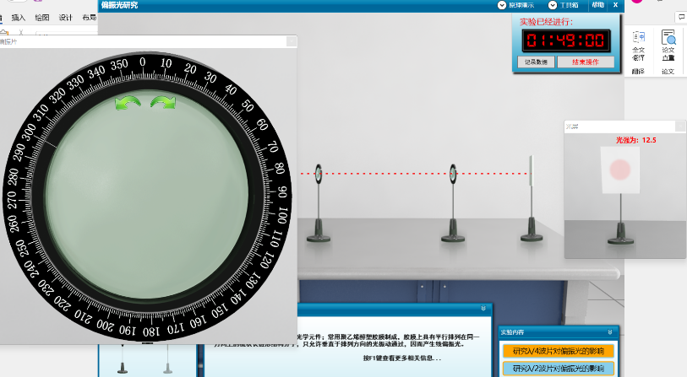

实验二截图

