PMM3 vs MLE-TN: Comparison of Semiparametric and Parametric Estimation of Linear Regression Parameters under Two-piece Normal Distributed Errors
Serhii Zabolotnii¹[0000-0003-0242-2234], Anatolii Chepynoha ²[0000-0003-3921-6557] and Pavlo Klopotovskyi²[0000-0002-4958-2377],
¹ Cherkasy State Business College, Cherkasy, Ukraine
² Cherkasy State Technological University, Cherkasy, Ukraine
a.chepynoha@chdtu.edu.ua
Abstract. This paper addresses the problem of estimating the parameter vector of a linear regression model under symmetric non-Gaussian errors following a Two-piece Normal (TN) distribution. Three methods are compared: Ordinary Least Squares (OLS), Maximum Likelihood Estimation for the TN distribution (MLE-TN), and the third-power Polynomial Maximization Method (PMM3). MLE-TN is fully parametric; PMM3 is semiparametric, using only the 2nd, 4th and 6th-order moments. Theoretical analysis shows that PMM3 achieves up to a 95.5% variance reduction compared to OLS at $λ=5$ (the TN shape parameter), while MLE-TN provides up to a 28-fold advantage for large $λ$. A Monte Carlo study confirmed that the empirical efficiency coefficient $g₃$ converges to the theoretical value for $n≥100$. Under misspecification PMM3 never falls below OLS (ARE from 1.02 to 2.68), whereas MLE-TN can be less efficient than OLS. On real-world data (Iris versicolor), PMM3 achieves a 43% bootstrap variance reduction and improves LOO-CV by 2.3% over OLS. An empirical efficiency threshold for PMM3 is established at $γ_{4}≲-0.7$.
Keywords: Polynomial Maximization Method, Linear Regression, Two-piece Normal distribution, Maximum Likelihood Estimation, Estimation Efficiency, Robustness, Monte Carlo.
- Introduction
The Ordinary Least Squares (OLS) method [5] is the Best Linear Unbiased Estimator under Gaussian errors, but its efficiency depends on the shape of the error distribution [2]. When normality is violated, OLS loses its asymptotic optimality, whereas estimators exploiting higher-order moments may achieve lower variance.
In practical applications, including metrology, medicine, econometrics, and the natural sciences, measurement errors frequently follow symmetric but non-Gaussian distributions. Platykurtic distributions () commonly arise in measurements with a limited operating range, in regression residual histograms, and when multiple sources of uniformly distributed errors are aggregated.
One important family of such distributions is the Two-piece Normal (TN) distribution, introduced in [8] and further investigated in [14]. The TN distribution covers a broad spectrum of symmetric shapes, ranging from an approximately Gaussian form at () to a strongly bimodal form at ($λ≫1$), making it a natural benchmark for studying symmetric platykurtic distributions with .
Three fundamentally different approaches can be distinguished: Parametric approach (MLE-TN): jointly estimates all parameters $\left(β , η , λ\right)$, attains the Cramér–Rao lower bound under correct model specification, but is sensitive to model misspecification [6], [18]; Semiparametric approach (PMM3): utilizes only the 2-nd, 4-th and 6-th order moments. It does not require knowledge of the functional form of the error distribution and remains robust under model misspecification; Nonparametric and robust approaches: including Weighted Least Squares (WLS), Least Absolute Deviations (LAD) regression [13], quantile regression [9], and adaptive Maximum Likelihood Estimation [15].
The present study addresses the following practical question: under what conditions, and to what extent, does PMM3 outperform both MLE-TN and OLS.
  - Literature Review
In [2], a general expression for the asymptotic relative efficiency of OLS was derived in terms of the cumulants of the underlying distribution. Subsequently, [16] systematically investigated parameter estimation in linear regression models with symmetric non-Gaussian errors. The studies reported in [1] and [4] confirmed that, for $γ_{4}<-0.5$, classical OLS may perform worse than the optimal estimator. Robust regression techniques [6] and LAD regression [13] are primarily designed for leptokurtic ($γ_{4}>0$) distributions. In contrast, for platykurtic ($γ_{4}<0$) distributions, none of the standard methods can be regarded as optimal. In [12], a semiparametric regression framework with an unspecified error distribution was developed and shown to outperform MLE when the assumption of normality is misspecified. In [14], both Bayesian and frequentist approaches to linear regression with TN-distributed errors were proposed, and MLE estimation was investigated using L-BFGS-B optimization. Furthermore, [11] developed an objective Bayesian methodology for the broader class of two-piece distributions. Both studies emphasize that, under model misspecification, parametric approaches may be inferior to semiparametric alternatives [18].
As for the Polynomial Maximization Method (PMM), it was developed by Kunchenko and Lega [10]. The theoretical efficiency coefficient of PMM3 derived in [17] is given in Section 2.4.
In [20], PMM was extended to linear regression with asymmetric errors (PMM2, $g_{2}=1-{γ_{3}^{2}}/{(2+γ_{4})}$) and in [19], the first application of the PMM3 to linear regression with symmetric non-Gaussian errors of general form was presented. In [7], a normality test based on the sample skewness and kurtosis was proposed. The corresponding adaptive decision algorithm is: normally distributed residuals – apply OLS; asymmetric residuals – apply PMM2; symmetric platykurtic residuals – apply PMM3.
  - Scientific contribution of the study
Although previous studies have investigated PMM3 for general symmetric distributions and MLE-TN for the Two-piece Normal model, a systematic direct comparison between PMM3 and MLE-TN within the TN framework has not previously been conducted. The principal contributions of this work are as follows:
(i) Theoretical comparison: derivation and analysis of analytical expressions for $g_{3}(λ)$, $ARE(\text{MLE-TN})(λ)$, and the efficiency curve comparing PMM3 and MLE-TN; (ii) Monte Carlo validation: $λ∈\{0.5,1,1.5,2,3,5\}$, $n∈\{46,100,200,500\}$, using $M=500$replications; (iii) Robustness analysis: demonstration that PMM3 does not fall below OLS under model misspecification (ARE from 1.02 to 2.68), whereas MLE-TN may experience a substantial loss of efficiency; (iv) Numerical stability: verification that the Newton-Raphson algorithm converges in 100% of the replications across all 24 Monte Carlo scenarios; (v) Empirical threshold $γ_{4}≲-0.7$: establishment and justification of an empirical efficiency threshold based on seven real-world datasets; (vi) Real-data application: analysis of the Iris versicolor dataset ($n=50$, $γ_{4}=-0.966$), demonstrating that PMM3 achieves a 43% reduction in variance.
- Materials and methods
  - Linear regression model
Consider the following linear regression model:
$y_{v} = {x_{v}}^{T}β + ε_{v}, v = 1, … , n$, (1)
where $y_{i}$ denotes the response variable, $x_{i}∈R^{p}$ is the vector of regressors, $β∈R^{p}$ is the vector of unknown regression parameters, and $ε_{i }$ are independent and identically distributed random errors.
Assumption. For PMM3: the error term satisfies $ε_{v}$ ~ a symmetric distribution with $E\left(ε\right)=0$ and possesses finite moments up to the sixth order. For MLE-TN: the error term follows the Two-piece Normal distribution, $ε_{v}$ ~ $TN\left(0,η,λ\right)$.
  - Two-piece Normal (TN) distribution
The Two-piece Normal (TN) distribution with zero location parameter, scale parameter $η>0$, and shape parameter $λ>0$ has the probability density function [14]:
$f (z | λ) = \frac{1}{\sqrt{2π}} · exp(-\frac{z^{2}}{2} - \frac{λ^{2}}{2}) · cosh(λz), z ∈ R$. (2)
The principal properties of the TN distribution are as follows: $λ→0$ – the distribution approaches the standard normal distribution N(0, 1); $λ>1$ – the distribution becomes bimodal, exhibiting two symmetric modes; $γ_{4}$ is strictly negative for all values of $λ$, indicating a platykurtic distribution.
The normalized excess kurtosis is given by:
$γ_{4} = \frac{μ_{4}}{{μ_{2}}^{2}} - 3 < 0$ for all $λ > 0$. (3)
  - MLE-TN: Maximum likelihood estimation
The MLE-TN approach jointly estimates the parameter vector $\left(β,η,λ\right)$ by maximizing the log-likelihood function:
$l(β, η, λ | y) = \sum_{v = 1}^{n}{log f (\frac{y_{v} - {x_{v}}^{T}β}{η} | λ)} - n log η$. (4)
The optimization procedure is performed using the L-BFGS-B algorithm with the following initial values: $β_{0}=\hat{β}_OLS$, $η_{0}=exp⁡(log SD{(\hat{e}_OLS}))$, $λ_{0}=1.0$. Advantages: achieves the Cramér–Rao lower bound under correct model specification; provides $ARE\left(MLE-TN/OLS\right)≫1$ for sufficiently large values of $λ$. Limitations: requires estimation of $p+2$ parameters; is sensitive to model misspecification; may exhibit numerical instability for small sample sizes and large n values of $λ$.
  - PMM3: Polynomial Maximization Method (S = 3)
The PMM3 estimator evaluates only the regression parameter vector $β$ by employing a moment-corrected score function. The algorithm consists of the following steps: compute the initial estimate $β^{(0)}=\hat{β}_OLS$ and evaluate the sample central moments of the residuals m₂, m₄, m₆, then the correction coefficient is estimated once according to
$κ = \frac{m_{6} - 3 m_{4}m_{2}}{m_{4} - 3 {m_{2}}^{2}}$. (5)
If the corresponding condition is violated $\left|m_{4} - 3 {m_{2}}^{2}\right|<{10}^{-10}$, the algorithm returns the Gaussian fallback solution $\hat{β}_OLS$.
The parameter vector is updated according to the Newton-Raphson procedure: $Z_{1v}=ε_{v}(κ-ε_{v}^{2})$; $Z=X^{T}Z_{1}$; $J=X^{T}diag(3ε^{2}-κ)X$; $β←β-J^{-1}Z$. The iterations continue until the prescribed convergence criterion is satisfied: ${\left\|Z\right\|}_{2}<{10}^{-6}$. In practice, convergence is typically achieved within 3-5 iterations. To ensure numerical stability, if the specified divergence condition is met, $\left\|β- \hat{β}_OLS\right\|$>10 the algorithm returns the initial estimate $\hat{β}_OLS$.
The theoretical efficiency coefficient of PMM3 is
$g_{3} = 1 - \frac{{γ_{4}}^{2}}{6 + 9γ_{4} + γ_{6}}$, (6)
where $γ_{4}={μ_{4}}/{μ_{2}^{2}-3}$, $γ_{6}={μ_{6}}/{μ_{2}^{3}-15({μ_{4}}/{μ_{2}^{2})+30}}$ – normalized fourth and sixth-order cumulants. An important advantage of PMM3 is that it does not require knowledge of the distribution: cumulants are estimated directly from the sample.
  - Asymptotic normality of PMM3
Under the standard regularity conditions, the PMM3 estimator is consistent and asymptotically normally distributed. $\sqrt{n} ({\hat{β}}_{PMM3} - β) →ᵈ N(0, g_{3}·σ²·{(X^{T}X / n)}^{-1})$ Its asymptotic covariance matrix is reduced by a factor of ($1/g_{3}$) relative to that of the OLS estimator: $Var({\hat{β}}_{PMM3}) = g_{3}·Var({\hat{β}}_{OLS})$
For the Gaussian case ${(γ}_{4}=0)$ $g_{3}=1$ PMM3 is asymptotically equivalent to OLS. For platykurtic distributions ($γ_{4}<0)$ $g_{3}<1$ PMM3 is more efficient than OLS. The consistency of PMM3 depends only on the assumption of zero-mean errors and does not require specification of the exact distributional form. A more detailed derivation is provided in [10] and [20]. The three methods differ in what they must assume. OLS and PMM3 both estimate only the p coefficients of the vector and require no knowledge of the distributional form, whereas MLE-TN estimates p + 2 parameters and requires the TN form to be correctly specified. Under TN errors OLS is the baseline (ARE = 1), PMM3 attains g₃ < 1 whenever the fourth-order cumulant is negative, and MLE-TN attains the Cramér–Rao bound.
  - Theoretical characteristics of the TN distribution
The shapes of the TN density are shown in the left panel of Fig. 1 and the theoretical efficiency curve $g_{3}(λ)$ in the right panel. Evaluated at the six shape values used throughout this study, the moment formulas give γ₄ = -0.080, -0.500, -0.959, -1.280, -1.620 and -1.849 with g₃ = 0.9988, 0.9286, 0.6574, 0.3868, 0.1490 and 0.0454 for λ = 0.5, 1.0, 1.5, 2.0, 3.0 and 5.0, corresponding to a variance reduction relative to OLS of 0.1%, 7.1%, 34.3%, 61.3%, 85.1% and 95.5%. The distribution is bimodal for λ > 1, that is for every λ ≥ 1.5 in this set.
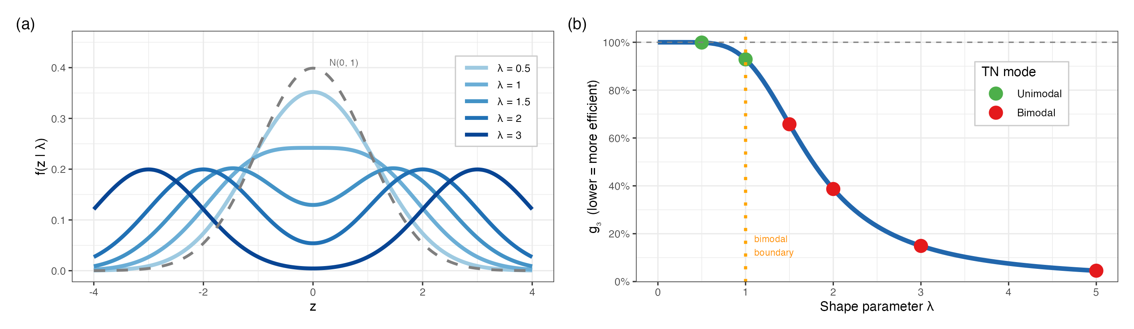
Fig. 1. Two-piece Normal model. Left: TN densities for λ ∈ {0.5, 1, 1.5, 2, 3}, standard normal dashed. Right: theoretical efficiency g₃ as a function of λ; the dotted line marks the bimodality boundary λ = 1, unimodal cases green, bimodal red.
- Results and discussion
  - Monte Carlo study
The data-generating model is defined as:
$y_{v} = 1 + β_{1}x_{v} + ε_{v}, ε_{v} \sim TN(0, 1, λ)$. (7)
The simulation parameters: number of replications $M=500$; sample sizes n ∈ {46, 100, 200, 500}; shape parameters $λ∈\{0.5,1,1.5,2,3,5\}$; random seed = 20260312.
Metrics: Bias=${\hat{β}}_{1}-1$; Var$({\hat{β}}_{1}$); MSE=Bias²+Var; ARE=Var(OLS)/Var(method); $g_{3}_emp$ = Var(PMM3)/Var(OLS).
The results for all 24 scenarios are summarised in Figs. 2 and 3; the full numeric table is provided in the supplementary material (see Data and Code Availability).
Here ARE > 1 indicates superiority over OLS. Furthermore $g_{3}_emp$ = Var(PMM3)/Var(OLS), $∆g_{3}= {(g_{3}_emp-g_{3}_theor)}/{g_{3}_theor×100\%}$. For $n≥100$ the deviation remains within $<±10\%$.
PMM3 significantly outperforms OLS at $λ≥1.5$: ARE ranging from 1.5 to 23.8 – the theory has been confirmed. MLE-TN is even more effective than PMM3 for $λ≥1.5$ (assuming the TN specification is correct), but it estimates $p+2$ parameters – excessive parameterization for small n. The empirical efficiency coefficient $g_{3}_emp$ approximates its theoretical value $g_{3}_theor$ with an accuracy of approximately ±10% for sufficient sample sizes ($n≥100$). For the most challenging scenario, $λ=5$, $n=100$, the efficiencies were ARE(PMM3) = 23.8 compared with ARE(MLE-TN) = 27.4. Thus, PMM3 lags behind MLE-TN by only about 15%, while requiring no prior knowledge of the underlying error distribution.
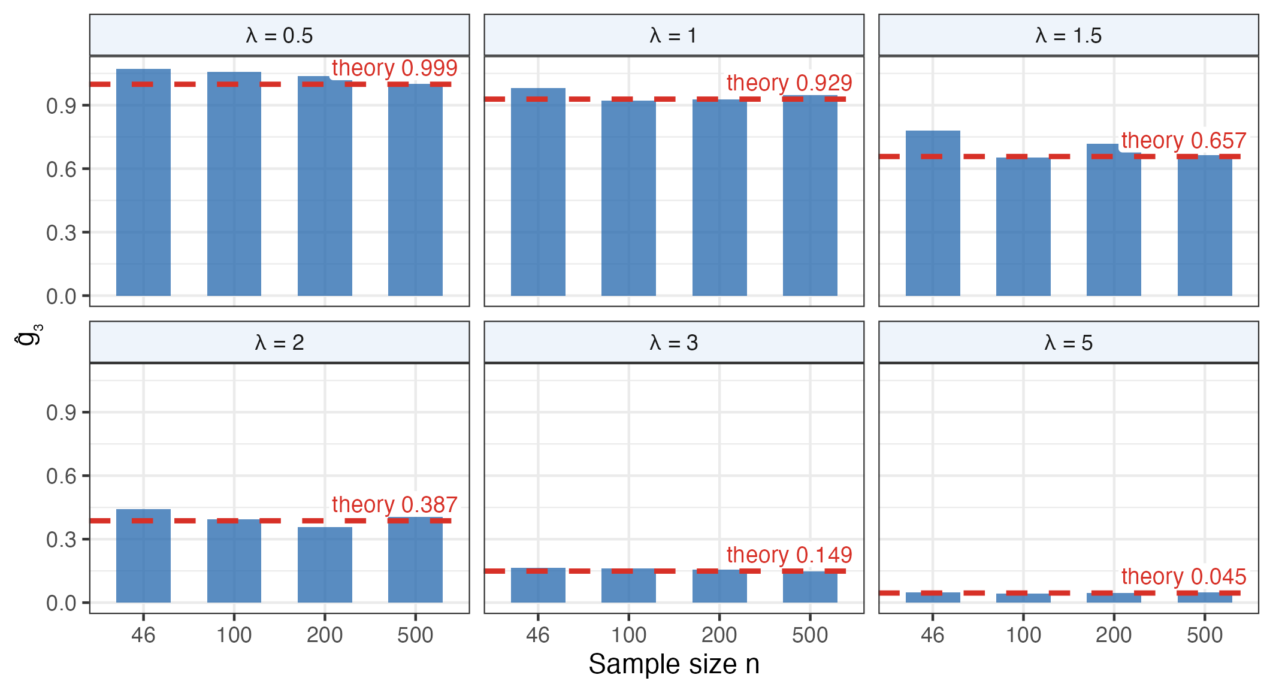
Fig. 2. Empirical efficiency coefficient ĝ₃ (bars) against its theoretical value (dashed line) for all 24 Monte Carlo scenarios (six values of λ × four sample sizes n, M = 500).
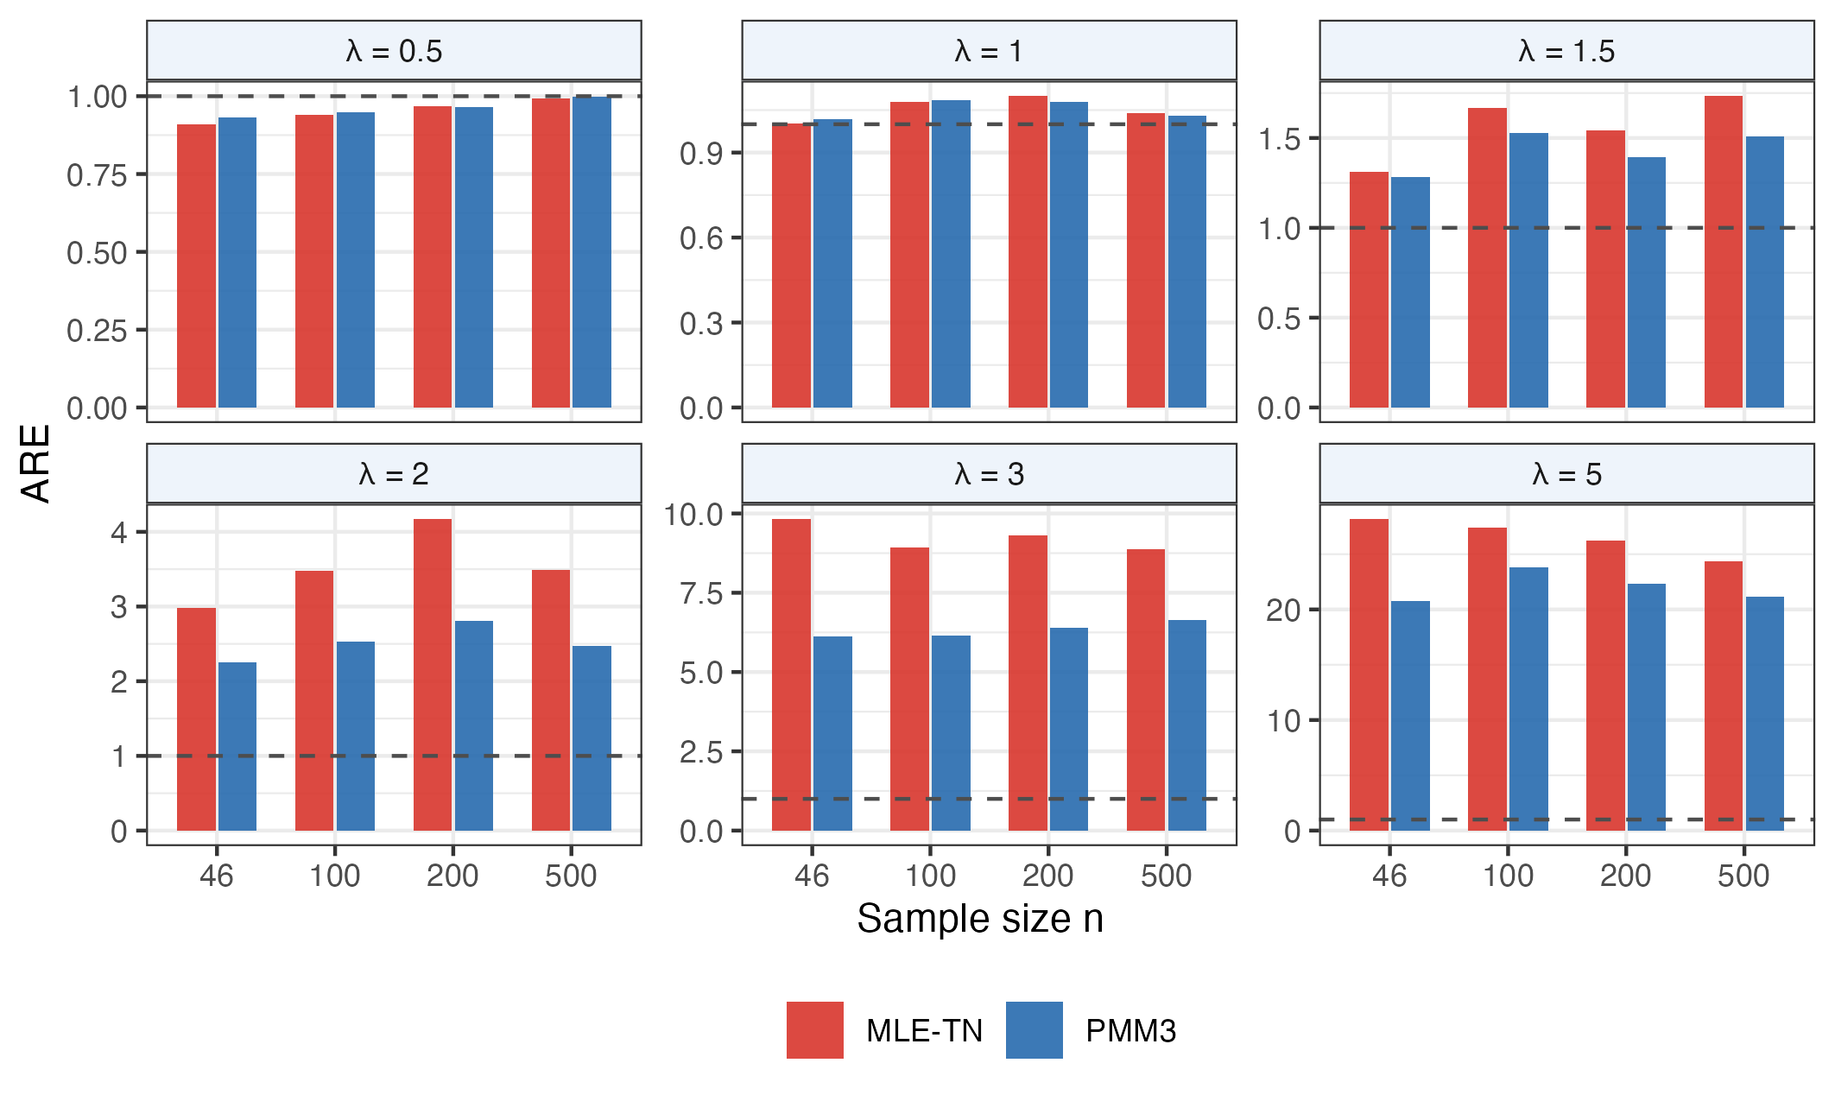
Fig. 3. Monte Carlo ARE of MLE-TN and PMM3 relative to OLS, for six shape values λ and four sample sizes n (M = 500). ARE > 1 means more efficient than OLS.

  - Real-world data: Fisher's iris dataset (Iris versicolor)
A subset of the classical Fisher Iris dataset [3] corresponding to the species Iris versicolor was used for empirical evaluation. The dataset contains $n=50$ observations.
${Sepal.Length}_{v} = β_{0} + β_{1} · {Sepal.Width}_{v} + ε_{v}$. (8)
OLS Residual Diagnostics: $n=50$; ${\hat{γ}}_{3}=0.273$ (indicating only negligible asymmetry); ${\hat{γ}}_{4}=-0.966$ (indicates pronounced platykurticity); $span/SD≈3.58$ – suggesting a restricted measurement range.

The corresponding theoretical efficiency is: ${g_{3}}_{theor}=0.483$ which corresponds to a 51.7% reduction in variance. Based on the residual diagnostics: $γ_{4}=-0.966 <-0.7$ PMM3 is recommended.
Table 1. Comparison of estimation methods for iris versicolor ($n=50$).
Method | $${\hat{β}}_{1}$$ | LOO-MSE | $g_{3}_emp$ (bootstrap)
OLS | 0.865 | 0.2070 | 1.000 (baseline)
PMM3 | 0.797 | 0.2022 | 0.570
MLE-TN | 0.753 | 0.2109 | 0.746
The relative variance is computed as $g_{3}_emp$ = Var(method)/Var(OLS) using bootstrap estimation with $B=2000$ replications.
PMM3 achieved the smallest prediction error: LOO-MSE = 0.2022, which is lower than that obtained by OLS = 0.2070 and MLE-TN = 0.2109. Bootstrap analysis indicates a 43% reduction in variance $(g_{3}_emp=0.570)$, compared with the theoretical prediction of 51.7%. Given the relatively small sample size ($n=50$), this agreement can be considered satisfactory. Despite the additional parameters $\left(η , λ\right)$, MLE-TN exhibited the poorest performance. Consequently, for datasets characterized by $n=50$ and $γ_{4}≈-0.97$, PMM3 represents the optimal estimation strategy.
Negative example. For the whiteside dataset (MASS package, household gas consumption versus outdoor temperature, n = 56) the residuals give γ₄ = −0.431, i.e. above the threshold: the theoretical gain is only 8.0% (g₃ theor = 0.920), the bootstrap ratio is g₃ emp = 0.978 and LOO-MSE PMM3/OLS = 0.999. Five further datasets with γ₄ ∈ [−0.54, −0.12] give g₃ emp ∈ [1.03, 1.36] and LOO-MSE PMM3/OLS ≤ 1.013, i.e. no gain, which supports the threshold γ₄ ≲ −0.7.
  - Robustness under model misspecification
Robustness was assessed by generating data from non-TN error distributions (Table 2), with sample size $n=100$, number of Monte Carlo replications $M=500$.
Table 2. ARE under model misspecification ($n=100,M=500$).
True DGP | $γ_{4}$ (true) | ARE(MLE-TN) | ARE(PMM3)
Uniform | −1.200 | 1.655 | 2.685
Triangular | −0.600 | 0.969 | 1.061
Logistic | +1.200 | 0.994 | 1.023
Student’s t10 | +1.000 | 0.982 | 1.047
PMM3 is robust: ARE ≥ 1.02 for all four distributions, so it performs no worse than OLS even when its assumptions fail; for the uniform law (γ₄ = −1.2) it reaches 2.685, above MLE-TN (1.655). MLE-TN is considerably more sensitive to misspecification: under the triangular law its ARE = 0.969 is below OLS. The Newton–Raphson implementation converged in 100% of the 200 replications with no NA outcomes for every λ ∈ {0.8, 1.0, 1.2, 1.5, 2.0, 3.0}, including the strongly bimodal cases, in 2.8–3.7 iterations on average, with absolute bias below 0.003.
- Conclusions
- Theoretical results. PMM3 provides a 7% to 95% reduction in variance relative to OLS for TN-distributed errors with $λ∈\{1,…,5\}$. Under correct model specification, MLE-TN can achieve an even greater efficiency gain; however, it requires estimation of $p+2$ parameters. Monte Carlo study. MLE-TN is substantially more efficient than PMM3 for large values of $λ$, provided that the TN specification is correct. The empirical efficiency coefficient $g_{3}$ of PMM3 converges to its theoretical value for sample sizes of approximately $n≥100-200$.
- Robustness. PMM3 never falls below OLS under model misspecification (ARE from 1.02 to 2.68), whereas MLE-TN may perform worse than OLS. PMM3 is therefore the safe choice when the error distribution is uncertain.
- Real-world data. For the Iris versicolor dataset ( $γ_{4}=-0.966$, $n=50$) PMM3 achieves a 43% reduction in variance, while its predictive performance satisfies LOO-MSE PMM3 < OLS < MLE-TN.
- Empirical threshold. PMM3 demonstrates a practical advantage over OLS only when $γ_{4}≲-0.7$. For −0.7 < $γ_{4}$ < 0 no method offers a practical advantage over OLS (prediction error within 2% of OLS). In practice: prefer MLE-TN when the TN model is justified and n is large, PMM3 when the error distribution is uncertain, and OLS for approximately Gaussian errors.
Data and Code Availability. The R code of the study, the stored results of all experiments and a script that reruns the simulation and checks it against the stored tables are openly available under the MIT licence at https://github.com/SZabolotnii/Ku-PMM3-MLE-TN-code-supplement and archived on Zenodo: https://doi.org/10.5281/zenodo.22849684.

References
- Andargie, A.A., Rao, K.S.: Estimation of a linear model with two-parameter symmetric platykurtic distributed errors. J. Uncertain. Anal. Appl. 1, 13 (2013). doi: 10.1186/2195-5468-1-13.
- Cox, D. R.; Hinkley, D. V. A note on the efficiency of least-squares estimates. JRSS-B 1968, 30(2), 284–289.
- Fisher, R.A.: The use of multiple measurements in taxonomic problems. Ann. Eugen. 7(2), 179–188 (1936)
- Ganguly, S.S.: Robust regression analysis for non-normal situations under symmetric distributions arising in medical research. J. Mod. Appl. Stat. Methods 13(1), 446–462 (2014). doi: 10.22237/jmasm/1398918480.
- Gauss, C. F. Theoria Motus Corporum Coelestium. Perthes and Besser: Hamburg, 1809.
- Huber, P.J.: The behavior of maximum likelihood estimates under nonstandard conditions. In: Proc. 5th Berkeley Symp. Math. Statist. Probab., vol. 1, pp. 221–233. Univ. California Press, Berkeley (1967).
- Jarque, C.M., Bera, A.K.: A test for normality of observations and regression residuals. Int. Stat. Rev. 55(2), 163–172 (1987). doi: 10.2307/1403192.
- John, S. The three-parameter two-piece normal family. Communications in Statistics 1982, 11(8), 879–885.
- Koenker, R., Hallock, K.F.: Quantile regression. J. Econ. Perspect. 15(4), 143–156 (2001).
- Kunchenko, Yu. P.; Lega, Yu. G. Polynomial parameter estimation of close to Gaussian random variables. Radioelectronics and Communications Systems 1992, 35(8), 76–78.
- Leisen, F., Rossini, L., Villa, C.: Loss-based approach to two-piece location-scale distributions with applications to dependent data. Stat. Methods Appl. 29(2), 309–333 (2020). doi: 10.1007/s10260-019-00481-x.
- Ma, Y., Wang, S., Xu, L., Yao, W.: Semiparametric mixture regression with unspecified error distributions. TEST 30(2), 429–444 (2021). doi: 10.1007/s11749-020-00725-z.
- Narula, S.C., Wellington, J.F.: The minimum sum of absolute errors regression: a state of the art survey. Int. Stat. Rev. 50(3), 317–326 (1982).
- Salinas, H., Bakouch, H., Qarmalah, N., Martínez-Flórez, G.: A flexible class of two-piece normal distribution with a regression illustration to biaxial fatigue data. Mathematics 11(5), 1271 (2023). doi: 10.3390/math11051271.
- Stone, C.J.: Adaptive maximum likelihood estimators of a location parameter. Ann. Stat. 3(2), 267–284 (1975). doi: 10.1214/aos/1176343056.
- Tiku, M.L., Islam, M.Q., Selçuk, A.S.: Non-normal regression. II. Symmetric distributions. Commun. Stat. – Theory Methods 30(6), 1021–1045 (2001).
- Warsza, Z.L., Zabolotnii, S.W.: A polynomial estimation of measurand parameters for samples of non-Gaussian symmetrically distributed data. In: Szewczyk, R., Zieliński, C., Kaliczyńska, M. (eds.) Automation 2017. Adv. Intell. Syst. Comput., vol. 550, pp. 468–480. Springer, Cham (2017). doi: 10.1007/978-3-319-54042-9_45.
- White, H.: Maximum likelihood estimation of misspecified models. Econometrica 50(1), 1–25 (1982). doi: 10.2307/1912526.
- Zabolotnii, S.W., Warsza, Z.L., Tkachenko, O.: Estimation of linear regression parameters of symmetric non-Gaussian errors by polynomial maximization method. In: Szewczyk, R., Zieliński, C., Kaliczyńska, M. (eds.) Automation 2019. Adv. Intell. Syst. Comput., vol. 920, pp. 636–649. Springer, Cham (2020). doi: 10.1007/978-3-030-13273-6_59.
- Zabolotnii, S.W., Warsza, Z.L., Tkachenko, O.: Polynomial estimation of linear regression parameters for the asymmetric PDF of errors. In: Szewczyk, R., Zieliński, C., Kaliczyńska, M. (eds.) Automation 2018. Adv. Intell. Syst. Comput., vol. 743, pp. 758–772. Springer, Cham (2018). doi: 10.1007/978-3-319-77179-3_75.

