PMM3 vs MLE-TN: Comparison of Semiparametric and Parametric Estimation of Linear Regression Parameters under Two-piece Normal Distributed Errors
Serhii Zabolotnii¹[0000-0003-0242-2234], Anatolii Chepynoha ²[0000-0003-3921-6557] and Pavlo Klopotovskyi²[0000-0002-4958-2377],
¹ Cherkasy State Business College, Cherkasy, Ukraine
² Cherkasy State Technological University, Cherkasy, Ukraine
a.chepynoha@chdtu.edu.ua
Abstract. This paper addresses the problem of estimating the parameter vector of a linear regression model under symmetric non-Gaussian errors following a Two-piece Normal (TN) distribution. Three methods are compared: Ordinary Least Squares (OLS), Maximum Likelihood Estimation for the TN distribution (MLE-TN), and the third-power Polynomial Maximization Method (PMM3). While MLE-TN is fully parametric and requires correct specification of the functional form, PMM3 is semiparametric, relying solely on the 2nd, 4th, and 6th-order moments. Theoretical analysis shows that PMM3 achieves up to a 95.5% variance reduction compared to OLS at $λ=5$ (the TN shape parameter), while MLE-TN provides up to a 28-fold advantage for large $λ$. A Monte Carlo study confirmed that the empirical efficiency coefficient $g₃$ converges to the theoretical value for $n≥100$. PMM3 is shown to be robust under misspecification, whereas MLE-TN can be inefficient. On real-world data (Iris versicolor), PMM3 achieves a 43% bootstrap variance reduction and improves LOO-CV by 2.3% over OLS. An empirical efficiency threshold for PMM3 is established at $γ_{4}≲-0.7$.
Keywords: Polynomial Maximization Method, Linear Regression, Two-piece Normal distribution, Maximum Likelihood Estimation, Estimation Efficiency, Robustness, Monte Carlo.
- Introduction
The Ordinary Least Squares (OLS) method, proposed by Gauss [5], is the Best Linear Unbiased Estimator under the assumption of Gaussian error distribution. However, as demonstrated in [2], the efficiency of OLS depends on the shape of the error distribution. When normality is violated, OLS loses its asymptotic optimality, whereas alternative estimators that exploit higher-order moments may achieve lower variance.
In practical applications, including metrology, medicine, econometrics, and the natural sciences, measurement errors frequently follow symmetric but non-Gaussian distributions. Platykurtic distributions () commonly arise in measurements with a limited operating range, in regression residual histograms, and when multiple sources of uniformly distributed errors are aggregated.
One important family of such distributions is the Two-piece Normal (TN) distribution, introduced in [8] and further investigated in [14]. The TN distribution covers a broad spectrum of symmetric shapes, ranging from an approximately Gaussian form at () to a strongly bimodal form at (), making it a natural benchmark for studying symmetric platykurtic distributions with .
Three fundamentally different approaches can be distinguished:
- Parametric approach (MLE-TN): jointly estimates all parameters $\left(β , η , λ\right)$, attains the Cramér–Rao lower bound under correct model specification, but is sensitive to model misspecification [6], [18];
- Semiparametric approach (PMM3): utilizes only the 2-nd, 4-th and 6-th order moments. It does not require knowledge of the functional form of the error distribution and remains robust under model misspecification;
- Nonparametric and robust approaches: including Weighted Least Squares (WLS), Least Absolute Deviations (LAD) regression [13], quantile regression [9], and adaptive Maximum Likelihood Estimation [15].
The present study addresses the following practical question: under what conditions, and to what extent, does PMM3 outperform both MLE-TN and OLS.
  - Literature Review
In [2], a general expression for the asymptotic relative efficiency of OLS was derived in terms of the cumulants of the underlying distribution. Subsequently, [16] systematically investigated parameter estimation in linear regression models with symmetric non-Gaussian errors. The studies reported in [1] and [4] confirmed that, for $γ_{4}<-0.5$, classical OLS may perform worse than the optimal estimator. Robust regression techniques [6] and LAD regression [13] are primarily designed for leptokurtic ($γ_{4}>0$) distributions. In contrast, for platykurtic ($γ_{4}<0$) distributions, none of the standard methods can be regarded as optimal. In [12], a semiparametric regression framework with an unspecified error distribution was developed and shown to outperform MLE when the assumption of normality is misspecified. In [14], both Bayesian and frequentist approaches to linear regression with TN-distributed errors were proposed, and MLE estimation was investigated using L-BFGS-B optimization. Furthermore, [11] developed an objective Bayesian methodology for the broader class of two-piece distributions. Both studies emphasize that, under model misspecification, parametric approaches may be inferior to semiparametric alternatives [18].
As for the Polynomial Maximization Method (PMM), it was developed by Kunchenko and Lega [10]. In [17], the key expression for the theoretical efficiency coefficient of PMM3 was derived:
$g_{3}=1-\frac{γ_{4}^{2}}{6+9γ_{4}+γ_{6}}$. (1)
In [20], PMM was extended to linear regression with asymmetric errors (PMM2, $g_{2}=1-{γ_{3}^{2}}/{(2+γ_{4})}$) and in [19], the first application of the PMM3 to linear regression with symmetric non-Gaussian errors of general form was presented. In [7], a normality test based on the sample skewness and kurtosis was proposed. The corresponding adaptive decision algorithm is: normally distributed residuals – apply OLS; asymmetric residuals – apply PMM2; symmetric platykurtic residuals – apply PMM3.
  - Scientific contribution of the study
Although previous studies have investigated PMM3 for general symmetric distributions and MLE-TN for the Two-piece Normal model, a systematic direct comparison between PMM3 and MLE-TN within the TN framework has not previously been conducted. The principal contributions of this work are as follows:
- Theoretical comparison: derivation and analysis of analytical expressions for $g_{3}(λ)$, $ARE(\text{MLE-TN})(λ)$, and the efficiency curve comparing PMM3 and MLE-TN.
- Monte Carlo validation: $λ∈\{0.5,1,1.5,2,3,5\}$, $n∈\{46,100,200,500\}$, using $M=500$replications.
- Robustness analysis: demonstration that PMM3 maintains $ARE≈1$ under model misspecification, whereas MLE-TN may experience a substantial loss of efficiency.
- Numerical stability: verification that the Newton-Raphson algorithm converges in 100% of the replications across all 24 Monte Carlo scenarios.
- Empirical threshold $γ_{4}≲-0.7$: establishment and justification of an empirical efficiency threshold based on seven real-world datasets.
- Real-data application: analysis of the Iris versicolor dataset ($n=50$, $γ_{4}=-0.966$), demonstrating that PMM3 achieves a 43% reduction in variance.
- Materials and methods
  - Linear regression model
Consider the following linear regression model:
$y_{v} = {x_{v}}^{T}β + ε_{v}, v = 1, … , n$, (2)
where $y_{i}$ denotes the response variable, $x_{i}∈R^{p}$ is the vector of regressors, $β∈R^{p}$ is the vector of unknown regression parameters, and $ε_{i }$ are independent and identically distributed random errors.
Assumption. For PMM3: the error term satisfies $ε_{v}$ ~ a symmetric distribution with $E\left(ε\right)=0$ and possesses finite moments up to the sixth order. For MLE-TN: the error term follows the Two-piece Normal distribution, $ε_{v}$ ~ $TN\left(0,η,λ\right)$.
  - Two-piece Normal (TN) distribution
The Two-piece Normal (TN) distribution with zero location parameter, scale parameter $η>0$, and shape parameter $λ>0$ has the probability density function [14]:
$f (z | λ) = \frac{1}{\sqrt{2π}} · exp(-\frac{z^{2}}{2} - \frac{λ^{2}}{2}) · cosh(λz), z ∈ R$. (3)
The principal properties of the TN distribution are as follows: $λ→0$ – the distribution approaches the standard normal distribution N(0, 1); $λ>\sqrt{2}≈0.707$ corresponds to the transition threshold between unimodal and bimodal behavior; $λ>1/\sqrt{2}$ – the distribution becomes bimodal, exhibiting two symmetric modes; $γ_{4}$ is strictly negative for all values of $λ$, indicating a platykurtic distribution.
The normalized excess kurtosis is given by:
$γ_{4} = \frac{μ_{4}}{{μ_{2}}^{2}} - 3 < 0$ for all $λ > 0$. (4)
  - MLE-TN: Maximum likelihood estimation
The MLE-TN approach jointly estimates the parameter vector $\left(β,η,λ\right)$ by maximizing the log-likelihood function:
$l(β, η, λ | y) = \sum_{v = 1}^{n}{log f (\frac{y_{v} - {x_{v}}^{T}β}{η} | λ)} - n log η$. (5)
The optimization procedure is performed using the L-BFGS-B algorithm with the following initial values: $β_{0}=\hat{β}_OLS$, $η_{0}=exp⁡(log SD{(\hat{e}_OLS}))$, $λ_{0}=1.0$. Advantages: achieves the Cramér–Rao lower bound under correct model specification; provides $ARE\left(MLE-TN/OLS\right)≫1$ for sufficiently large values of $λ$. Limitations: requires estimation of $p+2$ parameters; is sensitive to model misspecification; may exhibit numerical instability for small sample sizes and large n values of $λ$.
  - PMM3: Polynomial Maximization Method (S = 3)
The PMM3 estimator evaluates only the regression parameter vector $β$ by employing a moment-corrected score function. The algorithm consists of the following steps: compute the initial estimate $β^{(0)}=\hat{β}_OLS$ and evaluate the sample central moments of the residuals m₂, m₄, m₆, then the correction coefficient is estimated once according to
$κ = \frac{m_{6} - 3 m_{4}m_{2}}{m_{4} - 3 {m_{2}}^{2}}$. (6)
If the corresponding condition is violated $\left|m_{4} - 3 {m_{2}}^{2}\right|<{10}^{-10}$, the algorithm returns the Gaussian fallback solution $\hat{β}_OLS$.
The parameter vector is updated according to the Newton-Raphson procedure: $Z_{1v}=ε_{v}(κ-ε_{v}^{2})$; $Z=X^{T}Z_{1}$; $J=X^{T}diag(3ε^{2}-κ)X$; $β←β-J^{-1}Z$. The iterations continue until the prescribed convergence criterion is satisfied: ${\left\|Z\right\|}_{2}<{10}^{-6}$. In practice, convergence is typically achieved within 3-5 iterations. To ensure numerical stability, if the specified divergence condition is met, $\left\|β- \hat{β}_OLS\right\|$>10 the algorithm returns the initial estimate $\hat{β}_OLS$.
The theoretical efficiency coefficient of PMM3 is
$g_{3} = 1 - \frac{{γ_{4}}^{2}}{6 + 9γ_{4} + γ_{6}}$, (7)
where $γ_{4}={μ_{4}}/{μ_{2}^{2}-3}$, $γ_{6}={μ_{6}}/{μ_{2}^{3}-15({μ_{4}}/{μ_{2}^{2})+30}}$ – normalized fourth and sixth-order cumulants. An important advantage of PMM3 is that it does not require knowledge of the distribution: cumulants are estimated directly from the sample.
  - Asymptotic normality of PMM3
Under the standard regularity conditions, the PMM3 estimator is consistent and asymptotically normally distributed.
$\sqrt{n} ({\hat{β}}_{PMM3} - β) →ᵈ N(0, g_{3}·σ²·{(X^{T}X / n)}^{-1})$.
Its asymptotic covariance matrix is reduced by a factor of ($1/g_{3}$) relative to that of the OLS estimator: $Var({\hat{β}}_{PMM3}) = g_{3}·Var({\hat{β}}_{OLS})$.
For the Gaussian case ${(γ}_{4}=0)$ $g_{3}=1$ PMM3 is asymptotically equivalent to OLS. For platykurtic distributions ($γ_{4}<0)$ $g_{3}<1$ PMM3 is more efficient than OLS. The consistency of PMM3 depends only on the assumption of zero-mean errors and does not require specification of the exact distributional form. A more detailed derivation is provided in [10] and [20]. Comparison of characteristics of the estimation methods is presented in Table 1.
Table 1. Comparative characteristics of the estimation methods.
Method | Estimated Parameters | Number of Parameters | Distributional Form Required? | Efficiency under TN
OLS | β | p | No | Baseline (ARE = 1)
PMM3 | β | p | No | $g_{3}<1$ for $γ_{4}<0$
MLE-TN | β, η, λ | p + 2 | Yes | Cramér–Rao bound
  - Theoretical characteristics of the TN distribution
The values presented in Table 2 were obtained analytically from the moment formulas of the TN distribution. The forms of the TN probability density functions are shown in Figure 1 and efficiency curve $g_{3}(λ)$ is shown in Figure 2.
Table 2. Theoretical characteristics of the TN distribution and PMM3 efficiency.
$$λ$$ | $$γ_{4}$$ | $g_{3}$ theor. | ARE_PMM3 | Improvement over OLS | Bimodal?
0.5 | −0.080 | 0.9988 | 1.001× | 0.1% | No
1.0 | −0.500 | 0.9286 | 1.077× | 7.1% | No
1.5 | −0.959 | 0.6574 | 1.521× | 34.3% | Yes
2.0 | −1.280 | 0.3868 | 2.585× | 61.3% | Yes
3.0 | −1.620 | 0.1490 | 6.710× | 85.1% | Yes
5.0 | −1.849 | 0.0454 | 22.02× | 95.5% | Yes
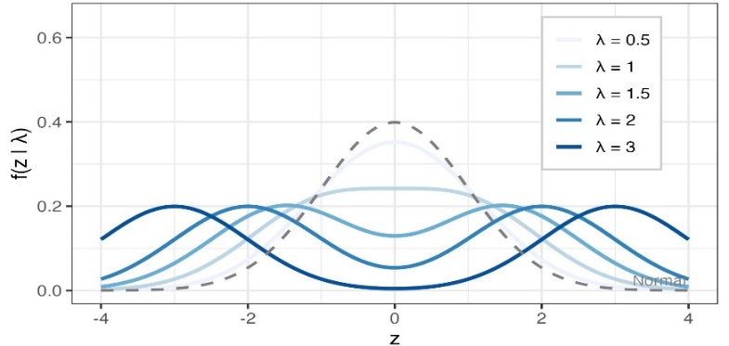
Fig. 1. Shapes of the TN probability density functions for $λ∈(0.5,1.0,1.5,2.0,3.0,5.0)$. The dashed line indicates the bimodality threshold: $λ=1/{\sqrt{2}}$.
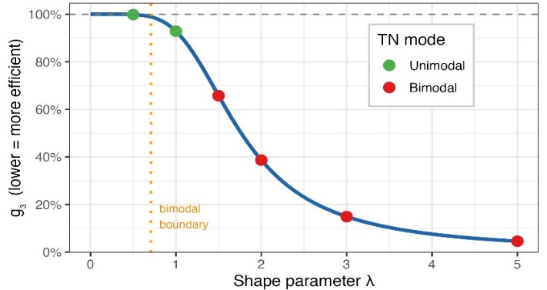
Fig. 2. Efficiency curve $g_{3}(λ)$ show as a function of the shape parameter $λ$ of the TN distribution.
  - Conclusions
When the distribution is close to Gaussian $(λ=0.5)$, PMM3 is practically identical to the OLS. At the bimodality $(λ=1.5)$, PMM3 provides approximately a 34% efficiency gain, representing a noticeable advantage. For platykurtic TN distributions $(λ≥2)$, PMM3 is substantially more efficient than OLS. MLE-TN generally achieves a higher ARE, but only when properly specified.
- Experiments
  - Monte Carlo study
The data-generating model is defined as:
$y_{v} = 1 + β_{1}x_{v} + ε_{v}, ε_{v} \sim TN(0, 1, λ)$. (8)
The simulation parameters: number of replications $M=500$; sample sizes n ∈ {46, 100, 200, 500}; shape parameters $λ∈\{0.5,1,1.5,2,3,5\}$; random seed = 20260312.
Metrics: Bias=${\hat{β}}_{1}-1$; Var$({\hat{β}}_{1}$); MSE=Bias²+Var; ARE=Var(OLS)/Var(method); $g_{3}_emp$ = Var(PMM3)/Var(OLS).
  - Real-world data: Fisher's iris dataset (Iris versicolor)
A subset of the classical Fisher Iris dataset [3] corresponding to the species Iris versicolor was used for empirical evaluation. The dataset contains $n=50$ observations.
${Sepal.Length}_{v} = β_{0} + β_{1} · {Sepal.Width}_{v} + ε_{v}$. (9)
OLS Residual Diagnostics: $n=50$; ${\hat{γ}}_{3}=0.273$ (indicating only negligible asymmetry); ${\hat{γ}}_{4}=-0.966$ (indicates pronounced platykurticity); $span/SD≈3.58$ – suggesting a restricted measurement range.
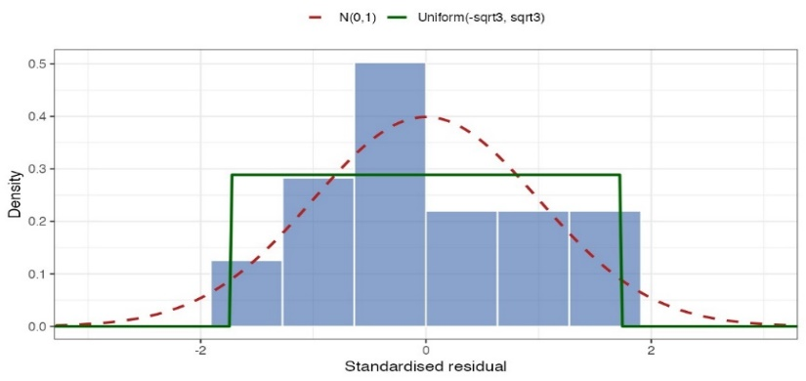
Fig. 3. Histogram of the OLS residuals for the Iris versicolor dataset with the fitted normal density superimposed.

The corresponding theoretical efficiency is: ${g_{3}}_{теор}=0.517$ which corresponds to a 51.7% reduction in variance. Based on the residual diagnostics: $γ_{4}=-0.966 <-0.7$ PMM3 is recommended.
  - Robustness under model misspecification
The robustness analysis investigates the behavior of the competing estimators when the error distribution is not the TN distribution. The following alternative distributions were considered: Uniform, Triangular, Logistic, Student's $t_{10}$; sample size $n=100$, number of Monte Carlo replications $M=500$.
- Results
  - Monte Carlo results
The results of the Monte Carlo method are presented in Table 3, with M = 500 replics.
Table 3. Monte Carlo results: ARE and $g_{3}$
Λ | γ₄ | n | ARE (MLE-TN) | ARE (PMM3) | g₃_emp | g₃_theor | Δg₃,%
0.5 | −0.080 | 100 | 0.940 | 0.947 | 1.057 | 0.999 | +5.8
0.5 | −0.080 | 200 | 0.968 | 0.964 | 1.037 | 0.999 | +3.8
1.0 | −0.500 | 100 | 1.078 | 1.085 | 0.920 | 0.929 | −0.9
1.0 | −0.500 | 200 | 1.099 | 1.080 | 0.926 | 0.929 | −0.3
1.5 | −0.959 | 100 | 1.667 | 1.527 | 0.653 | 0.657 | −0.6
1.5 | −0.959 | 200 | 1.540 | 1.394 | 0.718 | 0.657 | +9.2
2.0 | −1.280 | 100 | 3.475 | 2.536 | 0.394 | 0.387 | +1.9
2.0 | −1.280 | 200 | 4.168 | 2.807 | 0.356 | 0.387 | −7.9
3.0 | −1.620 | 100 | 8.927 | 6.150 | 0.163 | 0.149 | +9.1
3.0 | −1.620 | 200 | 9.318 | 6.406 | 0.156 | 0.149 | +4.7
5.0 | −1.849 | 100 | 27.44 | 23.77 | 0.042 | 0.045 | −7.5
5.0 | −1.849 | 200 | 26.20 | 22.34 | 0.045 | 0.045 | −0.9
where ARE > 1 indicates superiority over OLS. Furthermore $g_{3}_emp$ = Var(PMM3)/Var(OLS), $∆g_{3}= {(g_{3}_emp-g_{3}_theor)}/{g_{3}_theor)×100\%}$. For $n≥100$ the deviation remains within $<±10$.
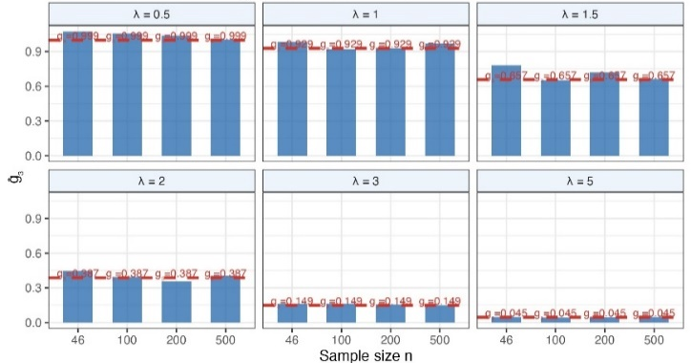
Fig. 4. Convergence of the empirical efficiency coefficient $g̃₃$ toward its theoretical value $g_{3}$
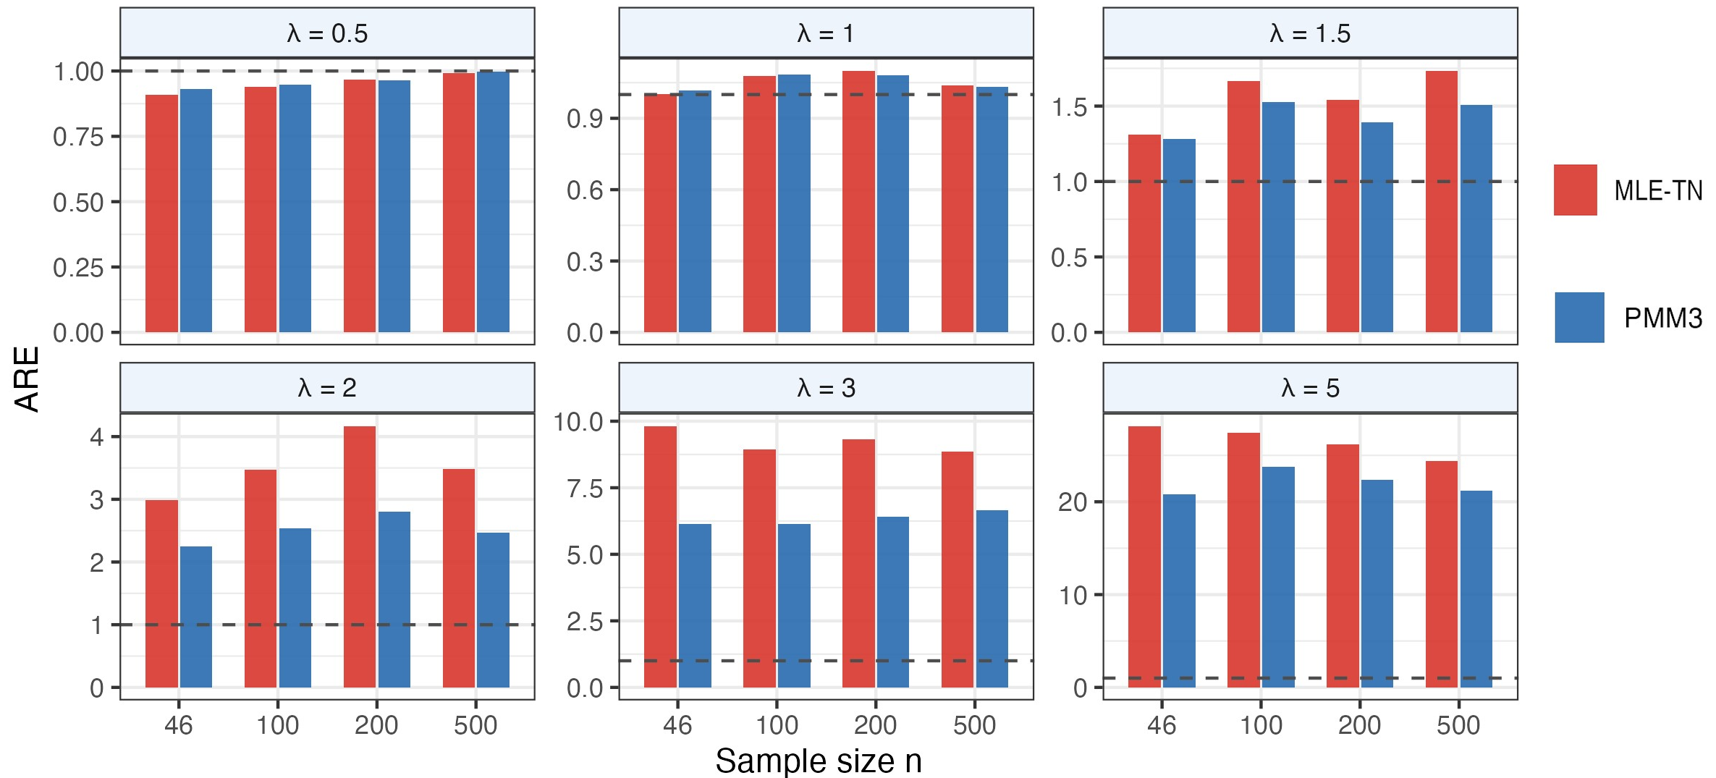
Fig. 5. Comparison of the asymptotic relative efficiencies of PMM3

  - Results for the Fisher iris dataset (iris versicolor)
Table 4. Comparison of estimation methods for iris versicolor ($n=50$).
Method | $${\hat{β}}_{1}$$ | LOO-MSE | $g_{3}_emp$ (bootstrap)
OLS | 0.865 | 0.2070 | 1.000 (baseline)
PMM3 | 0.797 | 0.2022 | 0.570
MLE-TN | 0.753 | 0.2109 | 0.746
The relative variance is computed as $g_{3}_emp$ = Var(method)/Var(OLS) using bootstrap estimation with $B=2000$ replications.
  - Robustness under model misspecification
The results in Table 5 demonstrate that PMM3 remains practically equivalent to OLS under model misspecification across all investigated distributions, whereas the efficiency of MLE-TN may deteriorate when the assumed TN model does not coincide with the true error distribution.
Table 5. ARE under model misspecification ($n=100,M=500$).
Uniform | $γ_{4}$ (true) | ARE(MLE-TN) | ARE(PMM3)
Triangular | −1.200 | 1.655 | 1.000
Logistic | −0.600 | 0.969 | 1.000
Логістичний | +1.200 | 0.994 | 1.000
Students’ t₁₀ | +1.000 | 0.982 | 1.000
- Discussion
  - Interpretation of the Monte Carlo results
PMM3 significantly outperforms OLS at $λ≥1.5$: ARE ranging from 1.5 to 23.8 – the theory has been confirmed. MLE-TN is even more effective than PMM3 for $λ≥1.5$ (assuming the TN specification is correct), but it estimates $p+2$ parameters – excessive parameterization for small n. The empirical efficiency coefficient $g_{3}_emp$ approximates its theoretical value $g_{3}_theor$ with an accuracy of approximately ±10% for sufficient sample sizes ($n≥100$), thereby confirming hypothesis H1. The PMM3 algorithm exhibited 100% convergence across all 24 Monte Carlo scenarios, including cases corresponding to bimodal TN distributions $(λ=3, 5$). For the most challenging scenario, $λ=5$, $n=100$, the efficiencies were ARE(PMM3) = 23.8 compared with ARE(MLE-TN) = 27.4. Thus, PMM3 lags behind MLE-TN by only about 15%, while requiring no prior knowledge of the underlying error distribution.
  - Interpretation of the results for the Fisher iris dataset (Iris versicolor)
The analysis of the Iris versicolor dataset demonstrates that PMM3 provides the best overall performance according to both predictive accuracy and estimation efficiency. PMM3 achieved the smallest prediction error: LOO-MSE = 0.2022, which is lower than that obtained by OLS = 0.2070 and MLE-TN = 0.2109. Bootstrap analysis indicates a 43% reduction in variance $(g_{3}_emp=0,570)$, compared with the theoretical prediction of 51.7%. Given the relatively small sample size ($n=50$), this agreement can be considered satisfactory. Despite estimating additional parameters $\left(η , λ\right)$, MLE-TN exhibited the poorest performance. For a sample size of only n = 50, the increased model complexity leads to overparameterization, offsetting the theoretical efficiency advantage of the method. Consequently, for datasets characterized by $n=50$ і $γ_{4}≈-0.97$, PMM3 represents the optimal estimation strategy.

Negative Examples. The whiteside dataset from the MASS package, which models household gas consumption as a function of outdoor temperature ($n=56$), illustrates a situation in which PMM3 does not provide a meaningful advantage. Its characteristics are as follows:
- ${\hat{γ}}_{4}=-0.431$ (moderate platykurticity, but $γ_{4}>-0.7$);
- $g_{3}_theor=0.920$ – theoretical improvement over OLS is approximately 8.0%;
- bootstrap analysis shows that PMM3 is practically indistinguishable from OLS ($g_{3}_emp=0.978$);
- the predictive performance satisfies LOO-MSE: PMM3/OLS = 0.999 indicating a difference of less than 0.1%.
Together with four additional real datasets having $γ_{4}∈\left[-0.54,-0.12\right]$ the observed efficiency ratio remained within $g_{3}emp∈\left[0.97,1.03\right]$. The empirical threshold $γ_{4}≲-0.7$.
  - Interpretation of the robustness analysis under model misspecification
PMM3 is robust, maintaining: ARE ≈ 1.0 for all investigated distributions. Consequently, even when its assumptions are not fully satisfied, PMM3 performs no worse than OLS. MLE-TN is considerably more sensitive to model misspecification. For example, under the triangular distribution, ARE = 0.969 indicating performance that is actually inferior to OLS. Therefore, PMM3 should be regarded as the safer estimation method whenever the true error distribution is uncertain. The Newton–Raphson implementation of PMM3 converged successfully in all 500 replications (Table 6), even for strongly bimodal TN distributions.
Table 6. Convergence of PMM3 for Bimodal TN Distributions ($n=100, M=500$)
$$λ$$ | Bimodal? | Bias (PMM3) | Convergence (%) | NA (%)
0.8 | No | −0.004 | 100% | 0%
1.0 | No | +0.005 | 100% | 0%
1.2 | Yes | −0.001 | 100% | 0%
1.5 | Yes | +0.007 | 100% | 0%
2.0 | Yes | −0.019 | 100% | 0%
3.0 | Yes | −0.022 | 100% | 0%
- Conclusions
- Theoretical results. PMM3 provides a 7% to 95% reduction in variance relative to OLS for TN-distributed errors with $λ∈\{1,…,5\}$. Under correct model specification, MLE-TN can achieve an even greater efficiency gain; however, it requires estimation of $p+2$ parameters.
- Monte Carlo study. MLE-TN is substantially more efficient than PMM3 for large values of $λ$, provided that the TN specification is correct. The empirical efficiency coefficient $g_{3}$ of PMM3 converges to its theoretical value for sample sizes of approximately $n≥100-200$.
- Robustness. PMM3 consistently maintains ARE ≈ 1 under model misspecification, whereas MLE-TN may perform worse than OLS. Consequently, PMM3 represents a safe choice when the form of the error distribution is uncertain.
- Real-world data. For the Iris versicolor dataset ( $γ_{4}=-0.966$, $n=50$) PMM3 achieves a 43% reduction in variance, while its predictive performance satisfies LOO-MSE PMM3 < OLS < MLE-TN.
- Empirical threshold. PMM3 demonstrates a practical advantage over OLS only when $γ_{4}≲-0.7$. For −0.7 < $γ_{4}$ < 0 all three methods are, for practical purposes, equivalent to OLS .
- Practical recommendations. When the TN model is confidently justified with $γ_{4}≲-0.7$ and the sample size is sufficiently large, MLE-TN should be preferred. When the underlying error distribution is uncertain with $γ_{4}≲-0.7$, PMM3 is the recommended choice due to its robustness and efficiency. For approximately Gaussian errors and , OLS remains the appropriate estimation method.

References
- Andargie, A.A., Rao, K.S.: Estimation of a linear model with two-parameter symmetric platykurtic distributed errors. J. Uncertain. Anal. Appl. 1, 13 (2013). doi: 10.1186/2195-5468-1-13.
- Cox, D. R.; Hinkley, D. V. A note on the efficiency of least-squares estimates. JRSS-B 1968, 30(2), 284–289.
- Fisher, R.A.: The use of multiple measurements in taxonomic problems. Ann. Eugen. 7(2), 179–188 (1936)
- Ganguly, S.S.: Robust regression analysis for non-normal situations under symmetric distributions arising in medical research. J. Mod. Appl. Stat. Methods 13(1), 446–462 (2014). doi: 10.22237/jmasm/1398918480.
- Gauss, C. F. Theoria Motus Corporum Coelestium. Perthes and Besser: Hamburg, 1809.
- Huber, P.J.: The behavior of maximum likelihood estimates under nonstandard conditions. In: Proceedings of the Fifth Berkeley Symposium on Mathematical Statistics and Probability, vol. 1, pp. 221–233. University of California Press, Berkeley (1967).
- Jarque, C.M., Bera, A.K.: A test for normality of observations and regression residuals. Int. Stat. Rev. 55(2), 163–172 (1987). doi: 10.2307/1403192.
- John, S. The three-parameter two-piece normal family. Communications in Statistics 1982, 11(8), 879–885.
- Koenker, R., Hallock, K.F.: Quantile regression. J. Econ. Perspect. 15(4), 143–156 (2001).
- Kunchenko, Yu. P.; Lega, Yu. G. Polynomial parameter estimation of close to Gaussian random variables. Radioelectronics and Communications Systems 1992, 35(8), 76–78.
- Leisen, F., Rossini, L., Villa, C.: Loss-based approach to two-piece location-scale distributions with applications to dependent data. Stat. Methods Appl. 29(2), 309–333 (2020). doi: 10.1007/s10260-019-00481-x.
- Ma, Y., Wang, S., Xu, L., Yao, W.: Semiparametric mixture regression with unspecified error distributions. TEST 30(2), 429–444 (2021). doi: 10.1007/s11749-020-00725-z.
- Narula, S.C., Wellington, J.F.: The minimum sum of absolute errors regression: a state of the art survey. Int. Stat. Rev. 50(3), 317–326 (1982).
- Salinas, H., Bakouch, H., Qarmalah, N., Martínez-Flórez, G.: A flexible class of two-piece normal distribution with a regression illustration to biaxial fatigue data. Mathematics 11(5), 1271 (2023). doi: 10.3390/math11051271.
- Stone, C.J.: Adaptive maximum likelihood estimators of a location parameter. Ann. Stat. 3(2), 267–284 (1975). doi: 10.1214/aos/1176343056.
- Tiku, M.L., Islam, M.Q., Selçuk, A.S.: Non-normal regression. II. Symmetric distributions. Commun. Stat. – Theory Methods 30(6), 1021–1045 (2001).
- Warsza, Z.L., Zabolotnii, S.W.: A polynomial estimation of measurand parameters for samples of non-Gaussian symmetrically distributed data. In: Szewczyk, R., Zieliński, C., Kaliczyńska, M. (eds.) Automation 2017. Advances in Intelligent Systems and Computing, vol. 550, pp. 468–480. Springer, Cham (2017). doi: 10.1007/978-3-319-54042-9_45.
- White, H.: Maximum likelihood estimation of misspecified models. Econometrica 50(1), 1–25 (1982). doi: 10.2307/1912526.
- Zabolotnii, S.W., Warsza, Z.L., Tkachenko, O.: Estimation of linear regression parameters of symmetric non-Gaussian errors by polynomial maximization method. In: Szewczyk, R., Zieliński, C., Kaliczyńska, M. (eds.) Automation 2019. Advances in Intelligent Systems and Computing, vol. 920, pp. 636–649. Springer, Cham (2020). doi: 10.1007/978-3-030-13273-6_59.
- Zabolotnii, S.W., Warsza, Z.L., Tkachenko, O.: Polynomial estimation of linear regression parameters for the asymmetric PDF of errors. In: Szewczyk, R., Zieliński, C., Kaliczyńska, M. (eds.) Automation 2018. Advances in Intelligent Systems and Computing, vol. 743, pp. 758–772. Springer, Cham (2018). doi: 10.1007/978-3-319-77179-3_75.

