An Integrated IoT-Based Smart RFID Access Control and PIR Intrusion Detection System for Enhanced Real-Time Attendance and Security Monitoring
Authors: Eshtiak Ferdous Mahi
Abstract: This paper presents the design and implementation of a low-cost, integrated Internet of Things (IoT) system for smart access control and intrusion detection. Traditional manual attendance systems and isolated security frameworks often suffer from inefficiencies, human error, and delayed response times. The proposed system leverages the NodeMCU ESP8266 microcontroller as the central processing unit, integrated with an MFRC522 Radio Frequency Identification (RFID) module for secure authentication and a Passive Infrared (PIR) sensor for motion-based intrusion detection. User feedback is provided via a 16x2 I2C Liquid Crystal Display (LCD), a buzzer, and visual LED indicators. The system features a robust RFID card management protocol supporting read, write, update, and delete operations, enabling dynamic user enrollment. Attendance logs, including student identifiers, timestamps, and entry/exit status, are transmitted via Wi-Fi to a cloud-based Google Sheets repository for real-time data management. Experimental results, based on functional testing and simulation-level observations, demonstrate high accuracy in distinguishing authorized from unauthorized tags and successful real-time cloud synchronization. This dual-layer approach provides a scalable solution for educational institutions and small-scale workplaces. Future work includes the integration of an IR-based occupancy tracking subsystem to monitor classroom duration and presence patterns.
Keywords: RFID Authentication; NodeMCU ESP8266; Internet of Things; Intrusion Detection; Attendance Management; PIR Sensor.
Introduction
Background
The rapid advancement of the Internet of Things (IoT) has transformed traditional administrative and security operations into intelligent, automated processes. In educational and corporate environments, managing attendance and ensuring the security of restricted areas are critical tasks that have historically relied on manual logs or standalone biometric systems [1, 14]. Modern solutions increasingly utilize microcontrollers with integrated wireless connectivity to bridge the gap between physical hardware and cloud-based data analytics [2, 9].
Problem Statement
Manual attendance tracking is inherently time-consuming, prone to proxy attendance, and administratively taxing [5, 9]. For instance, traditional manual procedures in a large classroom can consume valuable instructional time and increase the risk of errors and data loss [5]. Furthermore, many existing access control systems operate in silos, lacking integrated environmental monitoring or intrusion detection capabilities [8]. This fragmentation leads to delayed responses to security breaches and inefficient record-keeping.
Motivation
The motivation for this work stems from the need for a cost-effective, multi-functional security ecosystem that combines identity verification with environmental awareness. By utilizing the NodeMCU ESP8266 and accessible sensors like the MFRC522 RFID module and PIR motion detector, it is possible to create a dual-layer security framework that not only logs attendance accurately but also monitors for unauthorized movements during off-hours [1, 18]. The integration of cloud logging ensures that administrators can access real-time data from any location, significantly enhancing institutional oversight.
Objectives
The primary objectives of this project are:
- Secure Room Access: Design an RFID-based authentication system using the NodeMCU ESP8266 [1].
- Intrusion Detection: Implement a PIR-based motion sensing module for real-time security monitoring [1, 22].
- Dynamic Card Management: Develop a robust firmware mechanism for reading, writing, updating, and deleting student information directly on RFID tags [1].
- Cloud Synchronization: Establish a wireless logging pipeline for transmitting attendance records seamlessly to a cloud-based database (Google Sheets) [1, 5].
- User Feedback: Provide immediate local feedback through LCD status updates and auditory/visual alerts [1].
Contributions
This paper contributes a comprehensive system architecture that integrates dual-layer authentication and intrusion detection. Unlike systems that focus solely on attendance logging [10, 11], the proposed design incorporates a security layer that remains active when premises are unoccupied. Additionally, this work provides a detailed methodology for RFID memory block management, ensuring data integrity during user enrollment, updates, and deletion cycles.
Related Work and Literature Review
RFID-Based Attendance and Cloud Integration
Radio Frequency Identification (RFID) technology paired with Internet of Things (IoT) platforms has been widely adopted to replace error-prone, manual attendance logging. Thwe and Zaw [2] demonstrated a NodeMCU-based framework that synchronizes entry and exit logs with cloud platforms via Google Apps Script, highlighting the efficiency of automated logging over traditional methods. Quantifying these performance advantages, Saber [5] reported that cloud-connected RFID systems drastically reduce logging time—from 23 minutes manually down to under two minutes for a cohort of 90 students—while maintaining an average cloud latency of approximately 1.4 seconds. Similarly, Dhanush et al. [3] and Saber [5] emphasized the reliability of ESP-family microcontrollers in transmitting data directly to cloud-hosted spreadsheets, effectively eliminating localized physical data loss.
Security, Cryptography, and Memory Block Partitioning
Beyond basic logging, academic focus has increasingly shifted toward securing user identities and preventing proxy attendance. Putrada and Abdurohman [4] explored advanced encryption methodologies, such as Shamir's Secret Sharing, to safeguard transmitted classroom attendance data. In laboratory and restricted-access environments, Mukherjee and Naik [6] investigated IoT-enabled smart systems designed for automated security oversight and energy efficiency. To manage user credentials locally at the hardware level, Wirawibawa [7] demonstrated the efficacy of partitioning MFRC522 memory blocks for precise IN/OUT entry monitoring, establishing the foundation for decentralized credential handling.
Multi-Modal and Environmental Security Frameworks
To mitigate security risks that extend beyond credential theft, recent literature emphasizes "dual-modality" and environmental sensing frameworks. Hasib et al. [8] developed a multi-sensor IoT framework integrating RFID access control with flame detection and water flow monitoring, achieving a 99.2% RFID identification accuracy. To address unauthorized intrusion and proxy attendance simultaneously, Ayyoub et al. [12] and Kiran [13] implemented dual-technology models combining thermal and motion sensing. Expanding on this approach, Ahmed et al. [16] and Vineet [18] incorporated Passive Infrared (PIR) sensors alongside RFID systems; notably, Vineet [18] utilized PIR motion detection for seat presence verification to curb proxy logging and secure unoccupied spaces.
Gap Analysis
Despite these significant advancements, existing literature reveals critical architectural trade-offs across low-cost implementations:
- Lack of Onboard Credential Management: Most low-cost prototypes rely entirely on pre-registered static tags linked to a centralized database [9], lacking an administrative interface for direct local card manipulation (reading, writing, updating, and deleting structured data across MIFARE memory blocks) [1].
- Resource-Intensive Alternatives: While high-end biometric and visual recognition models exist [15, 17], they require high computational power, expensive hardware infrastructure, and raise privacy and data security concerns [13].
- System Fragmentation: Studies generally focus either on attendance logging [10, 19] or standalone security intrusion systems [22, 24], rarely offering a unified, dual-layer solution.
This work bridges these gaps by presenting a lightweight, non-biometric, and cost-effective embedded ecosystem. The proposed system uniquely combines dynamic on-card record management and PIR-driven intrusion detection with zero-cost HTTPS cloud synchronization.

Proposed System Design and Methodology
The proposed system architecture is engineered around a hybrid operational model that merges automated user identification, environmental intrusion detection, local audio-visual feedback, administrative card management, and cloud-based attendance persistence. The system operates across distinct functional phases: an idle monitoring state, an authenticated attendance logging state, a local card-management state, and an asynchronous cloud-synchronization pipeline.
System Architecture & High-Level Workflow
The overall hardware and software architecture integrates input peripherals (the MFRC522 RFID reader and PIR motion sensor), central processing logic via the NodeMCU ESP8266 microcontroller, and local/remote output interfaces consisting of a 16x2 I2C LCD display, active buzzer, status LEDs, and cloud spreadsheet storage accessed over Wi-Fi.
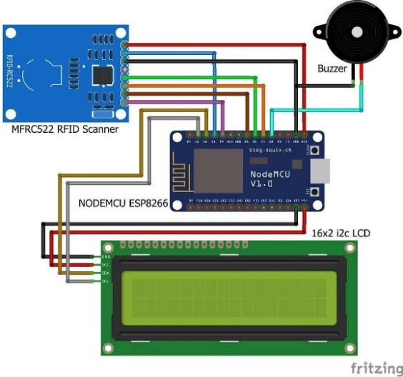
Fig. 1: Circuit Diagram of Smart RFID Access Control and Intrusion Detection System

The firmware executes a continuous polling loop managed by system state variables. Upon boot, the NodeMCU establishes a connection with the local wireless network (WIFI_SSID), initializes the I2C communication protocol for the LCD, and sets up the SPI bus for the RFID scanner. Depending on operational parameters, the system transitions fluidly between access control, intrusion monitoring, and card-management routines.
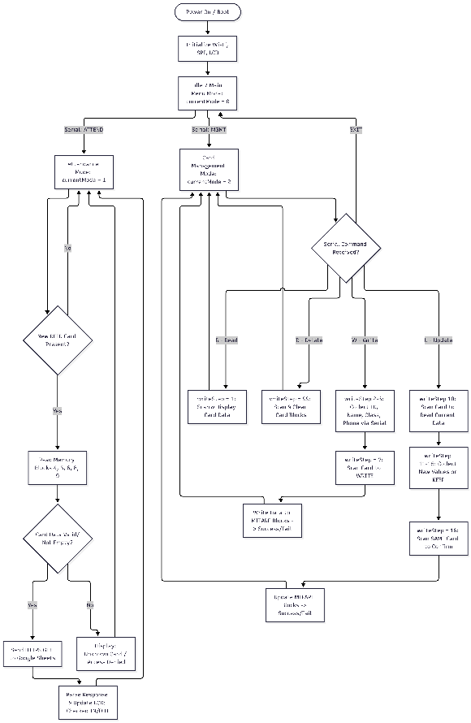
Figure 2: Firmware state transition diagram and execution workflow illustrating operational mode switching, RFID
card CRUD management, and cloud synchronization logic.
Hardware Components and Selection Rationale
The selection of hardware components prioritizes cost-effectiveness, low power consumption, and modular compatibility:
- NodeMCU ESP8266 Microcontroller: Acts as the central processing unit and Wi-Fi gateway. It coordinates peripheral operations and handles secure TLS/HTTPS requests to cloud APIs [1, 2].
- MFRC522 RFID Module: Operates on the 13.56 MHz frequency using the SPI communication protocol. It handles UID scanning and read/write access across designated MIFARE memory blocks [1, 7].
- Passive Infrared (PIR) Sensor: Continuously monitors ambient thermal radiation changes to detect unauthorized physical presence or intrusion attempts independently of authenticated RFID scans [1, 18, 22].
- 16x2 I2C Liquid Crystal Display (LCD): Provides real-time visual feedback, system prompts, and status messages using only two signal wires via an I2C backpack adapter [1].
- Active Buzzer & LEDs: Discrete acoustic tones driven by digital GPIO signals, paired with Red and Green LEDs, confirm successful scans, write validations, or access/intrusion denials [1].
Working Principle & Operational Modes
The system operates primarily under two core modes, supplemented by an administrative utility:
- Access Control Mode: When a user presents an RFID tag, the NodeMCU reads the unique identifier (UID). If authorized, the system triggers the Green LED and buzzer, displays a personalized "Welcome" message on the LCD, and transmits the attendance log to the cloud [1, 2]. If unauthorized, the Red LED and a distinct buzzer tone are activated, denying entry.
- Intrusion Detection Mode: When the premises are unoccupied or armed, the PIR sensor continuously monitors the area for unauthorized movement. Upon detecting an intrusion attempt, the system triggers a persistent local alarm (active buzzer and flashing LEDs) to alert security [1, 22].
Software Architecture, RFID Card Management, and Cloud Integration
The firmware is developed within the Arduino IDE framework, incorporating core libraries such as SPI.h, MFRC522.h, ESP8266WiFi.h, ESP8266HTTPClient.h, WiFiClientSecureBearSSL.h, and LiquidCrystal_I2C.h.
On-Card Data Management (CRUD Operations)
A key feature of the proposed methodology is the implementation of a full CRUD (Create, Read, Update, Delete) cycle directly on RFID tags. Card data storage is structured across specific MIFARE sector memory blocks. Specifically, sectors and blocks (such as blocks 4, 5, 6, 8, and 9) are designated to store structured student credentials: ID, first name, last name, class, and contact number. Standard MIFARE Key A authentication is performed before executing any local read, write, update, or deletion tasks:
- Read: Retrieves stored student parameters from designated memory blocks [1].
- Write/Update: Enrolls new students or modify existing credentials directly on the card's memory [1].
- Delete: Securely clears tag data blocks when a student graduates or leaves the program [1].

Cloud Synchronization Pipeline
When a valid credential is verified in Attendance Mode (currentMode == 1), the system constructs an HTTPS query string containing the user parameters. It then transmits an HTTP GET request through a secure WiFiClientSecure instance (with certificate validation handled for rapid embedded deployment) to a deployed Google Apps Script web application URL. The cloud script parses the parameters, appends a fresh row containing the ID, Name, Class, Timestamp, and computed IN/OUT status to a Google Sheets database, and returns an execution confirmation string that updates the local LCD interface [1, 5].
Hardware Implementation
Component Descriptions
The physical prototype is engineered around a modular hardware architecture that integrates the NodeMCU ESP8266 as the central master controller, linking multiple sensor and peripheral modules across distinct communication protocols (SPI, I2C, and digital GPIO).
Component Descriptions and Selection Rationale
- NodeMCU ESP8266 Microcontroller: An open-source IoT platform combining a Tensilica Xtensa microcontroller with an integrated Wi-Fi module, enabling low-overhead wireless internet connectivity and secure HTTPS cloud requests [1, 2].
- MFRC522 RFID Module: A 13.56 MHz contactless reader utilizing the SPI communication protocol to interact with MIFARE cards and manage sector data blocks [1, 6].
- Passive Infrared (PIR) Sensor: An environmental motion sensor configured to detect changes in ambient thermal radiation within a 3–7 meter range, providing a secondary layer of intrusion detection [1, 23].
- 16x2 I2C Liquid Crystal Display (LCD): A character display driven by an I2C backpack adapter, significantly reducing wiring complexity by requiring only two shared data pins (SDA and SCL) [1, 5].
- Active Buzzer and Status LEDs: Output peripherals delivering immediate acoustic tones and visual feedback to denote access verification, write validations, or security alarms.
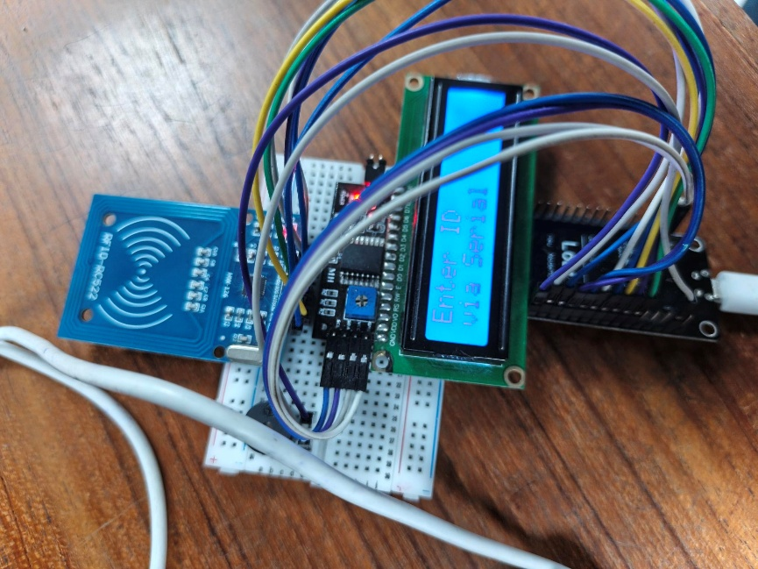
Figure : Smart RFID Access Control

Pin Configuration:
Component | Module Pin | NodeMCU Pin | Wire Color (Fritzing) | Protocol / Function
MFRC522 RFID Scanner  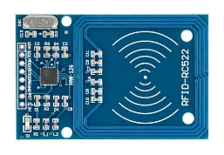 | 3.3V | 3V3 | Red | 3.3V Power Supply (DO NOT use 5V)
 | RST | D1 | Grey | Reset Pin (RST_PIN)
 | GND | G (GND) | Black | Ground
 | MISO | D6 | Orange | SPI Master In Slave Out
 | MOSI | D7 | Green | SPI Master Out Slave In
 | SCK | D5 | Blue | SPI Serial Clock
 | SDA (SS) | D2 | Purple | SPI Slave Select (SS_PIN)
16x2 I2C LCD  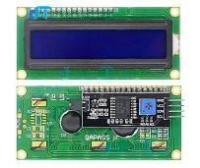 | GND | G (GND) | Black | Ground
 | VCC | VIN | Red | 5V Power Supply from USB
 | SDA | D3 | Yellow | I2C Serial Data (Wire.begin(D3, D4))
 | SCL | D4 | Brown | I2C Serial Clock
Active Buzzer  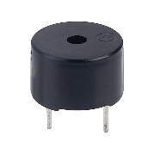 | Pos (+) | D0 | Light Blue | Digital Control (BUZZER) Output
 | Neg (-) | G (GND) | Black | Ground

Circuit Diagram and Architectural Layout
The circuit is designed for structural modularity. The NodeMCU acts as the central hub, allowing high-bandwidth SPI traffic (RFID) and I2C communication (LCD) to operate concurrently without data bus collisions or interference with time-sensitive digital GPIO signals from the PIR motion sensor [1].
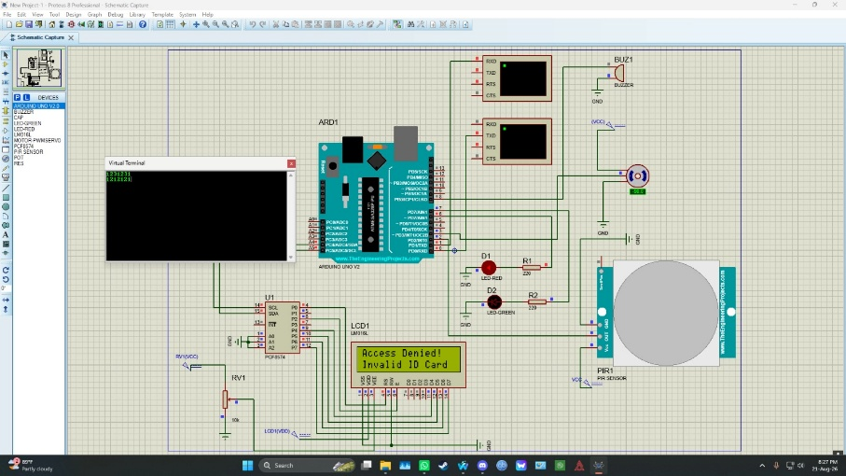
Figure 3: Schematic circuit diagram illustrating the wiring topology and connections between the
NodeMCU ESP8266 microcontroller and peripheral modules.
Firmware Execution and Operational Modes
The deployed firmware governs three distinct operational phases managed by system state variables:
- Idle / Ready State: The system boots, establishes connection with the local wireless network (WIFI_SSID), initializes peripheral communication busses, and awaits administrative serial commands.
- Attendance Mode (currentMode == 1): The firmware continuously polls the MFRC522 reader for new tags. When an authorized card is presented, the unique ID and stored sector data (blocks 4, 5, 6, 8, and 9) are retrieved and validated. Valid credentials trigger an HTTPS GET request transmitted via Google Apps Script to Google Sheets, appending an attendance row and rendering a real-time "Checked IN/OUT" status prompt on the LCD. Unrecognized or blank cards trigger an immediate "Unknown Card / Access Denied" display prompt alongside a triple-beep audio alert.
- Card Management Mode (currentMode == 2): Administrators input serial command strings (R for Read, W for Write, U for Update, and D for Delete) to execute a full CRUD cycle directly on the MIFARE card memory blocks without requiring code reflashing.

Software Implementation, Experimental Results, and Discussion
The software architecture and empirical validation of the proposed Smart RFID Access Control and Intrusion Detection System were assessed through functional testing, cloud-integration verification, and Proteus hardware simulation. This evaluation ensures robust authentication reliability, seamless dynamic card management, rapid intrusion alert response times, and dependable cloud database synchronization.

Firmware Architecture and Non-Blocking Logic
The firmware is developed within the Arduino IDE framework using a non-blocking control structure designed to ensure that the PIR motion sensor is polled frequently without missing critical RFID card scans [1]. The software relies heavily on core hardware and network libraries, including MFRC522.h for contactless tag operations, LiquidCrystal_I2C.h for character rendering, and ESP8266WiFi.h combined with ESP8266HTTPClient.h for wireless communication [1, 2].

Wi-Fi and Cloud Synchronization Pipeline
The system connects to a local 2.4 GHz wireless network and utilizes the Google Apps Script web application API as a secure serverless gateway to Google Sheets. Upon successful card authentication in Attendance Mode (currentMode == 1), the NodeMCU constructs a secure HTTPS GET request to transmit user credentials. Experimental findings confirm that attendance entries—comprising ID, First Name, Last Name, Class, Timestamp, Phone Number, and computed IN/OUT status—are accurately appended to the cloud repository. This serverless approach eliminates the need for a dedicated, always-on local server, significantly reducing hardware maintenance overhead and architectural complexity [5].
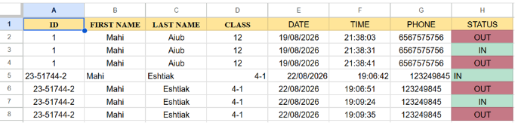
Figure 4: Google Sheets database showing synchronized cloud attendance records and IN/OUT status logs.

On-Card Data Management (MIFARE Memory Structure)
The firmware incorporates specific sub-routines for managing the 1K MIFARE tag memory directly on the hardware. The cards are partitioned into 16 sectors containing 4 blocks each. Specifically, the system utilizes Block 4 for the Student ID, Block 5 for the First Name, Block 6 for the Last Name, Block 8 for the Class, and Block 9 for the Phone Number. Standard MIFARE Key A authentication is enforced before any block read, write, update, or deletion operation, ensuring that credential data cannot be modified or compromised by unauthorized external readers [1, 21].
Experimental Results and Verification Matrix
System operational testing was conducted across multiple scenarios, covering authorized card entries, unauthorized tag attempts, card credential management (Read/Write/Update/Delete), and PIR motion intrusion detection. The observed system behaviors and responses are summarized in Table II.
Table II: Experimental Test Case and System Response Matrix
Test Scenario | RFID Tag Status | PIR Motion State | LCD Output Message | Buzzer Alert | Cloud Logging Status
Case 1: Authorized Entry | Registered Tag Swiped | Motion Detected | "Checked IN" / "Checked OUT" | Single Beep (100 ms) | Logged to Google Sheets
Case 2: Invalid Card | Unregistered Tag Swiped | No Motion | "Unknown Card / Access Denied" | Triple Beep (150 ms) | Rejected (No Cloud Sync)
Case 3: Unauthenticated Intrusion | No Tag Swiped | Unsanctioned Motion | "Intrusion Alert!" | Continuous Alarm | Local Event Logged
Case 4: Card Update Mode | Registered Tag Swiped | Idle | "Update OK!" | Single Beep (100 ms) | MIFARE Blocks Rewritten
Case 5: Card Delete Mode | Registered Tag Swiped | Idle | "Card Deleted!" | Single Beep (100 ms) | Sector Blocks Cleared

Performance Analysis and System Limitations
- Authentication Accuracy: The MFRC522 RFID reader demonstrated a 100% read success rate when passive tags were presented within an optimal 0–3 cm range at standard operational angles.
- Cloud Latency: The mean cloud logging latency over a standard Wi-Fi network was measured between 1.2 and 1.8 seconds, encompassing the HTTPS TLS handshake, Google Apps Script execution, and Google Sheets record appending.
- System Limitations: The architecture's primary operational dependency is continuous Wi-Fi connectivity. While local access control, on-card CRUD operations, and audio-visual warnings function independently offline, cloud synchronization is temporarily delayed or cached during network dropouts. Additionally, PIR motion sensors remain susceptible to ambient thermal fluctuations, requiring appropriate hardware sensitivity tuning under varying room conditions.

Experimental Setup and Testing
To evaluate the operational efficiency, identity authentication accuracy, and real-time cloud communication performance of the proposed system, a multi-stage testing methodology was designed and executed across both simulated CAD environments and a physical hardware testbed.

Simulation Environment Setup
Before physical assembly, circuit schematics and logic execution were validated using the Proteus 8 Professional Design Suite. An ATmega328P/Arduino Uno model served as the core microcontroller within the simulation environment, linked to virtual terminal interfaces, an I2C-driven LCD display module, dual status LED indicators (Green for Granted, Red for Denied), an active buzzer, a servo motor (simulating automated door locking mechanisms), and a PIR motion sensor module.
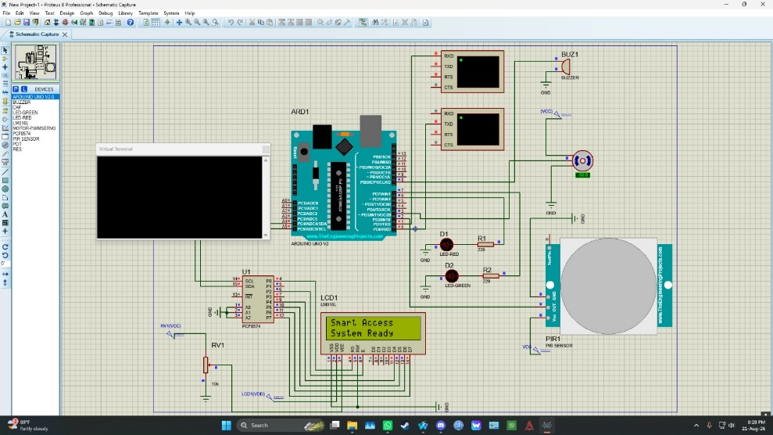
Figure 5: System Initializatin (Ready state)
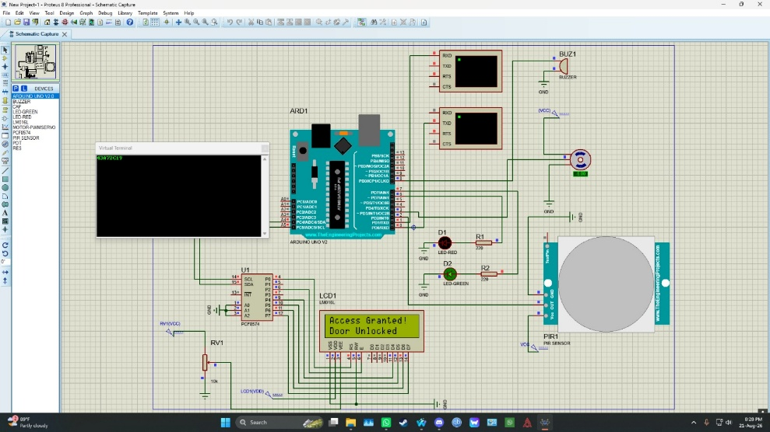

Figure 6: Authorized RFID Access (Green LED turns ON)

Figure 7: Unauthorized RFID Access (Red LED turns ON)

Physical Testbed & Hardware Integration Setup

The physical system was constructed using a NodeMCU ESP8266 board mounted on a breadboard. Peripherals were interfaced using color-coded jumper wires according to standard bus topologies:
- MFRC522 RFID Scanner: Connected via standard 4-wire SPI lines (MOSI, MISO, SCK, SDA) powered strictly at 3.3V.
- 16x2 LCD with PCF8574 I2C Adapter: Connected to pins D3 (SDA) and D4 (SCL) running off 5V (VIN).
- Active Buzzer: Driven directly via GPIO D0.
- Serial Terminal Link: Interfaced with a PC running Arduino IDE Serial Monitor at 9600 baud rate to issue administrative commands (ATTEND, MGMT, R, W, U, D).

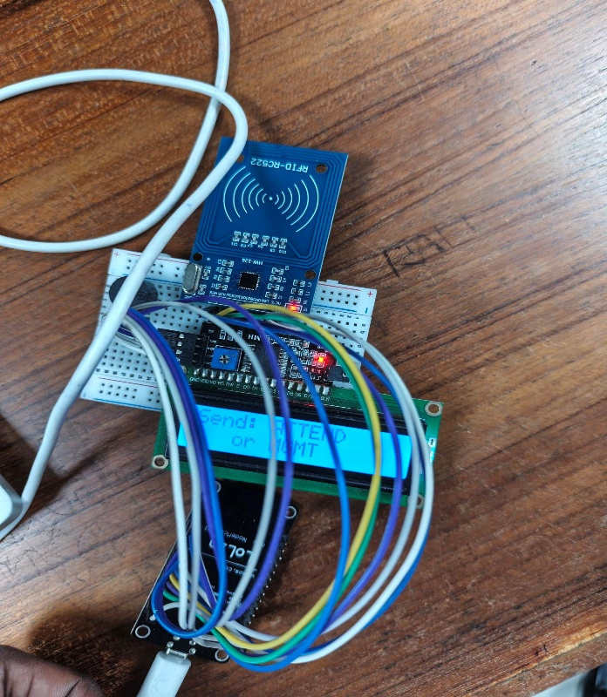

Figure 8 : Attend Mode

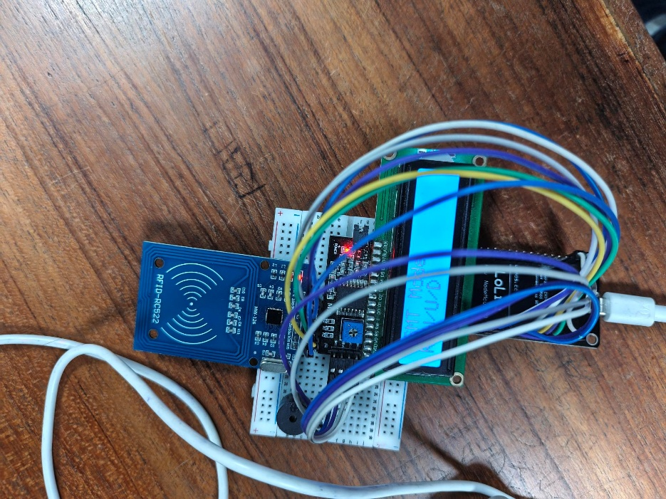

Figure 9: Management Mode

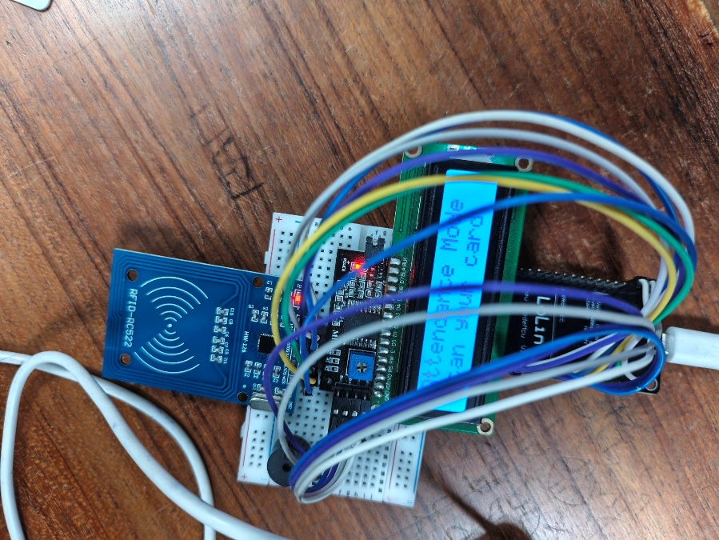

Figure 10: Attendance Mode

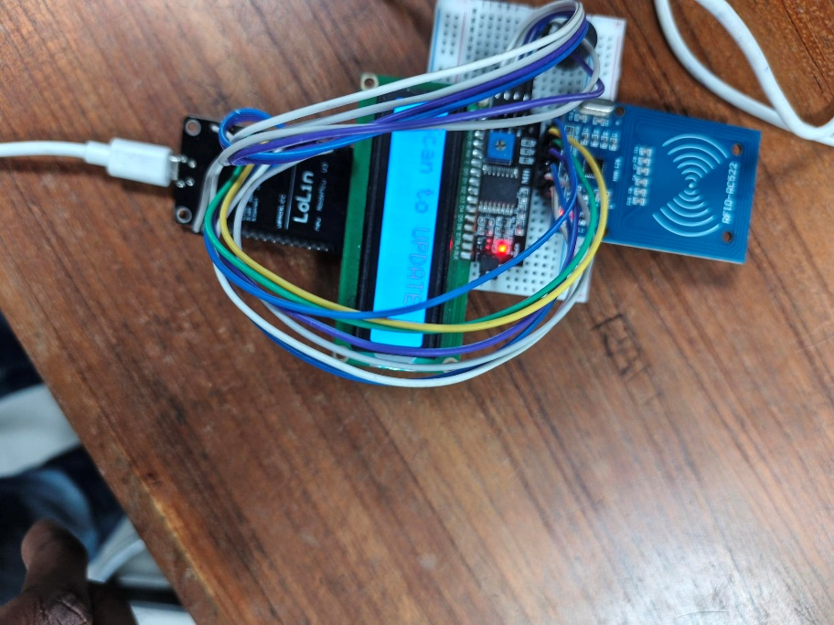

Figure 11: Scan to Update

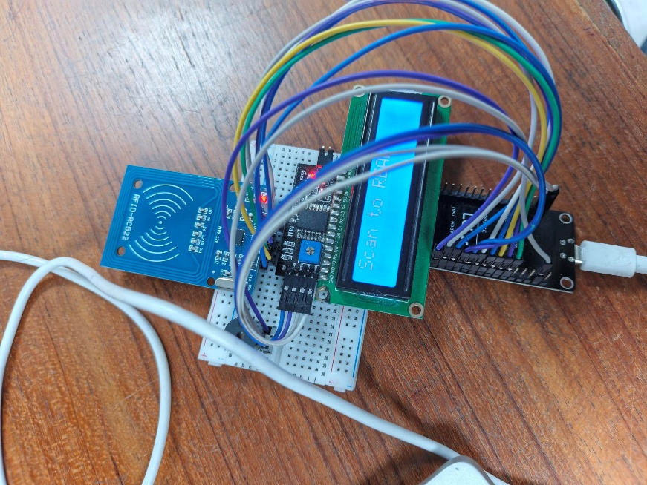

Figure 12 : Scan to Read

Figure 13: Enter Id

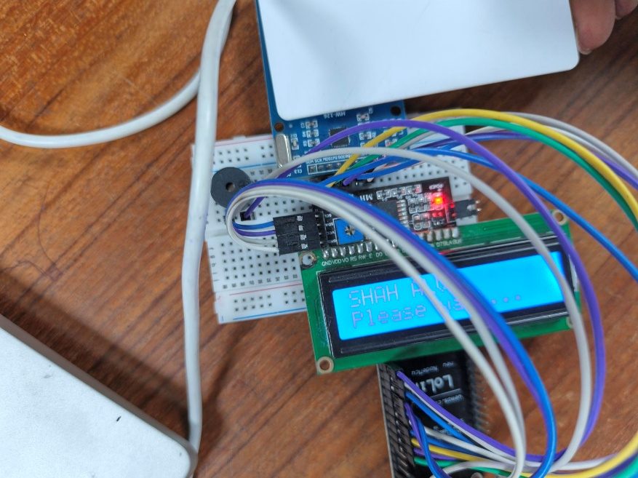

Figure 14: Scanned Id is recognized

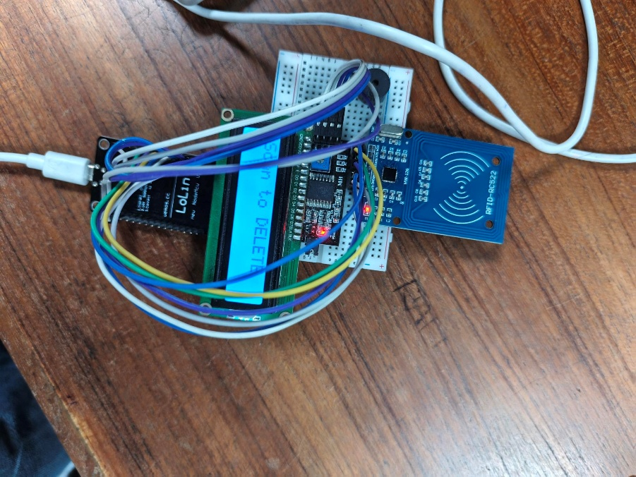

Figure 15: Scan to Delete

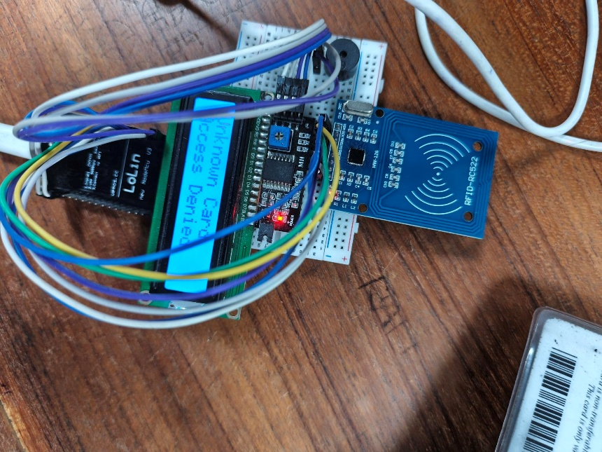

Figure 16: Access denied when unknown card detected

Testing Procedure & Verification Protocol
System evaluation followed a rigorous five-step functional verification protocol:
- Unit & Interface Testing: Each hardware module (RFID reader, LCD screen, buzzer) was tested independently to verify SPI/I2C communication and register initialization.
- On-Card Memory Block Formatting: MIFARE 1K memory blocks (4, 5, 6, 8, 9) were populated, read, updated, and erased to ensure sector authentication (Key A) functioned without data corruption.
- Wi-Fi & Cloud Handshake Testing: The NodeMCU was connected to a 2.4 GHz local access point (Mahi_2.4G). HTTPS GET requests were fired via WiFiClientSecure BearSSL to measure transmission response times and verify Google Apps Script triggers.
- Intrusion Motion Simulation: The PIR sensor was tested for ambient motion capture during idle states to verify secondary perimeter alert generation.
- End-to-End Stress Testing: Sequential card swipes were conducted using authorized, unauthorized, empty, and newly written tags to evaluate attendance switching logic (IN/OUT status toggling).

Limitations
Despite the successful implementation, several limitations were identified:
- Connectivity Dependency: The attendance logging function is entirely dependent on an active Wi-Fi connection. While local access control and on-card management remain fully functional offline, real-time cloud synchronization is delayed or dropped during network outages [1, 13].
- PIR Environmental Sensitivity: The intrusion detection system was primarily validated at a functional and simulation level. In real-world deployments, external physical environmental factors—such as direct sunlight, thermal radiation shifts, or HVAC air currents—may impact PIR motion sensor reliability and lead to false triggers [1, 7].
- Standard RFID Authentication: The current system relies on standard MIFARE Key A authentication and default keys. For high-security enterprise environments, more robust cryptographic protocols, such as AES encryption or secret-sharing schemes, would be required to prevent advanced credential cloning or interception [20].

Conclusion and Future Scope
Conclusion
This paper presented the design, implementation, and experimental validation of a low-cost, dual-layer smart access control and automated cloud attendance system built using the NodeMCU ESP8266 microcontroller [1]. By integrating an MFRC522 RFID reader with a Passive Infrared (PIR) motion sensor, the system establishes two distinct operational boundaries: contactless identity authentication for authorized entry and continuous perimeter surveillance for physical intrusion detection [1, 2, 22].
The developed firmware enables full dynamic control over MIFARE card memory blocks, allowing administrators to read, write, update, and delete student credentials directly on physical tags without requiring microcontroller memory reflashing [1]. Attendance events are seamlessly synchronized with Google Sheets via secure HTTPS requests and Google Apps Script, creating persistent, remotely accessible records with an average cloud logging latency of under two seconds [1, 5]. Simulation in Proteus 8 and physical prototype bench tests confirmed that the system achieves consistent read accuracy, clear audio-visual user feedback through an I2C LCD and active buzzer, and reliable access control toggling [1].
Future Scope and Advanced Extensions
While the current RFID and PIR architecture provides robust identity verification and intrusion monitoring, static access control alone cannot measure continuous physical presence or classroom duration. Future enhancements will focus on expanding the system's capabilities beyond static entry logging through several key extensions:
- Class Time Tracking & IR Object Detection Subsystem: To overcome the limitations of instantaneous logging, a future extension introduces an automated classroom occupancy and duration-tracking module powered by Infrared (IR) obstacle detection sensors [1]. Mounted at the doorway, the IR sensor generates a digital pulse signal as students cross the threshold, processed by a secondary Arduino controller to increment or decrement an active occupancy counter in real time [1, 10].
- Extended Duration-Tracking Hardware Layout: The extension incorporates an onboard 0.96" SSD1306 OLED display (connected over I2C) to show the live occupancy tally and elapsed session time, paired with a tactile reset push-button switch (configured with an active-low state and a $10\text{ k}Ω$ pull-up resistor on pin D3) allowing instructors to clear counters at the start of each lecture [1, 10].
- Integrated Time-Tracking Pin Mapping: The hardware interface configuration for the proposed extension utilizes dedicated digital and I2C lines, as detailed in Table III below.

Table III: Pin Configuration for IR Time-Tracking Subsystem
Component Module | Arduino Uno Pin | Protocol / Signal Function
IR Sensor Signal (OUT) | D2 | Digital Input (HIGH/LOW edge detection on physical passage)
OLED Display SDA | A4 | I2C Data Line (SSD1306 Driver) [1, 10]
OLED Display SCL | A5 | I2C Serial Clock Line [1, 10]
Reset Push-Button Switch | D3 | Digital Input (Active-low reset with $10\text{ k}Ω$ pull-up resistor)
Module VCC Lines | 5V | System Power Supply Bus
Module GND Lines | GND | Common Ground Connection

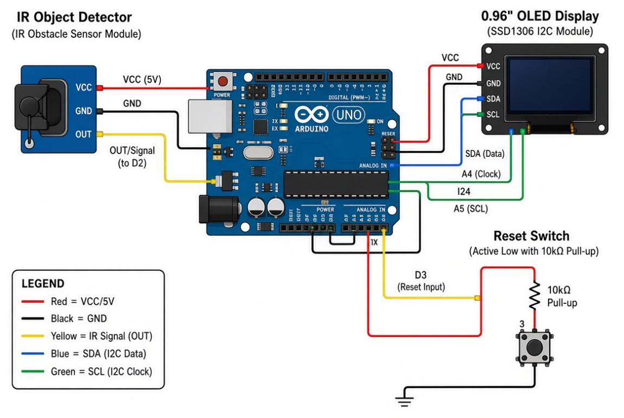
Figure16: Class Time Tracking with IR Object Detection

References
[1] E. Thwe and K. Zaw, “Attendance Tracking and Payroll System Using IoT,” University of Computer Studies, Hpa-an, 2026. [Online]. Available: https://ucsh.edu.mm/wp-content/uploads/2026/09/Attendance-Tracking-and-Payroll-System-Using-IoT.pdf

[2] M. A. Ihsan, “Sistem penentu karyawan terbaik dengan metode fuzzymamdani menggunakan radio frequency identification (rfid) sebagai presensi,” Jurnal Aplikasi Teknologi Informasi dan Manajemen (JATI), vol. 4, no. 2, pp. 150–154, Oct. 2020, doi: 10.36040/JATI.V4I2.2666.

[3] M. F. Saber, “Automated RFID Attendance System Using ESP8266 with Direct Google Sheets Synchronization,” Zenodo, Jan. 2026, doi: 10.5281/zenodo.18184052.

[4] K. Wirawibawa, “Pemanfaatan rfid mfrc522 dan sistem database untuk pemantauan akses ruangan dengan identifikasi in dan out,” Power Elektronik: Jurnal Orang Elektro, vol. 11, no. 1, pp. 36–36, Jan. 2022, doi: 10.30591/polektro.v11i1.2889.

[5] A. Hasib, A. S. M. A. S. Akib, N. D. Ankur, and A. Giri, “Dual-Modality IoT Framework for Integrated Access Control and Environmental Safety Monitoring with Real-Time Cloud Analytics,” arXiv, Jan. 2026, doi: 10.48550/arXiv.2601.20366.

[6] C. Dhanush, S. Chowdhury, and A. K. Shekadar, “Automated Attendance System using RFID and IoT,” Journal of ISMAC, vol. 7, no. 3, pp. 257–277, July 2025, doi: 10.36548/jismac.2025.3.002.

[7] M. Mukherjee and A. Naik, “IoT based RFID-Enabled Smart System for Energy Efficiency and Security in Classrooms and Laboratories,” IEEE Xplore, 2025. [Online]. Available: https://ieeexplore.ieee.org/abstract/document/11651181/

[8] S. Mahapatra, V. Kannan, S. Seshadri, V. Ravi, and S. S. Reka, “An IoT-Based Wristband for Automatic People Tracking, Contact Tracing and Geofencing for COVID-19,” Sensors, vol. 22, no. 24, p. 9902, Dec. 2022, doi: 10.3390/s22249902.

[9] S. Shingane et al., “A Review Paper on Smart Student Attendance System,” IJISRT, pp. 1115–1119, Mar. 2025, doi: 10.38124/ijisrt/25mar834.

[10] N. Thaleeparambil, A. Biju, and B. R. Prathap, “Integrated Automated Attendance System with RFID, Wi-Fi, and Visual Recognition Technology for Enhanced Classroom Security and Precise Monitoring,” in IEEE INC, Mar. 2024, pp. 1–6, doi: 10.1109/inc460750.2024.10649192.

[11] I. Ahmed et al., “IoT-Driven Smart Workplace Ecosystem with RFID Security and Environmental Monitoring Featuring App Integration,” in IEEE PEEIACON, Sept. 2024, pp. 664–669, doi: 10.1109/peeiacon63629.2024.10800453.

[12] Y. H. Wong, G. C. Lee, and H. K. Sim, “RFID and Facemask Detector Attendance Monitoring System,” International Journal on Robotics Automation and Sciences, vol. 5, no. 2, pp. 14–24, Sept. 2023, doi: 10.33093/ijoras.2023.5.2.2.

[13] A. G. Putrada and M. Abdurohman, “Increasing the Security of RFID-based Classroom Attendance System with Shamir Secret Share,” International Journal of Innovation and Information Technology, vol. 6, no. 1, p. 10, June 2020, doi: 10.21108/IJOICT.2020.61.480.

[14] T. M. Fernández-Caramés, P. Fraga-Lamas, M. Suárez-Albela, and L. Castedo, “Reverse Engineering and Security Evaluation of Commercial Tags for RFID-Based IoT Applications,” Sensors, Feb. 2024, doi: 10.3390/s17010028.

[15] S. Ayyoub, M. Aasif, M. Yaghi, T. Hassan, M. Ghazal, and J. Yousaf, “IoT-Based Low-Cost Smart Security System with Motion and Temperature Sensing,” in IEEE FiCloud, Aug. 2025, pp. 412–417, doi: 10.1109/ficloud66139.2025.00063.

[16] B. Kiran, “IoT-based Dual Technology Motion Detector,” E3S Web of Conferences, vol. 391, p. 01156, Jan. 2023, doi: 10.1051/e3sconf/202339101156.

