ITSAR2 313 – SYSTEM INTEGRATION AND ARCHITECTURE 2
LABORATORY REPORT: EXERCISE 2 — MICROSERVICES EDGE CASE TESTING
Sagum, Patrick Ruiz; Henson, Princess Terana Caram Rasonable;
Gargarita, Trisha Faith Casiano; Mogat, Ela Mae Trojillo;
Tibo-oc, Paul Felippe Gelle
Information Technology, College of Computer Studies
Carlos Hilado Memorial State University
Abstract
This laboratory exercise tested three microservices — student-service (port 8001), course-service (port 8002), and enrollment-service (port 8003) — against a 27-step sequential test suite covering HTTP status codes 200, 201, 400, 404, 409, 503, and 504. All tests were executed using curl -i to capture both response headers and JSON bodies in deterministic order, ensuring each step had the required data before proceeding to the next. The key finding is that the enrollment-service is the only service that returns 503 and 504 errors because it is the only service with external HTTP dependencies on student-service and course-service. All 27 test steps were confirmed to return the correct HTTP status codes and consistent ERROR_CODE strings across all services.
I. INTRODUCTION
Edge case testing verifies that a system handles abnormal inputs and failure conditions correctly. Testing only the happy path — valid inputs producing expected outputs — is insufficient for production systems. Real-world APIs receive malformed requests, reference nonexistent resources, and depend on services that can fail or respond slowly. Each of these scenarios must return a meaningful HTTP status code and a structured error response that clients can parse and handle programmatically.
HTTP status codes communicate the outcome of every API request. 2xx codes indicate success: 200 OK for reads and updates, 201 Created for new resources. 4xx codes indicate client errors: 400 Bad Request for invalid input, 404 Not Found for missing resources, 409 Conflict for duplicate entries. 5xx codes indicate server-side failures: 503 Service Unavailable when a dependency is offline, 504 Gateway Timeout when a dependency is too slow. Microservices introduce 503 and 504 scenarios that monolithic systems never face — a monolith has no external HTTP dependencies, making connection failures and timeouts architecturally impossible.
The test suite in this report is ordered sequentially so that each step builds on the data created by previous steps. This deterministic approach ensures reproducible results and eliminates test failures caused by missing or inconsistent data. A fresh database seed is performed before every full run to establish a known baseline of three students and three courses.
II. METHODOLOGY / IMPLEMENTATION
All three services were started on separate terminal windows before testing began. The enrollment-service depends on student-service and course-service for cross-service validation, so all three must be running simultaneously. A fourth terminal was used exclusively for curl commands. The test suite follows a fixed sequence of 27 steps covering full CRUD operations, all validation and not-found edge cases, duplicate detection, cross-service failure scenarios, cleanup, and verification.

ITSAR2 313 – SYSTEM INTEGRATION AND ARCHICTECTURE 2 Page 1 of 14
by: Engr. Joao Roumil G. Vergara, CpE
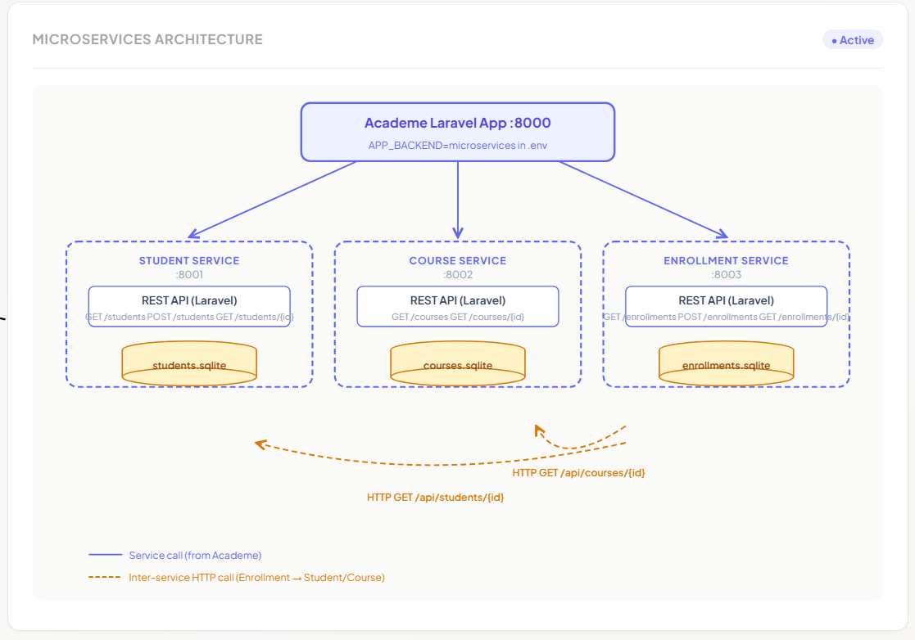
The following table lists every edge case scenario implemented and tested:
Status | Error Code | Trigger | Service
201 | — | Successful creation | All
200 | — | Successful read / update / delete | All
400 | VALIDATION_ERROR | Missing or invalid input fields | All
404 | NOT_FOUND | Resource ID does not exist | All
404 | STUDENT_NOT_FOUND | Invalid student_id on enroll | Enrollment
404 | COURSE_NOT_FOUND | Invalid course_id on enroll | Enrollment
409 | DUPLICATE_EMAIL | Email already registered | Student
409 | DUPLICATE_ENROLLMENT | Student already in course | Enrollment
503 | SERVICE_UNAVAILABLE | Dependency service offline | Enrollment
504 | GATEWAY_TIMEOUT | Dependency response too slow | Enrollment

A. Reset and Seed (Required Before Every Full Run)
Run the following from the project root before starting the test suite. This establishes a clean baseline of three students and three courses with the enrollment table empty.
cd lab2/services/student-service && php artisan migrate:fresh --seed
cd ../course-service && php artisan migrate:fresh --seed
cd ../enrollment-service && php artisan migrate:fresh

ITSAR2 313 – SYSTEM INTEGRATION AND ARCHICTECTURE 2 Page 2 of 14
by: Engr. Joao Roumil G. Vergara, CpE

B. Start Services
Open four separate terminal windows:
# Terminal 1
cd lab2/services/student-service && php artisan serve --port=8001

# Terminal 2
cd lab2/services/course-service && php artisan serve --port=8002

# Terminal 3
cd lab2/services/enrollment-service && php artisan serve --port=8003

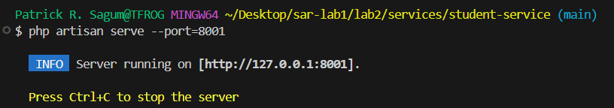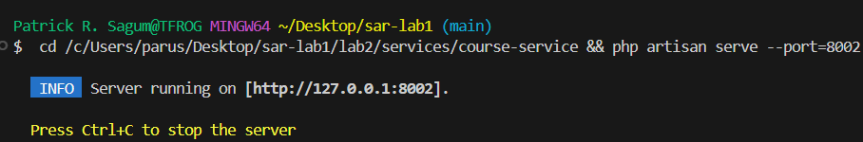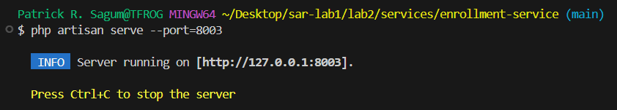
C. Sequential Test Flow
Use Terminal 4 for all curl commands. Execute steps in order — do not skip steps.
Step 1 — GET all students (Expected: HTTP 200)
curl -i http://localhost:8001/api/students
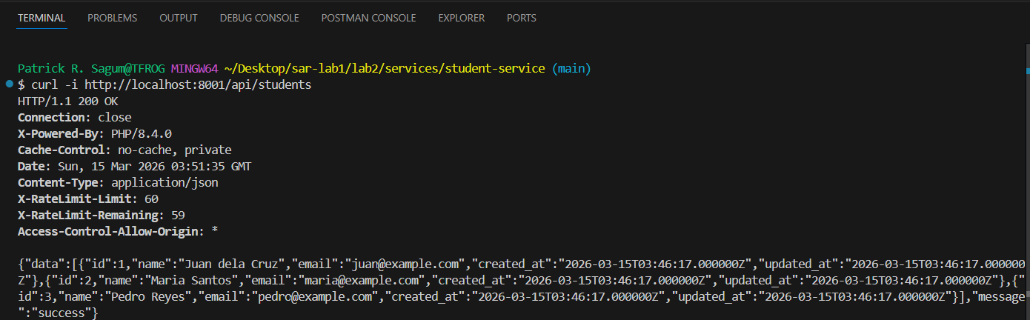

ITSAR2 313 – SYSTEM INTEGRATION AND ARCHICTECTURE 2 Page 3 of 14
by: Engr. Joao Roumil G. Vergara, CpE
Step 2 — GET all courses (Expected: HTTP 200)
curl -i http://localhost:8002/api/courses
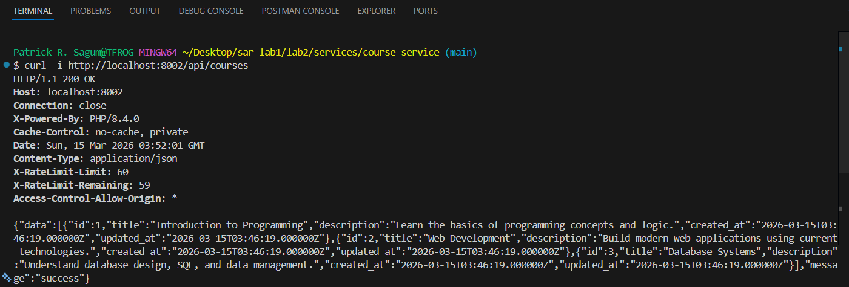

Step 3 — POST create student (Expected: HTTP 201)
curl -i -X POST http://localhost:8001/api/students \
-H "Content-Type: application/json" \
-d '{"name":"Sequential Student","email":"seq.student@example.com"}'
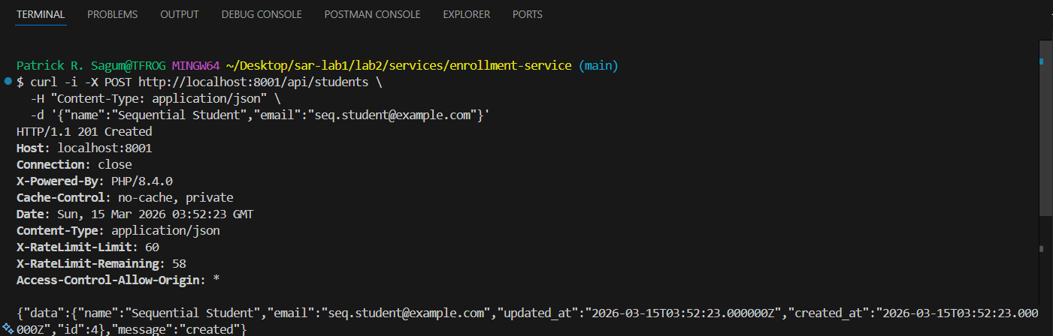
Step 4 — GET student by ID (Expected: HTTP 200)
curl -i http://localhost:8001/api/students/4
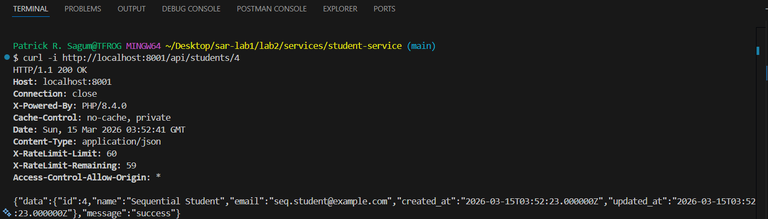

ITSAR2 313 – SYSTEM INTEGRATION AND ARCHICTECTURE 2 Page 4 of 14
by: Engr. Joao Roumil G. Vergara, CpE

Step 5 — PUT update student (Expected: HTTP 200)
curl -i -X PUT http://localhost:8001/api/students/4 \
-H "Content-Type: application/json" \
-d '{"name":"Sequential Student Updated","email":"seq.updated@example.com"}'
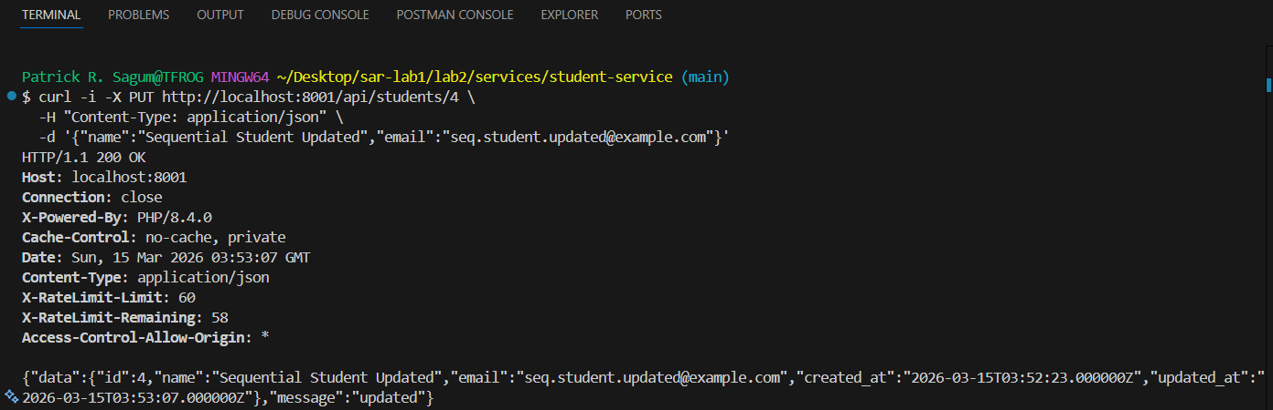
Step 6 — POST create course (Expected: HTTP 201)
curl -i -X POST http://localhost:8002/api/courses \
-H "Content-Type: application/json" \
-d '{"title":"Sequential Course","description":"Course for ordered testing"}'
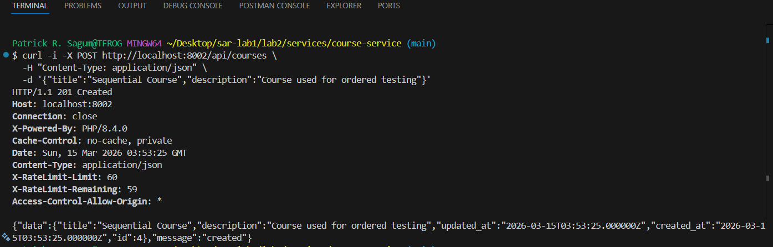
Step 7 — GET course by ID (Expected: HTTP 200)
curl -i http://localhost:8002/api/courses/4
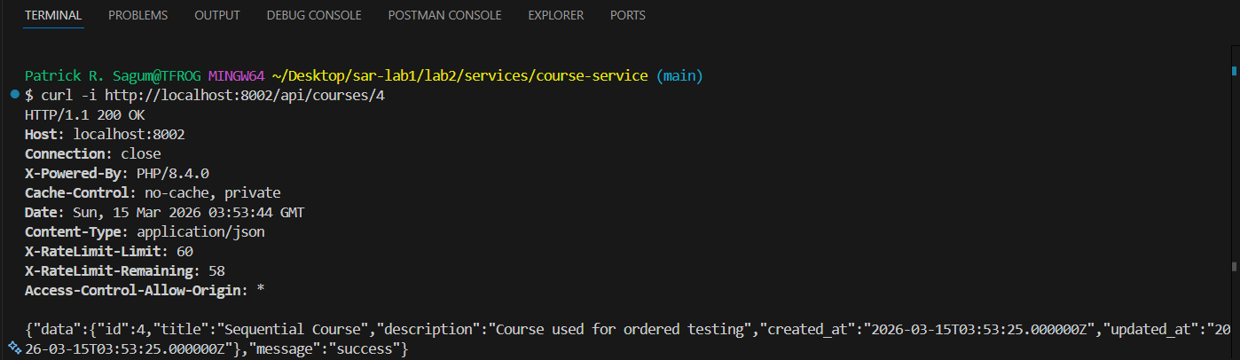

ITSAR2 313 – SYSTEM INTEGRATION AND ARCHICTECTURE 2 Page 5 of 14
by: Engr. Joao Roumil G. Vergara, CpE

Step 8 — PUT update course (Expected: HTTP 200)
curl -i -X PUT http://localhost:8002/api/courses/4 \
-H "Content-Type: application/json" \
-d '{"title":"Sequential Course Updated","description":"Updated for test"}'
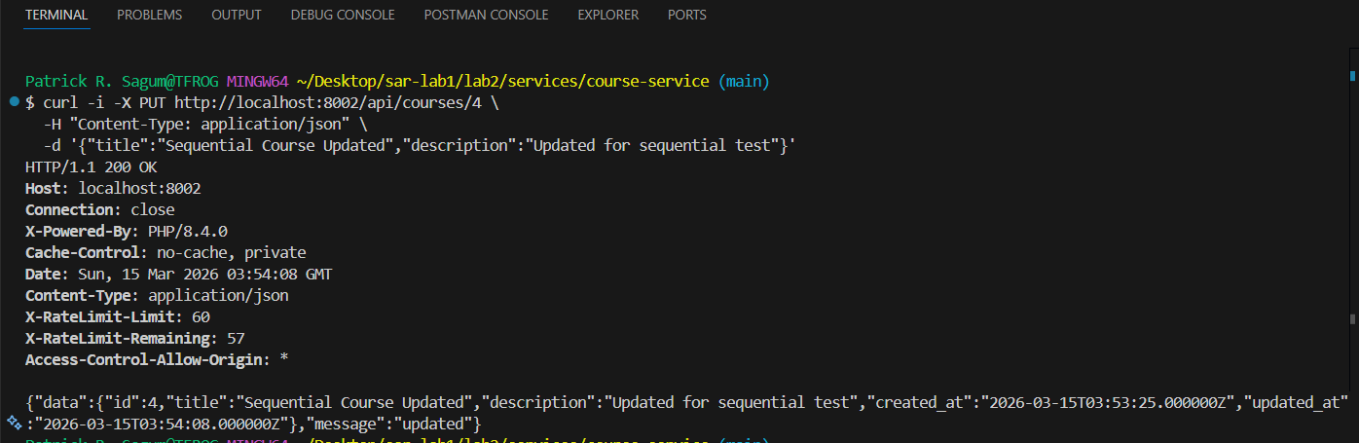
Step 9 — POST create enrollment (Expected: HTTP 201)
curl -i -X POST http://localhost:8003/api/enrollments \
-H "Content-Type: application/json" \
-d '{"student_id":4,"course_id":4}'
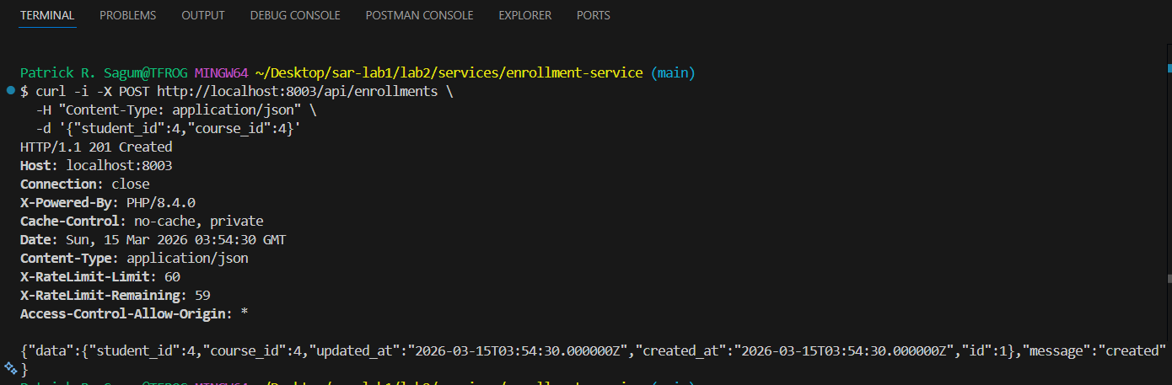
Step 10 — GET enrollment by ID (enriched) (Expected: HTTP 200)
curl -i http://localhost:8003/api/enrollments/1
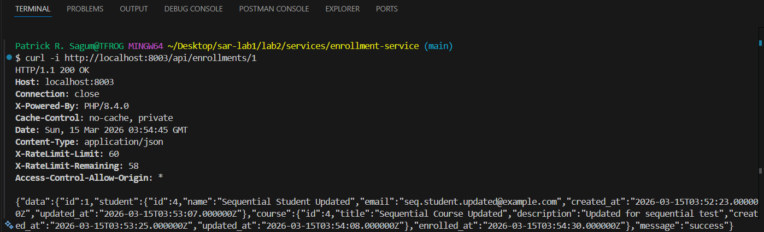

ITSAR2 313 – SYSTEM INTEGRATION AND ARCHICTECTURE 2 Page 6 of 14
by: Engr. Joao Roumil G. Vergara, CpE
Step 11 — GET enrollments by student (Expected: HTTP 200)
curl -i http://localhost:8003/api/enrollments/student/4
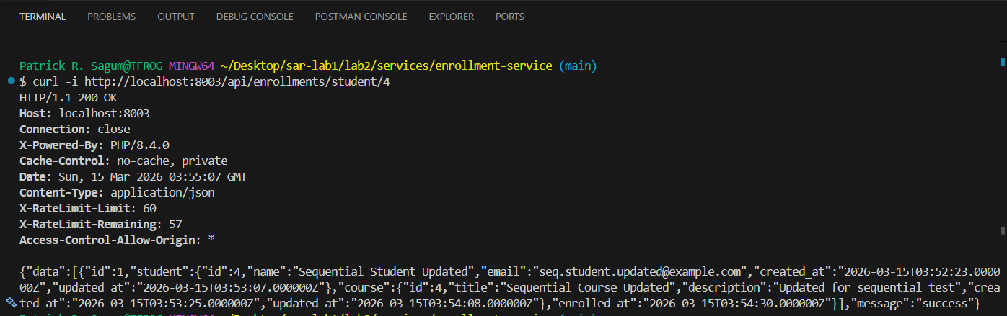
Step 12 — Validation — POST student missing name (Expected: HTTP 400)
curl -i -X POST http://localhost:8001/api/students \
-H "Content-Type: application/json" \
-d '{"email":"missing-name@example.com"}'
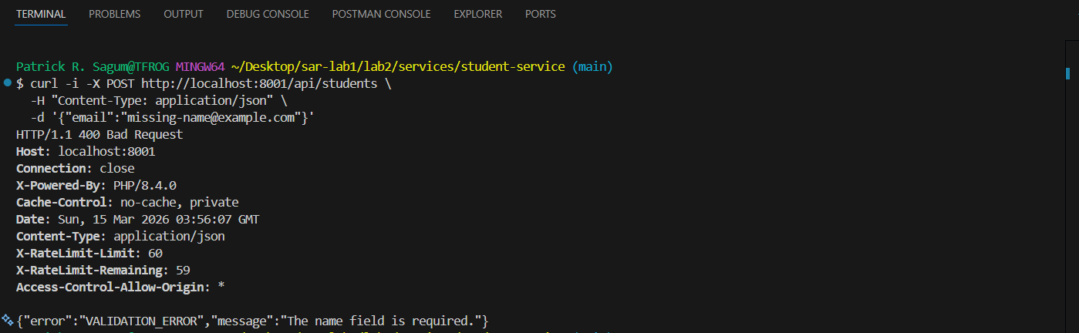
Step 13 — Validation — POST student invalid email (Expected: HTTP 400)
curl -i -X POST http://localhost:8001/api/students \
-H "Content-Type: application/json" \
-d '{"name":"Bad Email","email":"not-an-email"}'
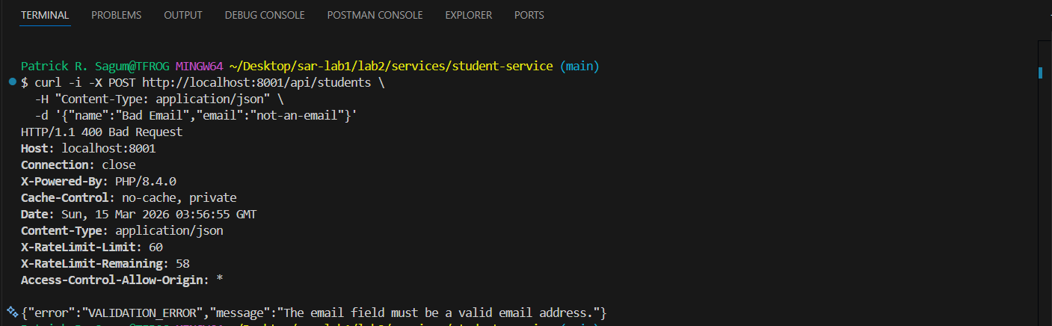

ITSAR2 313 – SYSTEM INTEGRATION AND ARCHICTECTURE 2 Page 7 of 14
by: Engr. Joao Roumil G. Vergara, CpE

Step 14 — Validation — POST enrollment missing course_id (Expected: HTTP 400)
curl -i -X POST http://localhost:8003/api/enrollments \
-H "Content-Type: application/json" \
-d '{"student_id":4}'
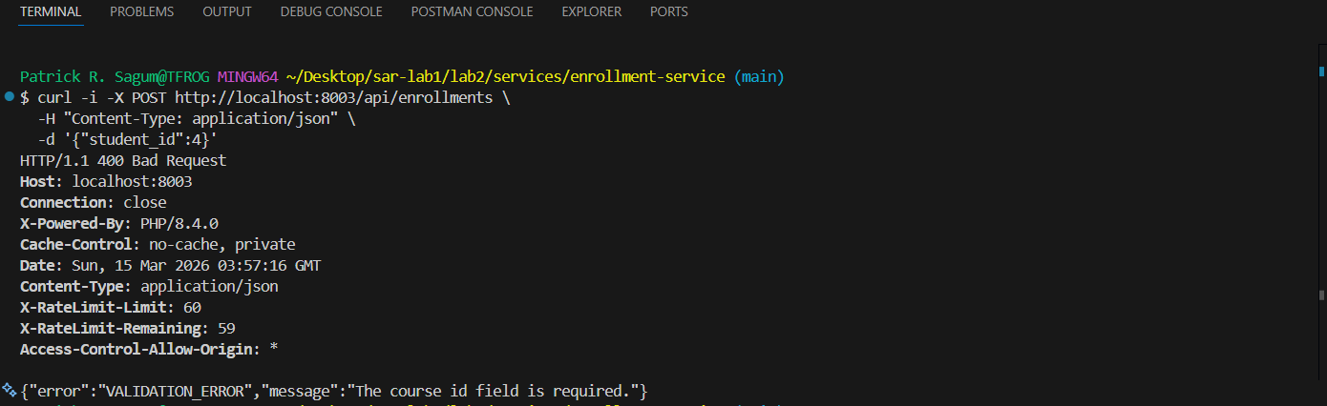

Step 15 — Not Found — GET nonexistent student (Expected: HTTP 404)
curl -i http://localhost:8001/api/students/9999
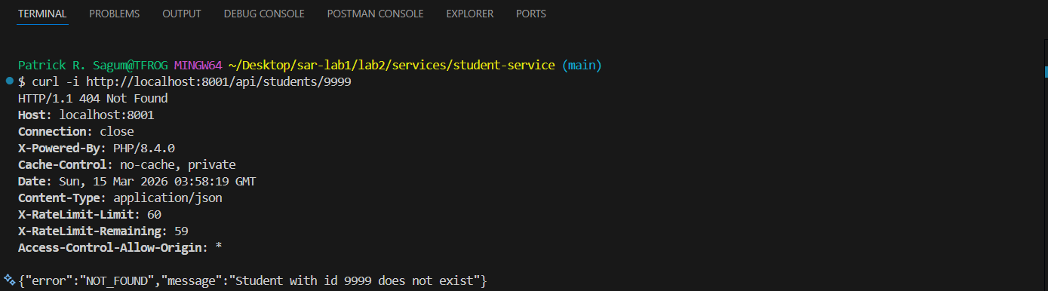
Step 16 — Not Found — GET nonexistent course (Expected: HTTP 404)
curl -i http://localhost:8002/api/courses/9999
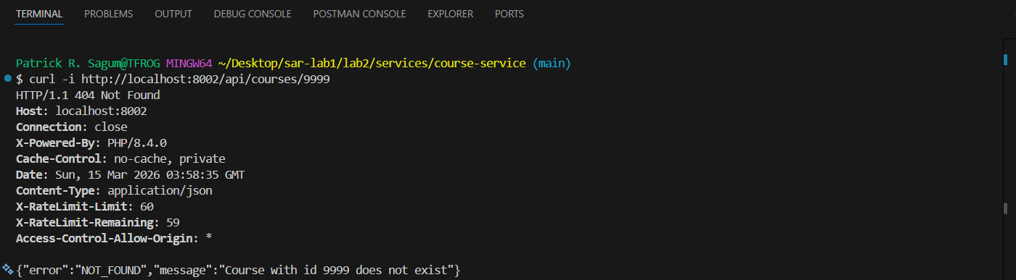

ITSAR2 313 – SYSTEM INTEGRATION AND ARCHICTECTURE 2 Page 8 of 14
by: Engr. Joao Roumil G. Vergara, CpE
Step 17 — Not Found — GET nonexistent enrollment (Expected: HTTP 404)
curl -i http://localhost:8003/api/enrollments/9999
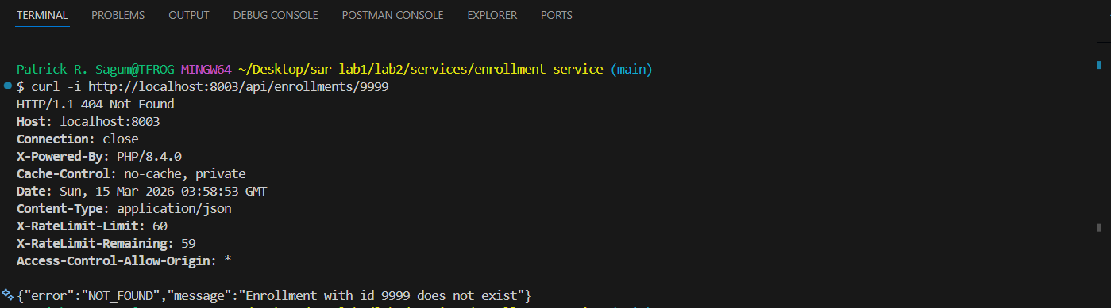
Step 18 — Duplicate — POST student existing email (Expected: HTTP 409)
curl -i -X POST http://localhost:8001/api/students \
-H "Content-Type: application/json" \
-d '{"name":"Duplicate Student","email":"juan@example.com"}'
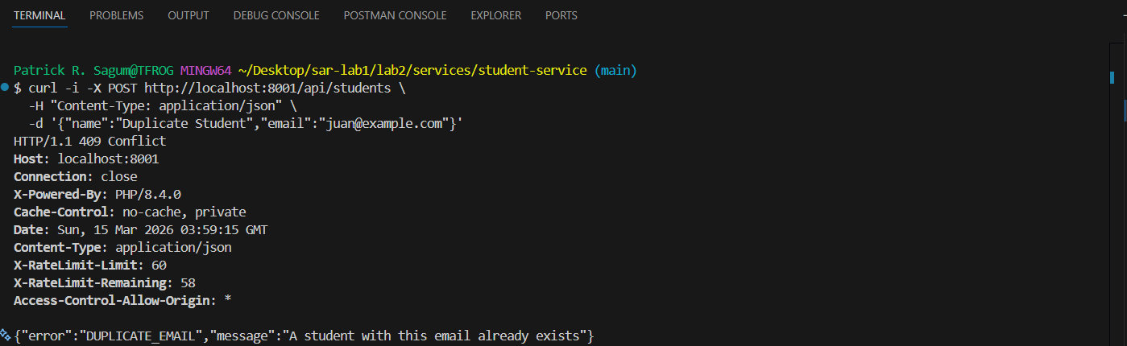
Step 19 — Duplicate — POST duplicate enrollment pair (Expected: HTTP 409)
curl -i -X POST http://localhost:8003/api/enrollments \
-H "Content-Type: application/json" \
-d '{"student_id":4,"course_id":4}'
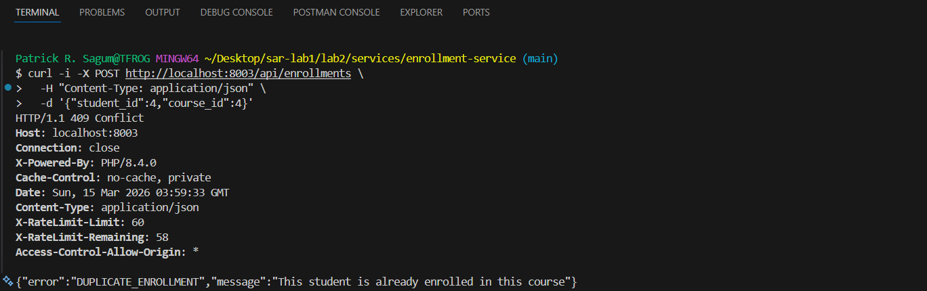

ITSAR2 313 – SYSTEM INTEGRATION AND ARCHICTECTURE 2 Page 9 of 14
by: Engr. Joao Roumil G. Vergara, CpE
Step 20 — Cross-service 404 — nonexistent student_id (Expected: HTTP 404)
curl -i -X POST http://localhost:8003/api/enrollments \
-H "Content-Type: application/json" \
-d '{"student_id":9999,"course_id":4}'
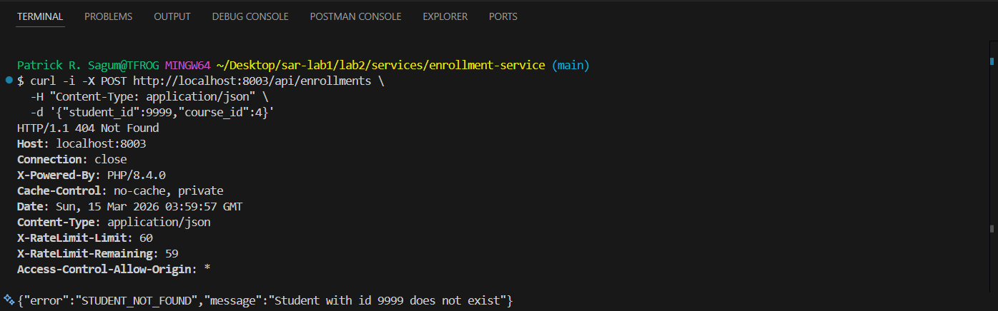
Step 21 — Cross-service 404 — nonexistent course_id (Expected: HTTP 404)
curl -i -X POST http://localhost:8003/api/enrollments \
-H "Content-Type: application/json" \
-d '{"student_id":4,"course_id":9999}'
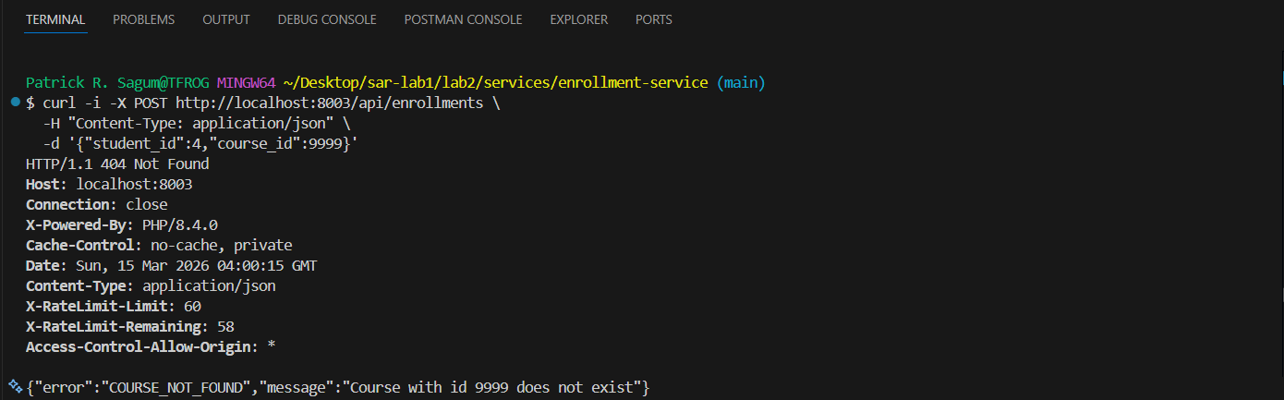
Step 22 — Dependency Down — student-service offline (Expected: HTTP 503)
MANUAL STEP REQUIRED
1. Press Ctrl+C on Terminal 1 to stop student-service (port 8001)
2. Run the curl command below in Terminal 4
3. Restart student-service on Terminal 1 before Step 23
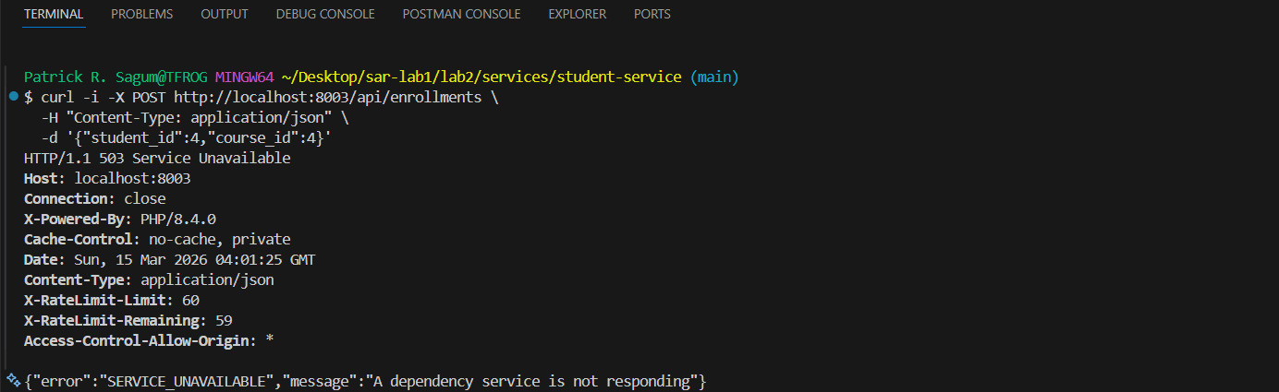

ITSAR2 313 – SYSTEM INTEGRATION AND ARCHICTECTURE 2 Page 10 of 14
by: Engr. Joao Roumil G. Vergara, CpE
# Stop student-service first (Ctrl+C on Terminal 1)
curl -i -X POST http://localhost:8003/api/enrollments \
-H "Content-Type: application/json" \
-d '{"student_id":4,"course_id":4}'

Step 23 — Dependency Timeout — student-service too slow (Expected: HTTP 504)
MANUAL STEP REQUIRED
1. Restart student-service if stopped from Step 22
2. Open: lab2/services/student-service/app/Http/Controllers/StudentController.php
3. In the show() method, add sleep(10); as the first line
4. Restart student-service on Terminal 1
5. Run the curl command below — it will timeout after 5 seconds
6. REMOVE sleep(10) immediately after capturing the screenshot

# Add sleep(10) to StudentController::show() first, then restart student-service
curl -i -X POST http://localhost:8003/api/enrollments \
-H "Content-Type: application/json" \
-d '{"student_id":4,"course_id":4}'
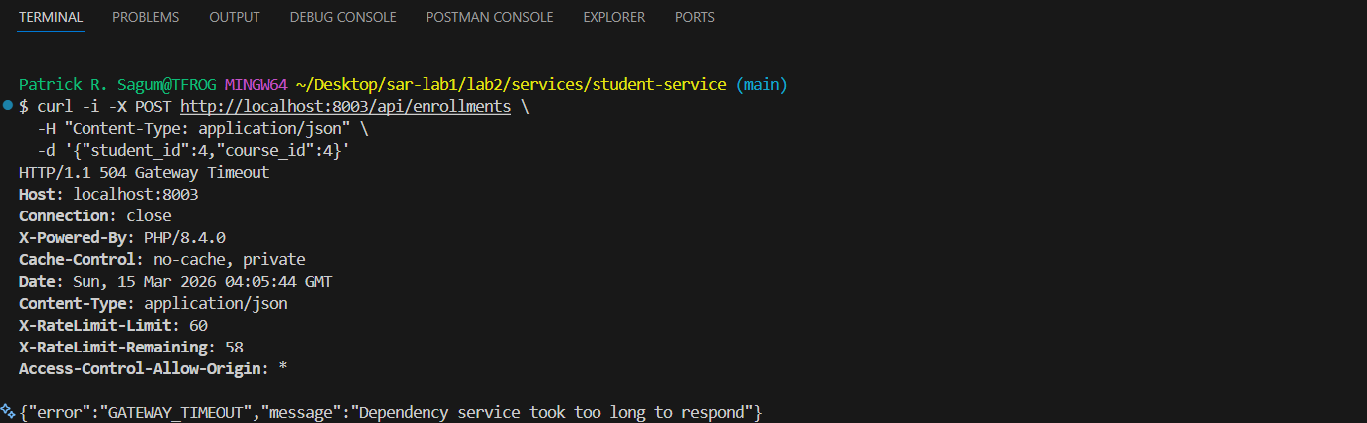

Step 24 — Cleanup — DELETE enrollment (Expected: HTTP 200)
curl -i -X DELETE http://localhost:8003/api/enrollments/1
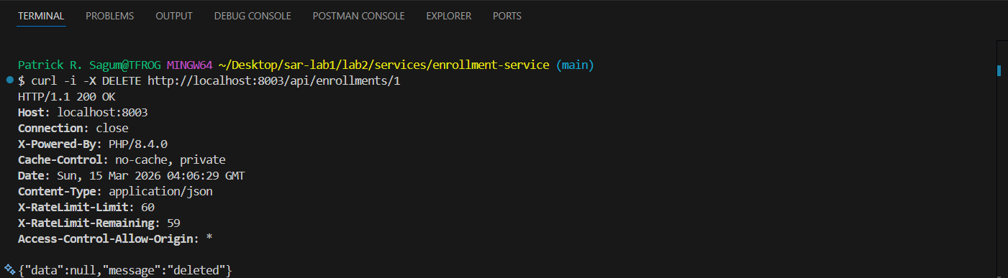

ITSAR2 313 – SYSTEM INTEGRATION AND ARCHICTECTURE 2 Page 11 of 14
by: Engr. Joao Roumil G. Vergara, CpE

Step 25 — Cleanup — DELETE student (Expected: HTTP 200)
curl -i -X DELETE http://localhost:8001/api/students/4
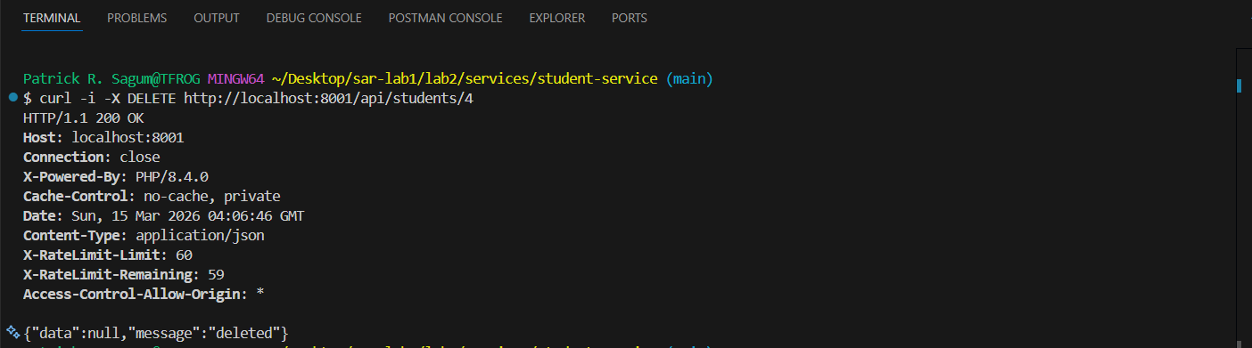
Step 26 — Cleanup — DELETE course (Expected: HTTP 200)
curl -i -X DELETE http://localhost:8002/api/courses/4
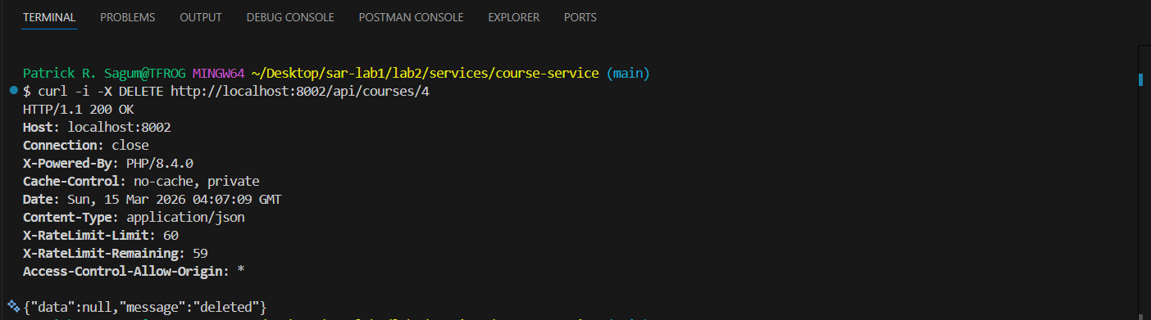
Step 27 — Verify cleanup — all three deleted resources return 404 (Expected: HTTP 404)
curl -i http://localhost:8001/api/students/4
curl -i http://localhost:8002/api/courses/4
curl -i http://localhost:8003/api/enrollments/1

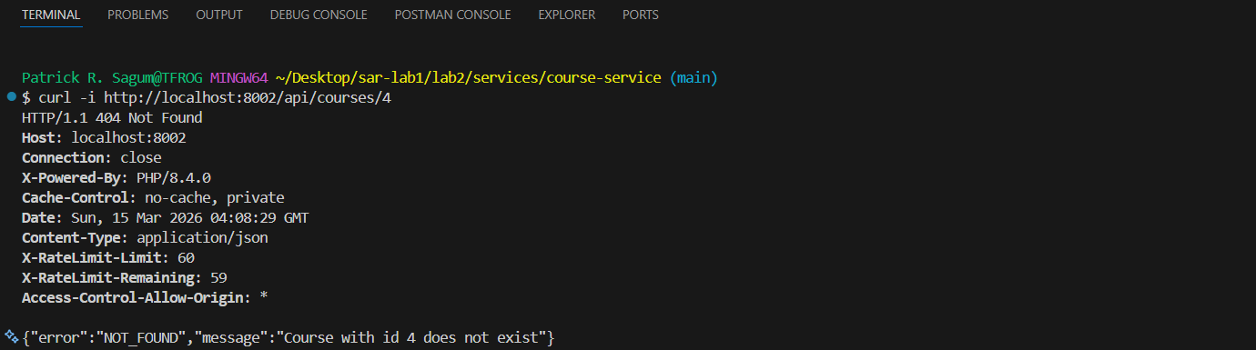

ITSAR2 313 – SYSTEM INTEGRATION AND ARCHICTECTURE 2 Page 12 of 14
by: Engr. Joao Roumil G. Vergara, CpE

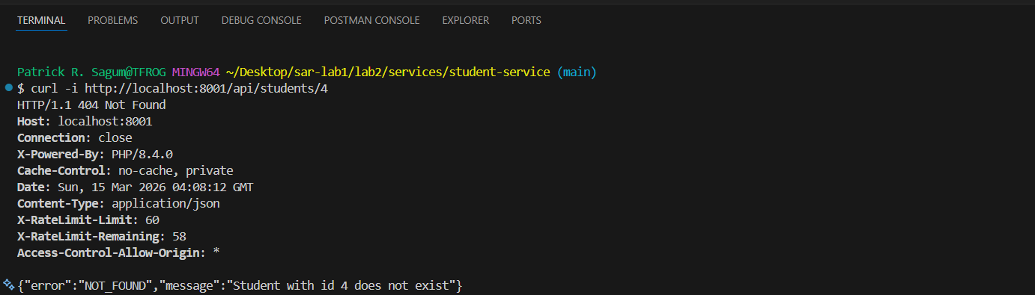
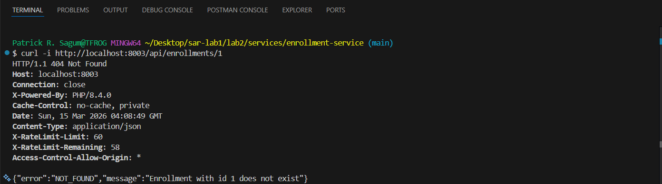

III. EXPERIMENTAL FINDINGS / OBSERVATIONS
All 27 test steps executed in sequential order returned the correct HTTP status codes. Steps 1 through 11 confirmed that all three services respond correctly to valid CRUD operations, including enriched responses from enrollment-service that embed student and course data. Steps 12 through 14 confirmed that validation errors return HTTP 400 with VALIDATION_ERROR and field-level error messages. Steps 15 through 17 confirmed that not-found errors return HTTP 404 with NOT_FOUND for direct lookups. Steps 20 and 21 confirmed cross-service not-found handling: enrollment-service correctly maps upstream 404 responses to STUDENT_NOT_FOUND and COURSE_NOT_FOUND.
Duplicate detection in Steps 18 and 19 worked correctly. Student-service returned DUPLICATE_EMAIL when the same email was submitted twice. Enrollment-service returned DUPLICATE_ENROLLMENT when the same student–course pair was submitted twice. The dependency failure tests in Steps 22 and 23 confirmed that enrollment-service distinguishes between an offline dependency and a slow dependency. A stopped service triggers ConnectionException without 'timed out' in the message, returning HTTP 503. A service with sleep(10) exceeds the Http::timeout(5) threshold and triggers ConnectionException with 'timed out', returning HTTP 504. Steps 24 through 27 confirmed that all three delete operations succeed and that deleted resources return 404 when queried.
IV. LAB DISCUSSIONS / COMPUTATIONS
Consistent ERROR_CODE strings across all three services are essential for frontend error handling. The Academe frontend uses a single error handler that reads the 'error' field from every JSON response. Because all three services follow the same {"error": "...", "message": "..."} response contract, the frontend does not require service-specific error logic. This consistency was confirmed across all 27 test steps — no service returned an unexpected format or an undocumented error code.

ITSAR2 313 – SYSTEM INTEGRATION AND ARCHICTECTURE 2 Page 13 of 14
by: Engr. Joao Roumil G. Vergara, CpE
Only the enrollment-service returns 503 and 504 errors because it is the only service with external HTTP dependencies. When creating an enrollment, the controller makes two sequential HTTP GET calls — one to student-service to verify the student exists and one to course-service to verify the course exists. Student-service and course-service query only their own local SQLite databases and have no outbound calls, making 503 and 504 responses architecturally impossible for those services.
The Http::timeout(5) configuration protects the system from hanging indefinitely when a dependency is unresponsive. The serviceError() helper method inspects the ConnectionException message using str_contains($e->getMessage(), 'timed out') to distinguish the two failure modes. This is a functional approach for this lab scope. In production, this would be replaced by circuit breakers with explicit /health endpoints to short-circuit requests to a known-failing service without waiting for the timeout.
Using curl -i rather than plain curl was essential for this test suite. Without the -i flag, curl only displays the response body and the HTTP status line (e.g., HTTP/1.1 503 Service Unavailable) is invisible. Since the entire purpose of edge case testing is verifying correct HTTP status codes, every command in the suite uses -i. The sequential ordering of steps was equally critical — Step 9 depends on IDs created in Steps 3 and 6, and Step 19 depends on the enrollment created in Step 9. Without deterministic ordering, data-dependency failures would obscure real bugs.
V. CONCLUSIONS
All 27 sequential test steps were executed and confirmed to return correct HTTP status codes and JSON error bodies. The test suite covered every endpoint across all three microservices: happy path CRUD (Steps 1–11), validation errors (Steps 12–14), not-found scenarios (Steps 15–17 and 20–21), duplicate detection (Steps 18–19), dependency failures (Steps 22–23), and cleanup verification (Steps 24–27). Microservices introduce failure modes — 503 Service Unavailable and 504 Gateway Timeout — that monolithic systems do not face because monoliths have no external HTTP dependencies. The enrollment-service is the single point of cross-service communication and therefore the only service requiring resilience handling. Production improvements would add circuit breakers to prevent cascade failures, retry logic with exponential backoff for transient errors, and /health endpoints on each service for monitoring and load balancer integration.

ITSAR2 313 – SYSTEM INTEGRATION AND ARCHICTECTURE 2 Page 14 of 14
by: Engr. Joao Roumil G. Vergara, CpE

References
Laravel Documentation. (2024). The PHP Framework for Web Artisans. https://laravel.com/docs
Fowler, M. (2002). Patterns of Enterprise Application Architecture. Addison-Wesley.
Richardson, C. (2018). Microservices Patterns. Manning Publications.
Mozilla Developer Network. (2024). HTTP Status Codes. https://developer.mozilla.org/en-US/docs/Web/HTTP/Status
curl Documentation. (2024). curl — command line tool and library. https://curl.se/docs/

ITSAR2 313 – SYSTEM INTEGRATION AND ARCHICTECTURE 2 Page 14 of 14
by: Engr. Joao Roumil G. Vergara, CpE

