Architecture Diagrams — Monolithic vs Microservices
Sagum, Patrick R.; Henson, Princess Terana Caram Rasonable;
Gargarita, Trisha Faith Casiano; Mogat, Ela Mae Trojillo;
Tibo-oc, Paul Felippe Gelle
Information Technology, College of Computer Studies
Carlos Hilado Memorial State University
Section 1 — Monolithic Architecture
The monolithic application is a single Laravel project located in lab1/academe/. It uses one SQLite database file (database/database.sqlite) and follows the Model–View–Controller–Repository (MVCR) pattern. Every request flows through the route layer, into a FormRequest for validation, then to a Controller that injects a Repository Interface. The concrete Repository Implementation talks to Eloquent Models, which read from and write to the single SQLite database. The Controller returns data to Blade views for server-side rendering. All three domains — Students, Courses, and Enrollments — live in one codebase, share one database, and deploy as a single unit. The APP_BACKEND variable in .env controls whether the Controller routes through the local Repository (monolithic mode) or through HTTP Service Clients (microservices mode).
“Monolithic Architecture — Single Laravel app, single SQLite database, all features in one codebase”
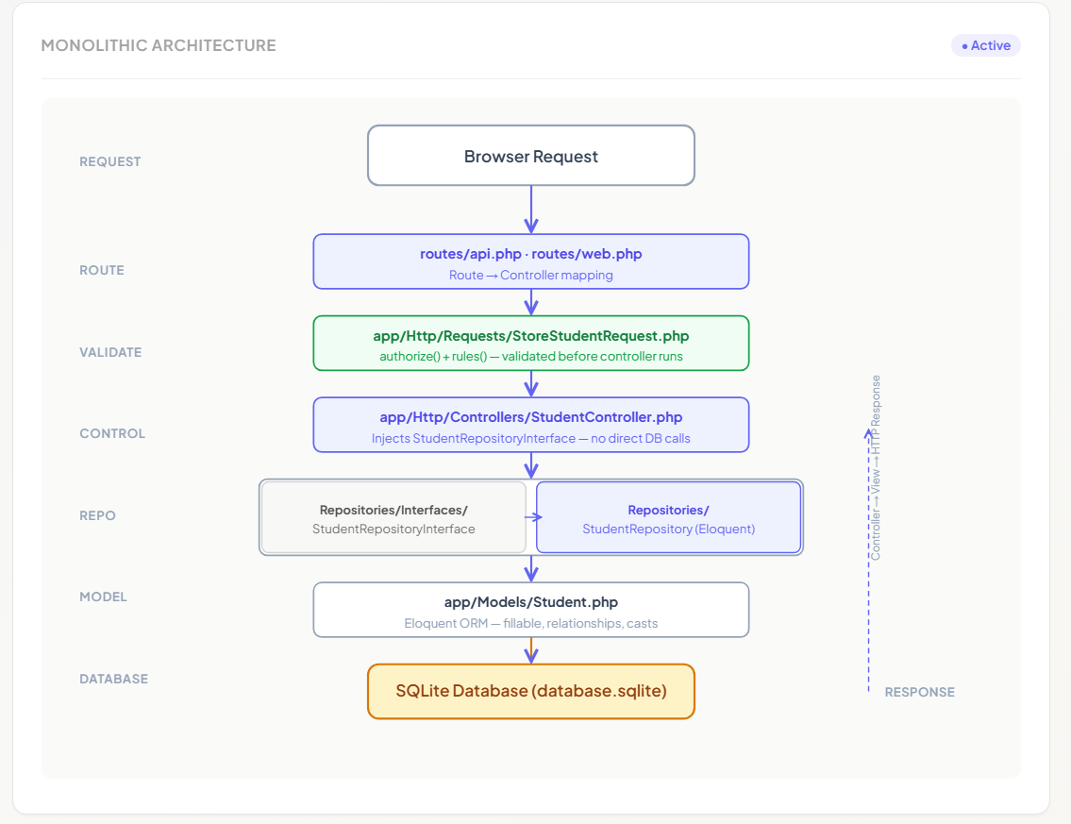
Section 2 — Microservices Architecture
The microservices decomposition splits the system into three independent Laravel applications: student-service (port 8001), course-service (port 8002), and enrollment-service (port 8003). Each service owns its own SQLite database file and exposes a JSON REST API. The enrollment-service validates foreign keys by making synchronous HTTP GET calls to the student-service and course-service before persisting any enrollment record. These calls use Http::timeout(5) and are wrapped in try/catch blocks to handle 503 (connection refused) and 504 (timeout) scenarios independently. Each service follows the same MVCR pattern internally — Controller → Repository Interface → Repository Implementation → Eloquent Model → SQLite. There is no shared database, no message queue, and no API gateway.
"Microservices Architecture — Three independent services each with own SQLite database, communicating via HTTP"
