ZENFLOW: POMODORO TIMER APPLICATION
Proponents : Patrick R. Sagum, Jurriel A. Guanzon, Jegrick A. Sildora, Kate Nicole D. Bermejo
Bachelor of Science in Information Technology
October 2025

SYSTEM DESCRIPTION
ZenFlow is a productivity-focused mobile application built with Flutter that implements the Pomodoro Technique for effective time management. The application helps users break work into focused 25-minute intervals (Pomodoros) separated by short breaks, with longer breaks after every 4 completed focus sessions. The app features a clean, dark-themed interface designed to minimize distractions while maximizing productivity.

Key Features:
- Customizable Pomodoro timer with Focus (25 min), Short Break (5 min), and Long Break (15 min)
- Task management system to track work items and completed Pomodoros per task
- Visual cycle progress tracking with animated indicators
- Audio notifications when timer sessions complete
- Local data persistence using Hive database for offline functionality
- Settings panel for customizing timer durations and behavior

APPLICATION SCREENSHOTS
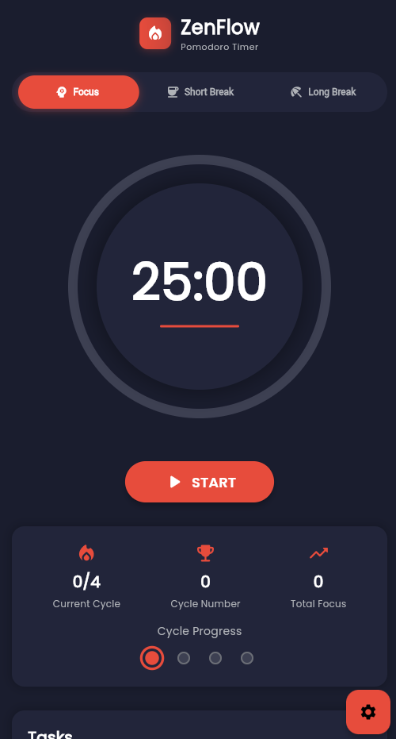
Below are screenshots demonstrating the main interface and key features of the ZenFlow application:
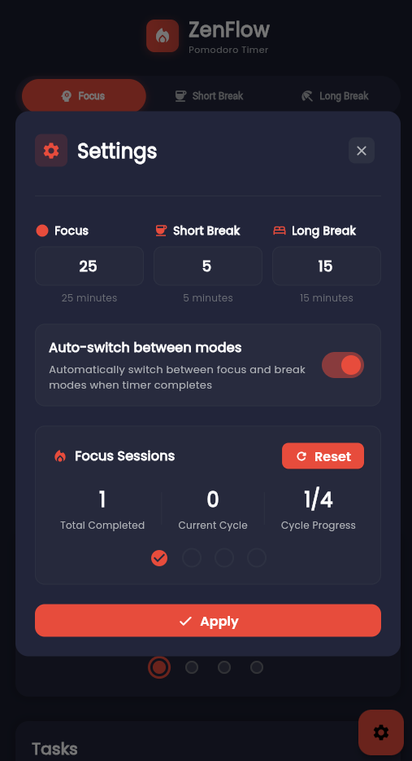
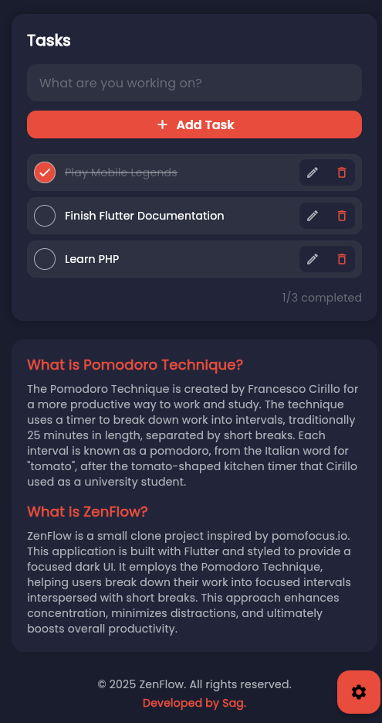

SYSTEM FUNCTIONALITY
INPUT / USER ACTIONS | OUTPUT / SYSTEM RESPONSE
Timer Control:  • User selects timer type (Focus/Short Break/Long Break)  • User clicks START button  • User can PAUSE or RESET timer | System Response:  • Timer countdown begins with MM:SS format display  • Background color changes based on timer type (Red=Focus, Yellow=Short, Blue=Long)  • Pause button replaces Start button when active  • Timer state persists across app sessions
Task Management:  • User enters task title in input field  • User clicks add button to create task  • User marks task as complete with checkbox  • User edits or deletes existing tasks | System Response:  • New task appears in active tasks list  • Task moves to completed section when checked  • Pomodoro counter increments for associated tasks  • All tasks saved locally in Hive database  • Edit dialog allows title modification
Settings Configuration:  • User opens settings (gear icon)  • User adjusts timer durations (Focus: 1-60 min, Breaks: 1-30 min)  • User sets cycles before long break (2-8)  • User toggles auto-switch option  • User clicks APPLY or RESET ALL | System Response:  • Settings modal displays current values  • Timer durations update immediately  • New settings persist in local storage  • Auto-switch automatically starts next timer  • Reset ALL clears all cycle counters to zero
Cycle Progress:  • User completes focus sessions  • System tracks progress through 4-session cycle | System Response:  • Visual dots show cycle status:  - Green checkmark: Completed session  - Red pulsing ring: Current session  - Grey dot: Upcoming session  • Completed cycles counter increments  • Long break triggered after 4 focus sessions
Timer Completion:  • Timer reaches 00:00 | System Response:  • Audio notification plays (system alert sound)  • Notification overlay appears with:  - Completion message and icon  - Next timer type suggestion  • User taps anywhere to dismiss  • Timer automatically switches to next type  • Session data saved to history

TECHNICAL ARCHITECTURE
Architecture Pattern: Clean Architecture with MVVM (Model-View-ViewModel) pattern, ensuring separation of concerns and maintainable code structure. Technology Stack: Flutter 3.5.3, Dart, Hive (NoSQL database), Provider (state management), Audioplayers (sound notifications), Google Fonts Data Persistence: All data stored locally using Hive database with three main collections: Tasks, Timer Sessions, and Settings. No internet connection required.

EXAMPLE DATA
Sample Task Data:
Task: "Finish Flutter Documentation"
- Status: Active
- Pomodoros Completed: 3
- Created: October 21, 2025
Task: "Review code architecture"
- Status: Completed
- Pomodoros Completed: 2
- Created: October 20, 2025
Sample Timer Session:
Session Type: Focus
Duration: 25 minutes
Start Time: 2:30 PM
End Time: 2:55 PM
Status: Completed
Associated Task: " Finish Flutter Documentation "

────────────────────────────────────────────────────────
ZenFlow - Built with Flutter & Clean Architecture Principles
Version 1.0.0 | October 2025

